NAME: OKEREKE OBIANUJU MIRRIAM
COLLEGE: MHS
DEPARTMENT: NURSING
COURSE: PHY102
MATRIC NO: 19/MHS02/094
COVID-19 HOLIDAY ASSIGNMENT

- A process where electric charges can be obtained without touching the object in action is known as electrostatic induction. When a positively charged rubber rod is brought near an uncharged(neutral) conducting sphere that is insulated, the repulsive force between the electrons in the rod and those in the sphere causes a redistribution of charges on the sphere in a way that some of the electrons moves towards the area furthest away from the rod. This is illustrated in the diagram below: 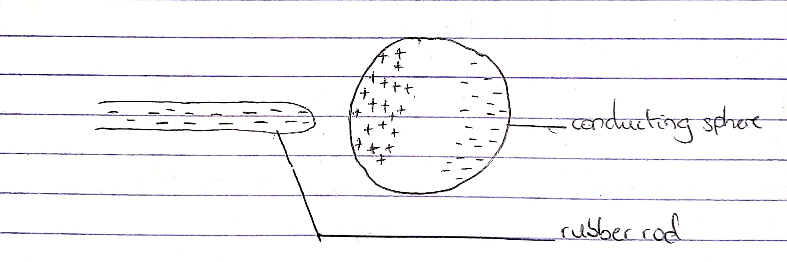Now the area closer to the rod contains excess positive charges because of the phenomenon that occurred previously. If a conducting wire is connected to the sphere then some of the electrons leave the sphere and travel down the earth. Its represented in the diagram below: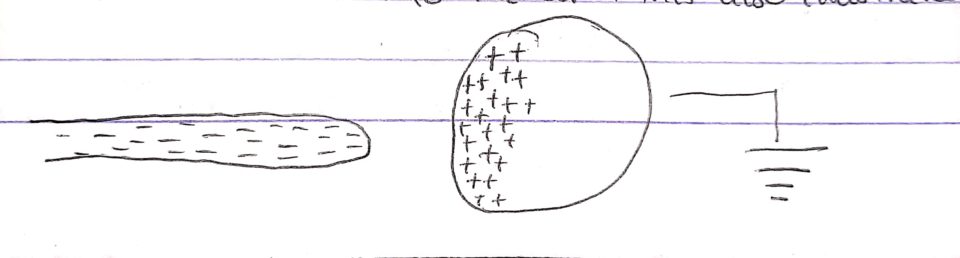 When the wire is disconnected from the conducting sphere, it is left with only excess positive charges as seen below: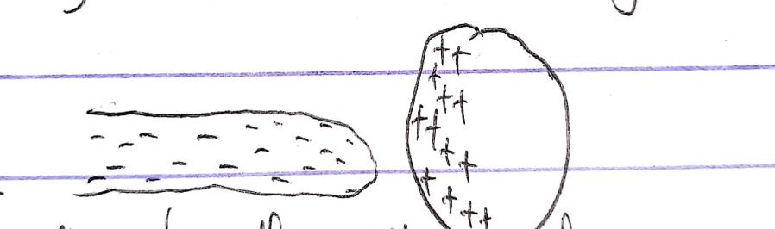Finally when the rubber rod Is removed from the area where the sphere is present, the induced positive charge remains on the ungrounded sphere and becomes uniformly distributed over the surface of the sphere.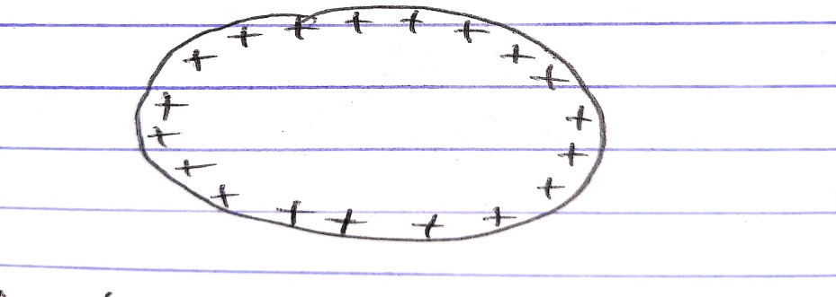
- Answer 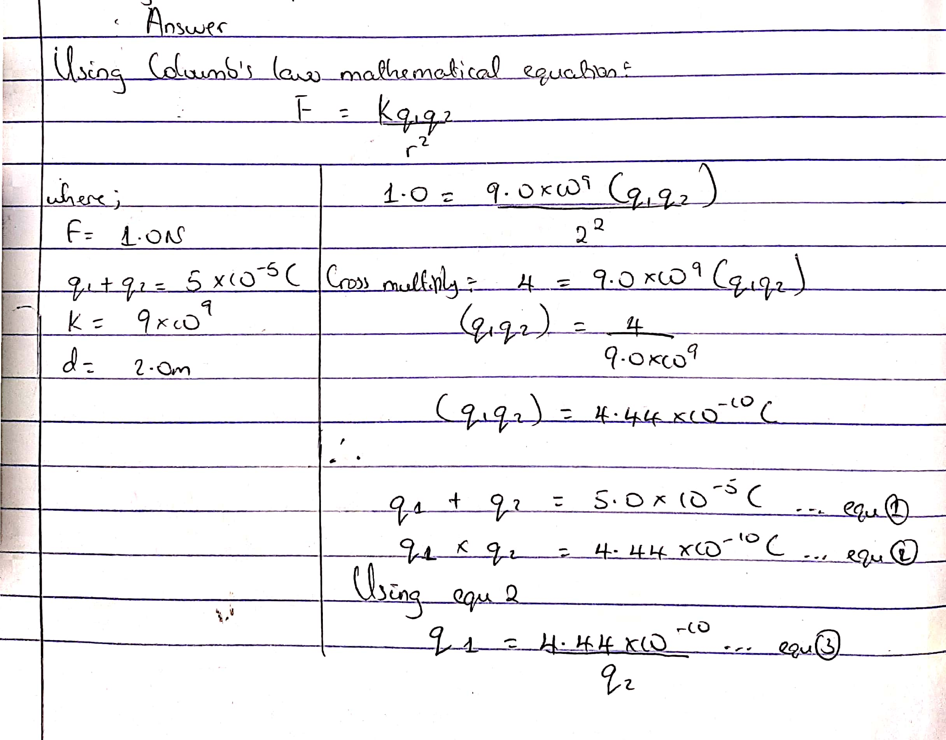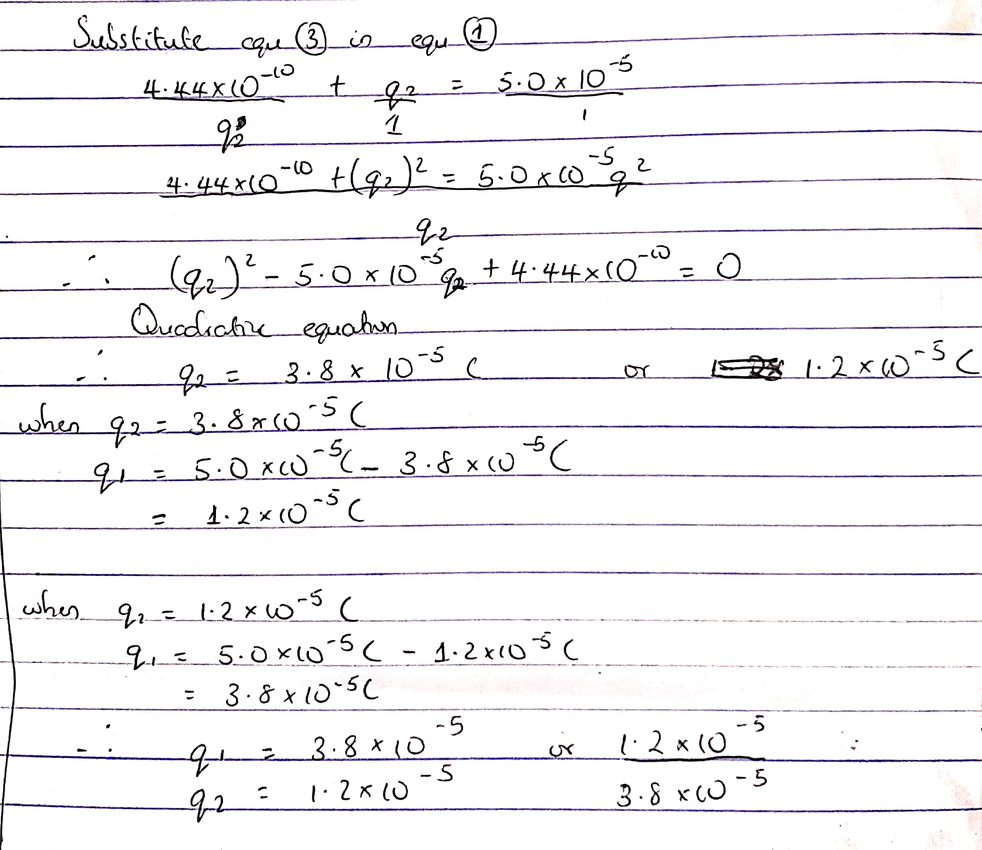
- Answer 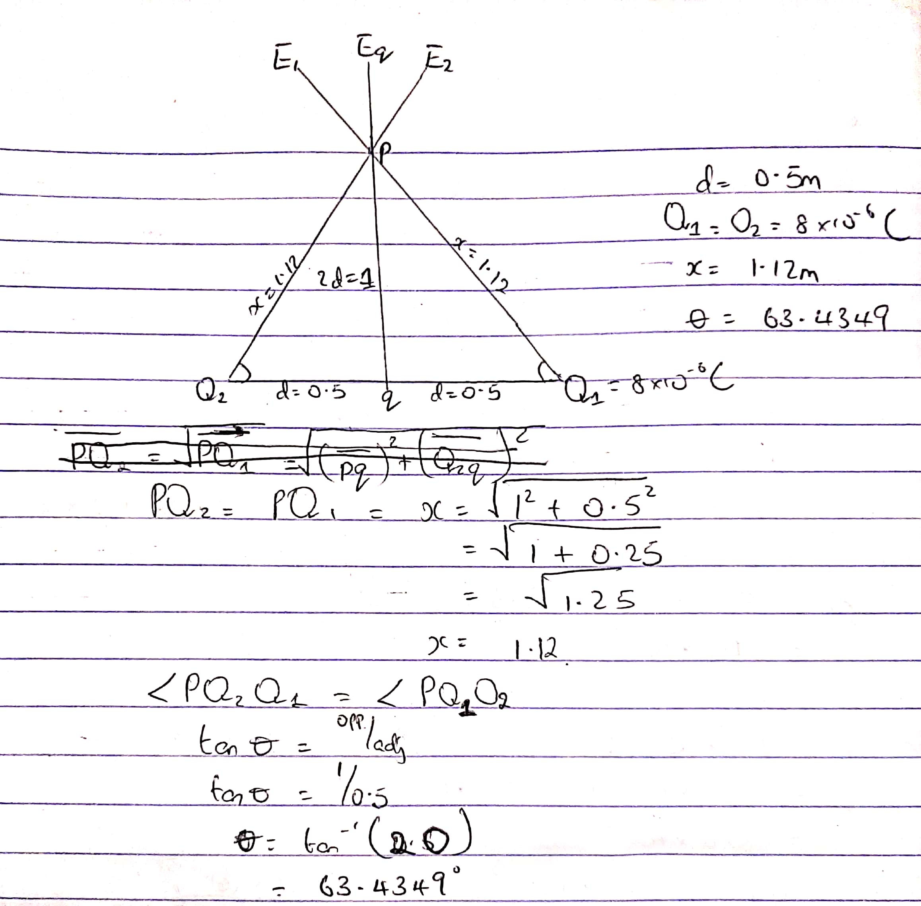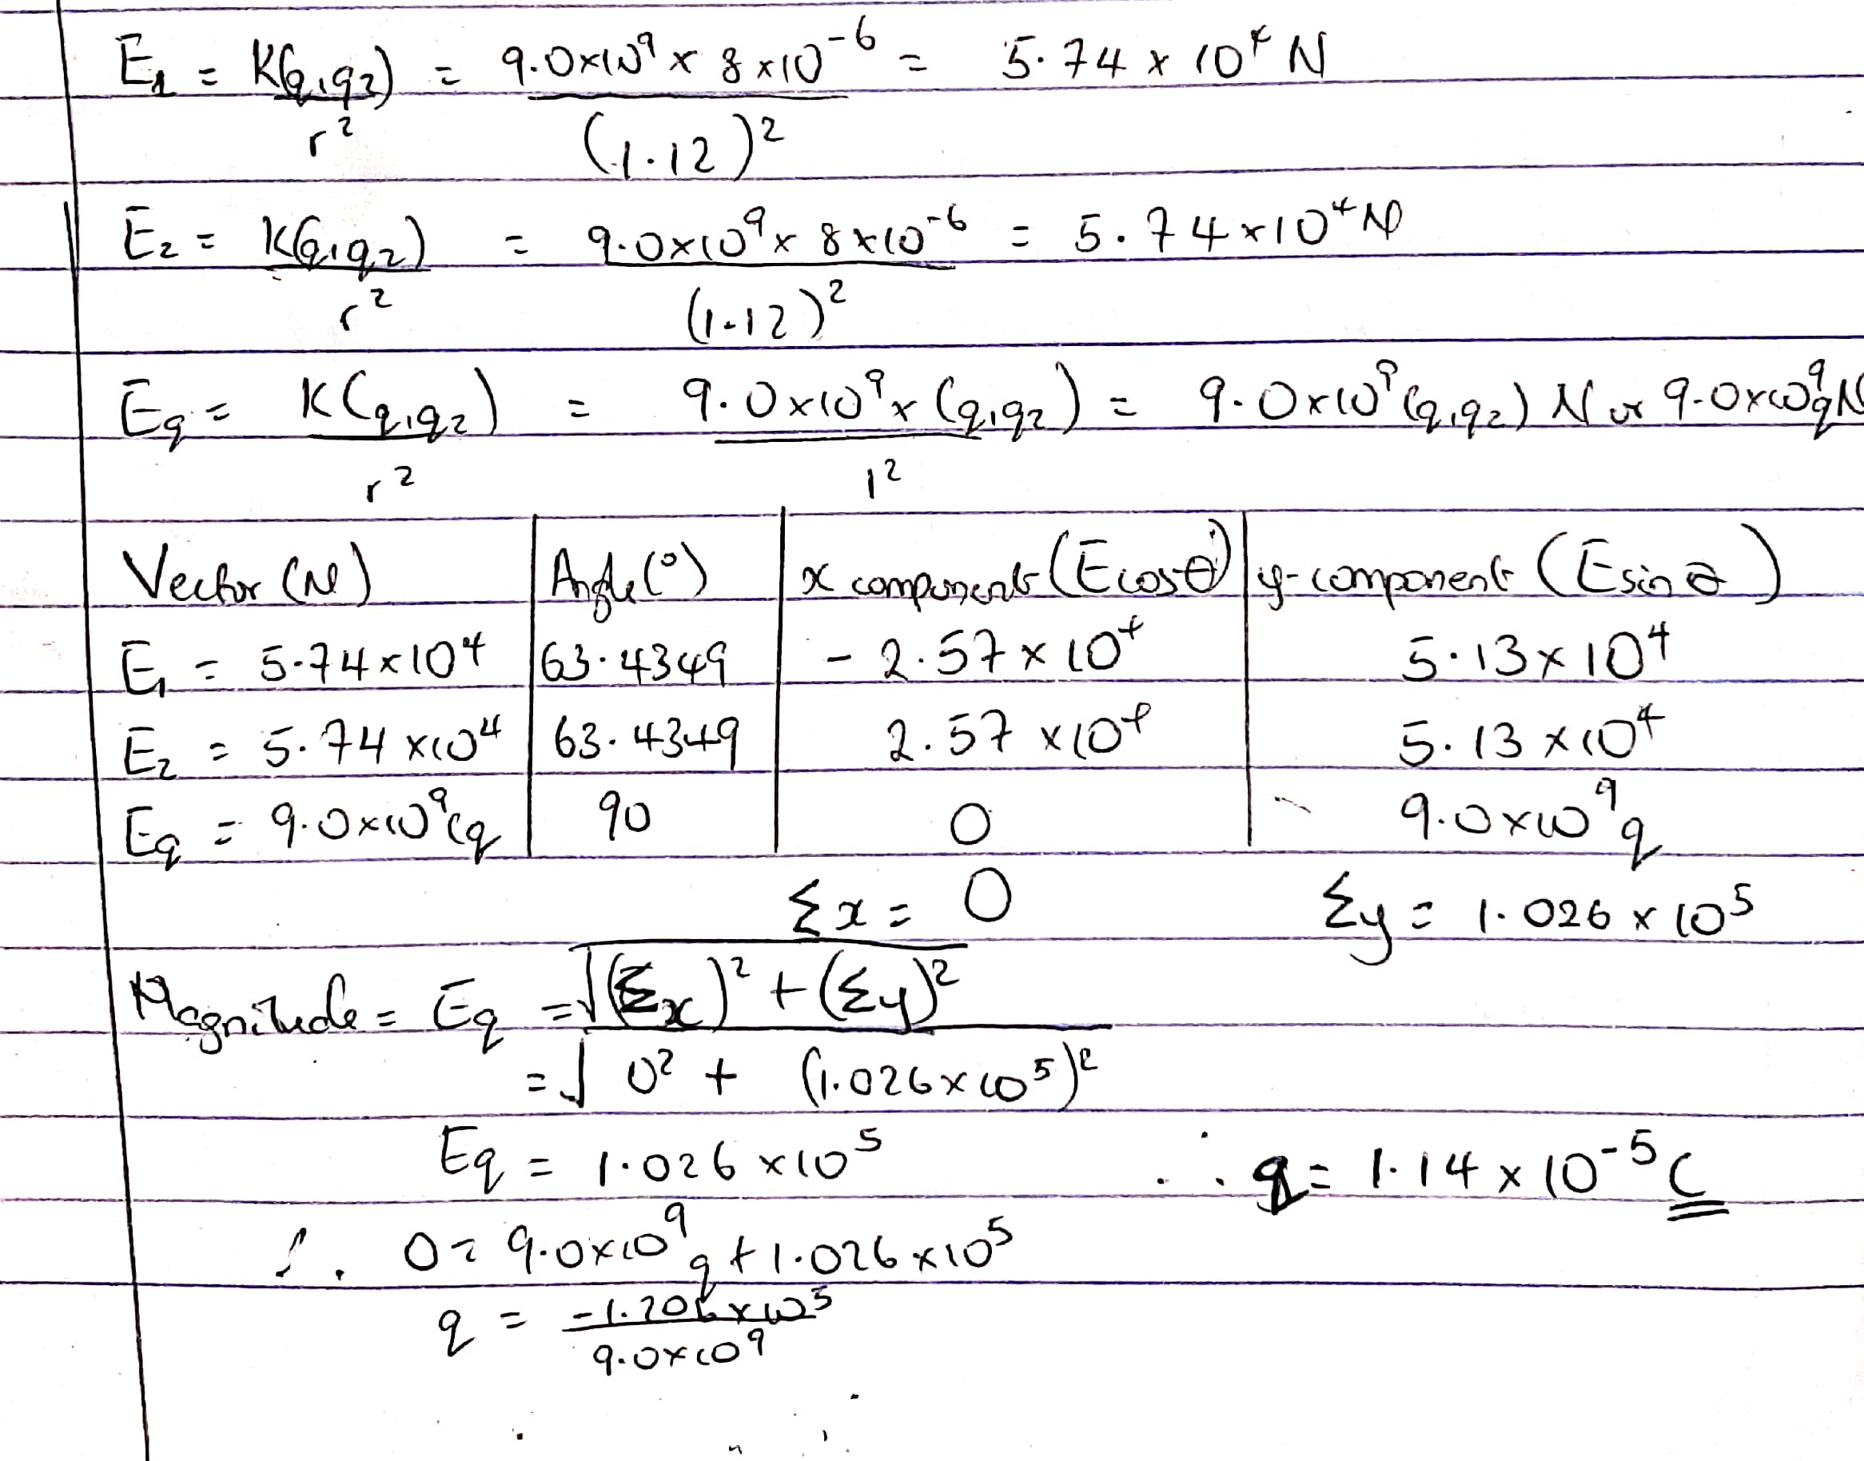
3.
- Answer 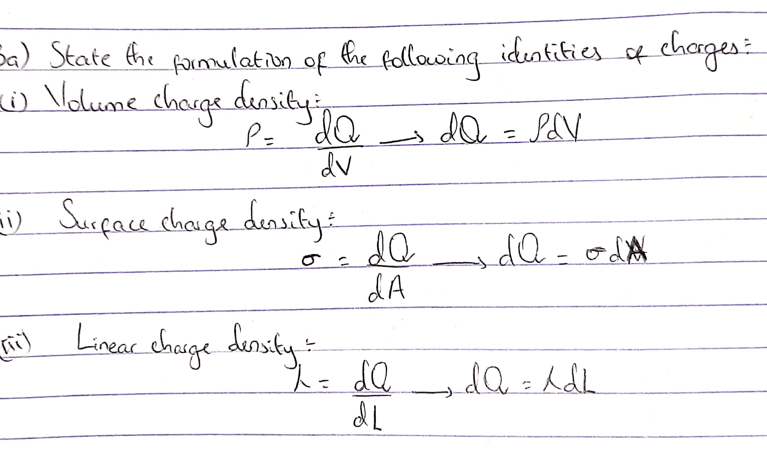
- Answer
Work per unit charge against electrical force is defined as the electric potential difference. It is measured in volts (V) or joules per coulomb (J/C). electric potential difference takes place between two points in an electric field and it is illustrated in the diagram below: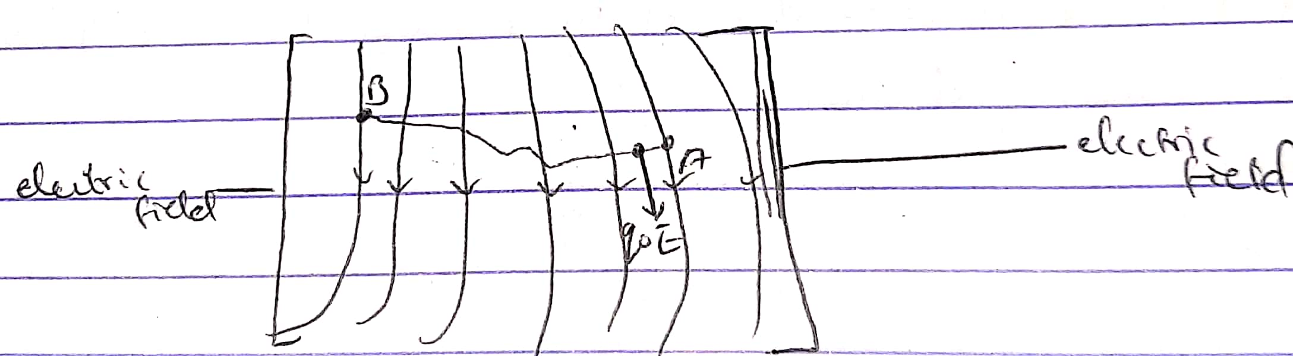 Take for instance a test charge(q₀) is moved from point A to point B along an arbitrary path in an electric field (E). A force exerted by the electric field (E) given by F= q₀E on the charge. To move test charge from point A to point B at constant velocity, an external force of F= -q₀E must act on the charge. The work done is given as:
$dW=F.dL$ …. (1)
Recall that: F= -q₀E …. (2)
Substitute equation (2) in (1)
$dW=-q^{0}EdL$ …. (3)
Total work done is;
W(A→B)ag = $-q ₀\int_{A}^{B}{EdL}$ …. (4)
Where A→B is the distance moved by the test charge.
With the definition of electric potential difference we can yield;
VB –VA =$\frac{W(A→B)ag}{q₀}$ …. (5)
Substituting equation (4) in (5) yields:
VB-VA=$-\int_{A}^{B}{EdL}$
4.
- Magnetic flux is defined as the strength of the magnetic field which can be represented by the lines of forces. It is represented by the symbol $(∅$). Mathematically given as $∅=B.dA$
- Answer 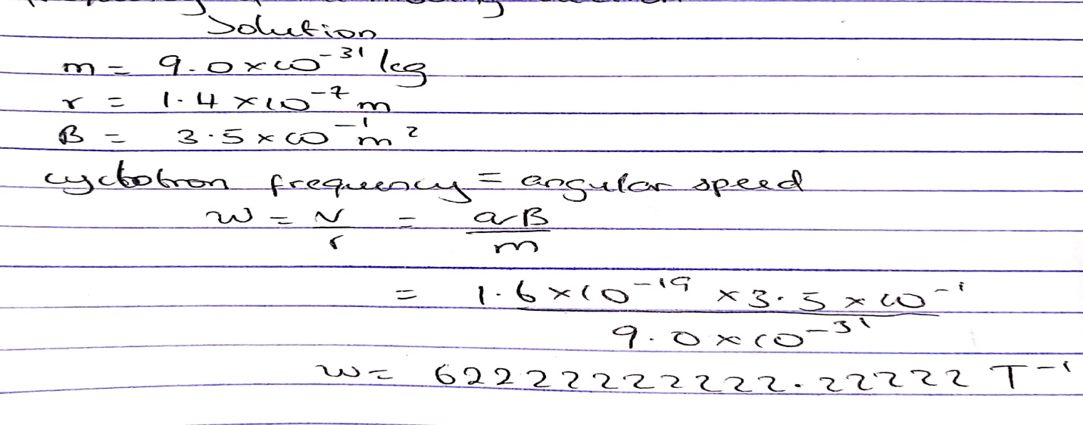
- Answer
With the given parameters in the equation 4b above, I was asked to find the cyclotron frequency that is also equal to the angular speed. It got its name (cyclotron frequency) because it is a frequency of an accelerator called cyclotron.
With the equation of angular speed being also equal to the equation of the cyclotron frequency given as: $w=\frac{V}{r}=\frac{qB}{m}$ I was able to get the answer in 4b with its unit as T⁻ⁱ
5.
- Answer
It states that magnetic field is directly proportional to the product of the permeability of free space, the current, the charge in length, the radius and is inversely proportional to the square of the radius. It is represented mathematically by: 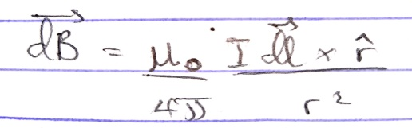
- Answer 