NAME: OLOGBOSERE ANTHONIA EFE
MATRIC NO.: 18/ENG05/049
DEPARTMENT: MECHATRONICS
COURSE CODE: ENG 284
COURSE TITLE: ENGINEER IN SOCIETY

- TITLE
Rehabilitation of Alfa Belgore Hall in Afe Babalola University, Ado- Ekiti, Ekiti State, Nigeria.
- NATURE WORK TO BE EXECUTED IN GENERAL
ABUAD intends to rehabilitate and renovate the Alfa Belgore Hall with adequate facilities for conducting examination, orientation, conference and hosting events of any other kind including detailed technical design, supply and installation of new equipment provided by the college of engineering.
Presently the building has a capacity of about 2000 people. The partitions walls are made with bricks in particularly good condition. The windows are steel made, single glazed. The total floor area to be renovated is approximately 210 Sqm. The structural height is approximately 10.5m. The building structure’s (column, beam, panel roof) on visual inspection showed no signs of structural defects.
The roof is constructed with RCC panel; on a top of this panel there is another part of roof that is constructed with wooden beams and CGI sheets to protect the RCC roof and to maintain the slope for rain water. From eye judgment, RCC roof panels seem to be in a good condition but the additional roof is partially damaged and thus requires rehabilitation. The under floor utilities (sewage) is condemned and is proven blocked. There is no water to the building. There is a temporary power supply to the building.
The architectural plan is included in the tender documents. The bidder should not change the main structural elements of the building and he does not need to calculate the main structural elements (frame structure) of the building. They bidder should submit other detailed calculation for all utility supplies like water, sewage, electricity etc. as there is no proper utility supply systems on that building.
All bidders are advised to satisfy themselves during the site visit that all possible items of work are included. The bidder is given an opportunity in the financial proposal form to include any additional items deemed necessary for proper completion of the works.

- PROPOSED SCOPE OF WORKS IN ORDER OF OCCURRENCE
Work will include but not limited to site civil, building core and shell, landscaping as well as interior construction and finishing works: floors, ceilings, partitions, doors and frames, fixtures, fittings, etc. Electrical, AC, ventilation, Fire protection systems, Plumbing and sanitary, Security, IT, AV system, and miscellaneous.
- Survey and securing of the proposed work site
- Removal and carting away of existing dilapidated roof and ceilings
- Removal and carting away of existing windows, burglary proofs and doors
- Removal and carting away of existing floor tiles
- Removal of electrical fittings
- Demolition and carting away of walls where necessary
- Construction of partition walls as may be required
- Installation of new roof
- Installation of woodwork carcass and all associated works
- Installation of roof covering (aluminum roofing sheets)
- Installation of noggins
- Electrical works: piping and wiring
- Mechanical works: piping, construction of septic tank, soak away pit and inspection chambers or repairs as may be required.
- Installation of doors, windows and burglary proofs
- Rendering/ plastering of walls as may be required and repair of cracks
- Installation of suspended ceiling
- Floor and wall tiling
- Painting stage one : priming
- Installation of electrical fittings
- Painting stage two : final coats
- Clean up and demobilization

- MANPOWER REQUIRED
The lead consultant of this project is the architect. The contractor shall be required to maintain minimum following manpower for continuous and technical working at site. Additional manpower shall be deployed as per job requirement as and when needed. The project team will consist of the following:
- Site engineer
- Safety engineer
- Supervisor
- Quantity Surveyor
- Architect
- Various Craftsmen such as electricians, carpenters etc.
- Various artisans such as bricklayers, painters etc.

- PROJECT GANTT CHART
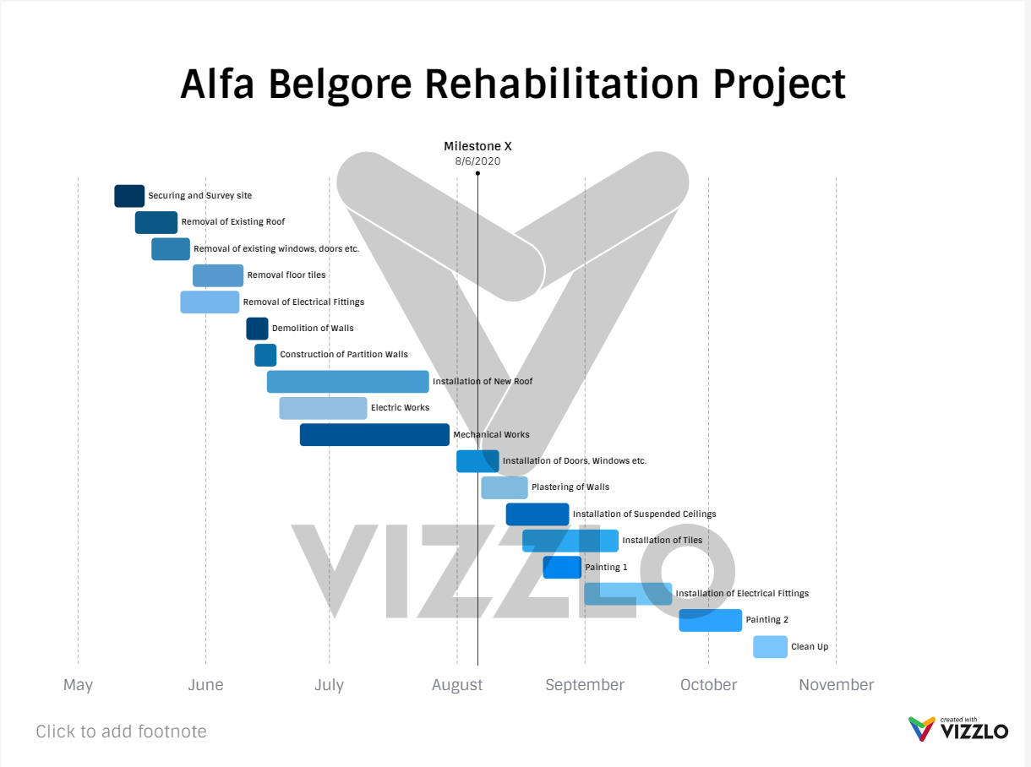

- BEME FOR THE PROJECT TEC
S/N | DESCRIPTION | AMOUNT(₦)
1. | Demolitions, removal and carting away
a. | Remove unsuitable existing roof and ceiling and cart away | 50,000.00
b. | Remove doors, windows and burglar proof and cart away | 25,000.00
c. | Remove existing floor and wall tiles and cart away | 50,000.00
d. | Remove existing electrical fittings and cart away | 10,000.00
e. | Demolish and cart away some internal walls as instructed by the contractor | 50,000.00
 | Summary | 185,000.00
2. | New Internal Walls
 | Hollow sandcrete blockwork in cement and sand mortar (1.6):
a. | 225mm thick blockwall | 200,000.00
b. | 150mm thick blockwall | 100,000.00
 | Summary | 300,000.00
3. | New Roof Installation
a. | Hardwood structural timber in rafters, wall plate, purlins, tie beams and fascia well treated and installed for roof carcass | 600,000.00
b | 0.55mm thick aluminium roofing sheets fixed to timber ourlins according to manufacturer’s instructions | 900,000.00
c. | Install semi hard wood for noggins, to receive suspended ceiling | 300,000.00
 | Summary | 1,800,000.00
4. | All electrical services
 | Provisional sum for all electrical services including piping, wiring and installation of fittings | 3,500,000.00
 | Summary | 3,500,000.00
5. | All mechanical services
 | Provisional sum for all mechanical services including piping, construction of septic tank, soak away pit, inspection chambers and air conditioning units | 5,000,000.00
 | Summary | 5,000,000.00
6. | Wall furnishings: Rendering
 | 12-25mm cement and sand smooth rendering to all new walls and for repair of cracks | 450,000.00
 | Summary | 450,000.00
7. | Ceiling furnishings
 | Provisional sum for suspended ceiling, supply and installation according to clients’ representatives instructions | 1,000,000.00
 | Summary | 1,000,000.00
8. | Windows, doors and burglar proof
a. | Supply and fix the approved factory made aluminum window units glazed with 5mm thick glass complete with locks and burglar proof | 3,000,000.00
b. | Supply and fix doors to the required specifications and sizes including all iron monger, hinges and frames | 1,500,000.00
 | Summary | 4,500,000.00
9. | Floor and wall tiling
a. | Supply non slip vitrified floor tiles as approved by the engineer and lay screeded bed, skirting inclusive | 2,000,000.00
b. | Supply vitrified wall tiles as approved the engineer and lay to approved pattern on screeded bed | 300,000.00
 | Summary | 2,300,000.00
10. | Painting
 | Prepare and apply one undercoat and two finishing coats of superior quality paint approved by the engineer on:
a. | Rendered walls, internally and externally | 800,000.00
b. | Reveals not exceeding 100mm wide internally | 200,000.00
 | Summary | 1,000,000.00
11. | Securing site
 | Erection of temporary fences around the perimeter, providing locations for temporary storage of materials | 25,000.00
 | Summary | 25,000.00
 | Total Estimated Cost (TEC) | 20,060,000.00
 | Miscellaneous, 10% of TEC | 2,006,000.00
 | Consultancy Fee, 15% of TEC | 3,009,000.00S
 | Site preparations and clearing after completion, 5% of TEC | 1,003,000.00
 | Transport, 12% of TEC | 2,407,200.00
 | Profit, 20% of TEC | 4,012,000.00
 | GRAND TOTAL | 32,497,200.00

- DELIVERABLES DUE DATE PAYMENT/INSTALLMENTS
- 30% of the total estimated cost (tec)as payment for mobilization after consensus of the work as mentioned in the scope of work 12 weeks after contract signature
- 30% of the tec be paid after 50% of completion of tasks listed in the scope of work
- The final payment of 40% of the tec at the total completion of the tasks listed in the scope of work and handover.
10% of the tec would be retain until the end of the 6 month defect liability period.
- PAYMENT SCHEDULE OF PROJECT TEC IN INSTALLMENTS
S/N | TOTAL ESTIMATED COST (TEC) | 20,060,000.00
1. | Mobilization, 30% of TEC | 6,018,000.00
 | 10% retention of mobilization | 601,800.00
 | Amount paid | 5,416,200.00
2. | 50% project completion payment, 30% TEC | 6,018,000.00
 | 10% retention of 50% project completion payment | 601,800.00
 | Amount paid | 5,416,200.00
3. | Project completion and handover, 40% TEC | 8,024,000.00
 | 10% retention on final payment | 802,400.00
 | Amount paid | 7,221,600.00
4. | Total retention for 6 month defect liability period | 2,006,000.00
5. | Total Payments | 18,054,000.00
6. | TEC = total payments + total retentions | 20,060,000.00

- LEAD CONSULTANT
The lead consultant is the consultant that directs the work of the consultant team and is the main point of contact for communication between the client and the consultant team, except for on significant design issues where the lead designer may become the main point of contact.
- BILL OF ENGINEERING MEASUREMENT AND EVALUATION (BEME)
Bill of Engineering Measurement and Evaluation (BEME) also referred to as 'Bill'; is a tool used before, during and post-construction to assess and value the cost of construction works. This includes the cost of materials, labor, equipment and all/any other resource(s) required for the success of any construction endeavor based on a pre-determined scope and specification.
Some of the objectives of a BEME are to provide sufficient information during the construction planning, for tendering and contracting purposes of for the purpose of knowing the estimated cost of the proposed project and to facilitate the comparison of rates and prices between bidders and enable the clients to assemble actual tendered rates and prices to prepare for future estimating and budgeting.

- DEFECT LIABILITY PERIOD
A defects liability period (also known as rectification provisions) is a set period of time after a construction project has been completed during which a contractor has the right to return to the site to remedy defects. A typical defects liability period lasts for 12 months. These periods can be of benefit to both parties.
For the contractor, it is likely to be more economical and efficient for it to carry out remedial works itself than to pay the costs of another contractor hired by the employer. From the employer’s perspective, it will not need to hire an alternative contractor to carry out the work, or to carry out the work itself and reclaim the cost. The employer will also not run the risk that any warranties provided by the original contractor may be affected by a third party carrying out works on the site.

- PROJECT LIFECYCLE
A project has a beginning and an end and passes through several phases of development known as life cycle phases. The five main phases of the project life cycle are as follows:
- Start-up: This phase is where the project objectives are defined and the conceptual aspects of the project agreed. This may be the phase where a problem is identified and potential solutions suggested.
- Definition: Once the project objectives have been clearly defined then the appraisal of the solutions is conducted in terms of risks, financial commitment and benefits. The scope of work is now defined in detail.
- Planning: This phase is where the project is broken down into manageable areas of work and planned in terms of time, cost and resources. This is a continuous process and will extend throughout the execution phase of the project.
- Execution: During this phase the work is implemented, controlled and monitored.
- Close-Out: The final phase of the project life cycle is close-out and demobilization, where resources are reassigned, the project is handed over and the post-project review is carried out.

- ENVIRONMENTAL IMPACT ASSESSMENT (EIA)
Environmental Impact Assessment (EIA) can be defined as the systematic examination of unintended consequences of a development project or program, with the view to reduce or negative impacts and maximize on positive one. It is a process of collecting information about environmental impacts of a proposed project and consequent relevant decision-making. It requires that a range of solutions to any given environmental pollution problem be developed, analyzed, and compared.
(EIA) was developed as a tool to minimize negative impact of human activities on the environment. The purpose of the environmental impact assessment is to assess the impact of a proposed activity on the environment before making the decision on whether to carry it out, and develop and assess measures to avoid or minimize those impacts if it is decided to carry out the activity.

- REASON SITE WAS SECURED
A construction site can become hazardous and dangerous the moment safety measures are ignored. A construction site poses several dangers; Open ditches, sharp metal rods, iron sheets, and large logs can cause injuries to people and pose risks to vehicles and machinery when left exposed. Putting temporary fencing around a construction site is one of the first safety measures that you should take. Fencing will fend off trespassers from accessing the building site and also provide security for the construction materials.
Each construction site has its own particular security issue depending on the nature, site and location of the project, as well as the amount the project takes, but in general there are three types or threats to construction sites:
- Threats to Properties and assets
- Threats to Operations
- Threats to Life

