NAME: NKEMJIKA DELIGHT PERFECTA

COURSE CODE: BUS 208

COURSE TITTLE: CONSUMER BEHAVIOUR

COLLEGE: LAW

MATRIC NUMBER: 18/SMS13/011

LECTURER: MRS OPEOLUWA

ASSIGNMENT:
In not less than 2000 words, explain explicitly how the pandemic{COVID 19} has affected consumer buying behavior

- Firstly, I would define the concept, Consumer behavior, which is the study of individual, groups or organizations and all activities associated with the purchase, use and disposal of goods and services, mental and behavioral responses that precede or follow these activities.
In simpler terms, according to Study.com, Consumer behavior is the study of how people make decisions about what they want to buy, want, need or act in regards to a product, service or company.
In countries heavily impacted by COVID-19, consumers are stockpiling food and other essential items, while isolating themselves from crowds. To find out how and when consumers started showing these behavioral changes, Nielsen1 conducted shopper behavior research that started during the beginning of the pandemic in China and extended to other countries that have also been affected. They monitored consumer trends, as COVID-19 news reached the general public and found out that consumers go through six behavioral stages based on their awareness of the COVID-19 spread in their communities:
1. Proactive health-minded buying: Increased interest in the acquisition of products that maintain well-being or health
2. Reactive health management: Prioritization of products for infection containment (e.g. face masks)
3. Pantry preparation: Higher purchases of shelf-safe products and increased store visits
4. Quarantined living preparation: Increased online shopping, decreased store visits and first signs of strain on the supply chain
5. Restricted living: Possible price gouging due to limited supplies and deterred online fulfillment
6. Living a new normal: Increased health awareness even as people return to their typical daily activities.
There’s no doubt that the crisis caused by the global Coronavirus (COVID-19) pandemic has created an incredibly difficult business climate. Businesses are being presented with many new challenges as international borders close, bricks-and-mortar businesses shut their doors, and people are told to isolate at home. Many companies face temporary or even permanent closures, with staff facing months of financial uncertainty and worry.
Consumer behavior has been forced to immediately change, and change on a massive scale. Those in isolation or under lockdown can’t perform their usual routines, especially since many local shops have been forced to close their doors for safety reasons. Concerns about the availability of goods have encouraged panic buying of items in bulk. Financial uncertainty and the prospect of a severe and long-term recession make for a stark backdrop which has led to an impact on consumer outlook, perceptions and behaviors.
For the businesses that remain active at this time, questions are inevitably being asked about how best to cope with the prevailing trading conditions, and how best their strategies should adapt. This is a difficult question to answer since the Coronavirus pandemic is so new that the circumstances are changing fluidly and on a daily basis. Defining a strategy now is difficult as there is limited evidence or precedent to base assumptions on.
Initial indications about what might happen to businesses and the economy could be gauged by looking at the data from the countries which first suffered from the effects of COVID-19. While there’s no guarantee that others will follow the same trajectory, analysis of these countries can reveal useful patterns and insights.
Online, the world is changing just as fast as offline. In early March 2020 The Drum reported on research that shows that, while annual advertising growth rates in China are predicted to fall from 7% growth in 2020 to 3.9%, ecommerce advertising spend is predicted to grow by 17.7% and social media spending to rise by 22.2%.
This seems to reflect the changes in consumer behavior as they switch from buying offline to buying online. They also show that as people are spending more time at home, brands have responded by shifting spend from offline media to online, with 14% reporting this course of action.
In the same piece of research, they go on to state that “e-commerce as a platform has already seen exponential growth, especially in FMCG which saw spending through e-commerce channels in China grow almost seven times as fast as the sector overall in 2019; a trend that the coronavirus outbreak is likely to accelerate.”
The same picture is painted in research published by Business Insider Intelligence and eMarketer analysts in March 2020, which suggests that ecommerce is likely to grow as consumers avoid physical stores. Their data suggests that 74.6% of US internet users said they’d be likely to avoid shopping centres and malls if the coronavirus outbreak in the country worsens, and over half would avoid shops in general.
A new study from Ipsos MORI from mid-March 2020 reveals that 50% of Chinese and 31% of Italian consumers say they’re now using ecommerce ‘more frequently’. In contrast, only 18% of UK respondents said that they were using online stores more frequently, with close to half reporting there was ‘no change’ in their ecommerce habits. However, now that the UK is in lockdown these statistics are likely to change dramatically, probably trending towards the figures seen in other countries with more advanced COVID-19 issues.
All consumers reported eating out less, particularly at restaurants with table service, and said they used delivery aggregators, bought prepared foods at grocery stores and used mobile order-ahead less than they did before that week.
– Even before March Madness was canceled and sports teams pushed pause (or stop) on live events, consumers had put social distance between themselves and sports arenas, as well as movie theatres.
– Consumers just said no to getting on planes — especially if those trips were to New York or any international destination for work or pleasure. The same held true for booking vacation rentals and using public transportation, and to a lesser degree for getting into Ubers — in part because they didn’t need to and in part because they didn’t want to.
In fact, 65.7 percent of consumers surveyed earlier weeks said they felt the media was making the virus seem worse than it actually was, which determined how they responded to going out or buying In general.
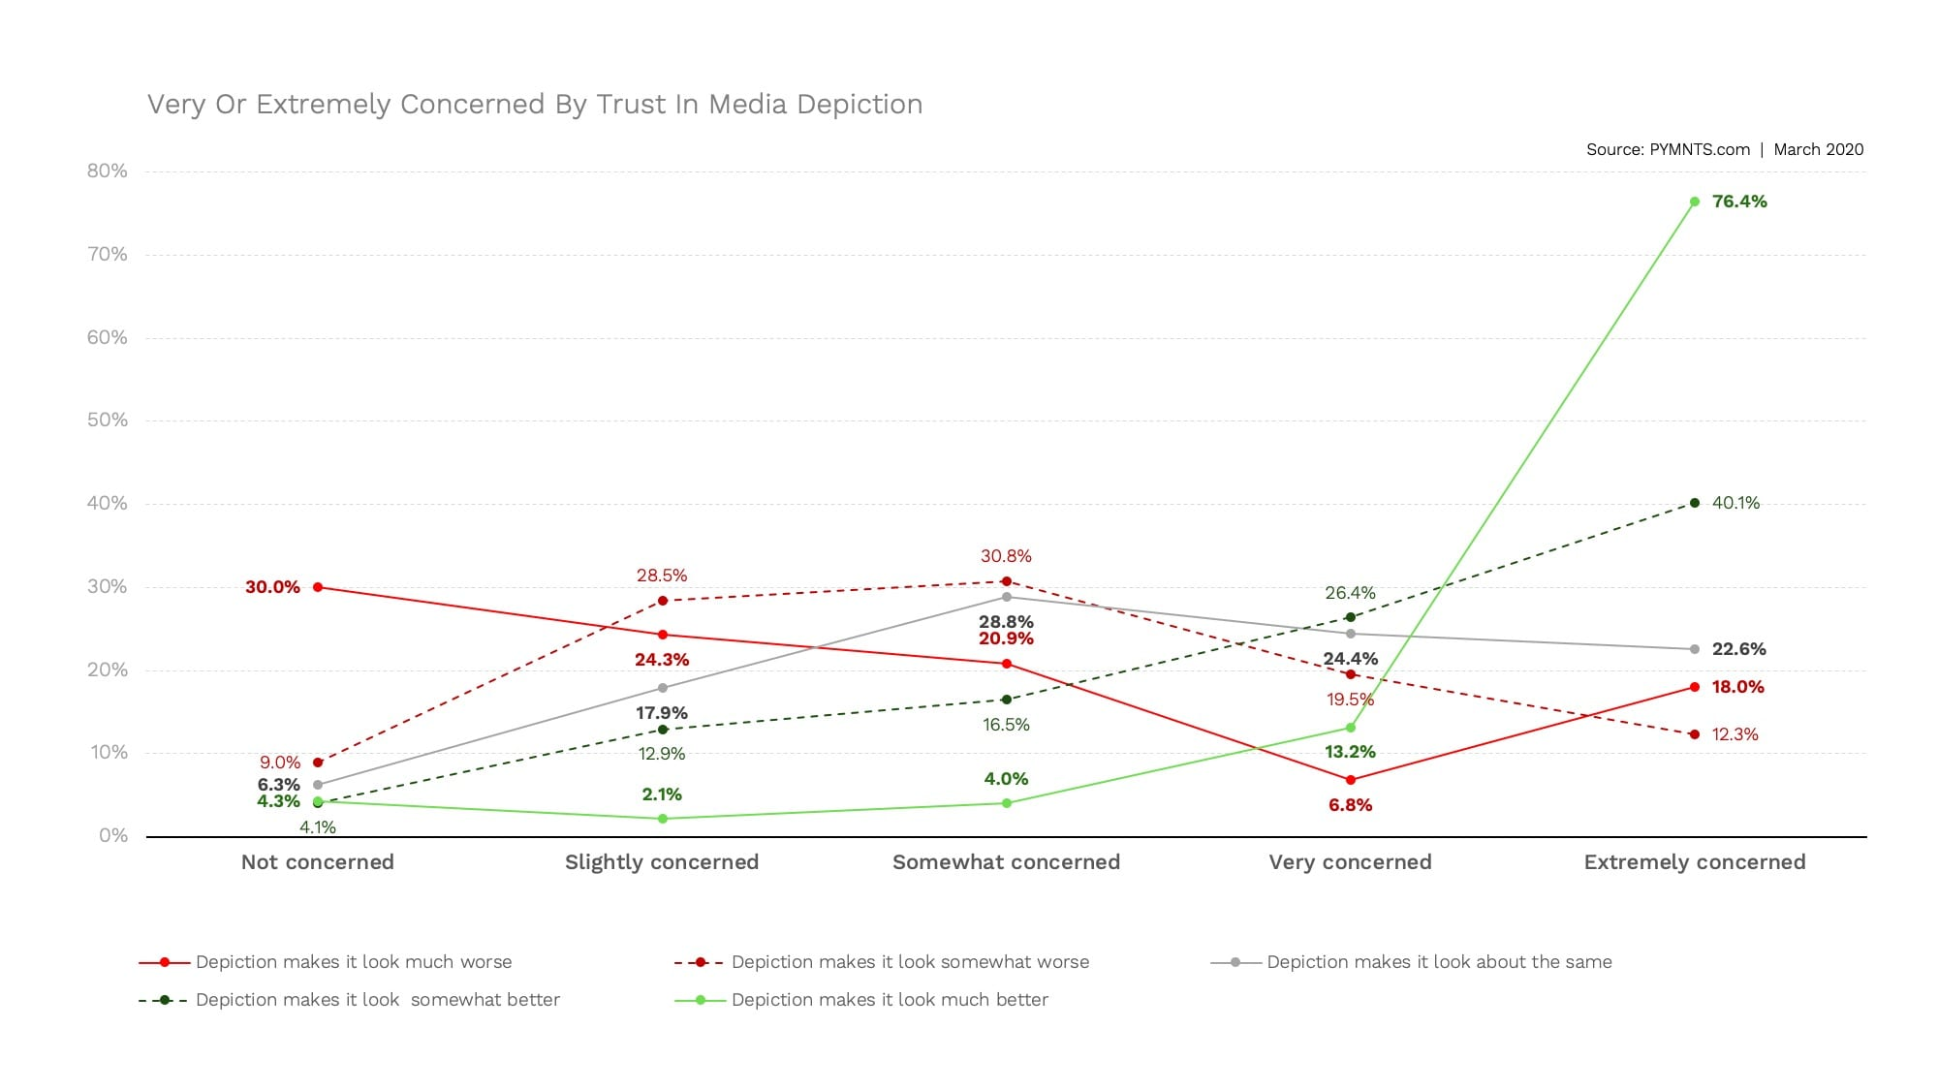

Consumers voluntarily put themselves under partial quarantine by working from home and by commuting via car rather than using public transit if they were going to work. They also made decisions to cancel work-related gatherings and leisurely plans of all sorts, from attending sports events and concerts to watching films in theaters — even before the sports franchisees decided to take unprecedented measures and do that for them.
Even back home, here in Nigeria most of the population which are statistically show that 65% do not have any idea of online shopping nor participate in it, have the greater disadvantage, since everyone has the stigma of being in crowds or having the possibility to encounter someone with the COVID 19 symptoms, they prefer to stay back at home, thereby reducing drastically the participation of buying and selling. Since, in Nigeria mist of what is done is face to face buying, that is no longer invoke, and those who are retailers who stocked their shops before the outbreak of the pandemic would have to lose out as well, their stocks would have to be left in their shops for an indefinite amount of time, thereby causing spoils and loss, with no money or help from the government. The possibility of starvation is present in these masses.
It’s still too early to tell how much consumer behavior will remain due to the COVID-19 pandemic. We’ll learn more and more about the immediate impact on stores and e-commerce as soon as additional countries move through the different stages and into restrictive living. However, it will be a while until we know if these changes in consumer behavior will be long term.
And at the mean time, it’s hard for more manufactured goods to be produced due to the shut- down, hence creating a shortage in the supply of food, as Nigeria is not able to stomach every mouth in it’s nation. Therefore, we’re not able to tell he fate of Nigeria if this pandemic should insist.
Final thoughts
You've likely noticed items like hand sanitizer, toilet paper and pasta flying off of grocery store shelves.
Not surprisingly, online sales during the coronavirus pandemic jumped 25% in just two days (March 13–15) compared to the first 11 days of the month. According to Adobe Analytics research on over a trillion web visits, that spike was driven by online grocery shopping, which saw a more than 100% increase in daily sales.
The other most popular items people shop for: health products, gym equipment and home supplies.
Retail experts say people are buying to fulfill three main needs - protection, entertainment and connection.
It has also been heard of about the increase on the order for medicines online, medicines like: cough syrups, pain relief pills, decongestants, vitamin coated pills etc.
There has also been a demand for fruits and vegetables, which according to www.abc.net have increased about 35.7%
For virus protection, sales of gloves, masks and hand sanitizer surged a staggering 817%. Over the last two months, over-the-counter drug purchases increased by 198% for cold and flu medications and 152% for pain relievers.
Online sales of toilet paper spiked by 186%, and canned foods and shelf-stable food sales increased 69%, according to Adobe.
Meanwhile, the global cooperation we need is potentially at risk now with countries scrambling to mitigate the pandemic in their own countries. Vietnam has ordered a temporary suspension of new rice export contracts due to fear over domestic supply. In 2018, Statistics Indonesia data show, Indonesia imported 767,180 tons of rice from Vietnam, or 34 percent of total rice imports. India’s government has permitted its major ports to halt some operations due to the coronavirus. Indonesia imports onion and bovine meat from India and has made deals to import 130,000 tons of sugar in early 2020 to fulfill demand. Closing of exports can potentially cause a global food crisis because of the arbitrary supply shortage and an immediate increase in global food prices.
The most vulnerable populations will face increased food insecurity: The threat of not having access to particular desired foodstuffs (which many people are experiencing for the first time in their lives) is eclipsed by the threat of not having any source of income or access to food at all. More than 820 million people around the world find themselves in this latter situation as they face the additional threat of a global pandemic.
Without a doubt, the number of people experiencing hunger is going to increase dramatically. Recommended or mandatory social isolation around the world means that millions of people that work in the restaurant, hotel, entertainment, and air travel industries, among others, will suddenly find themselves unemployed. As the economic crisis continues to expand, this sudden wave of unemployment will extend to other industries.
The quality of the food that is available is also likely to worsen. Ultra-processed foods were already popular due to their price point and widespread availability, and it is likely that the consumption of these products will increase as low-income populations find it increasingly difficult to access healthy food.
Students’ nutrition is in danger: More than 85 million children in Latin America and the Caribbean benefit from school nutrition programs, with these programs representing one of the primary sources of reliable food for 10 million children.
One of the most urgent measures that must be taken by local governments in the face of this pandemic is ensuring that public programs offer access to food for all students while schools are closed. The U.N. Food & Agriculture Organization (FAO) has recommended a wide range of measures, including distributing food directly to the most vulnerable families (through school sites or mobile distribution units), delivering emergency rations, and implementing initiatives to deliver fresh food directly to homes, among others.
REFERENCES:
- www.the jakartapost.com
- foodtank.com
- www.fda.com

