NAME: FAGBUYI AKINTOMIWA E.
DEPT.: CIVIL ENGINEERING
MATRIC NO.: 19/ENG03/009
COURSE CODE: PHY 102

COVID-19 HOLIDAY ASSIGNMENT

- i) Electric field is a region of space in which an electric charge will experience an electric force.
ii) Electric field intensity is the measure of the strength of electric field at any point.
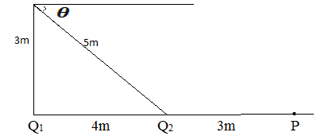

- P E₁ = 9 x 10⁹ x 8 x 10⁻⁹ = 1.5 N/C
7²
E₂ = 9 x 10⁹ x 12 x 10⁻⁹ = 12 N/C
3²
E_{net} = 12 + 1.5 = 13.5 N/C
- Q E₁ = 9 x 10⁻⁹ x 8 x 10⁻⁹ = 8N/C
3²
E₂ = 9 x 10⁹ x 12 x 10⁻⁹ = 4.32N/C
5²
VECTOR | ANGLE | X-component | Y-component
E₁ = 8 N/C | 90º | E₁x = 8 x cos 90º = 0 | E₁y = 8 x sin 90º = 8
E₂ = 4.32 N/C | 36.87º | E₂x = 4.32 x cos 36.87 = -3.46 | E₂y = 4.32 x sin 36.87 = 2.59
 |  | $ε$_{x} = -3.46 N/C | $ε$_{y} = 10.59 N/C

E = $√$(-3.46)² + ( 10.59)² = 11.14 N/C
- dQ
- Volume charge density, $ρ$ = dV dQ = $ρ$dV
dQ
- Surface charge density,$σ$ = dA dQ = $σ$dA
dQ
- Linear charge density, $γ$ = dL dQ = $γ$dL

b.) Electric potential difference can be defined as the work done per unit charge against electrical forces when a charge is transported from one point to the other.
V_{B} - V_{A} = W (AB) _{Ag}
q_{o}
c,)
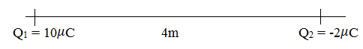

Q₁ = 10 $μ$C Q₂ = 2$μ$C
[ ]
1 Q_{1 x} Q₂
V= 4$π$E_{O} r₁ r₂

0 = 10 x 10⁻⁶ - 2 x 10⁻⁶
9 x 10 ⁹ r₁ r₂

2r = 10r₂ ; r₁ = 5r₂

From the diagram above, the position of v = 0 along the x – axis is 5m from Q₁ = 10 $μ$C and 1m from Q₂ = 2$μ$C.

- a) Magnetic flux can be defined as the strength of the magnetic field which can be represented by line of forces. It is represented by the symbol $φ$=B.dA

b) m = 9.11 x 10⁻³¹kg, r= 1.4 x 10⁻⁷m, B = 3.5 x 10⁻¹ weber/meter ²
Cyclotron frequency = angular speed
w = v = qB
r m

qB 1.6 x 10⁻¹⁹ x 3.5 x 10⁻¹
w = m = 9 x 10⁻³¹

w = 62222.2222 T⁻¹
c) The following parameters were given to us
i) Mass of the electron = 9.11 x 10⁻³¹kg
ii) Magnetic field of 3.5 x 10⁻¹ weber/meter ²
iii) Radius of 1.4 x 10⁻⁷m
and we were asked to find the cyclotron frequency which is likely the same thing as angular speed. It is called cyclotron frequency because it is a frequency of an accelerator called cyclotron.

Recall that angular speed is given as w after substituting we have
w = 1.6 x 10⁻¹⁰ x 3.5 x 10⁻¹
9x 10⁻³¹

= 62222.2222 T⁻¹
- a) The Biot-Savart law is an equation that describes the magnetic field created by a current-carrying wire, and allows you to calculate its strength at various points.

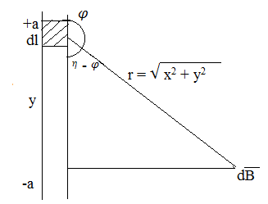
b) Section of a straight current carrying conductor

( )
$φ$oI 2a
β = 4$η$x (x² + a²) ^ $1/2$

When the length 2a of the conductor is very great in comparison to distance x from point P, we consider it infinitely long. That is a is much larger than x,
(x² + a²) ^ $1/2$ $≅$ a as a ∞
$φ$oI
β = 2$η$x
In a physical situation, we have axial symmetry about y- axis. Thus, at all points in a circle of radius r, around the conductor, the magnitude of β is
$φ$oI
β = 2$η$r (i)
Equation (i) defines the magnitude of the magnetic field of flux density β near a long, straight current carrying conductor.

