NAME: AHMED FAWWAZ ABIOLA

MATRIC NUMBER: 18/ENG06/004

COLLEGE: ENGINEERING

DEPARTMENT: MECHANICAL

COURSE CODE: ENG 284

COURSE TITLE: ENGINEER IN SOCIETY

SCOPE OF WORK FOR THE ALFA BELGORE REHABILITATION PROJECT
- TO ACQUIRE LAND It is the most important step in building construction. Single out a suitable location for construction the Alfa Begore Hall. It is suggested that do prior data collection before buying land or plot either by doing research online or seeking help from real estate agents or concerned persons regarding the effective cost of the same.
- TO SEEK TECHNICAL HELP After selecting proper land for building, take the help of a professional architect to create building designs and take his/her advice. An architect prepares plans as per building requirements, number of flats etc. Then after the architect consults with a structural engineer for details of the reinforcements to be used.
- PREPARING ESTIMATE AND BUDGET Building construction involves a huge amount of material and budget. After, Planning and structural detailing completed these details are transferred to the building estimator. The building estimator will estimate the material quantity, quantity of different items of work, and prepare an abstract sheet that shows the cost of building construction.
- APPROACH A BUILDER A builder or contractor for construction must be chosen carefully because it is a major factor for securing building construction quality and timely construction of work. Pre investigation must be done about the builder before handing work. In the contract document, all the work. In the contract document, all the work related details must be clearly stated. The contract document should cover layout and work details along with the payment methods, time scales and costs.
- SITE PREPARATION OR LEVELING The construction site must be cleaned before the work is executed. This work involves the removal of roots of trees, debris and leveling ground area.
- EXCAVATION AND PCC The foundation of building ground is the excavated with the help of excavating machines as per the building dimensions specified in drawings. In this foundation trench, a layer of PCC(Plain cement concrete)is laid in the dug portion before placing the reinforcements for the foundation.

G. FOUNDATION The building is supported on the foundation. The foundation is the lowermost part of the building that is in contact with the soil. The foundation bottom level must be checked before concreting it.
H. PLINTH BEAM AND SLAB After the foundation work is done ground beam formwork preparation is started and poured with concrete. Over the plinth beam, masonry work is started. And space between foundation and plinth beam filled with soil.
I. BRICK MASONRY WORK As column and beam framework completed masonry work is started with different materials such as bricks, concrete blocks, etc. Masonry work is done using a cement mortar mix. It is a mixture of cement and sand.
J. THE LINTEL OVER DOOR/WINDOW GAPS The lintel is constructed on the door and window to support the masonry work over it.
K. FLOOR SLAB OR ROOF STRUCTURE Then the framework is started to construct slab resting on the column and beam. Over slab formwork, slab reinforcement is placed as per slab detailed drawing.

L. DOOR WINDOW FRAMING AND FIXATIONS The door/window frames are fixed at their specified position given in the drawing.
M. ELECTIRCAL AND PLUMBING As we all know that buildings are constructed with a clean finish in which electrical and plumbing work is not visible. They are installed in the walls and slabs such that they are concealed and not visible after the finishing work is done.

N. EXTERIOR FINISHING Once this work is completed, external plastering and finishing work is started. Waterproofing is also done to prevent rising dampness in the wall.
O. TERRACE AND ROOF FINISHING On top of the slab, waterproofing is done to prevent any leakage in the slab. Generally, terrazzo tiling is done to prevent the slab from a weathering effect.
P. INTERNAL FINISHING Internal walls are plastered with smooth finish and flooring is done with tiles. Later on, the walls are painted or textured.

GANT CHART
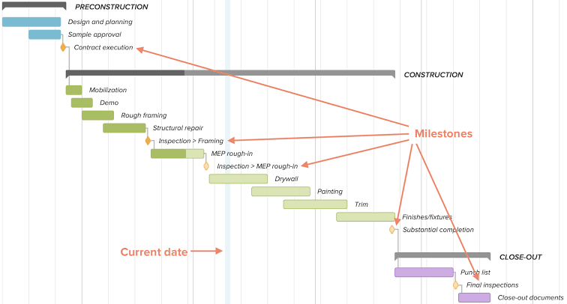
THE PROJECT TEAM
The individuals involved in the construction of the Alfa Begore Hall are as follows:
- SPECIALIST CONSULTANT There are Specialist Consultant for an array of subjects; sustainability, acoustics, fire, security to name just a few. Most will not get involved in product selection, but do write the overall performance specification, which indicates the performance criteria that must be attained by the chosen product. So Specialist Consultants indirectly influence product choice.
- ARCHITECT The Architect develops the buildings design, taking the Client’s brief and combining it with the advice of the Specialist Consultants. This then has to be developed to meet the requirements of the building regulations and increasingly sustainability. He is also known as the lead consultant.
- ENGINEER Working with the architect will be a number of engineers that are responsible for structural, mechanical and electrical designs. The Structural Engineer is a key member of the Project Team. Structural Engineer design the skeleton or structure of the building, enabling Architects to focus their talents on creating a design that satisfies their client’s demands.
- CONTRACTOR The contractor oversees and manages the construction of the building for the Client, following the Architect and Engineer’s designs. The work is delivered under a contractual agreement. The Main Contractor will select sub-contractors based on the capability, availability and price. The Contractor is looking for products that offer ease of installation, good availability and represent value. They want confidence that their sub-contractors are familiar with installation, to avoid complications.

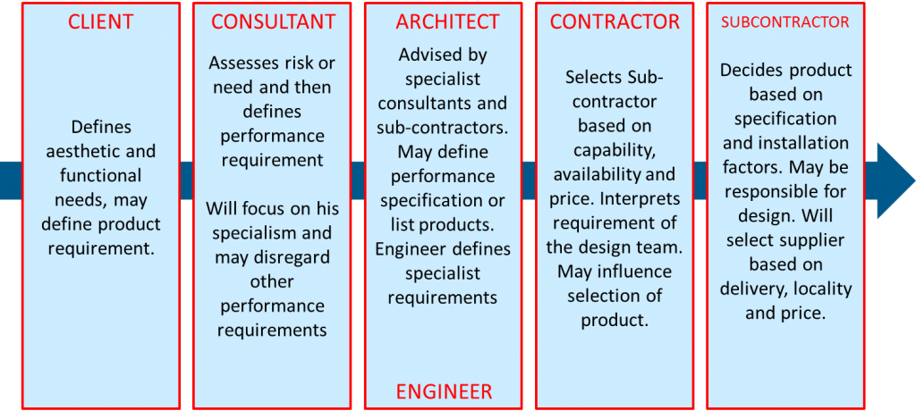
“Keep the number of site entrances and exits to a minimum” This is telling us that only the individuals carrying out the project are allowed to enter the site and anyone who doesn’t fall into the category should not be allowed in the site in order to prevent accidents and to prevent criminals from entering the site and stealing tools and other items.
Apart for this there are other ways of securing a site:
- Protect site assets.
- Surveillance of the people on site.
- Provide site safety.
- Provide controlled and monitored site evacuation.

BEME TABLE
S/N | Items | Specification | Quantity | Unit cost | Estimated Cost (N) | Estimated Cost ($)
1 | Cement |  | 60 bags | 1,000 | 60,000 | 155
2 | Planks | Soft wood(1*12*12) | 20 | 700 | 14,000 | 36
3 | Stainless steel |  | 2 sheets | 25,000 | 50,000 | 129
4 | Gravels | 25 tons | 1 | 30,000 | 30,000 | 77
5 | Sand | 25 tons | 2 | 15,000 | 30,000 | 77
6 | Profit |  |  |  | 70,000 | 180
7 | Transportation to site |  |  |  | 40,000 | 103
8 | Labour |  |  |  | 30,000 | 77
9 | Galvanized iron sheet | 200*120*230 mm | 2 | 28,000 | 56,000 | 144
10 | Grinding plate | Power flex | 1 | 20,000 | 20,000 | 52
11 | Clearing of site | m^2 |  |  | 25,000 | 64
12 | Consultancy fee |  |  |  | 35,000 | 90
13 | Moulded Bricks |  | 50 | 800 | 40,000 | 103
14 | Miscellaneous |  |  |  | 30,000 | 77
 | Total |  |  |  | 530,000 | 1366

PAYMENT SCHEDULE
S/N | Description of work | Unit of measurement | Price (N) | Price ($)
1 | Mobilization | Per day | 70,000 | 180
2 | Completion | Per day | 70,000 | 180
3 | Completion and Handover | Per day | 120,000 | 309
4 | Defect Liability period | 6 months | 30,000 | 77
 | Total |  | 290000 | 746

BEME Bill of Engineering Measurement and Evaluation (BEME) is used before, during and post-construction to assess and value the cost of construction works. This includes the cost of materials, labor, equipment and any other resources required for the success of the project.
DEFECT LIABILITY PERIOD This is a period of time following practical completion during which a contractor remains liable under the building contract for dealing with any defects which become apparent. A defects liability period is usually a period of around six or 12 months but it can vary depending on the contract used.
ENVIRONMENT IMPACT ASSESSMENT Environment impact assessment (EIA) is a process to assess the environmental consequences of any project and design proper mitigation plans to minimize the possible adverse impacts.
PROJECT LIFE CYCLE Every large construction has a life cycle which can be compared to a biological life cycle where activities begin gradually and build rapid as the project commences to final deliverables.
LEAD CONSULTANT The lead consultant is the consultant that directs the work of the consultant team and is the main point of contact for communication between the client and the consultant team, expect for mon significant design issues where the lead designer may become the main point of contact.

