AGBEJA AYOOLUWA OREOLUWA
15/MHS01/012
COMPUTER ENGINEERING
COE 506
- Define the following acronyms as they apply to digital logic circuits
- ASIC- Application Specified Integrated Circuit
- PAL – Programmable Array Logic
- PLA – Programmable Logic Array
- PLD – Programmable Logic Device
- CPLD- Complex Programmable Logic Device
- FPGA- Field Programmable Gate Array

- Granularity has the effect on FPGA as an increase in granularity increases the number of switches as each block has more pins and the length of wires increase with an increase size of logic block. Basically, an increase in granularity level results in lesser delay between the input and the output. And as this increases, the number of levels of logic in critical path decreases.

- 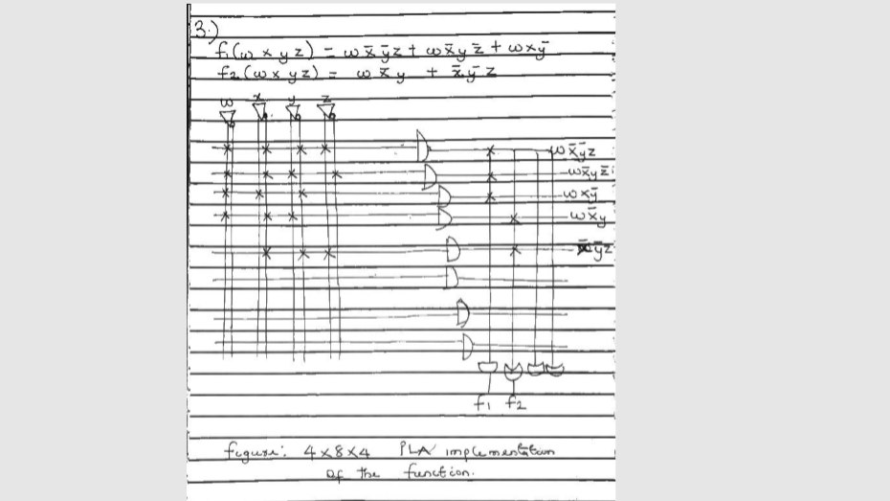

- Not only will the stored program be non -volatile, it will also be read only. This is the reason these fuse-programmed devices are called One Time Programmable devices and this allows data to be written to memory only once. Once this memory has been programmed, the value is retained should a loss of power occur. This memory is applied to repeatable and reliable read of data.

