NAME- Chidi Milestone Miracle
Dept- Chemical Engineering
MATRIC NO: 18/eng01/005
ENGINEERING CONSULTANCY ASSIGNMENT

- SCOPE OF WORK
OVERVIEW- The Alfa belgore hall at Afe Babalola University is under construction based on the lack of space in it. The work commenced on the 14th of January with aim of expanding and elevating the building to create space.
Tasks in the process of construction
- Rearrangement and evacuation of the area and building
- Demolishion of walls of the building
- Design of new plan
- Construction of new plan
- Roofing
- Wiring/plumbing
- Painting
PROFESSIONALS TO BE CONSULTED
- Civil Engineers I.eplumbing, bricklayers etc
- Electrical Engineers
- Painters
- Architects
ESTIMATED TIME OF WORK
- Rearrangement and evacuation of the area and building —1week
- Demolishion of walls of the building —1week
- Design of new plan—2weeks
- Construction of new plan—3weeks
- Roofing —3weeks
- Wiring/plumbing —2 ½ weeks
- Painting—2 ½ weeks
PRODUCTS & ESTIMATED PRICES
Cement bags | N15500
Sand | N300000
Bricks or blocks | N100000
Iron/ rods | N50000
Woods/nails | N50000
Zinc(aluminum) | N300000
Buckets of paints | N300000
Germain floor | N200000

ESTIMATED AMOUNT FOR HAND WORK
Civil engineers | N3500000
Electrical engineers | N1500000
Architects | N700000
+products | N5700000
Total estimated cost := N7000000

RESULT
Thé construction has been completed, now been upgraded and has better efficiency and had been expanded

2)GANT CHART

TASK | DURATION | START DATE | END DATE
Rearrangement & Evacuation of Hall | 7 | 14-Jan | 21-Jan
Demolishment of Wall | 7 | 21-Jan | 28-Jan
Design of new plan | 14 | 28-Jan | 11-Feb
Construction of new plan | 21 | 11-Feb | 2-Mar
Roofing | 21 | 2-Mar | 23-Mar

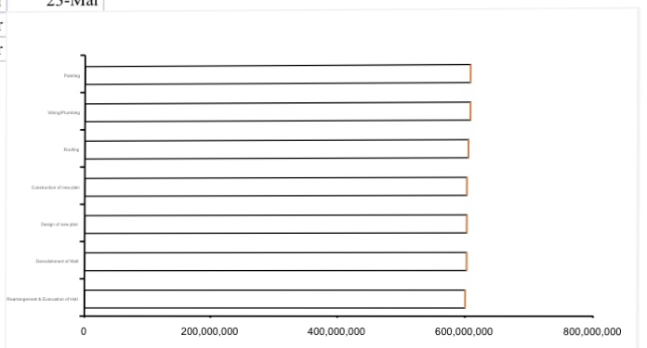

4) Thé building and construction site were secured because they are often natural targets for thieves as they generally contain lots of high value plants, materials and equipments. This can be easily accessible for criminals if proper and effective security is not put in place.
Also to reduce the risk of severe injuries from the construction materials and avoid vandilazation of properties and construction materials

5) BEME
Description | Rate(%) of N7000000 | Cost(N)
Miscellaneous | 10 | 700000
Tec for consultancy | 15 | 1050000
Tec for site preparation | 5 | 350000
Tec for transportation | 12 | 840000
Text as profit | 20 | 1400000
Total | 62 | 4340000
Total cost of BEME- Total estimated cost = N2660000

6) PAYMENT SCHEDULE
TOTAL REMAIN AMOUNT =N2660000
Description | Rate(%) | Cost(N)
Mobilisation | 30 | 798000
Text at 50% of completion | 30 | 798000
Final payment tec at completion | 40 | 1064000
6month defect liability period | 10 | 266000

7) MEANINGS
BEME- Bill of Engineering Measurement and Evaluation also referee to as bill , it’s a tool used before, during and post construction to asses and value the cost of construction works
Defect liability period- A defects liability period is a period of time following practical completion during which a contractor remains liable under the building contract for dealing with any defects which become apparent.
LEAD CONSULTANT - The lead consultant is the consultant that directs the work of the consultant team and is the main point of contact for communication between the client and the consultant team, except for on significant design issues where the lead designer may become the main point of contact.

PROJET LIFE CYCLE- A project life cycle is the sequence of phases that a project goes through from its initiation to its closure.

ENVIRONMENTAL IMPACT ASSESSMENT (EIA)- Environmental Impact Assessment (EIA) is a process of evaluating the likely environmental impacts of a proposed project or development, taking into account inter-related socio-economic, cultural and human-health impacts, both beneficial and adverse.

