NAME: CHIOKE VICTOR U.P
MATRIC NO: 18/ENG02/031
COLLEGE: ENGINEERING
DEPARTMENT: COMPUTER ENGINEERING
COURSE CODE: ENG 284
COURSE TITLE: ENGINEER IN SOCIETY

THE PROJECT:
REHABILITATION OF ALFA BELGORE HALL

THE SCOPE:
The Scope of Work covers the following:
- Mobilization/Takeover of Site: This is the movement of equipment and personnel to site with its attendant cost

- Preliminaries: This entails the hiring and erection of scaffold

- Removal of electrical connections: It involves the removal of electrical networks from the building

- Roof dismantling works: It entails the removal of roofing sheets and roof truss

- Block work: It entails the addition of 3 courses of block on existing building to raise the height

- Roof reconstruction: this entails the erection of new roof truss and installation of new roofing sheets

- Pre-rendition: Entails the scraping of old paint and preparing the wall surfaces to receive new paint

- Ceiling/Electrical works: This involves the re-establishment of electrical connections and ceiling of the building

- Rendition: This the application of new coats of paint on the walls of a building.

- Demobilization/Handover: This is the removal of equipment and personnel from the site.

GANTT CHART OF THE REHABILITAION PROJECT
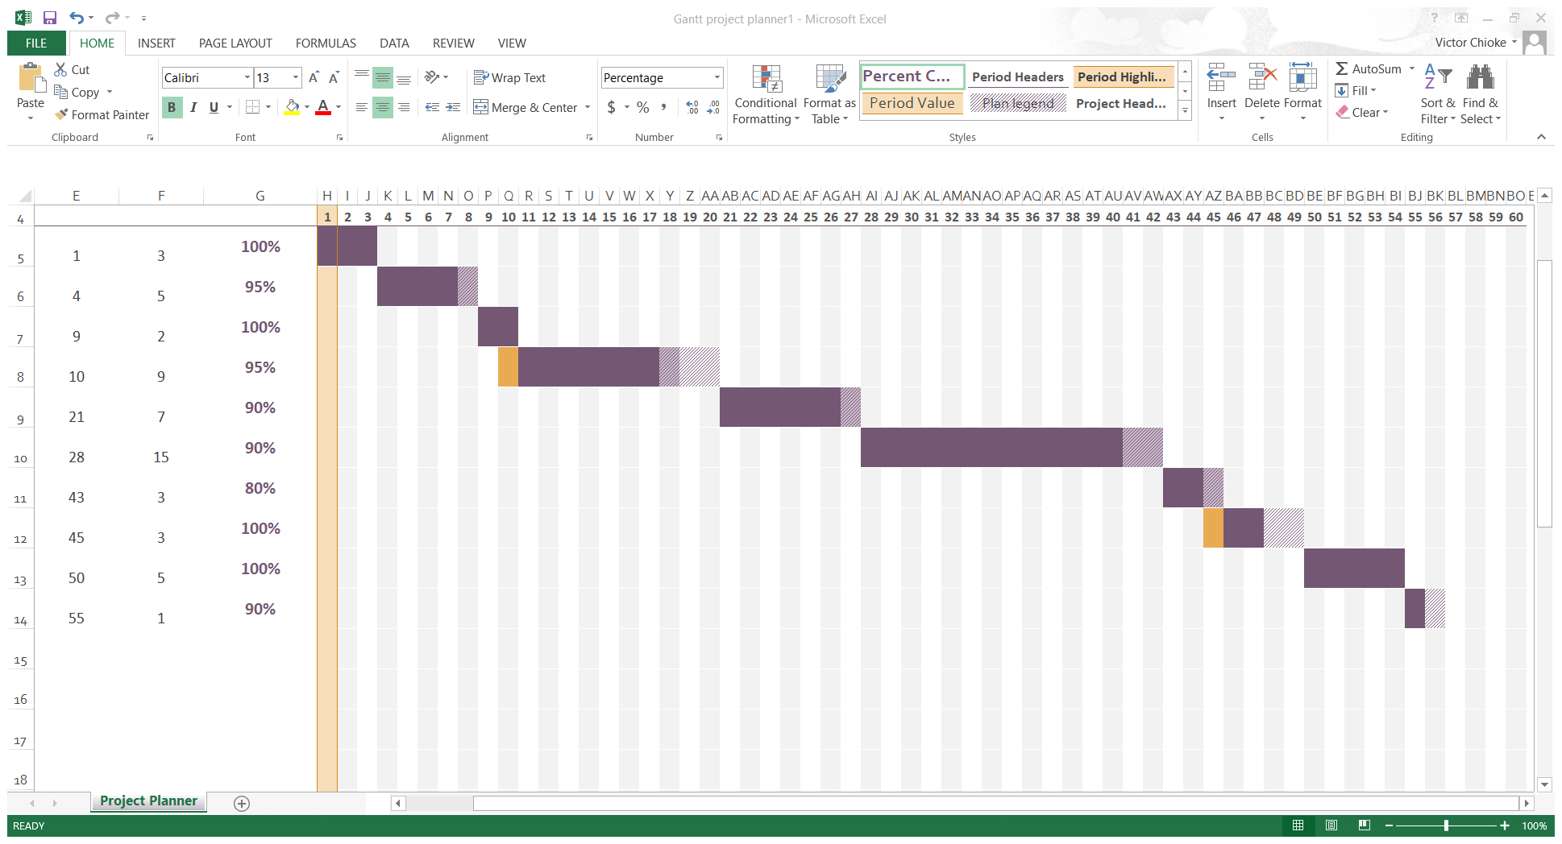

HUMAN RESOURCES NEEDED;
They are stated as follows:
- Project Manager
- Architect
- Electrical, Mechanical and Structural Engineers
- Bricklayers
- Electricians
- Plumbers
- Painters
- Laborers
- Security Personnel
The project Team comprises of the Project manager, Architect, Electrical engineer, Mechanical Engineer and the Structural Engineer working with the artisans with the Architect as the lead consultant

The Site and works need to be secured from and against vandals

BILL OF ENGINEERING MEASUREMENT AND EVALUATION FOR REHABILITATION OF ALFA BELGORE HALL
BILL NO | DESCRIPTION | LUMP SUM ESTIMATED COST(₦)
1 | Mobilization | 750,000
2 | Preliminaries | 1,250,000
3 | Removal of electrical connections | 100,000
4 | Roof dismantling works | 1,000,000
5 | Block work | 778,000
6 | Roof reconstruction | 22,500,000
7 | Pre-rendition | 50,000
8 | Ceiling/Electrical works | 1,250,000
9 | Rendition | 2,500,000
 | Total Estimated Cost (TEC) | 30,178,000.00
 | Miscellaneous (10% TEC) | 3,017,800.00
 | Consultancy (15% TEC) | 4,526,700.00
 | Preparation of clearing after completion (5% TEC) | 1,508,900.00
 | Transport Cost (12% TEC) | 3,621,360.00
 | Profit (20% TEC) | 6,035,600.00
 | Grand Total | 48,888,360.00

PAYMENT SCHEDULE FOR THE PROJECT
Payment Schedule NO | Milestone | % TEC | Amount Due (₦)
1 | Mobilization | 30% | 9,053,400.000
2 | 50% Completion | 30% | 9,053,400.000
3 | Completion and Handover | 40% | 12,071,200.00
4 | 6 Months Defect Liability Period | 10% | 3,017,800.00

7. a. BEME
This means a Bill of Engineering Measurement and Evaluation of the cost of a project. This is usually prepared by an Engineer

b. Defect liability Period
This is a period immediately after a project within which nothing is expected to go wrong with the project. If anything goes wrong during this period, the contractor is expected to remedy it at his own expense and at no extra cost to the client

c. Lead Consultant
The lead consultant is the consultant that directs the work of the consultant team and is the main point of contact for communication between the client and the consultant team, except for on significant design issues where the lead designer may become the main point of contact.

d. Project Life Cycle
A project life cycle is the sequence of phases that a project goes through from its initiation to its closure. In a predictive life cycle, the specifics are defined at the start of the project, and any alterations to scope are carefully addressed. In an adaptive life cycle, the product is developed over multiple iterations, and detailed scope is defined for iteration only as the iteration begins.

e. Environmental Impact Assessment (EIA)
This is an assessment of the likely effect of a project on its immediate surroundings. It is aimed at ensuring that the project does not endanger inhabitants (animals, plants, aquatic, and soil) within the project environment.

