NAME: AMADI-DURU, C. Melvin

DEPT: ELECTRICAL/ELECTRONICS ENGINEERING.

MAT NO: 18/ENG04/013

COURSE CODE: ENG 284

COURSE TITLE: ENGINEER IN SOCIETY

Project Outline
-Outline the Scope of work in detail in order of occurrence
-Prepare a project Gant Chart
-List all the human resources needed and constitute the Project Team stating who the Lead Consultant is.
-Explain why the site was secured
-Develop a BEME for the project by lump sum projections including 10% of the total estimated cost (Tec) as Miscellaneous, 15% tech as consultancy fee, 5% Tec for site preparations and clearing after completion, 12% of tech for transport cost, 20% Tec as profit
- Prepare a payment schedule as follows
a) 30% Tec for Mobilization (b) Next 30% Tec at 50% completion c) Final payment of 40% Tec at completion and handover. Retain 10% Tec for a 6 months Defect liability period.
- What is BEME, Defect liability period, Lead consultant, Project life cycle, Environmental Impact Assessment (EIA)

PROJECT TITLE: THE ALFA BELGORE REHABILITATION.

SCOPE OF WORK:
Client demands and complaints
-Alfa Belgore hall has served the university for 9 years, at first the university population was just over 600 and the capacity of the hall was 3,500. It was predicted the hall’s size would serve the university for 15 years as the population grew arithmetically. But high demand for admission into the university has increased the population exponentially.
Previously predicted population by 2018:
3,200-4,500 Students and Staff (Teaching & Non-Teaching)
Current population as at January 2018:
9,688 Students and Staff (Teaching & Non-Teaching)
The goal:
We’ve enlisted Melvin Amadi Consulting to assist us achieve the goal of expanding Alfa Belgore hall to a capacity of 12,000. Besides the expansion, we would like the hall to be equipped with state of the art technology. It should be a picture of modern day infrastructural genius.

Melvin Amadi Consulting
-We visited the hall last week and have assessed the project at hand.
-These are steps of how we intend to go about the expansion and upgrade.
-There are several shops surrounding the hall, we noticed the Bookshop and ICT. They’ll need to be evacuated with immediate effect, the expansion will require us to demolish those structures and we want to try our best to avoid casualties.
-We will need to secure the site with an aluminum fence for safety and privacy purposes.

-The windows, bathrooms and everything inside will need to be ripped apart

Productivity Estimate
-The project will take more than 5months so we strongly advise all the recreational activities that usually take place in the hall find another venue.

Estimate Installation methods
-Ventilation cooling systems instead of the Air conditioners will be installed, security cameras and a surveillance room will be put into the hall as well. Smart wireless microphones and speakers will be brought in.

-The hall will be replastered and repainted. A new stage will be built as well.

-The founder and management will then come for inspection before the finishing touches are put in place.

-The hall will be unveiled to the school.

GANTT CHART OF PROJECT

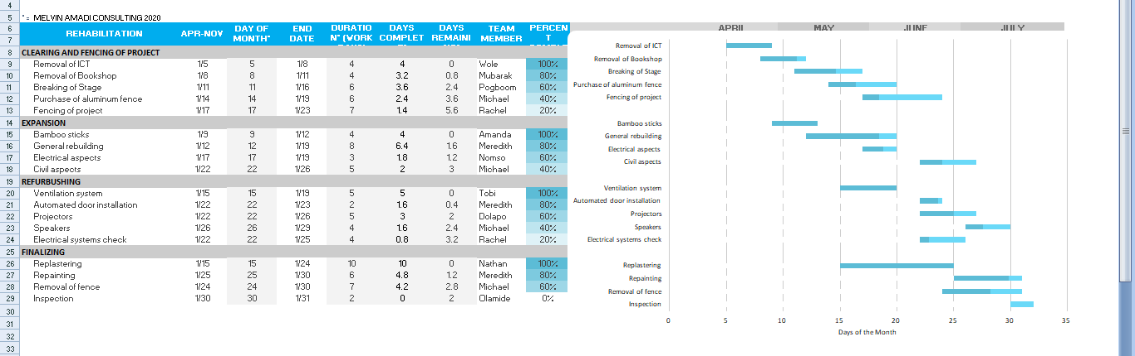

Human resources required for the project
-Architect
-Civil & Electrical Engineer
-Surveyor
-Draftsperson
-Builders & Artisans
-Certifier
-bricklayers
-Demolition Operatives
-Glaziers
-Floorers
-Carpenters
-Painters
-Plasterers
-Plumber
-Roof Tiller
Materials Needed
-Granite
-Sharp sand
-Plastering sand
-Iron rod (imported type)
-Water
-Cement

Lead Consultant: Tom Dele-Bashiru
Lead consultants have hands-on roles which involve the day-to-day running of continuing client projects. They are team leaders, analyzing and reviewing proposals from the team, providing appropriate solutions to problems, and making decisions on the way forward by acting as liaisons between the client and the consultancy team. Their work involves directly dealing with the client to clearly understand its needs, and to provide possible solutions for the client’s consideration. The team receives and works on the client’s information from the lead consultant.
WHY IS A FENCE CONSTRUCTED?
The Contractor is responsible for the security of the construction site.
There is a reason that workers wear personal protective equipment (PPE) such as vests and hardhats. A construction site can be a dangerous place. It is especially dangerous for someone unfamiliar with the project, such as a wandering pedestrian, to be on the project. There are too many moving parts, what with heavy equipment, big holes in the ground, overhead objects, etc. You should NEVER enter a construction site without the authorization to be there. The fences try to keep these people out.
Construction sites are a common place for vandalism. Vandals will break into job trailers; steal equipment, materials, etc. The fence is to keep these people out.
Stray animals have a tendency to wander into construction sites. The fences are to keep them out.
A fence delineates the construction zone. The Belgore project is extremely high profile. People try to wander in all the time. People also try to drive in all the time. We can put signs up on and around fencing telling these people to keep out. Without a fence, we would have people wandering everywhere. Even with the fence, they try to wander in, but we have a point of control at the gate. We also have hired a security guard for after hours.

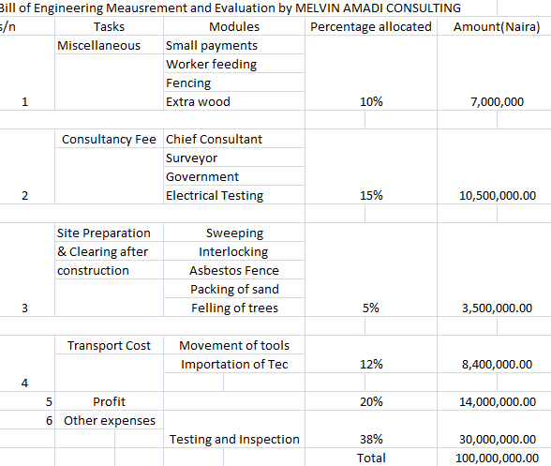

S/N | Work description | Percentage allocated | Amount(Naira)
1 | Mobilization  -The commencement of the Project  -Acquiring Machinery  -Hiring of workers | 30.0% | 6,000,000
2 | Tec at Completion | 30.0%-50.0% | 9,000,000
3 | Final payment of Tech at completion and handover | 40.0% | 12,000,000
4 | Retain Tec for a 6 months Defect liability period | 10.0% | 3,000,000

Total: 30,000,000.00

BEME (BILL OF ENGINEERING MEASUREMENT AND ENGINEERING): A Detailed billing of the day to day expenses and tax levied during a construction project. For all engineering work it is good to know before the cost of construction. This bill includes cost of materials, labor, equipment and all/any other resource(s) required for the success of the construction.
LIABILITY PERIOD: The so-called defect liability period (DLP) has started it is a set period of time after the construction of the project has been completed, during which the contractor has the right and must return to the site to remedy any defects. A typical DLP lasts 12 months.
Any defects or faults that arise during this period are classed as obvious defects and are discovered by normal examination. Alternatively, these can be hidden defects that can only be discovered after a period of time, after usage and occupation, for example due to defective materials or workmanship leading to water leakage. These defects must be put right by the contractor at the contractor’s own expense.

Lead Consultant:
Lead consultants have hands-on roles which involve the day-to-day running of continuing client projects. They are team leaders, analyzing and reviewing proposals from the team, providing appropriate solutions to problems, and making decisions on the way forward by acting as liaisons between the client and the consultancy team. Their work involves directly dealing with the client to clearly understand its needs, and to provide possible solutions for the client’s consideration. The team receives and works on the client’s information from the lead consultant.
PROJECT LIFE CYCLE:
A project life cycle is the sequence of phases that a project goes through from its initiation to its closure. The number and sequence of the cycle are determined by the management and various other factors like needs of the organization involved in the project, the nature of the project, and its area of application. The phases have a definite start, end, and control point and are constrained by time. The project lifecycle can be defined and modified as per the needs and aspects of the organization. Even though every project has a definite start and end, the particular objectives, deliverables, and activities vary widely. The lifecycle provides the basic foundation of the actions that has to be performed in the project, irrespective of the specific work involved.
Environmental Impact Assessment (EIA):
Environmental impact assessment (EIA) is one of the main legislative tools established to minimize an anthropogenic impact on the environment. EIA can be defined as “a process by which information about the environmental effects of a project is collected, both by the developer and from other sources, and taken into account by the relevant decision-making body before a decision is given on whether the development should go ahead.” Any EIA consists of three key stages. The first stage (preliminary assessment) involves the identification and collection of relevant information, which is called screening. During this step the decision is made on whether an EIA is required for the project. If an EIA is required, then the second stage starts. The second stage, called scoping identifies what constitutes relevant information to be identified and assessed with respect to key impacts of the proposed development. The results from scoping process are reported to the relevant decision-makers in an “environmental impact statement” (EIS). The final stage comprises the review of the EIS and its adequacy as a basis for the competent/approving authority to make the decision on “development conditions.”

