Name: Lotanna Francis Onyekwelu
Department: Mechatronics Eng
Matric no: 18/ENG05/052
ENGINEERING IN SOCIETY ASSIGNMENT
As a designated student consulting engineer in the rehabilitation project of Alfa Belgore hall, the following indicates the order in which the scope of work follows;
- Description of work/planning; renovation of the hall both interior and exterior, the work shall be done per scope of work, specifications and contract conditions which requires an experienced contractor which will provide all labor, material tools, equipment and supervision.
- Securing the surrounding area for safety and mandatory construction procedures / work area protection.
- Clearing and removal of interior and exterior hardware within the vicinity to enable commencement of work.
- Removal of roofing and ceiling
- Construction of a 1st floor within the hall with restrooms, a lobby, staircase, control room and a stage.
- Renovation of all restrooms on ground floor with toilets and sinks.
- Renovation of the ICT room.
- Tiling and plumbing work.
- Roofing
- Repainting applications
- Electrical wiring and reinstallations.
- Site clearance and cleanup.

2. Project Gant chart

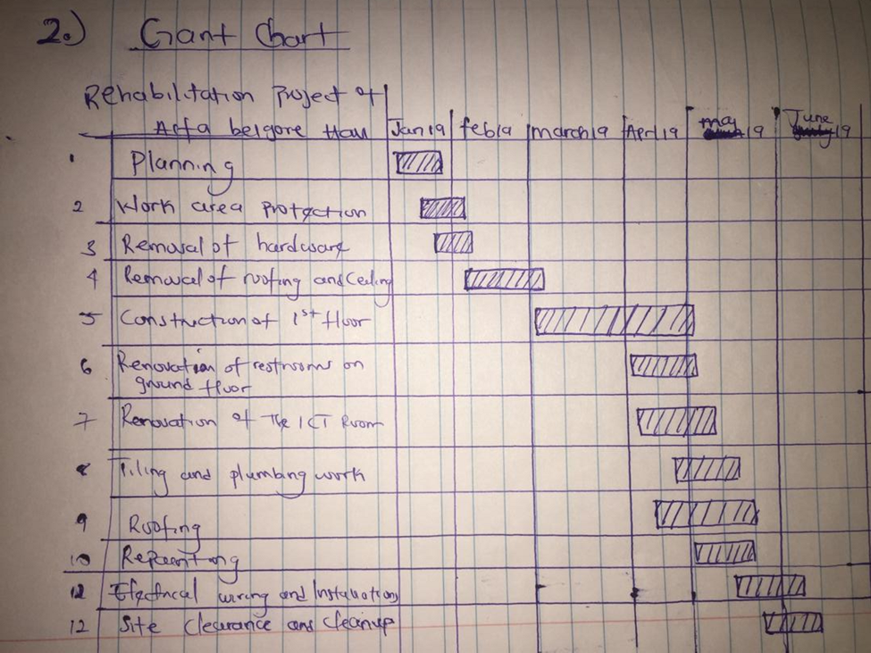

3. Project team consisting of all the human resources needed and consultants.
a. Land surveyor
- Geotechnical engineer
c. Architect
D. Structural engineer
- Quantity surveyor
- Building service engineer
- The building contractor
- The consultant.
Only one consultant is needed for a construction of such scale, the lead consultant will there for be the architect who develops the blueprint and building plan for the construction and all others work in relation to him.

4. Explain why the site was secured; this was done for safety reasons and precaution measures so as to prevent individuals from straying into the construction site.

5. Development of a BEME for the project by lump sum projectors including 10% of the total estimated cost (tec) as miscellaneous, 15% tec as consultancy fee, 5% tec for site preparation and clearing after completion, 12% of tec for transport cost, 20% tec as profit.
Estimation and Evaluation: On planning and preparation of the project, the bill was broken down based on miscellaneous, building rehabilitation & construction and finishing. It was arrived at an estimate of twenty-five million naira (25,000,000)

ITEM DESCRIPTION QUANTITY UNIT RATE(%) AMOUNT
- Miscellaneous; this includes the 10 3,000,000
Varieties of thigs done in the cite ie.
Relocation, removal of electrical
Materials, roof ets
- Consultant fee 12 4,000,000

- Site preparation 7 2,000,000

- Transport cost 10 3,500,000

- Income 23 5,500,000

- Materials needed 28 5,500,000

- Maintenance 10 1,000,000

TOTAL 25,000,000

Payment Schedule
S/N ITEM PAID FOR RATE COST DATE
- Mobilization 30% 8,000,000 JAN 19TH
- Payment for completion 50% 10,000,000 APRIL 6TH
Of the project.
- Payment for final 20% 7,000,000 JUNE 19TH
Work.

DEFINITIONS;
BILL OF ENGINEERING MEASUREMENT AND EVALUATION (BEME):
This is a tool used before, during and post construction to determine the cost of construction work.

DEFICIT LIABILITY PERIOD: Is a period of time following practical competition during which a contractor remains liable under the building contract for dealing with any defects which became apparent.

LEAD CONSULTANT: Is the consultant that directs the work if the consultant team and is the main point of contact for communication for the client, he projects the client’s ideas and wishes to the team.

PROJECT LIFE CYCLE: Is the sequence of phases that a project goes through from its initiation to its closure.

ENVIRONMENTAL IMPACT ASSESSMENT: Is the assessment of the environmental consequences of a plan, policy or actual project prior to the decision to move forward with the proposed action.

