TERM PAPER

ON

SOIL PERMEABILITY AND CAPILLARITY
PRESENTED BY
LADAN FIDALEH
17/ENG03/033
SUBMITTED TO
THE DEPARTMENT OF CIVIL ENGINEERING
COLLEGE OF ENGINEERING,
AFE BABALOLA UNIVERSITY, ADO-EKITI, EKITI STATE, NIGERIA.

IN PARTIAL FULFILLMENT OF REQUIREMENTS FOR THE AWARD OF
BACHELOR OF ENGINEERING (B. ENG.) DEGREE IN CIVIL ENGINEERING

CERTIFICATION
This is to certify that this work was undertaken by LADAN FIDALEH with Matriculation Number 17/ENG03/033, prepared and presented to the Department of Civil Engineering, Afe Babalola University, Ado-Ekiti.

ABSTRACT
In the civil engineering field, it is important to know more about soil mechanics, which exposes one to know how water passes through /enters, its movement and the amount of water flowing through soil in unit time. This knowledge is important in determining the quantity of seepage under hydraulic structures, in designing earth dams and construction of foundations.

ACKNOWLEDGEMENTS
All glory and praise be to the Almighty God for his favour and grace upon my life and for the wisdom, knowledge and understanding he has given to me from onset till now. Also I would love to acknowledge my parents and family for their support and sacrifices they continually provide.

TABLE OF CONTENTS
CERTIFICATION ii
ABSTRACT iii
ACKNOWLEDGEMENTS iv
LIST OF FIGURES vi
INTRODUCTION 1
1.1 SOIL PERMEABILITY 1
1.1.1 IMPORTANCE OF SOIL PERMEABILITY 2
1.1.2 FACTORS THAT AFFECT SOIL PERMEABILITY 2
1.2 HOW TO TEST FOR SOIL PERMEABILITY 4
1.2.1 SOIL PERMEABILITY TEST APPLICATIONS 4
1.3 FORMULA OF HYDRAULIC CONDUCTIVITY 7
2 SOIL CAPILLARITY 8
2.1 CAPILLARY RISE IN DIFFERENT RISE IN SOIL 8
2.1.1 EFFECT OF CAPILLARY RISE IN SOIL 8
2.2 SURFACE TENSION IN SOILS 8
2.3 CALCULATION OF CAPILLARY RISE HEIGHT OF SOILS 8
2.4 RELATIONSHIP BETWEEN SOIL PERMEABILITY AND CAPILLARITY 8

INTRODUCTION

SOIL PERMEABILITY
Soil permeability which is also known as hydraulic conductivity is a soil property which allows the seepage of fluid through its interconnected gap spaces. It is important to know about the soil before and what it is generally made up of. Most times, soils are generally made up of “layers”, that is where permeability falls in place, then the soil quality which often varies greatly from a layer to another. For example, when a pond construction is about to commence, it is important to determine the relative positioning of the permeable layers.
Also, the word permeability refers to the movement of air and water through the soil, which is important because it affects the supply of root-zone air, moisture, and nutrients available for plant uptake. It is also important to note that the design of a pond needs to be planned to avoid permeable layers at the bottom in order to prevent excessive water loss into the subsoil by seepage.
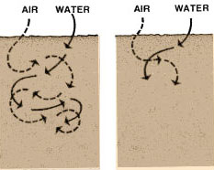

Figure 1: SOIL PERMEABILITY

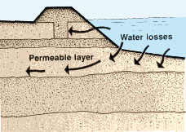

Figure 2: SOIL PERMEABILITY

IMPORTANCE OF SOIL PERMEABILITY
The following listed below shows the importance of soil permeability;
- Soil permeability is the property of the soil to transmit water and air.
- A pond built in impermeable soil will lose little water through seepage.
- The more permeable the soil, the greater the seepage.
- Permeability influences the rate of settlement of a saturated soil under load.
- Filters made of soils are designed based upon their permeability.
- Helps to determine the design of earth dams.

FACTORS THAT AFFECT SOIL PERMEABILITY
The factors below shows the factors that affect soil permeability;
- Shape of particles
- Particle size
- Structure of soil mass
- Void ratio of soil
- Properties of pore fluid
- Temperature
- Degree of saturation
- Absorbed water

- Void ratio – In this case, increase in the void ratio increases the area available for flow. Therefore, permeability increases for critical conditions.
- Shape of particles – Permeability is inversely proportional to specific surface.

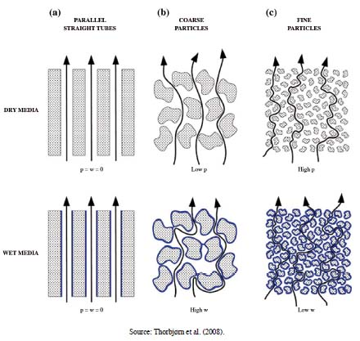
Figure 3: PARTICLE SHAPES

- Structure of soil mass – For same void ratio the permeability is more for flocculent structure as compared to the dispended structure.
- Degree of saturation – The permeability of partially saturated soil is less than that of fully saturated soil.

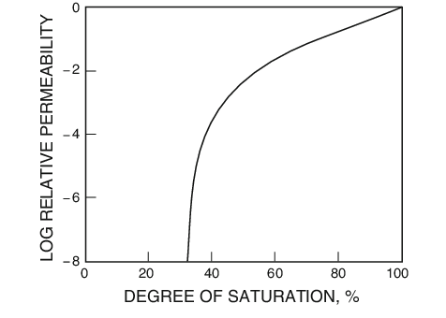

Figure 4: SATURATION GRAPH

HOW TO TEST FOR SOIL PERMEABILITY
First thing to know is that soil permeability measurements determine how well water/ fluid passes through soil. Large pores in granular soil or sand allow water to move rapidly, while small pores in silt or clay cause water to seep through slowly. The main tests to measure soil permeability are the constant head, the falling head and the percolation test.
NB: Homeowners may need a permeability test for building, landscape or major gardening projects. You can easily do a percolation test yourself, but it is advisable you check whether local laws require you to hire a professional.

SOIL PERMEABILITY TEST APPLICATIONS
Soil permeability measurements help determine the rate of soil settling, which you need to know before constructing buildings or determining how much water will flow toward an excavation. Good drainage from high soil permeability is needed for installation of a septic system. Low permeability, found in clay soils, works well for placement of ponds, such as a fish pond. Soil permeability measurements also help determine the stability of slopes and earth dams. Growing vegetables requires good drainage; a permeability test can indicate whether your soil is suitable or needs to be amended before planting.
- Constant Head Permeability: Test The constant head test is a laboratory test done on sandy or granular soil samples. Under constant pressure, a piston forces water through a column of water-saturated soil to determine the flow rate of water. The water in the test is de-aired and kept at constant temperature. The test apparatus has a water reservoir on top and an outlet reservoir on thebottom. The permeability of the soil sample is calculated from the height of the soil sample, the sample's cross section, pressure measurements, the volume of passed water and the time interval.
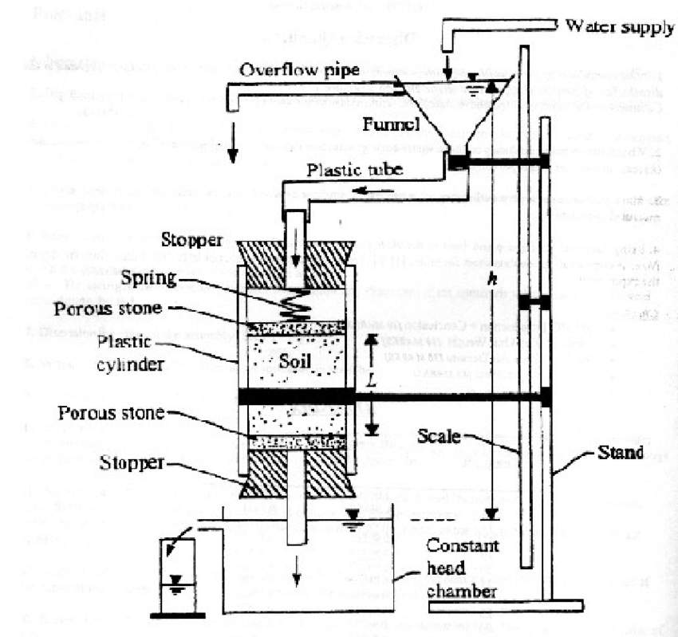
Figure 5: CONSTANT HEAD PERMEABILITY TEST

- Falling Head Permeability Test: The falling head permeability test is for low permeability soils, such as silts and clays. A relatively small soil sample is used, because water flow will be slow. After tamping down the sample and saturating it with water, a standpipe is connected to the container holding the soil. The standpipe is filled with water, and the initial water level is measured. The decline in water level in the standpipe is measured again after the water flows through the sample in a specified time. The permeability of the soil sample is calculated from the size of the soil sample, the cross section of the standpipe, the drop in water level and the time taken.
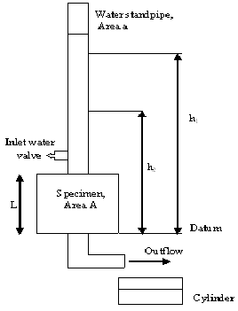
Figure 6: FALLING HEAD PERMEABILITY TEST

- Percolation Test: For the percolation test, a field test done in the area of interest, a tester digs a series of holes in the ground and fills them with water for a few hours or overnight to saturate the soil. Sandy or gravelly soils take shorter than silty or clay soils to become saturated. After water has saturated the soil surrounding the test holes, the tester adds new water and records the time it takes for the water level in the holes to drop. The permeability, or more accurately the percolation rate, is calculated from the drop in water level in inches or centimetres per specified time.
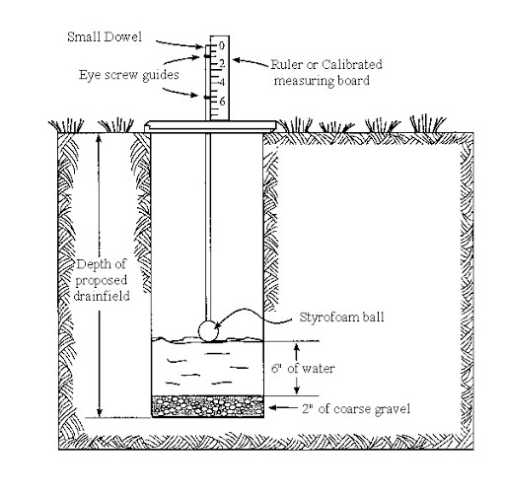
Figure 7: PRE COLATION TEST

FORMULA OF HYDRAULIC CONDUCTIVITY
Hydraulic conductivity is the ease with which water moves through porous spaces and fractures in soil or rock. It is subject to a hydraulic gradient and affected by saturation level and permeability of the material. Hydraulic conductivity is generally determined either through one of two approaches. An empirical approach correlates hydraulic conductivity to soil properties. A second approach calculates hydraulic conductivity through experimentation.
Estimation by Empirical Apporach
Allen Hazen derived an empirical formula for approximating hydraulic conductivity from grain size analyses:
K=C(D₁₀)²

Where;
C Hazen's empirical coefficient, which takes a value between 0.0 and 1.5 (depending on literatures), with an average value of 1.0. A.F. Salarashayeri & M. Siosemarde give C as usually taken between 1.0 and 1.5, with D in mm and K in cm/s. D₁₀ is the diameter of the 10 percentile grain size of the material

SOIL CAPILLARITY
Capillarity is the phenomenon by which water rises in a cylindrical column. The narrower the column the higher the capillarity; similarly, the denser the substratum present in the column, the higher the capillary effect. Capillarity is the phenomenon by which water rises in a cylindrical column. The narrower the column the higher the capillarity; similarly, the denser the substratum present in the column, the higher the capillary effect.
Soil Capillarity is the primary force that enables the soil to retain water, as well as to regulate its movement through out the layers of soil on the earth’s crust and through the roots and stems of plants from the soil which they reside on. In soil, there are millions of vertical channels/pipes called "capillary tubes". Whenever there is a downpour, excess water runs underground through these capillary tubes and when it is dry, these same tubes transport water to the surface.
Trees have their roots in these capillary tubes which also contain threads of fungi which are hygroscopic (attracting water) and with their lateral roots, they soak up capillary water when it is hot and dry. This is how a tree survives heat and drought. Even in rocks, minuscule and invisible fissures function as capillary tubes. Water molecules behave in two ways;
- Cohesion Force: Because of cohesion forces, water molecules are attracted to one another. Cohesion causes water molecules to stick to one another and form water droplets.
- Adhesion Force: This force is responsible for the attraction between water and solid surfaces. For example, a drop of water can stick to a glass surface as the result of adhesion.

CAPILLARY ACTION:
  - Capillary action, also referred to as capillary motion or capillarity, is a combination of cohesion/adhesion and surface tension forces.
  - Capillary action is demonstrated by the upward movement of water through a narrow tube against the force of gravity.
  - Capillary action occurs when the adhesive intermolecular forces between a liquid, such as water, and the solid surface of the tube are stronger than the cohesive intermolecular forces between water molecules.
  - As the result of capillarity, a concave meniscus (or curved, U-shaped surface) forms where the liquid is in contact with a vertical surface.
  - Capillary rise is the height to which the water rises within the tube, and decreases as the width of the tube increases. Thus, the narrower the tube, the water will rise to a greater height.
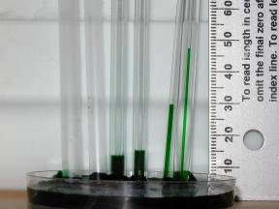Capillarity in different sizes of tubes

SOIL SURFACE TENSION
Interconnected pore space in soils hold water due to surface tension effects. The pores in a soil act like capillaries that absorb and retain water, the smaller the pore, the larger the energy with which water is retained in the soil (large pores are easy to drain, and small ones are difficult to drain).
Water surfaces behave in an unusual way because of cohesion. Since water molecules are more attracted to other water molecules as opposed to air particles, water surfaces behave like expandable films. This phenomenon is what makes it possible for certain insects to walk along water surfaces.

CAPILLARY RISE IN DIFFERENT SOILS
The phenomenon of capillarity also occurs in the soil. In the same way that water moves upwards through a tube against the force of gravity; water moves upwards through soil pores, or the spaces between soil particles.
- The height to which the water rises is dependent upon pore size. As a result, the smaller the soil pores, the higher the capillary rise.
- Finely-textured soils typically have smaller pores than coarsely-textured soils. Therefore finely-textured soils have a greater ability to hold and retain water in the soil in the inter-particle spaces. We refer to the pores between small clay particles as micropores. In contrast, the larger pore spacing between lager particles, such as sand, are called macropores.
- In addition to water retention, capillarity in soil also enables the upward and horizontal movement of water within the soil profile, as opposed to downward movement caused by gravity. This upward and horizontal movement occurs when lower soil layers have more moisture than the upper soil layers and is important because it may be absorbed by roots.
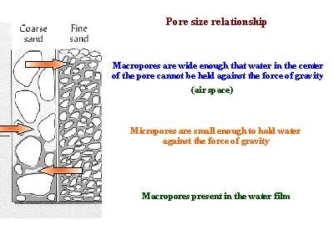

RELATIONSHIP BETWEEN SOIL PERMEABILITY AND CAPILLARITY
The size of the soil pores is of great importance with regard to the rate of infiltration (movement of water into the soil) and to the rate of percolation (movement of water through the soil). Pore size and the number of pores closely relate to soil texture and structure, and also influence soil permeability and capillarity as shown above.
The permeability of individual soil horizons may be evaluated by the visual study of particular soil characteristics which have been shown by soil scientists to be closely related to permeability classes. The most significant factor in evaluating permeability is structure: its type, grade, and aggregation characteristics, such as the relationship between the length of horizontal and vertical axes of the aggregates and the direction and amount of overlap, since the soil capillarity deals with the vertical movement of water molecules through the soil capillary pores against gravity, we can say that the greater the permeability of a soil sample, the less the capillarity of the soil sample.
Higher permeability means wider pores within the soil sample, therefore the surface tension existing will be less rather than more in a soil sample with less permeability. Hence, we can say that soil permeability is inversely proportional to capillarity.
