NAME: OLUYOLE OLUWATOBI VINCENT
DEPARTNMENT: COMPUTER
MATRIC NO: 18/ENG02/081
COURSE: ENGINEER IN THE SOCIETY(ENG284)
PROJECT: CONSULTING ENGINEER
QUESTION
The Alfa Belgore Rehabilitation project is ongoing. As a designated Student Consulting Engineer you are expected to do the following
1. Outline the Scope of work in detail in order of occurrence
2. Prepare a project Gant Chart
3. List all the human resources needed and constitute the Project Team stating who the Lead Consultant is.
4. Explain why the site was secured
5. Develop a BEME for the project by lump sum projections including 10% of the total estimated cost (tec) as Miscellaneous, 15 % tech as consultancy fee, 5% tec for site preparations and clearing after completion, 12% of tec for transport cost. 20% tec as profit
6. Prepare a payment schedule as follows
(a) 30 % tec for Mobilisation (b) Next 30 % tec at 50% completion (c) Final Payment of 40 %tec at completion and hand over. Retain 10 % tec for a 6 months Defect liability period
7. What is BEME, Defect Liability Period, Lead Consultant, Project Life cycle, Environmental Impact Assessment (EIA)
Answers
- Scope of the Work

Project Overview – This should include a brief outline of the project summary as well as key objectives. In essence, you’d need to answer questions including why the project is necessary, etc.
Project Deliverables – Each project endeavor consists of specific expectations and target objectives, and this is where you make a detailed outline of all such information
Project Schedule – For each of the deliverables above, there are certain tasks required to complete them. This section should include all such tasks, including time limits and expected delivery dates, project milestones as well as when the entire project is expected to be completed
Roles and Responsibility – Here, you will include all such information relating to tasks as well as assign people who would carry them out.
Project Management – This will discuss all the nitty-gritties concerning how the project will be managed. This will include issuing of payments, legal requirements, change management, legal requirements and a host of others
Reporting requirements – In your construction scope of work checklist, this will clearly specify the reporting relationship of members of the construction team
Additional information that may constitute an addition to the scope.
- Project Gant chart
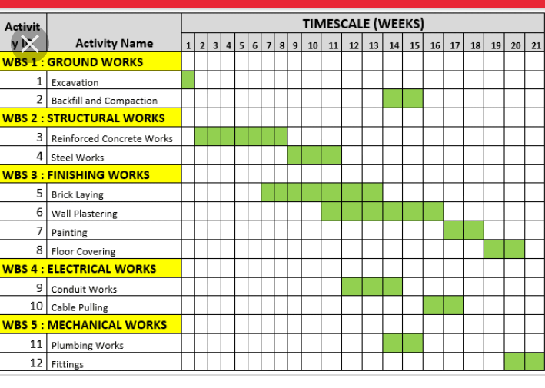
3) Human resources needed
1Role analysis.
2Role specification.
- Workforce planning.
- Recruitment and selection of temporary and permanent staff as required.
- Training and development.
- Performance management.
- Compensation (remuneration).
- Legal issues.
- Managing employee payroll, benefits and
- compensation.
- Communicating with employees.
- Resolving disputes.
- Evaluating performance.
- Managing employee relations.
- Ensuring equal opportunities.
- Making sure staff facilities are suitable and well-maintained.
4) Explain why the site was secured
The site was secured because there was a need to prevent students/lectures from going to the construction site to prevent major or minor accidents of any kind
5)
The projections | Cost
At 10% | 5 Million naira
At 15% | 11 Million naira
At 5% | 1 Million naira
At 12% | 10 Million naira
At 20% | 20 Million naira

6)
MOBILIZATION | 20 MILLION NAIRA
COMPLETION | 10 MILLION NAIRA
COMPLETION AND HAND OVER | 5 MILLION NAIRA
DIRECT LIABILITY PEROID | 20 MILLION NAIRA

7)
BEME- this refers to a tool used before, during to access the value of the construction work
A defect liability is a period of time following practical completion which a contractor remains liable under the building contract for dealing with any defect which become apparent
The lead consultant is the consultant that directs the work of the consultant team and is the main point of contact between the client and the consultant team, except for on significant design issues where the lead designer may become the main point of contact
Project life cycle refers to the series that took place in the project making
Environmental assessment is the assessment of the environmental consequences of a plan, policy, program, or actual projects skills piror to the decision to move forward with the proposed action

