NAME: ISIOMA ONOCHIE-ONYETENU BRIAN
MATRIC NO: 18/ENG08/016
COURSE CODE: ENG284
COURSE TITLE: ENGINEER IN THE SOCIETY

1a) Kick-off meeting: A meeting is held between the appropriate high parties to discuss the rehabilitation project of Alfa Belgore hall. In the meeting, various aspects of the rehabilitation project will be discussed. E.g
- Project Overview: Here, they talk about the summary of the objective and the key objectives in the project.
- Project Deliverables: Here, all the expected objectives and targets for the project should be outlined. It should include all the relevant information that will help the contractor understand the project better.
- Project Scope: This should include all the goals for the project. You should plan when certain aspects of the project will be completed.
- Project Schedule: Here, you should have a schedule of all the required tasks and when they should be completed.
- Project Management: This should include details about payment i.e(when and how payments will be made).

1b) Architectural Drawing: When the meeting is done, An Architect is called to make/draw the plans for the renovation of the building. This is where the parts of the hall to be demolished and renovated are chosen.
1c) Site Mobilization: These are the activities carried out after the contractors have been appointed, but before the contractors commence work on the site. It is a preparatory stage in which the majority of the activities are managed by the Lead consultant.
After the site mobilization, the site is closed for safety reasons.
1d) Demolition of Structures: At this stage, the structures planned by the architect to be demolished are demolished to make way for the renovation process.
1e) Renovation: This is the stage or process where the bad or damaged things in the hall are improved/replaced. E.g The roof of the hall can be changed.
1f) Test: This is where the building is tested and the mistakes in the construction are found and rectified.
1g) Handover and close out: This takes place when the construction has been completed. The employer is able to occupy the development but the contractor remains responsible for rectifying problems or defects during a period known as the ‘defects liability period’ which is also known as the ‘rectification period’. The period lasts for at least six to twelve months. A formal hand over is needed to prevent arguments on terms and defect reporting protocol should be agreed on. This should all be done for inspection of site. After all that is agreed upon, the contractor prepares an information exchange or ‘data drop’ as required by the employers information requirements. This is where the data client can check whether the accounts are balanced or not.
1h) In-Use: ‘In use’, sometimes referred to as ‘operation’, describes the period after any defects have been rectified and fine turning carried out when the development is in ‘normal’ operation.

2)

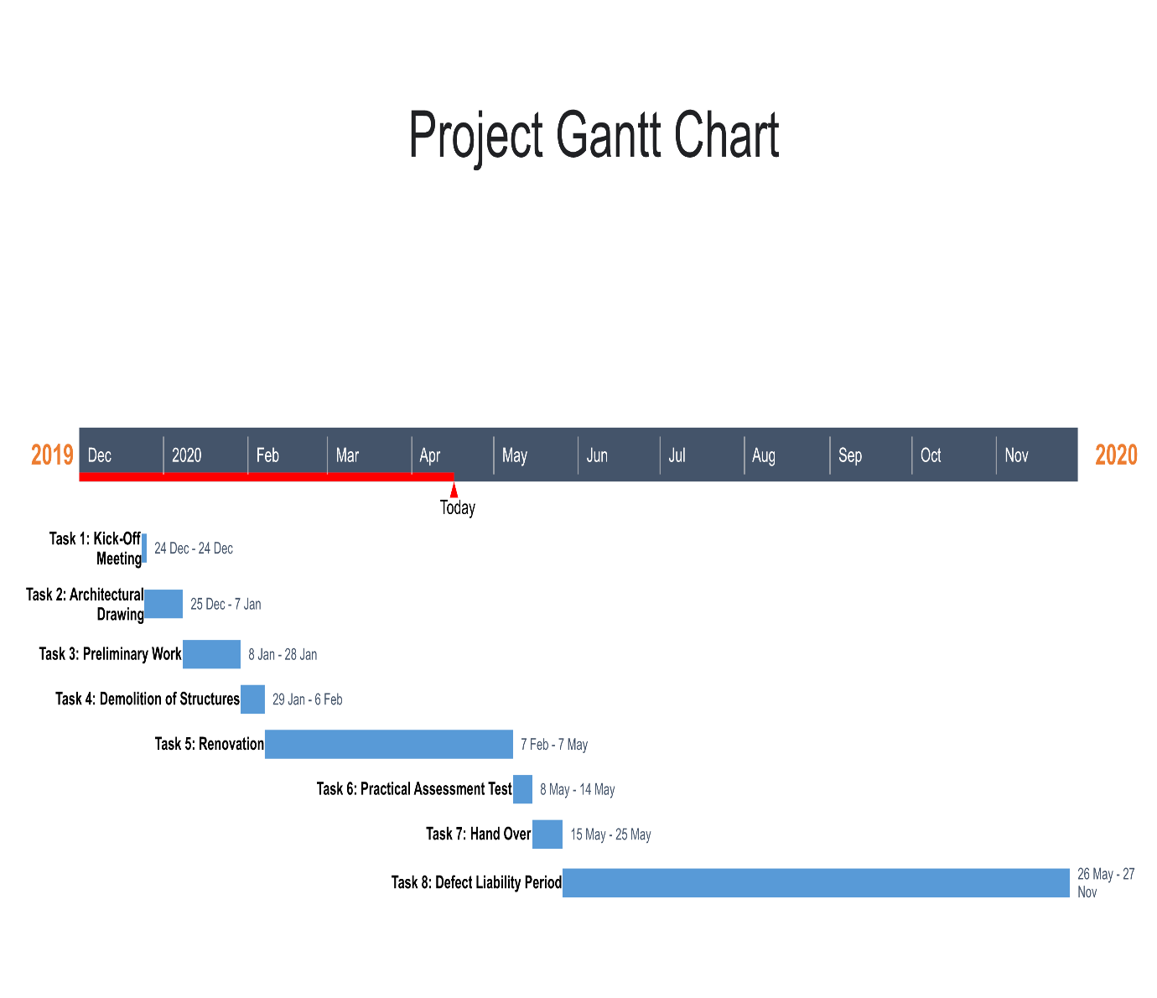

3)

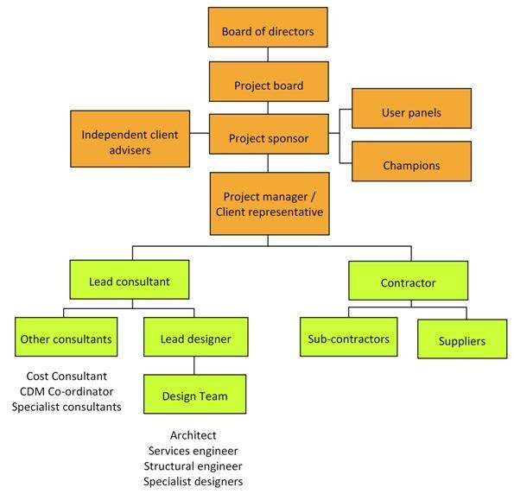

The other human resources include that of the: Electrical Engineers, Civil Engineers, etc.

The Lead Consultant is the consultant that directs the work of the consultant team and is the main point of contact for communication between the client and the consultant team. He/She should be the Architect as the renovation plans were drawn by him/her.

4) The site was secured for the following reasons:
- To prevent students from entering the renovated building when it is not safe.
- To prevent Dust from affecting students.
- To prevent students from falling into excavation holes or piles of sand during the renovation.
- To prevent students from stepping on sharp objects.
- To prevent injury to students from falling objects.

5)

BEME (Bill of Engineering Measurements and Evaluation)
S/N | Description | Percentage | Total Estimated Cost(tec) | Description cost
1 | Miscellaneous | 10% | ₦ 500,000,000 | ₦50,000,000
2 | Consultancy fee | 15% | ₦ 500,000,000 | ₦ 75,000,000
3 | Site Preparations and Clearing after completion | 5% | ₦ 500,000,000 | ₦ 25,000,000
4 | Transport cost | 12% | ₦500,000,000 | ₦ 60,000,000
5 | Profit | 20% | ₦ 500,000,000 | ₦ 100,000,000
 | Total | 62% |  | 310,000,000.00

6)

Payment Schedule
Description | Percentage | Total Estimated Cost(tec) | Total amount to be paid | Percentage Retained | Amount Retained | Payment
Mobilization | 30% | ₦ 500,000,000 | ₦ 150,000,000 | 0% | ₦ - | ₦ 150,000,000
At 50% completion | 30% | ₦ 500,000,000 | ₦ 150,000,000 | 0% | ₦ - | ₦ 150,000,000
Final Payment | 40% | ₦ 500,000,000 | ₦ 200,000,000 | 10% | ₦ 70,000,000 | ₦ 150,000,000
After 6months (and no defect found) | 10% | ₦ 500,000,000 | ₦ 50,000,000 | 0% | ₦ - | ₦ 70,000,000
Total |  |  |  |  |  | ₦ 520,000,000

7i) BEME(Bill of Engineering Measurement and Evaluation): A BEME which stands for Bill of Engineering Measurement and Evaluation is a tool used before, during and after construction to assess the cost of construction works.
ii) Defect Liability Period: This is a set period of time after the construction has been completed, in which the contractor has the right and must return back to the site to fix any defects. The period usually lasts for 12months.

iii) Lead Consultant: The lead consultant is the consultant that directs the work of the consultant team and is the main point of contact for communication between the client and the consultant team, except for on significant design issues where the lead designer may become the main point of contact. His role may include: Co-ordinating, monitoring and reviewing the work of the consultant team (and others, such as specialist designers and specialist contractors), Arranging consultant team meetings and planning work stages, Preparing programmes and progress reports, Seeking instructions from the client, Advising the client on the choice of procurement route, Advising the client on the need to appoint additional advisers, consultants or specialist designers, Establishing change control procedures at key stages, for example when the project brief is frozen or when detailed design is frozen, Arranging value management exercises, Advising the client on the choice of contract and contract conditions.

iv) Project Life Cycle: This refers to a four-step process that is followed by all project managers when moving through project completion. They are the phases that represent the path a project takes from the beginning to its end.

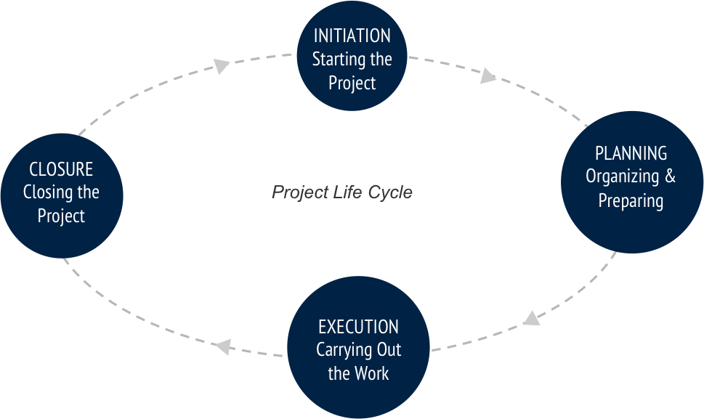
V)Environmental Impact Assessment(EIA): This involves a systematic process for identifying, predicting and evaluating potential impacts associated with a development project. The EIA process must proffer mitigation measures to avoid, reduce or minimize the negative impacts on the environment, public health and property and may highlight the foreseeable positive impacts.

