NAME: AGWU JUANITA OLUCHI
DEPARTMENT: PHARMACOLOGY
MATRIC NO: 18/MHS07/003
COURSE CODE: BCH 204
Assignment Title: Beta oxidation of fatty acids

Question
Describe the three stages of beta oxidation (show pathways where necessary)

Answer
Beta oxidation is a metabolic process involving multiple steps by which fatty acid molecules are broken down to produce energy. This stages include:

- DEHYDROGENATION: In the first step, acyl-CoA is oxidized by the enzyme acyl CoA dehydrogenase. A double bond is formed between the second and third carbons (C2 and C3) of the acyl-CoA chain entering the beta oxidation cycle; the end product of this reaction is trans-Δ2-enoyl-CoA (trans-delta 2-enoyl CoA). This step uses FAD and produces FADH2, which will enter the citric acid cycle and form ATP to be used as energy.
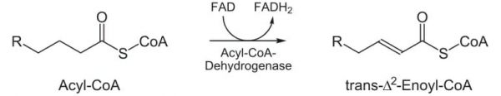

- HYDRATION: In the second step, the double bond between C2 and C3 of trans-Δ2-enoyl-CoA is hydrated, forming the end product L-β-hydroxyacyl CoA, which has a hydroxyl group (OH) in C2, in place of the double bond. This reaction is catalyzed by another enzyme: enoyl CoA hydratase. This step requires water.
In other words, Water is added to saturate the double bond and form
3-hydroxyacyl-CoA, catalyzed by enoyl-CoA hydratase.

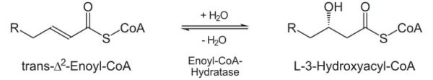

- OXIDATION: In the third step, the hydroxyl group in C2 of L-β-hydroxyacyl CoA is oxidized by NAD+ in a reaction that is catalyzed by 3-hydroxyacyl-CoA dehydrogenase. The end products are β-ketoacyl CoA and NADH + H. NADH will enter the citric acid cycle and produce ATP that will be used as energy.

