NAME: NWUDU OKECHUKWU JEREMIAH
MATRIC NO: 18/ENG04/055
DEPT: ELECTRICAL/ELECTRONICS ENGINEERING
COURSE CODE: ENG284
COURSE TITLE: ENGINEER IN SOCIETY

SCOPE OF WORK
Below are the important and summary of the required rehabilitation works in order of occurrence. The work shall include but not limited to the following;
- Plan & Design
- Acquire Subcontractor
- Design Package
- City Permit/Inspection
- Demolition
- Demolition Cleanup
- Prep for Construction
- Procurement of materials
- Mechanical
- Electrical
- Plumbing
- Paint
- Flooring
- Test and Commission
- Cleanup
- Turnover

GANTT CHART
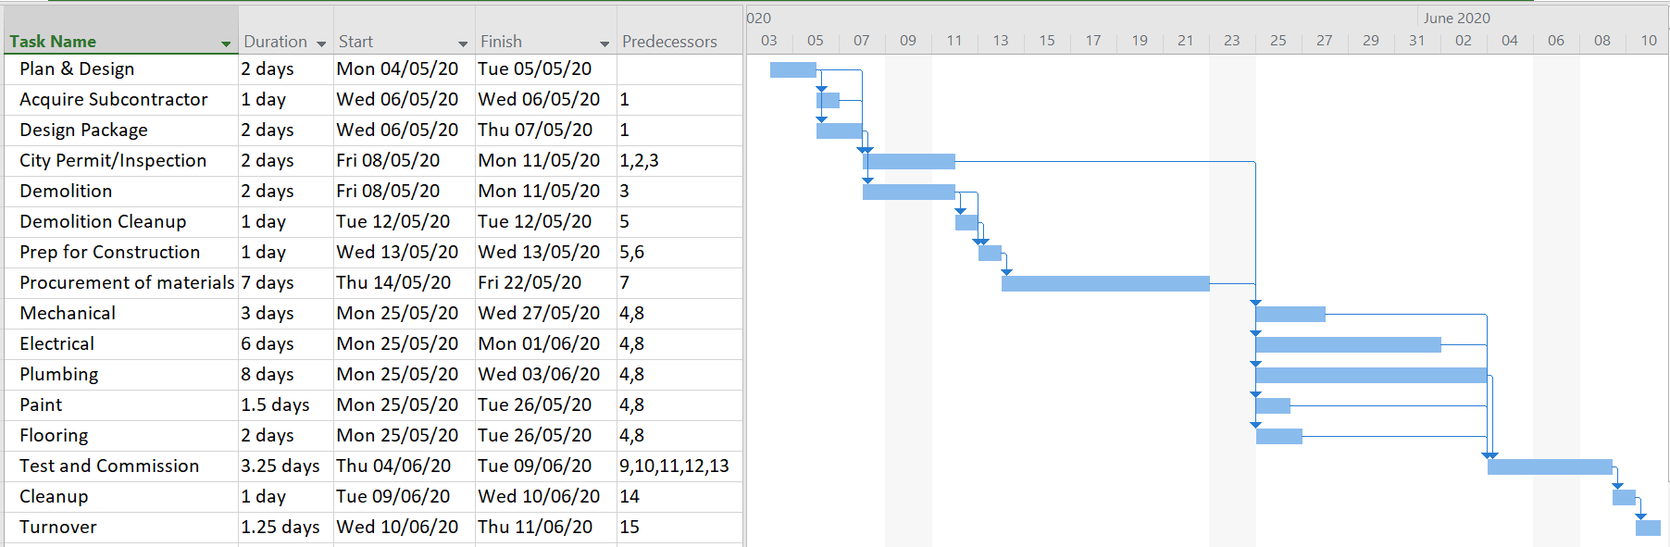

HUMAN RESOURCE PLAN

The Project team is made up of the project manager, Electrical engineer, Mechanical engineer, Plumber, painter, demolition team, building inspector and design team. The project manager is the controlling figure for the project i.e. lead consultant

SECURING THE SITE

The site was secured on the basis of associated activities that are proposed e.g. the size of the hall, number of persons to be accommodated and the existing development context of the site. The following were also considered before securing the site
(i) New multi-purpose halls should preferably not be allowed in predominantly residential areas.
(ii) The existing development context of the site should be compatible with the activity.
(iii) At the design stage of new multi-purpose halls, consideration to be given to the site lay-out, with a view to preventing noise disturbance. In particular, attention should be paid to the location of entrances, exits, windows, car parks and access roads.
(iv) The site should not be located within any Environmentally Sensitive Area (ESA) and its prescribed buffer zone such as wetland, steep slope and in areas that are likely to be affected by hazards such as inland flooding, landslide and storm surges, amongst others.
(v) On site wastewater disposal facility such as septic tanks and absorption pits/leaching fields shall be located not less than 30 m from any water course
(vi) Existing natural drains and watercourses on or in the vicinity of the site shall not be tampered with.

BILL OF ENGINEERING MEASUREMENTS AND EVALUATION

S/N | DESCRIPTION | COST
1 | Subcontractor | ₦ 1,700,000.00
2 | City Permit/Inspection | ₦ 200,000.00
3 | Procurement of materials | ₦ 2,600,000.00
4 | Mechanical | ₦ 1,000,000.00
5 | Electrical | ₦ 1,000,000.00
6 | Plumbing | ₦ 1,000,000.00
7 | Paint | ₦ 1,500,000.00
8 | Flooring | ₦ 1,400,000.00
9 | Test and Commission | ₦ 300,000.00
10 | Miscellaneous | ₦ 2,000,000.00
11 | Consultancy fee | ₦ 3,000,000.00
12 | Site Preparations and clearing after completion | ₦ 1,000,000.00
13 | Transport cost | ₦ 2,400,000.00
14 | Profit | ₦ 4,000,000.00
 | Project Budget | ₦20,000,000.00
PAYMENT SCHEDULE
 | PAYMENT SCHEDULE | AMOUNT
1 | Mobilisation | ₦ 6,000,000.00
2 | 50% completion | ₦ 6,000,000.00
3 | Completion and handover | ₦ 6,000,000.00
4 | Defect liability period | ₦ 2,000,000.00

BEME – Bill of Engineering Measurement and Evaluation (BEME) also referred to as 'Bill'; is a tool used before, during and post-construction to assess and value the cost of construction works. This includes the cost of materials, labor, equipment and all/any other resource(s) required for the success of any construction endeavor based on a pre-determined scope and specification

DEFECTS LIABILITY PERIOD – The defects liability period (or 'DLP') is a fixed period of time, starting from the date of practical completion, during which the contractor has an express contractual right to return to the site to rectify defects.

LEAD CONSULTANT – The lead consultant help clients make sound preparations for their upcoming projects and ensure that contractors complete the project on cost. They provide cost estimates, draw budgets, select contractors, administer construction contracts, and resolve differences between contractors and project owners

PROJECT LIFE CYCLE – The project management life cycle is usually broken down into four phases: initiation, planning, execution, and closure. These phases make up the path that takes a project from the beginning to the end.

ENVIRONMENTAL IMPACT ASSESMENT – Environmental Impact Assessment (EIA) is a process of evaluating the likely environmental impacts of a proposed project or development, taking into account inter-related socio-economic, cultural and human-health impacts, both beneficial and adverse

