12th Of April 2020

SCOPE OF WORK (SOP) OF RENOVATION OF ALF BEGORY HALL

Scope of work
• Site Inspection of the project
• Materials and Labour Required
• Presentation of the BOQ ( Bill of Quantity) to the office of the registrar in a sealed envelope bearing the address.

SCope of work after boq presentation
• Hiring of Materials / resources and site personnels
• Demolishing ( areas which are not needed on the initial plan)
• Erection of projections, Civil work, Iron works
• Electrical and Electronics works (i.e Wiring)
• Rendering (plastering) of work
• Re-roofing
• Final testing ( Electrical etc.), carpentry
• Commissioning

Sign:..............................

GANT CHART
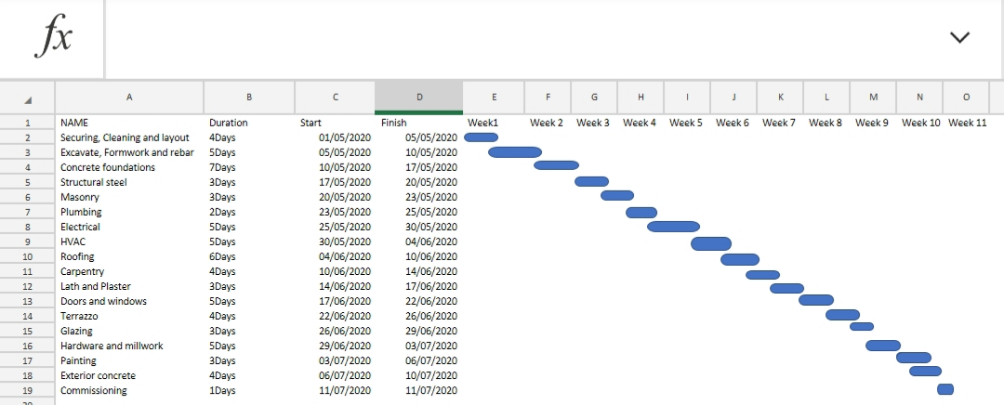

Human Resources Needed

- Role analysis.
- Role specification.
- Workforce planning
- Recruitment and selection of temporary and permanent staff as required..
- Training and development.
- Performance Management
- Compensation (remuneration).
- Legal issues.
- Managing employee payroll, benefits and compensation
- Communicating with employees.
- Resolving disputes.
- Evaluating performance.
- Managing employee relations.
- Ensuring equal opportunities.
- Making sure staff facilities are suitable and well-maintained.

WHY THE CONSTRUCTION SITE IS SECURED

- Theft of expensive equipment
- Risk of serious injury can result in compensation claims
- Protecting against vandalism and arson
- Preventing trespassers from entering the building site and climbing on equipment which puts not only the valuables but also the trespasses in danger

What is BEME: Bill of Engineering Measurement and Evaluation (BEME) also referred to as 'Bill'; is a toolused before, during and post-construction to assess and value the cost of construction works. Thisincludes the cost of materials, labor, equipment and all/any other resource(s) required for the success ofany construction endeavor based on a pre-determined scope and specification.
What is Defect liability period: A defects liability period is a period of time following practical completion during which a contractor remains liable under the building contract for dealing with any defects which become apparent. Depending on the form of contract you are reading, it may also be referred to as a rectification period or defects correction period.

Who is a Lead consultant : The lead consultant is the consultant that directs the work of the consultant team and is the main point of contact for communication between the client and the consultant team, except for on significant design issues where the lead designer may become the main point of contact.

WHAT IS PROJECT LIFE CYCLE: A project life cycle is the sequence of phases that a project goes through from its initiation to its closure.

WHAT IS ENVIRONMENTAL IMPACT ASSESSMENT (EIA):
Environmental Impact Assessment (EIA) is a process of evaluating the likely environmental impacts of a proposed project or development, taking into account inter-related socio-economic, cultural and human-health impacts, both beneficial and adverse.

