NAME: OGUN MARYANN OKANILEMEN

MATRIC NO: 18/ENG04/057

DEPARTMENT: ELECTRICAL ENGINEERING

COURSE: ENGINEER IN SOCIETY

DATE: MONDAY 13TH APRIL, 2020

As a designated student consulting engineer I am expected to do the following
- Outline the scope of work in detail in order of occurrence
SCOPE OF WORK.
In the scope of work it comprises of the electrical, mechanical and plumbing installations.
- Cut all electrical appliance and supply from the building
- Remove all chairs, tables e.t.c from the building
- Call a carpenter to remove the roof
- Remove all the titles from the building
- Removing faulty or broken pipes
- Removing all the toilets.
- Putting up a temporary fence around the site
- Removal of temporary sites offices after the completion of the building.
- Removal of temporary fence after the completion

- Prepare a Gant chart.
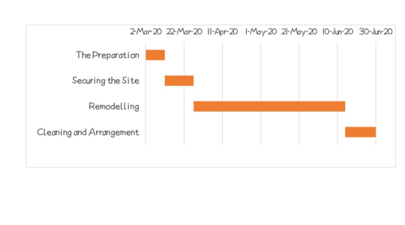

- List all the human resources needed and constitute the project team stating who the lead consultant is

HUMAN RESOURCES.
- An electrician
- A bricklayer
- A carpenter
- A painter
- A plumber
After constituting the project team the lead consultant is CRESCENT KONSULT (architects & development consultants).

- Explain why the site was secured.
The site was secured because it was an ongoing construction and to prevent unauthorized personals from entering the site and to prevent unwanted accidents.

- Develop a BEME for the project by lump sum projections including 10% of the total estimated cost (tech) as miscellaneous, 15% tech as consultancy fee, 5% tech for site preparations and clearing after completion, 12% of tech for transport cost, 20% tech as profit.

- Prepare a payment schedule as follows
- 30% tech for mobilization.
- Next 30% tech at 50% completion
- Final payment of 40% tech at completion and hand over. Retain 10% tech for a 6 months defect liability period.
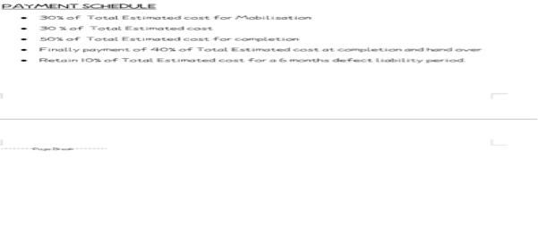
- What is BEME, defect liability period, lead consultant, project life cycle, environmental impact assessment (EIA)?

- BEME means Bill of Engineering Measurement and Evaluation. It is a tool used before, during and post construction to assess and value the cost of construction. This includes the cost of materials, labor, equipments and all other resources.

- DEFECT LIABILITY PERIOD is a period of time following practical completion during which a contractor remains liable under the building contact for dealing with any defects which became apparent. It is also referred to as a “rectification period or defects correction period”. It is usually a period around 6 or 12 months.

- LEAD CONSULTANT is the consultant that directs the work of the consultant team and is the main point of contact for communication between the client and the consultant team.

- PROJECT LIFE CYCLE it is the sequence of phases that a project goes through from its initiation to its closure.

- ENVIRONMENTAL IMPACT ASSESSMENT (EIA) it is a process of evaluating the likely environmental impacts of a proposed project or development, taking into account inter-related socio-economic, cultural and human-health impacts both beneficial and adverse.

