NAME: BASSEY JOY ANIETIE

DEPARTMENT: CHEMICAL ENGINEERING

MATRIC NO: 18/ENG01/004

COURSE: ENGINEERING IN THE SOCIETY

COURSE CODE: ENG 284

Scope of work for Alfa Belgore rehabilitation project.
The Alfa Belgore hall is a multipurpose hall located in Afe Babalola University, Ado-Ekiti. The hall was named after Former Chief Justice of Nigeria, Hon. Justice Alfa Belgore GCON (Retired). It was built to accommodate over 500 students.

Problem statement
The hall presently can accommodate up to 500 students but that isn’t enough for the large amount of students currently attending the prestigious university. The building hasn’t been damaged in any way and is still in good shape. It also has two toilets across each other; female and male.
The hall needs to be expanded due to the lack of space and the inability to accommodate the desired amount of students. Apart from the space, the hall in general needs to be renovated.

Required works
The farthest wall of the building needs to be taken down completely in order to extend the building and create more space. The land at that side of the building needs to be cleared and a foundation needs to be built on that particular place to match that of the building presently. Also, the building needs to be totally painted internally and externally and in addition, the metal protection doors need to be either repaired or replaced, if need be. The female and male toilets are not in the best shape due to the usage of the students and the writings and markings on the walls and the doors. So, new basins including water mixers and toilet seats need to be installed. The walls and doors also need to be painted and worked on. The floor and wall ceramic is either demolished or cracked and need to be replaced. Some of the lighting fixtures are missing in addition to electrical panels and switches which need to be compensated. Installation of more air-conditioning is required because of the extension of the hall.
Special gadgets may be required to get access to that part of the structure where the work is to be carried out. The access arrangements may be in the form of suspended platforms, scaffoldings, jacking arrangements, anchoring systems, etc.

Timely availability of the material, safe handling, adverse effect on the structure, surface preparation required availability of the equipment and financial implications. The process of rehabilitation has to be carried out in such a manner that the safety of the structure is not jeopardized. Therefore it is necessary to plan the operations properly and then carry out it accordingly. Due to ageing, structures may get damaged and unless effective steps are taken to renovate, safety may be affected. As such, it is necessary to plan well in advance and take necessary preventive steps.

The works shall include:
A - Demolishing, dismantling and Preparation Works
B - Concrete, Block and Plastering Works
C - Painting and Coating works
D - Doors, Windows and Metal Works
E - Plumbing and Sanitary Works
F - Electrical Works
G - Air-conditioning Works

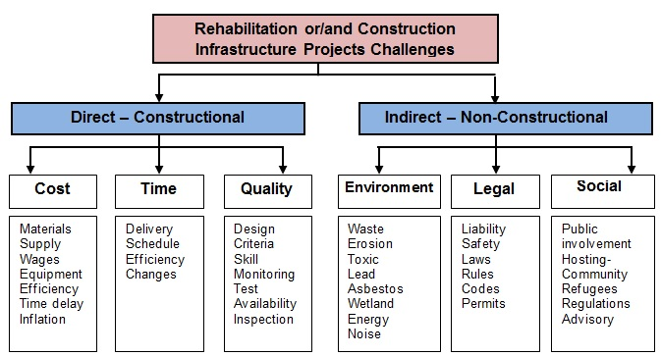
Objective
The project is going to be carried out with the aim of rectifying the problems that have been stated with the infrastructure above. That has to do with the organizational capacity building of the building. The administration will be deployed to handle the problems of the building.

Administration
The administration of this project will consist of:
Consultants
Architects
Interior designers
Mechanical Engineers
Electrical Engineer
Mason
Roofers
Civil engineers
Services engineer
Structural engineer
Specialist designers

Timeline and conclusion
The rehabilitation of this building is estimated to take about five to six months and then, would be back to its normal and regular function by the seventh month. The cost estimation should be up to ₦30 million to be able to successfully achieve the aims and objectives of this project.

Gantt chart

The lead consultant should be the architect as the renovation plans were drawn by him/her.

The site was secured to prevent:
-Injury to students from falling objects
-Accidents occurring between delivery vehicles to site and students
-Students from falling into excavation holes or piles of sand or gravel during renovation
-Dust that affects students
-Students from stepping on sharp objects
-Students from entering the renovated building when it is not safe

BEME (BILL OF ENGINEERING MEASUREMENT AND EVALUATION)

Total estimated cost (TEC) = Thirty million naira only (₦30,000,000)
Miscellaneous (10% of TEC) =
$\frac{10}{100} ×30,000,000$
= ₦3,000,000

Consultancy fee (15% of TEC) =
$\frac{15}{100}×30,000,000$
= ₦4,500,000

Site preparations and cleaning after completion (5% of TEC) =
$\frac{5}{100}×30,000,000$
=₦1,500,000

Transport cost (12% of TEC) =
$\frac{12}{100}×30,000,000$
= ₦3,600,000

Profit (20% of TEC) =
$\frac{20}{100}×30,000,000$
=₦6,000,000

Payment Schedule
Total estimation cost (TEC) = ₦30,000,000
Description Percentage Total amt to be paid % retained Amt retained Payment
Mobilization 30% ₦9,000,000 0% ₦- ₦9,000,000

At 50% completion 30% ₦9,000,000 0% ₦- ₦9,000,000

Final Payment 40% ₦12,000,000 10% ₦3,000,000 ₦9,000,000

After 6 months 10% ₦3,000,000 0% ₦- ₦3,000,000
(And no defects
found)
Total ₦30,000,000

What is BEME?
Bill of Engineering Measurement and Evaluation (BEME) also referred to as 'Bill'; is a tool used before, during and post-construction to assess and value the cost of construction works. This includes the cost of materials, labour, equipment and all/any other resource(s) required for the success of any construction endeavor based on a pre-determined scope and specification.

What is defect liability period?
The defects liability period (now called the 'rectification period' in Joint Contracts Tribunal (JCT) contracts) begins upon certification of practical completion and typically lasts six to twelve months. During this period, the client reports any defects that arise to the contract administrator who decides whether they are defects (i.e. works that are not in accordance with the contract), or whether they are in fact maintenance issues. If the contract administrator considers they are defects, then they may issue instructions to the contractor to make them good within a reasonable time.

What is a lead consultant?
The lead consultant is the consultant that directs the work of the consultant team and is the main point of contact for communication between the client and the consultant team, except for on significant design issues where the lead designer may become the main point of contact.

What is a project life cycle?
The Project Life Cycle refers to the four-step process that is followed by nearly all project managers when moving through stages of project completion. This is the standard project life cycle most people are familiar with. The Project Life Cycle provides a framework for managing any type of project within a business.

What is Environmental impact assessment?
Environmental impact assessment is the assessment of the environmental consequences of a plan, policy, program, or actual projects prior to the decision to move forward with the proposed action.

