NAME: UDOH, DANIEL G.
DEPARTMENT: MECHATRONICS ENGINEERING.
MATRIC NO: 18/ENG05/062.
COURSE: ENG 284 ENGINEER IN SOCIETY.

PROJECT TITLE: ALFA BELGORE REHABILITATION PROJECT.
Scope of Works:
The Administration of Afe Babalola University, Ado Ekiti, Ekiti State, Nigeria are interested in the rehabilitation, reconstruction and advancement of the Alfa Belgore Hall in the University and they have employed the best consulting firm in Africa which is the Westman Consulting Group to undergo this Project.

The Administration and the Consulting Firm (Westman Consulting Group) concluded the focus would be made on the existing Hall and that further investigation was required regarding the improvement of operations in the existing Hall. This investigation would entail rehabilitation of the Alfa Belgore infrastructure, improved Hall space, and improved road access to the Belgore hall, as a short to medium term alternative, while demand in the Hall’s need for an Increase in space(area) and ventilation.

Westman Consulting Group has signed an agreement with the School Management for the rehabilitation of the Hall and Westman Consulting Group (WCG) has agreed with the Management to implement early construction and procurement activities as a means to expedite completion of the overall project.
This agreement will be an effective instrument to facilitate a flexible funding mechanism that will reduce significantly implementation costs and time for construction and related services in support of the Project. Key aspects of this Cooperative Agreement will be initial site investigations and a simplified project design process, followed by the cost efficient delivery of a varied array of activities to be implemented at the request of WCG. The overall management will be
provided by a core management team with project specific resources

allocated to the activities defined in the Scope of Construction activities of this Cooperative Agreement within the agreement time frame.

The Consultancy Firm(WCG) has prepared a Drawing & Specifications(D&S) which would be specific on the following points;
- Health and Safety as per WCG requirements and international standards;

- Respect of environmental standards;

- The contractor has to haul out the demolition products and dispose of it in accordance with local regulations.

- There shall be no sale of salvaged material within the Port’s property limits.

Description of Services

Westman Consulting Group(WCG) will perform the work set out in this Schedule of Requirement(SOR). We will also assume the site supervision during the built. Accordingly, the Consultant may not be associated in any way, including an overlap of principal subcontractors as determined by WCG, with any entity or team that submits an offer/proposal on the execution of the work. By making a submitting an offer/proposal, we will agree to this separation.

Tasks to be performed or arranged by Westman Consulting Group(WCG) include but are not limited to:

- Provide a complete review and assessment of the required elements based on the recent studies;

- Execute a detailed topographical survey, compile the data, update the existing topographical plan and calculate the offset from the topographical survey;

- Review of relevant available information to characterize the anticipated subsurface conditions;

- Provide detailed Drawings & Specifications;

- Provide a Bill of Engineering Measurement and Evaluation(BEME).

- We are to generate a detailed project schedule in conjunction with the Management that will be incorporated into the SOR. The schedule will include key milestones for the complete project delivery;

- Coordination and the cooperation of the Consultant with the
School Management will be paramount for the implementation
of this project.

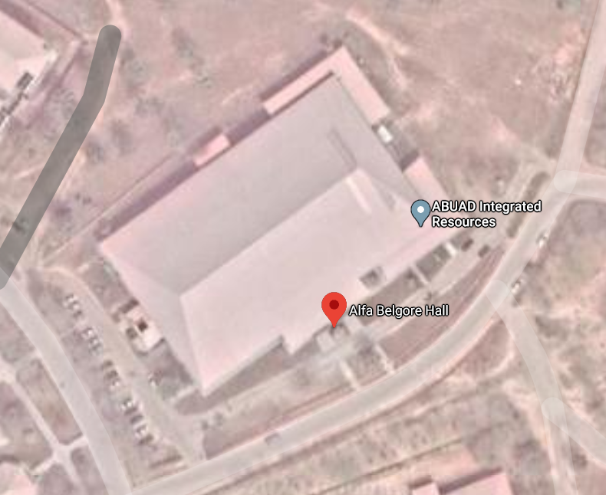
Aerial View of the Alfa Belgore Hall

Required works:
The required works that need to be done is mainly the concrete repair works as some parts of the building slabs and beams have been directly targeted and need to be restored. Some of the building walls have been either destroyed or heavily cracked which triggers a demolition and re-building works associated with plastering and painting works.

The building needs to be totally painted internally and externally and its wooden doors and windows in addition to the metal protection doors need to be either repaired or replaced. The female and male toilets are in very bad shape due to the theft acts that targeted the

water mixers and water boilers so, new basins, including water mixers, and toilet seats need to be installed in addition to the water network of the building that needs to be taken care of by replacement of the existing punctured water lines and water tanks. The floor and wall ceramic is either demolished or cracked and need to be replaced.

Most of the lighting fixtures are missing in addition to electrical panels and switches which need to be compensated. Installation of new air-conditioning is required to replace the stolen and damaged ones.

Below are the important and summary of the required rehabilitation works;

(I) Demolishing, dismantling and Preparation Works.
(II) Concrete, Block and Plastering Works.
(III) Painting and Coating works.
(IV) Doors, Windows and Metal Works.
(V) Plumbing and Sanitary Works.
(VI) Electrical Works.
(VII) Air Conditioning Works.

Schedule:
 | Project allocation to WCG. | March 27, 2020.
1. | Project Start | April 1-7
2. | On site Visit and Document Review | April 8-22
3. | Submission of Draft D&S (50%) | April 23-29.
4. | Submission of Draft D&S (90%) | April 30 - May 7
5. | Submission of D&S Final | May 8-16

GANTT CHART FOR THE REHABILITATION PROJECT.
Works | April 1-7 | 8-22 | 23-29 | 30- May 7 | 8-16
Project Start.
On site Visit and Document Review.
Submission of Draft D&S(50%).
Submission of Draft D&S(90%).
Submission of D&S Final.

The lead consultants for this Project would be Engr. Prof. Wara Samuel, Engr. Victor Babafemi and Engr. Oyebode Oluwadara who are the Founder, CEO, and President of Westman Consulting Group(WCG) and the Human Resources provided by our agency that are involved and the professionals that constitute the Project team are;

- Structural Engineers: They design, assess and inspect structures to ensure that that are efficient and stable.

- Building Services Engineer: They plan, design, monitor and inspect systems to make buildings comfortable, functional, efficient and safe.

(III) Consultant team: They provide tasks such as;
- Providing advice on setting up and defining the project.
- Developing and coordinating the design.
- Preparing production Information and Tender Documentation.
- Inspecting the work of contractors.
- The members of the consultant team are:
- Architect
- Cost Consultant
- Services Engineer
- They provide Contract Administration.

(IV) Sub-Contractors(Labourers)

(V) Civil Engineer: Perform engineering duties in planning, designing,
and overseeing construction and maintenance of building
structures and facilities. Under the civil Engineer we have;
- Water Engineer.
- Transport Engineer.
- Sanitary engineer.
- Geotechnical Engineer.

(VI) Electrical Engineer: They design, develop, and test electrical devices and equipment and deal with the complete wiring of the building.

- The Site was secured because it helps prevent vandalism along with the theft of tools, copper, building materials and machines. Construction site theft costs the industry perhaps billions of dollars each year that is why we can protect the site by the use of intruder detection, lighting, CCTV, Fences, gates, barriers and bollards.

Bill of Engineering Measurement and Evaluation(BEME); Case Study of Alfa Belgore Rehabilitation.
Total Estimated Cost(TEC) = ₦200,000,000

Item | Item Description | Quantity m³ | Rate ₦ | Amount ₦
1. | Site preparation and Clearing.(5%) |  |  | 10,000,000
2. | Consultancy fee(15%) |  |  | 30,000,000
3. | Transportation(12%) |  |  | 24,000,000
4. | Provision of Roofing sheets and Roofing Equipment. | 1000 | 15,000 | 20,000,000
5. | Provision of Blocks and Paving stones(Damp-proofing and Grouting Inclusive) | 1000 | 25,000 | 20,000,000
6. | Provision of Cranes, Trucks and Construction machines. |  |  | 36,000,000
7. | Profit (20%) |  |  | 40,000,000
8. | Miscellaneous(10%) |  |  | 10,000,000
 | Sum of Works(Item 1-8) |  |  | 190,000,000
 | Provide 5% VAT |  |  | 10,000,000
 | T0TAL |  |  | 200,000,000

Payment Schedule for the Alfa Belgore Rehabilitation Project.
 | Estimated Completion Date. | Construction Breakdown. | Draw(%TEC)
1. | 6th April. | Mobilisation. | 30%
2. | 28th April. | 50% Completion | 30%
3. | 15th May. | Completion | 40%
4. | 15th November. | Deficit liability Period. | 10%

- Bill of Engineering Measurement and Evaluation(BEME): is a tool used before, during and post-construction to assess and value the cost of construction works.

- Deficit Liability Period: is a period of time following practical completion during which a contractor remains liable under the building contract for dealing with any defects which become apparent.

- Lead Consultant: is the consultant that directs the work of the consultant team and is the main point of contact for communication between the client and the consultant team.

- Project Life Cycle: is the sequence of phases that a project goes through from its initiation to its closure.

- Environmental Impact Assessment(EIA): is the assessment of the environmental consequences of a plan, policy, program, or actual projects prior to the decision to move forward with the proposed action.

THANK YOU, ENJOY!

