OKENABIRHIE OGHENEMERU NITA
18/ENG08/015
BIOMEDICAL ENGINEERING
ENG 284

- The scope of work are presented below
-OverView of the Project ;The main objective is the rehabilitation of the alpha belgore hall
-Scope of Project ; this contains the technical specifications and the budget allocation for the completion of the project
-Project deliverables; the objective is to ensure the rehabilitation of the alpha belgore hall from top to bottom beginning with the roof top. The top needs to be reformed due to its current state of appearance. The walls are to be reformed due to its states of appearance has brought discomfort to the school.
-Schedule of the project ; the project is to last for a minimum of 8months but taking other problems that might come it should last for about a year or so.
-Management of the project ; the project administrators are to make sure the projects are carried out effectively and ensure the payments of the workers when due.
A-Demolishing, dismantling and preparation works
B-Concrete, Block and plastering works
C-Painting and Coating works
D-Doors ,windows and Metal works
E- Plumbing and Sanitory works
F-Electrical Works
G- Air-conditioning works

2 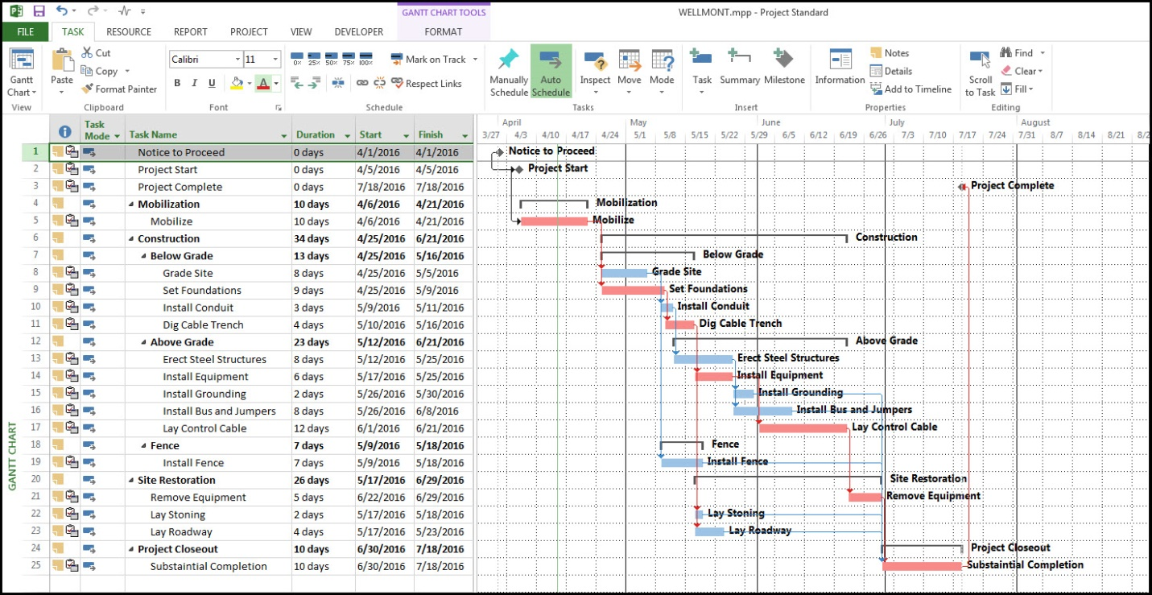

3 HUMAN RESOURCES
Must have up to 3years Experience with electrical works
Must have Minimum 4years experience in refurbishing
Must have up to 3years experience with plumbing
PROJECT TEAM,
1. Client
2. Consultant
3. Architects (Engineer)
4. Contractor
5. Sub-contractor
The client is the Lead consultant .

4. the site was secured to prevent people from coming close to the construction site so as to avoid dangers from occurring and to give room for the workers to do their job.
5
The projections | Cost
At 10% | 5 million naira
At 15% | 11 million naira
At 5% | 1 million naira
At 12% | 15 million naira
At 20% | 22 million naira

6
Mobilization | 20 million naira
Completion | 15 million naira
Completion and hand over | 10 million naira
Defect liability period | 22 million naira

7. BEME is a reported in a systematic, transparent and scholarly manner with the aim of being user friendly, enabling the practitioner to judge and employ evidence according to their individual criteria and context.The BEME stands for the Bill of Engineering Measurement and Evaluation.

Defect liability period is a period of time following practical completion during which a contractor remains reliable under the building contract for dealing with any defects which become apparent.

Lead consultant is the consultant that directs the work of the consultant team and is the main point of contract for communication between client and the consultant team. The le ad consultant is in charge of preparing progress reports, helps in seeking instructions from the client, arranges value management exercises

Project life cycle is the sequence of phases that a project goes through from its initiation to its closure.The number and sequence of the cycle are determined by the management and various other factor like needs of the organisation involved in the project, the nature of the project, and its area of applications. The phases have a definite start,end and control point and are constrained by time. The project life cycle can be defined and modified as per the needs and aspects of the organisation.

Environmental impact assessment is the assessment of the environmental consequences of a plan, policy, program, or actual projects prior to the decision to move forward with the proposed action.

