NAME:ADEGOKE-ALAGBE SAMUEL CHARLES
MAT NO: 18/ENG/03/006
DEPT:CIVIL ENGINEERING

ALFA BELGORE REHABILITATION PROJECT
Scope of work
- Demolishing, Dismanting and preparing
- Concrete works
- Block works
- Waterproofing system provision
- Plastering works
- Painting works
- Tiling and marble works
- Doors, Windows, Metal Works, and Suspending ceiling
- Air conditioner works
- Electrical Works

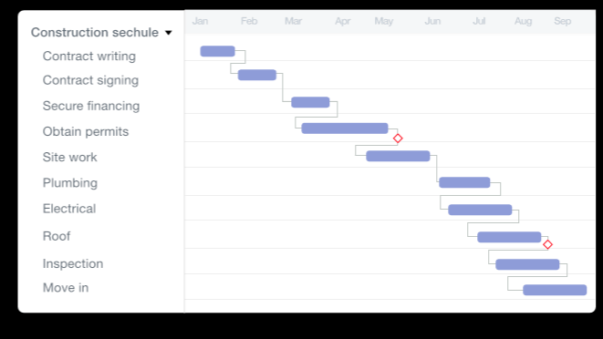

3. HUMAN RESOURCES NEEDED:
- Role analysis
- Role specification
- Workforce planning
- Recruitment and selection of temporary and permanent staff as required
- Training and development
- Performance management
- Compensation(remuneration)
- Legal issues
- Managing employee payroll, benefits and compensation.
- Communicating with employees
- Resolving disputes
- Evaluating performances
- Managing employee relations
- Ensuring equal opportunities
- Making sure staff facilities are suitable and well-maintained
PROJECT TEAM
- Surveyor
- The Architect
- The Engineers
- The Quantity surveyor
- The Builder
- THE PROJECT MANAGER IS THE LEAD CONSULTANT
The members of the consultant team that are likely to be required on most project are:
- Architect
- Cost consultant
- Services engineer
- Structural engineer
The client may wish to allocate the roles of lead designer and lead consultant to one or more appropriate to appoint a design co-ordinator for the co-ordination and integration of design prepared by specialist contractor, and an information manager for building information modeling.
During the early stage of the project, the client might appoint INDEPENDENT CLIENT ADVISER to give them independent professional acvice. They might also appoint a PROJECT MANAGER to represent the client and take responsibility for the day to day management of the project
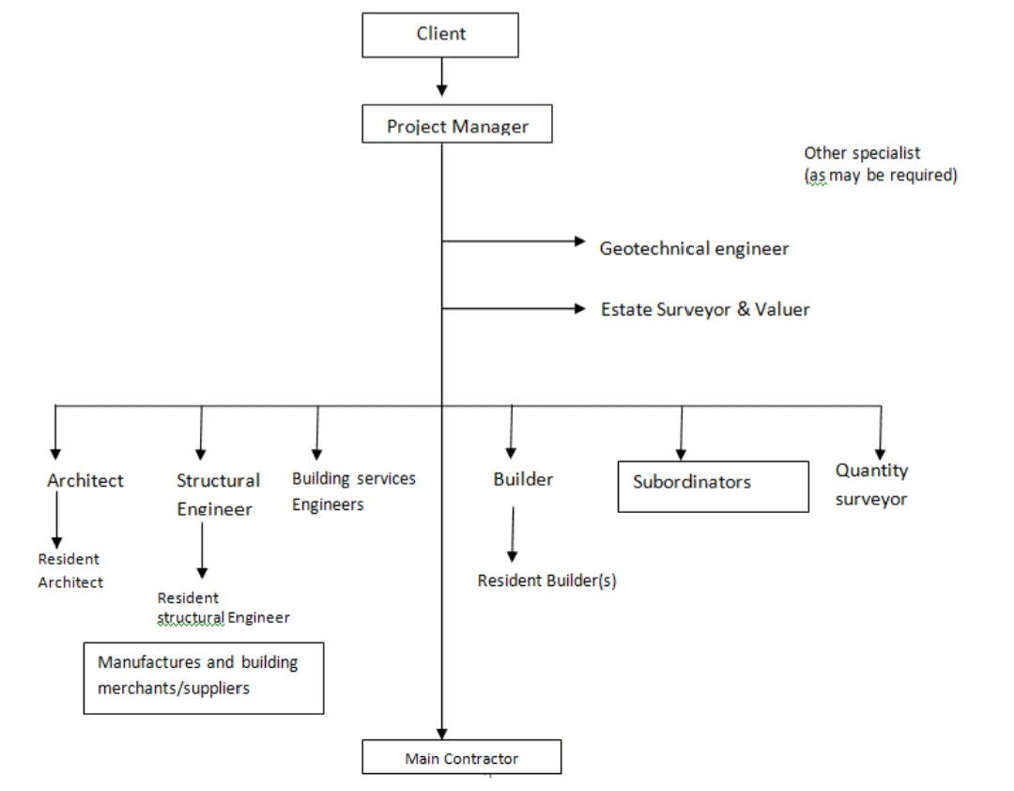

4
WHY THE SITE WAS SECURED
- security for a temporary construction site is necessary due to vandalism and theft. Alfa Belgore site rehabilitation security and supervision are essential, especially in last phase of the construction project when expensive materials and equipment are present on the construction site.
After all, theft or vandalism of the construction site not only result in a lot of extra cost, they also causes delays, which means that the project is delivered later than anticipated. These are all consequences that could have been prevented with the help of appropriate construction site security
- To prevent accident on the part of student or loitering the construction site.

BILL OF ENGINEERING MEASUREMENT AND EVALUATION

ITEM N0 | DESCRIPT | QTY | UNIT COST | TOTAL COST
1 | Roofing sheet | 100 | N 1,400.00 | N 140,000.00
2 | Cement bags | 500 | N 180,000.00 | N 90,000,000.00
3 | Truck of gravel | 12 | N 35,000.00 | N 420,000.00
4 | Trucks of sands | 13 | N 45,000.000 | N 585,000.00
5 | Glass which will be brought as 12x12 | 10 | N 50.000.00 | N 500,000.00
6 | light bulbs fittings | 40 | N 8,000.00 | N320,000.00
7 | Copper wires | 60 | N2,500.00 | N100,000.00
8 | projector | 3 | N150,000.00 | N450,000.00
9 | t.v | 4 | N100,000.00 | N400,000.00
10 | Pipes of different sizes | 46 | N80,000.00 | N 3,680,000.00
11 | Light bulbs | 13 | N450,000.00 | N5,550,000.00
12 | window | 12 | N25,000.00 | N300,000.00
13 | Cctv cameras | 5 | N100,000.00 | N500,000.00
14 | Light bulb | 4 | N50,000.00 | N200,000.00
15 | Total estimated cost |  |  | N 103,145,000
16 | Miscellaneous(10%) |  |  | 10314500
17 | Consultancy(15%) |  |  | N 15471750
18 | site preparation(5%) |  |  | N 5157250
19 | Transportation (12%) |  |  | N 12377400
20 | Profit(20%) |  |  | N 20629000

PAYMENT SCHEDULE
- 30% of Total Estimated cost for mobilization
- 30% of Total Estimated cost
- 50% of Total Estimated cost of completion
- Finally payment of 40% of Total Estimated cost at completion and hand over
- Retain 10% of Total Estimated cost for a 6months defect liability period

BEME: stand for Bill of Engineering measurement and Evaluation.also referred to as ‘Bill’; is a tool used before, during and post-construction to asses and value the cost of construction works

DEFECT LIABILITY PERIOD:
A defects liability period is a period of time following practical completion during which a contractor remains liable under the building contract for dealing with any defects which become apparent. Depending on the form of contract you are reading, it may also be referred to as a rectification period or defects correction period.

A defects liability period is usually a period of around six or 12 months but it can vary depending on the contract used. Any defects or faults which arise during this period (for example - due to defective materials or workmanship) must be put right by the contractor at its own expense.

LEAD CONSULTANT:
Agreements.
The lead consultant is the consultant that directs the work of the consultant team and is the main point of contact for communication between the client and the consultant team, except for on significant design issues where the lead designer may become the main point of contact.

The lead consultant's role might include:

Co-ordinating, monitoring and reviewing the work of the consultant team (and others, such as specialist designers and specialist contractors).
Arranging consultant team meetings and planning work stages.
Preparing programmes and progress reports.
Seeking instructions from the client.
Advising the client on the choice of procurement route.
Advising the client on the need to appoint additional advisers, consultants or specialist designers.
Establishing change control procedures at key stages, for example when the project brief is frozen or when detailed design is frozen.
Arranging value management exercises.
Advising the client on the choice of contract and contract conditions.
Assist the client in defining selection criteria for contractors and preparing pre-qualification questionnaires.
Co-ordinating the review of tenders.

PROJECT LIFE CYCLE:
A project life cycle is the sequence of phases that a project goes through from its initiation to its closure. The number and sequence of the cycle are determined by the management and various other factors like needs of the organization involved in the project, the nature of the project, and its area of application. The phases have a definite start, end, and control point and are constrained by time. The project lifecycle can be defined and modified as per the needs and aspects of the organization. Even though every project has a definite start and end, the particular objectives, deliverables, and activities vary widely. The lifecycle provides the basic foundation of the actions that has to be performed in the project, irrespective of the specific work involved.

Project life cycles can range from predictive or plan-driven approaches to adaptive or change-driven approaches. In a predictive life cycle, the specifics are defined at the start of the project, and any alterations to scope are carefully addressed. In an adaptive life cycle, the product is developed over multiple iterations, and detailed scope is defined for iteration only as the iteration begins.

Characteristics of the Project Life Cycle
Although projects are unique and highly unpredictable, their standard framework consists of same generic lifecycle structure, consisting of following phases:

The Initiation Phase: Starting of the project

The Planning Phase: Organizing and Preparing

The Execution Phase: Carrying out the project

The Termination Phase: Closing the project

ENVIRONMENTAL IMPACT ASSESSMENT?
What is Impact Assessment?
Impact assessments are carried out to assess the consequences of individual projects -- Environmental Impact Assessment -- or of policies and programmes -- Strategic Environmental Assessment.
Environmental Impact Assessment
Environmental Impact Assessment (EIA) is a process of evaluating the likely environmental impacts of a proposed project or development, taking into account inter-related socio-economic, cultural and human-health impacts, both beneficial and adverse.

