NAME: OJO TEMITAYO ADEPEJU
DEPT: MECHATRONICS
MAT NO:18/ENG05/044
COURSE:ENG 284
THE ALFA BELGORE REHABILITATION PROJECT

- SCOPE OF THE PROJECT
- The school management first holds a meeting with relevant school board members during which they discuss reasons why a renovation is necessary, and make plans with regards to alternative venues that can be used during the renovation period.
- During the meeting, other decisions are deliberated upon; such as which renovations company is to be enlisted for the project actualization.
- The management reaches an agreement with the team sent in to discuss the details of the project, its duration, payment plans and workforce mobilization plans.
- The team drafts a “preliminary list to show the project specifications and a simple breakdown of the project requirements
- A team of professionals is then brought to the site to do a brief survey and determine how many hands would be required to meet project milestones and delivery deadline. This team will include the lead consultant, the site foreman, the team leaders of each group of work specialization, and the leader of the laborers.
- The structure is cleared out, as equipment and other things are removed from the building and carried to previously agreed alternative venues.
- The perimeter of the structure is cordoned off using aluminium sheets and bamboo sticks. This is done to restrict and regulate movement in and out of the site.
- The roofing sheets are first removed. Reusable sheets are picked out, whilst the remaining are discarded.
- The civil engineers and laborers commence the additional construction work required, in conjunction with the electrical engineers (to specify areas where additional electrical wiring spaces are required) and the plumbers/water and waste water engineering team (for plumbing and pipe layout space specifications.
- On completion of the added floor(s), the roofing team arranges the sheets and nail them in place.
- The plumbers and electricians proceed to fix in all toilets and plumbing equipment and all wiring and lighting appliances respectively.
- The painters and tilers come in to work together and simultaneously do their jobs in sections (painting before tiling).
- The debris around the site is cleared and properly disposed.
- The completed project is cleaned to remove dust and other dirt particles.
- The moving team places all initially removed equipment in their new positions, and installs the new additional appliances in their appropriate locations.
- The site area is unsealed and the last of the obstructions cleared away.

PROJECT GANTT CHART
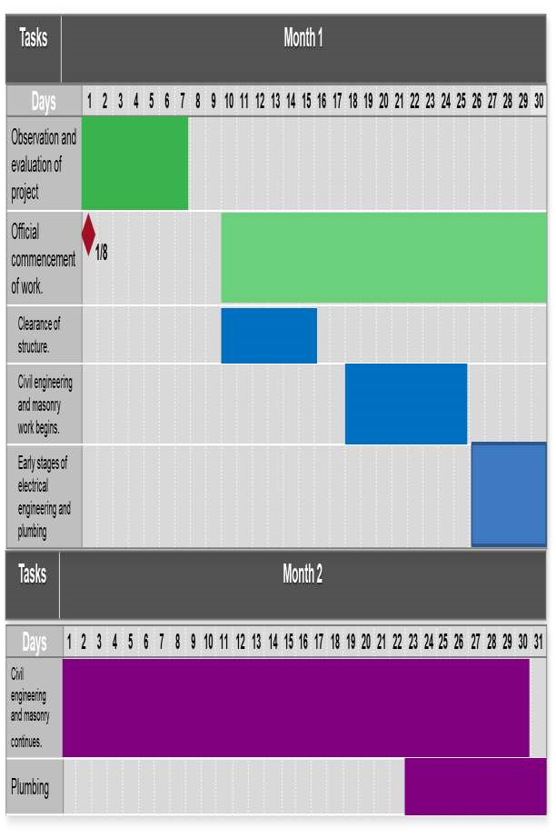
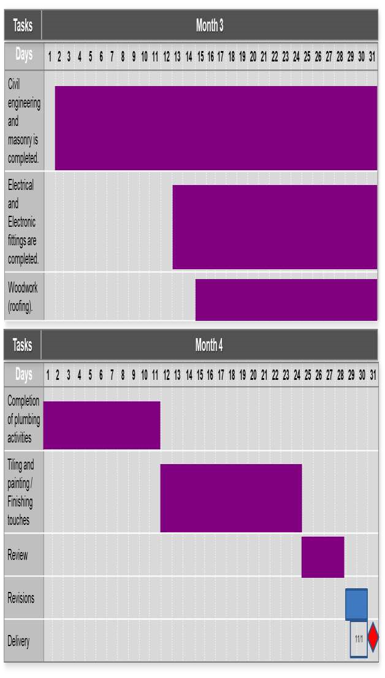
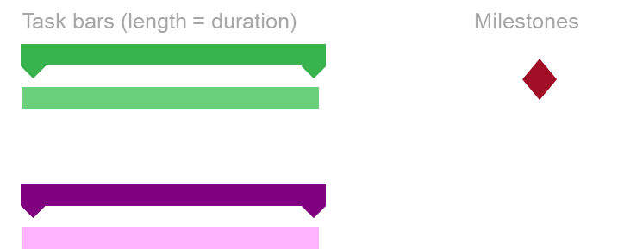

- HUMAN RESOURCES NEEDED FOR THE PROJECT.
- Engineering Consultants
- Civil engineers
- Mechanical engineers
- Electrical engineers
- Water and waste water engineers
- Technicians
- Artisans (Carpenters)
- Laborers (Masons and Plumbers)
PROJECT TEAM AND THEIR DESIGNATIONS.
- Engineering consultants : The team constitutes of three (3) consultants; an Engineering Professor (Lead consultant), and two Engineering Doctors.
- Mechanical engineers : Two (2) mechanical engineering doctors serve as project sub-managers.
- Civil engineers : There are four (4) civil engineers enlisted for the project implementation.
- Electrical engineers : On this project, there are five (5) electrical and electronics engineers.
- Water and Waste Water engineers : These two (2) engineers have the duty of monitoring the creation and implementation of an effective water system and waste water disposal system for the structure by the plumbers and their apprentices.
- Artisans : The twenty artisans to work on the roofing aspect of the project are monitored and supervised by the project foreman (one of the supervising mechanical engineers), ensuring safety precautions are observed and effective delivery of quality service.
- Laborers : Forty laborers and ten plumbers are enlisted for the project, and are expected to do the majority of the heavy lifting in the course of the project completion.

- The site had to be fenced primarily for safety reasons. As the renovation is being done on a building located in an area that is primarily populated by students and lecturers, the fencing helps keep them from wandering into the site. The fence also prevents accidents that could occur due to debris and harmful things that could “fly off” during construction.
Also fencing helps safeguard the tools on the site, and any workers who have to continue working even at odd hours.

- Bill of Engineering Measurement and Evaluation (BEME) for the Rehabilitation and Expansion of Alfa Belgore Hall.
S/N | Tasks | Sub-tasks | Percentage  TEC | Amount(NGN)
1. | Consultancy fee | Chief consultant | 15% | 15,000,000
 |  | Other consultants
2. | Site preparation and clearing  after construction. | Interlocking | 5% | 5,000,000
 |  | Fencing
 |  | Felling of trees and removal of obstacles
 |  | Sweeping and cleaning
3. | Transport costs. | Movement of tools. | 12% | 12,000,000
 |  | Movement of workers.
4. | Profit |  | 20% | 20,000,000
5. | Miscellaneous | Small payments | 10% | 10,000,000
 |  | Workers’ feeding
 |  | Accommodation
6. | Other expenses | Testing and inspection. | 38% | 38,000,000
 |  | Workers’ wages
 |  | Insurance
 |  |  | Total | 100,000,000

- Payment Schedule for the Project.
S/N | Work Description | Percentage TEC required | Time Payment is Due | Amount (NGN)
1. | Mobilization : Down-payment  of wages, importation of some materials and machinery, procurement of accommodation. | 30% | On commencement of project. | 30,000,000
2. | Second payment : Procurement of materials, payment of worker, miscellaneous costs and other expenses. | 30% | After 50% completion of project. | 30,000,000

3. | Final payment : Completion of wages, profits, consultancy fees. | 40% | Completion and  Handover | 40,000,000

Note : 10% Total Estimated Cost (TEC) is to be retained for a 6-months defect liability period.

- Definition of Terms.
BEME : Bill of Engineering Measurement and Evaluation
(BEME) also referred to as 'Bill'; is a tool used before, during and post-construction to assess and value the cost of construction works. It also details the terms and conditions of the construction or repair contract, and itemizes all the work to enable a contractor to price the work for which he or she is bidding. The quantities may be measured in number, area, volume, weight or time. Preparing a BEME requires that design has been completed so that specifications can be drawn up.
Defect Liability Period : A defects liability period is a period of time following practical completion during which a contractor remains liable under the building contract for dealing with any defects which become apparent. It is a period of time, usually starting from the date of practical completion, during which the contractor has an express contractual right to return to the site to rectify defects.
Lead Consultant : Lead consultants have hands-on roles which involve the day-to-day running of continuing client projects. They function as the link between the client, and the other workers. They are team leaders, analyzing and reviewing proposals from the team, providing appropriate solutions to problems, and making decisions on the way forward by acting as liaisons between the client and the consultancy team. Their work involves directly dealing with the client to clearly understand its needs, and to provide possible solutions for the client’s consideration.
Project Life Cycle : A project life cycle is the sequence of phases that a project goes through from its initiation to its closure. The number and sequence of the cycle are determined by the management and various other factors like needs of the organization involved in the project, the nature of the project, and its area of application. The phases have a definite start, end, and control point and are constrained by time. The project lifecycle can be defined and modified as per the needs and aspects of the organization.
Environmental Impact Assessment [EIA] : Environmental Impact Assessment is defined as an activity designed to identify the impact on the bio-geophysical environment, on man and well-being, of legislative proposals, projects, policies and operational procedures and to interpret and communicate information.
EIA is basically a systematic process of identifying the future consequences of a current or proposed action.
PAGE

