NAME: FATIMA AUDI
MATRIC NO: 18/ENG08/004
DEPT: BIOMEDICAL ENGINEERING
COURSE CODE: ENG 284
COURSE TITLE: ENGINEERS IN SOCIETY
ASSIGNMENT TOPIC: ENGINEERING CONSULTANCY

SCOPE OF WORK:
To renovate the Alfa Belgore hall, in the sense that, the hall will be expanded. The order of work is as follows:
- INSPECTION: Pre-inspection of the building will take place, in order to pin-point the problems and also have a grasp on how to go about the expansion.
- DESIGN: After the inspection, the any additional design needed will be deliberated on and planned in order to fit into the expansion plan.
- SECURITY: The site will be secured using temporary barricade, so that passersby will not sustain injury from falling rubble.
- CLEARANCE: The hall will be cleared of every furniture, appliance, fixtures (which includes the roof, some beams and pillars, rubble from breaking the wall), people etc.
- INSPECTION: Further inspection will be carried out to ensure that everything that was supposed to be cleared was cleared.
- STRUCTURAL REPAIR: The renovation starts.
- RE-ROOFING: After repairs and expansion, the hall is re-roofed.
- FIXTURES: Fixtures that might have been damaged or consciously removed will be fixed.
- PAINTING: The hall is painted.
- FINAL INSPECTIONS: The building is inspected again, to make sure that everything that needed to be done was done.
PROJECT GAANT CHART:

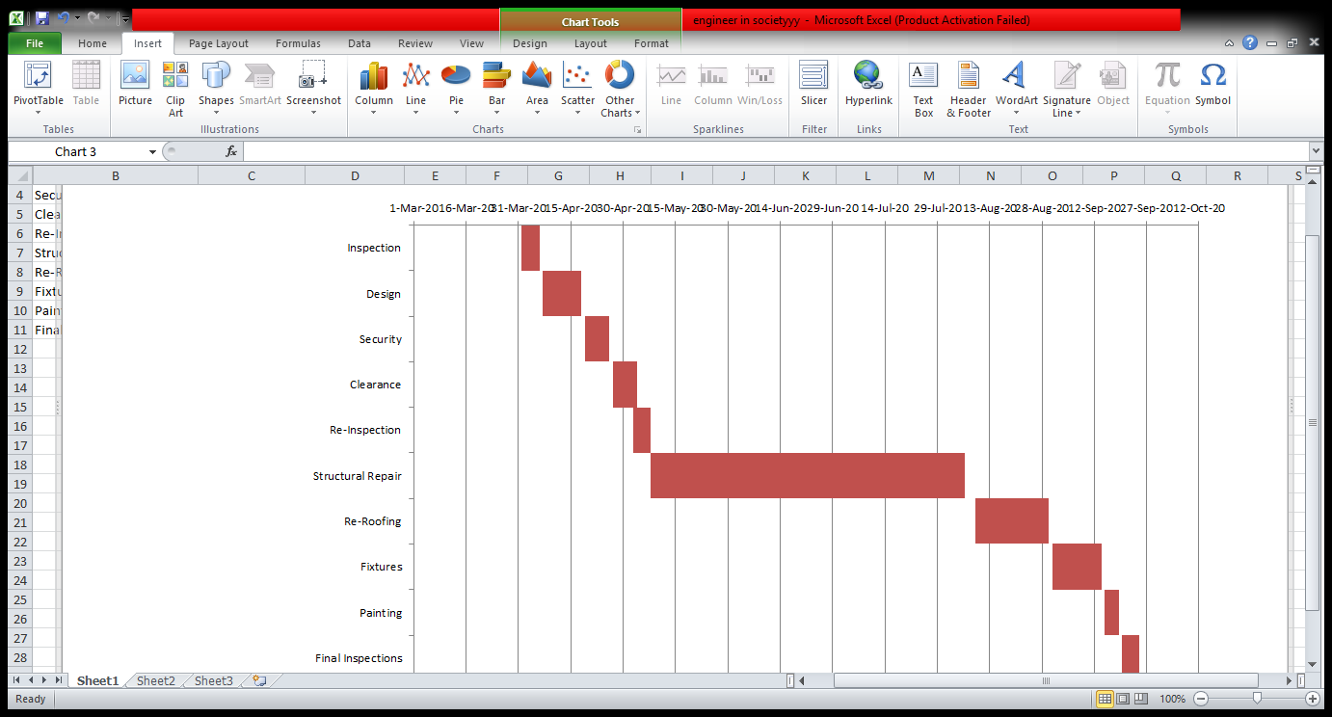
HUMAN RESOURCES NEEDED:
- Owner
- Architect ( lead Consultant)
- Engineer: Civil, Elect/Elect
- Contractors
- Code Official
- Consultant
- Designer
SECURING THE SITE: The site being secured was necessary in order to minimize injury and prevent unnecessary accidents upon both workers and passersby.
BEME FOR THE PROJECT:
S/N | DESCRIPTION | UNIT PRICE (N) | COST ( N)
1 | Miscellaneous | 10% of total | 500,000
2 | Consultancy Fee | 15% of total | 750,000
3 | Site Preparation and Clearing | 5% of total | 250,000
4 | Transport Fee | 12% of total | 600,000
5 | Profit | 20% of total | 1,000,000
6 | Surplus | 38% of total | 1,900,000
7 | Total |  | 5,000,000

PAYMENT SCHEDULE:
Total Contract Amount: N5,000,000
S/N | DESCRIPTION | SCHEDULE DATE | PAYMENT CLAIMED (N) | PAYMENT MADE(N) | PAYMENT DATE
1 | Mobilization | 27-Apr-20 | 1,500,000 | 1,500,000 | 30-Apr-20
2 | 50% Completion | 3-Aug-20 | 1,500,000 | 1,500,000 | 3-Aug-20
3 | Completion and Handover | 25-Sep-20 | 1,500,000 | 1,500,000 | 27-Sep-20
4 | Defect Liability Period | 25-Mar-20 | 500,000 | 500,000 | 25-Mar-20

BEME (Bill of Quantities):
A BEME review is a description and evaluation of evidence pertinent to a clearly formulated topic/question that uses explicit scientific methodologies and methods to systematically identify, assemble, critically analyze and synthesize information relevant to the review topic.
DEFECT LIABILITY PERIOD:
A defects liability period is a period of time following practical completion during which a contractor remains liable under the building contract for dealing with any defects which become apparent. Depending on the form of contract you are reading, it may also be referred to as a rectification period or defects correction period. A defects liability period is usually a period of around six or 12 months but it can vary depending on the contract used. Any defects or faults which arise during this period (for example - due to defective materials or workmanship) must be put right by the contractor at its own expense.
LEAD CONSULTANT:
The lead consultant is the consultant that directs the work of the consultant team and is the main point of contact for communication between the client and the consultant team, except for on significant design issues where the lead designer may become the main point of contact.
PROJECT LIFE CYCLE:
The Project Life Cycle refers to the four-step process that is followed by nearly all project managers when moving through stages of project completion. This is the standard project life cycle most people are familiar with. The Project Life Cycle provides a framework for managing any type of project within a business. Leaders in project management have conducted research to determine the best process by which to run projects. It has been found that following a project life cycle is critical for any services organization. The Project Life Cycle is the standard process by which teams achieve project success.
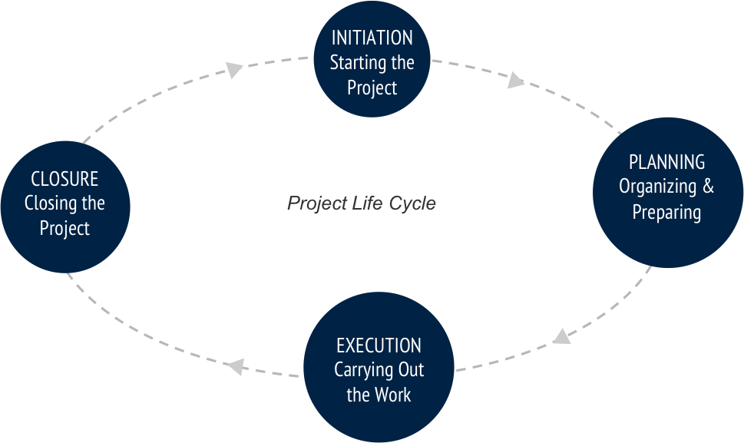

ENVIRONMENTAL IMPACT ASSESSMENT (EIA):
Environmental Impact Assessment (EIA) is a process of evaluating the likely environmental impacts of a proposed project or development, taking into account inter-related socio-economic, cultural and human-health impacts, both beneficial and adverse. UNEP defines Environmental Impact Assessment (EIA) as a tool used to identify the environmental, social and economic impacts of a project prior to decision-making. It aims to predict environmental impacts at an early stage in project planning and design, find ways and means to reduce adverse impacts, shape projects to suit the local environment and present the predictions and options to decision-makers. By using EIA both environmental and economic benefits can be achieved, such as reduced cost and time of project implementation and design, avoided treatment/clean-up costs and impacts of laws and regulations.

