ENG 284 (ENGINEER IN SOCIETY) ASSIGNMENT
- SCOPE OF WORK
Alfa Belgore Hall is the main multi-purpose hall of Afe Babalola University, Ado Ekiti. The hall has served the school for many years, hosting many events, including the weekly ABUAD Chapel services. It is also conjoined to the school’s Bookshop and ICT centre.
The objective of the project is to increase the hall’s current holding capacity of 2000 – 4000 students and staff to a capacity of up to 9000 students and staff in order to accumulate the school’s growing population while also making improvements to the hall’s interior in order to make the hall more suitable for a variety of events.
- Securing the site: The execution of the project will commence during the ongoing school session and even after the end of the session, medical students and certain staff will still be present on the campus. The site will have to be sealed off to prevent unforeseen incidents caused by unauthorized personnel.
- Clearing out the interior of the building: Before any work is started, the building will have to be cleared out so that valuable equipment does not get damaged and also so that there are no obstructions during work.
The bookshop and ICT centre will also have to be cleared out and relocated because their work cannot continue if the area is sealed off to unauthorized personnel i.e. students and staff
- Removal of roofing and ceiling: In order to increase the capacity of the hall, an extra level will be added. Before this level can be added, the roof and ceiling of the building will have to be taken off
- Construction of extra level: After the roof is removed, construction of the floor, walls, windows etc. that constitute the upper level will begin.
- Installation of new roof
- Construction of interior of extra level: Internal structures will be added to the upper level once the building’s exterior is complete. The ground floor may also be redesigned
- Clearing of rubble: After the construction is complete ,the surrounding area will be ridden with different materials which must be removed before the building is usable and habitable.
- 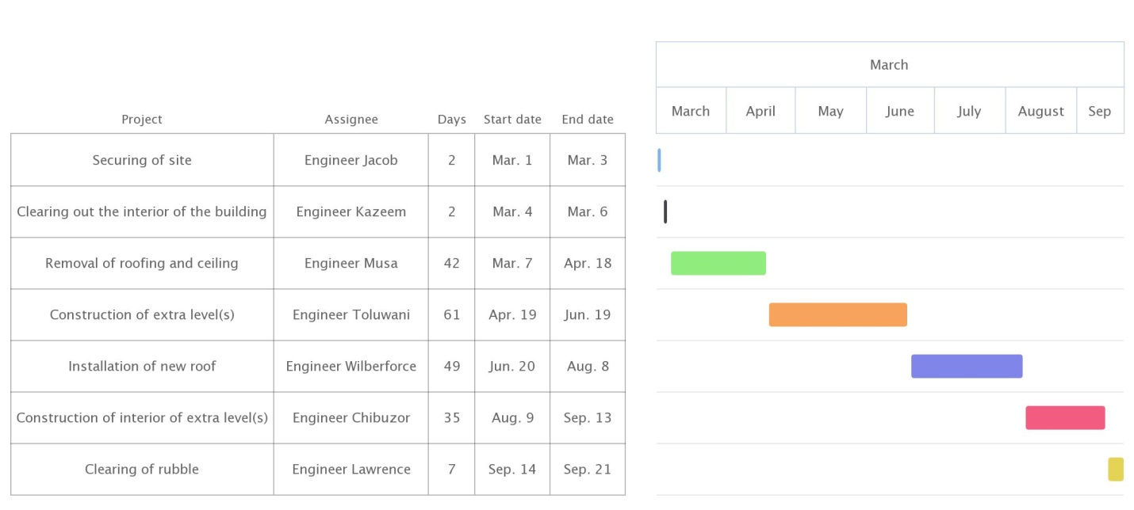
- HUMAN RESOURCES NEEDED
- Architect
- Civil Engineers
- Building Engineers
- Electricians
- Bricklayers
- Carpenters
- Painters
- Plumber
Leading consultant: Engineer Musa Olaoluwa

- The site was secured to prevent non-workers from coming close to the project. Without the site being secured, there is a significantly higher chance of the occurrence of accidents leading to injuries to both workers and civilians. It is also secured to prevent theft of equipment and essentially to make sure unforeseen delays are avoided so that the project can be completed within the designated time period.

S/N | CATEGORY | ITEM(S) | ALLOCATION | AMOUNT
 | MISCELLANEOUS | WORKERS’ FOOD | 10% | N5,400,000
 |  | FENCING MATERIALS
 |  | EXTRA WOOD, CEMENT ETC.
 | CONSULTANCY FEE | LEADING CONSULTANT | 15% | N8,100,000
 |  | OTHER CONSULTANTS
 | SITE PREPARATION & CLEARING AFTER CONSTRUCTION | BROOMS | 5% | N2,700,000
 |  | MOPS
 |  | SOAP AND OTHER CLEANING MATERIALS
 | TRANSPORT COST | TRUCKS FOR MATERIALS | 12% | N6,480,000
 |  | WORKERS’ TRANSPORT FARES
 | PROFIT |  | 20% | N10,800,000
 | OTHER EXPENSES |  | 38% | N20,520,000

Payment Schedule
1 | 30% Tec for mobilization | N14,580,000
2 | 30% Tec at 50% completion | N14,580,000
3 | 40% at completion & hand-over | N19,440,000
4 | Retention 10% of Tec | N5,400,000
 | Total | N54,000,000

- Bill of Engineering Measurement and Evaluation is a tool used before, during and post construction to assess and value the cost of construction works. This includes the cost of materials, labor, equipment and all/any other resource(s) required for the success of any construction endeavor based on a pre-determined scope and specification
Defect liability period is a period in which a client reports any defects that arise to the contract administrator whether they are defects (i.e. works that are not in accordance with the contract) or whether they are in fact, maintenance issues. If the contract administrator considers they are defects, then they may issue instructions to the contractor to make them good within a reasonable time. It begins upon certification of practical completion and typically lasts six to twelve months
A lead consultant is a consultant who has hands-on roles which involve the day-to-day running of continuing client projects. They are team leaders, analyzing and reviewing proposals from the team, providing appropriate solutions to problems and making decisions on the way forward by acting as liaisons between the client and the consultancy team. Their work involves directly dealing with the client to clearly understand its needs and to provide possible solutions for the client’s consideration. The team receives and works on the client’s information from the lead consultant.
A project life cycle is the sequence of phases that a project goes through from its initiation to its closure. The number and sequence of a cycle are determined by the management and various other factors like needs of the organization involved in the project, and its area of application. The phases have a definite start, end and control point and are constrained by time. The project lifecycle can be defined and modified as per the needs and aspects of the organization. Even though every project has a definite start and end, the particular objectives, deliverables and activities vary widely. The lifecycle provides the basic foundation of the actions that have to be performed in the project, irrespective of the specific work involved.
Environmental Impact Assessment (E.I.A.) is a process of evaluating the likely environmental impacts of a proposed project or development, taking into account, inter-related socioeconomic, cultural and human-health impacts, both beneficial and adverse. It aims to predict environmental impacts at an early stage in project planning and design, find ways and means to reduce adverse impacts, shape projects to suit the local environment and present the predictions and options to decision makers. By using E.I.A., both environmental and economic benefits can be achieved, such as reduced cost and time of implementation and design, avoided treatment/clean-up costs and impacts of laws and regulations.

