**AFE BABALOLA UNIVERSITY**

ENGINEERING CONSULTANCY ASSIGNMENT

ENGINEER IN SOCIETY. ENG 284

Date of Submission: 15th April 2020

ALFA BELGORE REHABILITATION PROJECT

AREMU TOBILOBA EMMANUEL

18/ENG03/015

**TABLE OF CONTENT**

LIST OF TABLES i

LIST OF FIGURES i

1. SCOPE OF WORK 1

2. PROJECT GANNT CHART 2

3. HUMAN RESOURCES AND PROJECT TEAM 4

4. SITE SECUREMENT 4

5. BEME DEVELOPMENT 4

6. PAYMENT SCHEDULE 6

7. DEFINITION 7

7.1. BEME 7

7.2. DEFECT LIABILITY PERIOD 7

7.3. LEAD CONSULTANT 7

7.4. PROJECT LIFE CYCLE 8

7.5. ENVIRONMENT IMPACT ASSESSMENT (EIA) 9

# LIST OF TABLES

Table 1. BEME Development 5

Table 2. Payment Schedule. 6

# LIST OF FIGURES

Figure 1. Estimated Task and Gantt Chart for Alfa Belgore Rehabilitation Project. 2

Figure 2. Gantt Chart for Alfa Belgore Rehabilitation Project. 3

Figure 3. Project Life Cycle. 9

As the designated student Consulting Engineer on the Alfa Belgore Rehabilitation project, the following are expected.

# SCOPE OF WORK

The project scope of work for the project is outlined as follows:

1. Mark-out of area that require rehabilitation.
2. Mark-out of area for demolition.
3. Demolition of existing.
4. Form works: This work concerns building new walls and also reconstruction of demolished walls.
5. Concrete work: casting concrete in locations around the building to get it ready for the waterproofing, also a preventive measure against cracked walls.
6. Roofing: the hall will be roofed using aluminum and so on
7. Plastering work: This work concerns plastering new walls and also walls where plastering was removed by various factors.
8. Frames of Doors, windows and metal works: All the doors and windows are to be replaced in Aluminum or metallic as stipulated in the Bill of Quantities.
9. Tiling : This concern part of the floor where tiles are cracked or broken, new installation of tiles in the toilets and offices within the Alfa Belgore hall.
10. Plumbing (mechanical works): The work consists of restoration of the toilet pipes and drainage system which are broken.
11. Electrical installation: In addition to the electrical installation i.e sockets and lighting system. New installation is required and hooked to the existing network.
12. Air-conditioning works: A/C is required in the building in order to balance temperature change in the hall
13. Painting works: This general and will be applied to the interior and exterior of the building

# PROJECT GANNT CHART

The project Gannt chart is shown on Figure 1 and Figure 2below.

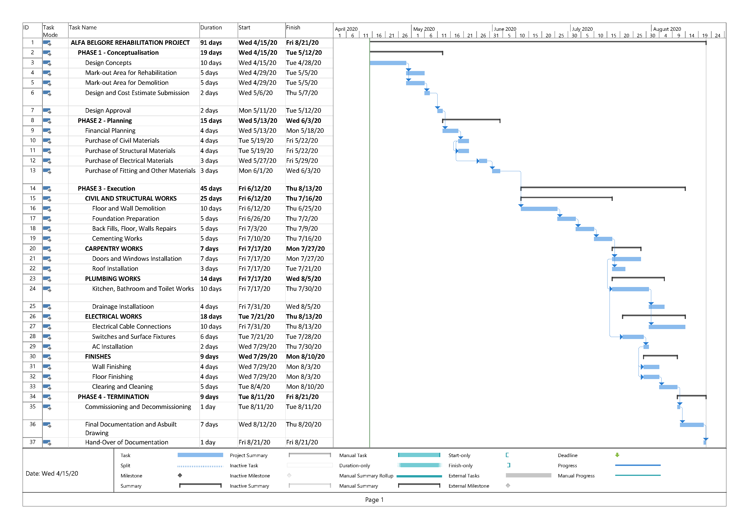

Figure . Estimated Task and Gantt Chart for Alfa Belgore Rehabilitation Project.

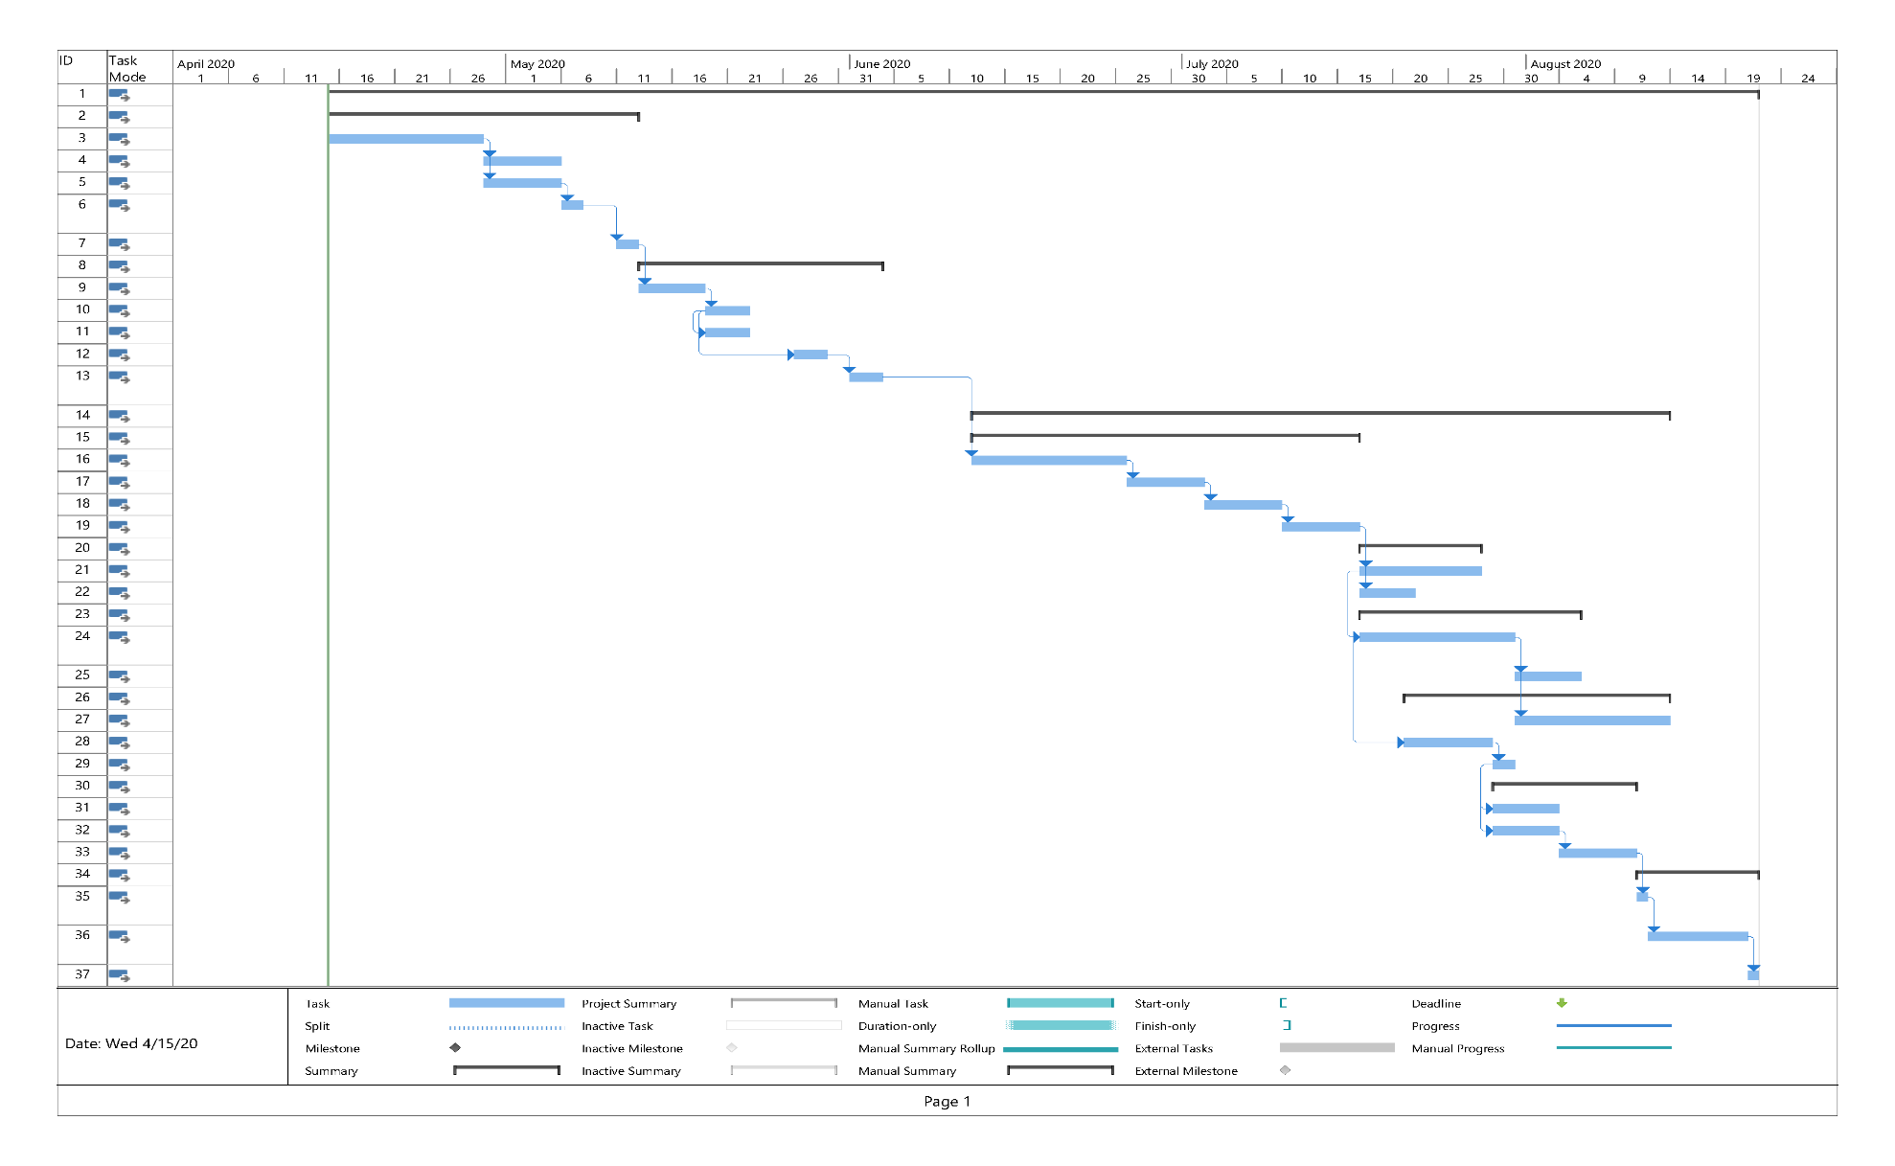

Figure . Gantt Chart for Alfa Belgore Rehabilitation Project.

# HUMAN RESOURCES AND PROJECT TEAM

The list of human resources needed and the project team with lead consultant includes the following:

1. Project Manager
2. Architect – Lead Consultant
3. Design Engineer
4. Civil Engineer
5. Electrical Engineer
6. Structural Engineer
7. Quantity Surveyor
8. Geotechnical Engineer
9. Construction Manager
10. Mechanical Engineer
11. Social / Environmental Specialist
12. Site Engineer

# SITE SECUREMENT

The site was secured to prevent cases of theft of construction materials in store during preparation and construction. It is also required to monitor the movement of personnel and construction workers in and out of the construction site.

# BEME DEVELOPMENT

Development of BEME for the project by lump sum projections including:

1. 10% of the total estimated cost as miscellaneous,
2. 15% tech as consultancy fee,
3. 5% for site preparations and clearing after completion,
4. 12% of for transport cost,
5. 20% as profit

Table . BEME Development

|  |  |  |  |  |  |  |
| --- | --- | --- | --- | --- | --- | --- |
| **Item No.** | **Description** | **Unit** | **Quantity** | **Material Rate (₦)** | **Labour Rate (₦)** | **Cost (₦)** |
| 1 | Cement | Bags | 500 | 2,550.00 | 38,250.00 | 1,313,250.00 |
| 2 | Blocks |  | 2800 | 200.00 | 16,800.00 | 576,800.00 |
| 3 | Sand | Truck (6-Tons) | 6 | 23,000.00 | 4,140.00 | 142,140.00 |
| 4 | Granite | Truck (6-Tons) | 3 | 40,000.00 | 3,600.00 | 123,600.00 |
| 5 | Water | Trips (6-Tons) | 10 | 5,000.00 | 1,500.00 | 51,500.00 |
| 6 | Steel Rod (10 mm) | Tons | 1 | 165,000.00 | 4,950.00 | 169,950.00 |
| 7 | Binding Wire | Rolls | 8 | 7,000.00 | 1,680.00 | 57,680.00 |
| 8 | Doors |  | 8 | 100,000.00 | 24,000.00 | 824,000.00 |
| 9 | Windows |  | 8 | 10,000.00 | 2,400.00 | 82,400.00 |
| 10 | Toilets |  | 4 | 110,000.00 | 13,200.00 | 453,200.00 |
|  |  |  |  |  |  |  |
| 11 | Roof | Square metre | 120 | 3,200.00 | 11,520.00 | 395,520.00 |
| 12 | Air Conditioning Unit |  | 5 | 110,000.00 | 16,500.00 | 566,500.00 |
| 13 | Tiles | Square metre | 200 | 2,000.00 | 12,000.00 | 412,000.00 |
| 14 | Electrical Wires | Rolls | 10 | 15,000.00 | 4,500.00 | 154,500.00 |
| 15 | Electrical Fixtures |  | 2 | 50,000.00 | 3,000.00 | 103,000.00 |
| 16 | Plumbing Fixtures |  | 8 | 40,000.00 | 9,600.00 | 329,600.00 |
| 17 | Wood |  | 20 | 3,000.00 | 1,800.00 | 61,800.00 |
| 18 | Wall Finishes |  | 10 | 40,000.00 | 12,000.00 | 412,000.00 |
| 19 | Painter |  | 4 |  | 20,000.00 | 20,000.00 |
| 20 | Electrician |  | 5 | - | 30,000.00 | 30,000.00 |
| 21 | Plumber |  | 4 | - | 20,000.00 | 20,000.00 |
| 22 | Carpenter |  | 4 | - | 20,000.00 | 20,000.00 |
| 23 | **TOTAL MATERIAL & LABOUR COST** | | | | | **6,566,640.00** |
| 24 | **Miscellaneous** | 10% |  |  |  | 656,664.00 |
| 25 | **Consultancy Fee** | 15% |  |  |  | 984,996.00 |
| 26 | **Site Preparation and Clearing After Completion** | 5% |  |  |  | 328,332.00 |
| 27 | **Transport Cost** | 12% |  |  |  | 787,996.80 |
| 28 | **Profit** | 20% |  |  |  | 1,313,328.00 |
|  | **TOTAL COST** | | | | | **10,390,756.80** |

# PAYMENT SCHEDULE

Table 2 shows the payment schedule with assumption that the total payment is ten (10) million Four thousand Eight Hundred and Sixty Naira and Eighty Koboand based on

1. 30% tec for Mobilisation,
2. Next 30% tecat 50% completion,
3. Final Payment of 40% tec at completion and handover

Table . Payment Schedule.

|  |  |  |  |  |  |
| --- | --- | --- | --- | --- | --- |
| **PAYMENT SCHEDULE** | | | | | |
| **S/N** | **ITEM**  **DESCRIPTION** | **DATE** | **TOTAL SUM** | **%** | **TOTAL PRICE  (NGN)** |
| 1 | Mobilization | 15-04-2020 | 10,390,756.80 | 30% | 3,091,387.04 |
| 2 | Payment at 50% Completion | 12-05-2020 | 30% | 3,091,387.04 |
| 3 | Final Payment at Completion and Handover | 18-06-2020 | 40% | 4,105,182.72 |
|  | **TOTAL SUM** | | **10,390,756.80** | | |
| **AMOUNT IN WORDS:** | | | **TEN MIILION, THREE HUNDRED AND NINETY THOUSAND AND SEVEN HUNDRED AND FIFTY SIX NAIRA EIGHTY KOBO** | | |

# DEFINITION

## BEME

BEME is simply stands for “Bill of Engineering Measurements and Evaluation. BEME is a list of work items, their estimated quantities and cost prepared based on specification and drawings presented for a project. It is an important tool that is used to assess and estimate the cost before, during and post-construction of the project works. The items evaluated will normally include the following:

1. Cost of materials,
2. Labour cost,
3. Equipment cost, etc.

which are resources required for the successful completion of the construction based on the pre-determined scope and specification.

These are necessary to provide sufficient information during construction planning, tendering and contracting. In addition, they are required to make comparison of rates and cost of items required in the project.

## DEFECT LIABILITY PERIOD

Defects liability period (DLP) is a fixed period of time, starting from the date of practical completion, during which the contractor has an express contractual right to return to the site to rectify defects. This period is sometimes referred to as rectification period or defects correction period.

Typically, during this period, the contractor has the right to return to the site to rectify defects or complete unfinished work;the principal is entitled to continue holding security, to secure the contractor’s obligations in respect of incomplete or defective work; andthe superintendent continues to remain involved in the project.

## LEAD CONSULTANT

The lead consultant is simply an entity (company or personnel) appointed by the client to manage andadminister the services of all consultants on multi-disciplinary projects where morethan one professional service provider is appointed on a project. In multi-disciplinaryengineering projects where these services are provided they are often called"Engineering Management Services".

In other words, the lead consultant is the consultant that directs the work of the consultant team and is the main point of contact for communication between the client and the consultant team, except for on significant design issues where the lead designer may become the main point of contact.

## PROJECT LIFE CYCLE

Project life-cycle refers to the different phases in a project from the conceptualization / start-up/ initiation phase to the termination / close-out phase of the project. A typical project life-cycle will normally include the following phases:

**Conceptualisation Phase:**

This phase is sometimes referred to as the initiation or start-up phase where the project objectives are defined and the conceptual aspects of the project agreed. This may be the phase where a problem is identified, potential solutions suggested and the scope of work is defined. The business contract and cases are created at this phase.

**Planning Phase:**

This phase is where the project is broken down into manageable areas of work and planned in terms of time, cost and resources. This phase will involve determining resource availability, creating a project budget and allocation of tasks to certain resources. This is a continuous process and will extend throughout the execution phase of the project.

**Execution Phase:**

This is when the actual work of the project is performed / implemented. Required materials, tools, and resources are controlled, monitored and transformed to reach the project goals. During this phase, performance is continually measured to ensure the project is successful.

**Termination Phase:**

The termination phase is the final phase which is also referred to as the “Close-out phase”. This phase involves closing out and demobilisation, where resources are reassigned, the project is handed over and the post-project review is carried out.

Figure . Project Life Cycle.

## ENVIRONMENT IMPACT ASSESSMENT (EIA)

Environmental Impact Assessment (EIA) is a systematicanalysis toolused to identify and evaluate the likelihood of environmental impacts as a result of a proposed project or development, taking into account inter-related socio-economic, cultural and human-health impacts, both beneficial and adverse.It aims to predict environmental impacts at an early stage in project planning and design, find ways and means to reduce adverse impacts, shape projects to suit the environment and present the predictions and options to decision-makers.