NAME: Ginigeme Stanley
Matric No.: 18/ENG04/039
Course Code: ENG284
Course: Engineer in the Society

1a) Kick-Off meeting: A meeting is held to discuss the rehabilitation project of Alfa Belgore Hall.
b) Architectural Drawing: After the meeting, an Architect is called to make the plans for the renovation. This is where the parts of the hall to be demolished and renovated are chosen.
c) Site mobilization: This refers to the activities carried out after the client has appointed the contactors (the engineers, mason's etc.), but before the trade contractors commence work on site. It is a preparatory stage during which the majority of activities are managed by the Lead consultant.
After site mobilization the site is closed for safety reasons.
d) Demolition of structures: This is the stage where the structures planned by the architect to be demolished are demolished to make way for the renovation process.
e) Renovation: This is where things in the hall are improved for instance the roof can be changed, the floor can be tiled etc.
f) Test: This is where the building is tested and mistakes in construction are found and rectified.
g) Handover and close-out: This takes place after construction The employer is able to occupy the development but the contractor remains responsible for rectifying defects during a period known as the 'defects liability period' (or 'rectification period') which typically lasts six to twelve months. A formal hand-over in needed to prevent arguments on terms and defect reporting protocol should be agreed on. This should all be done after inspection of the site. After all that is agreed upon, the contractor prepares an information exchange (or 'data drop') as required by the employer's information requirements. This is where the client can then check whether the accounts are balanced or not.

h) In-Use: 'In use', sometimes referred to as 'operation', describes the period after any defects have been rectified and fine tuning carried out when the development is in 'normal' operation.

2.
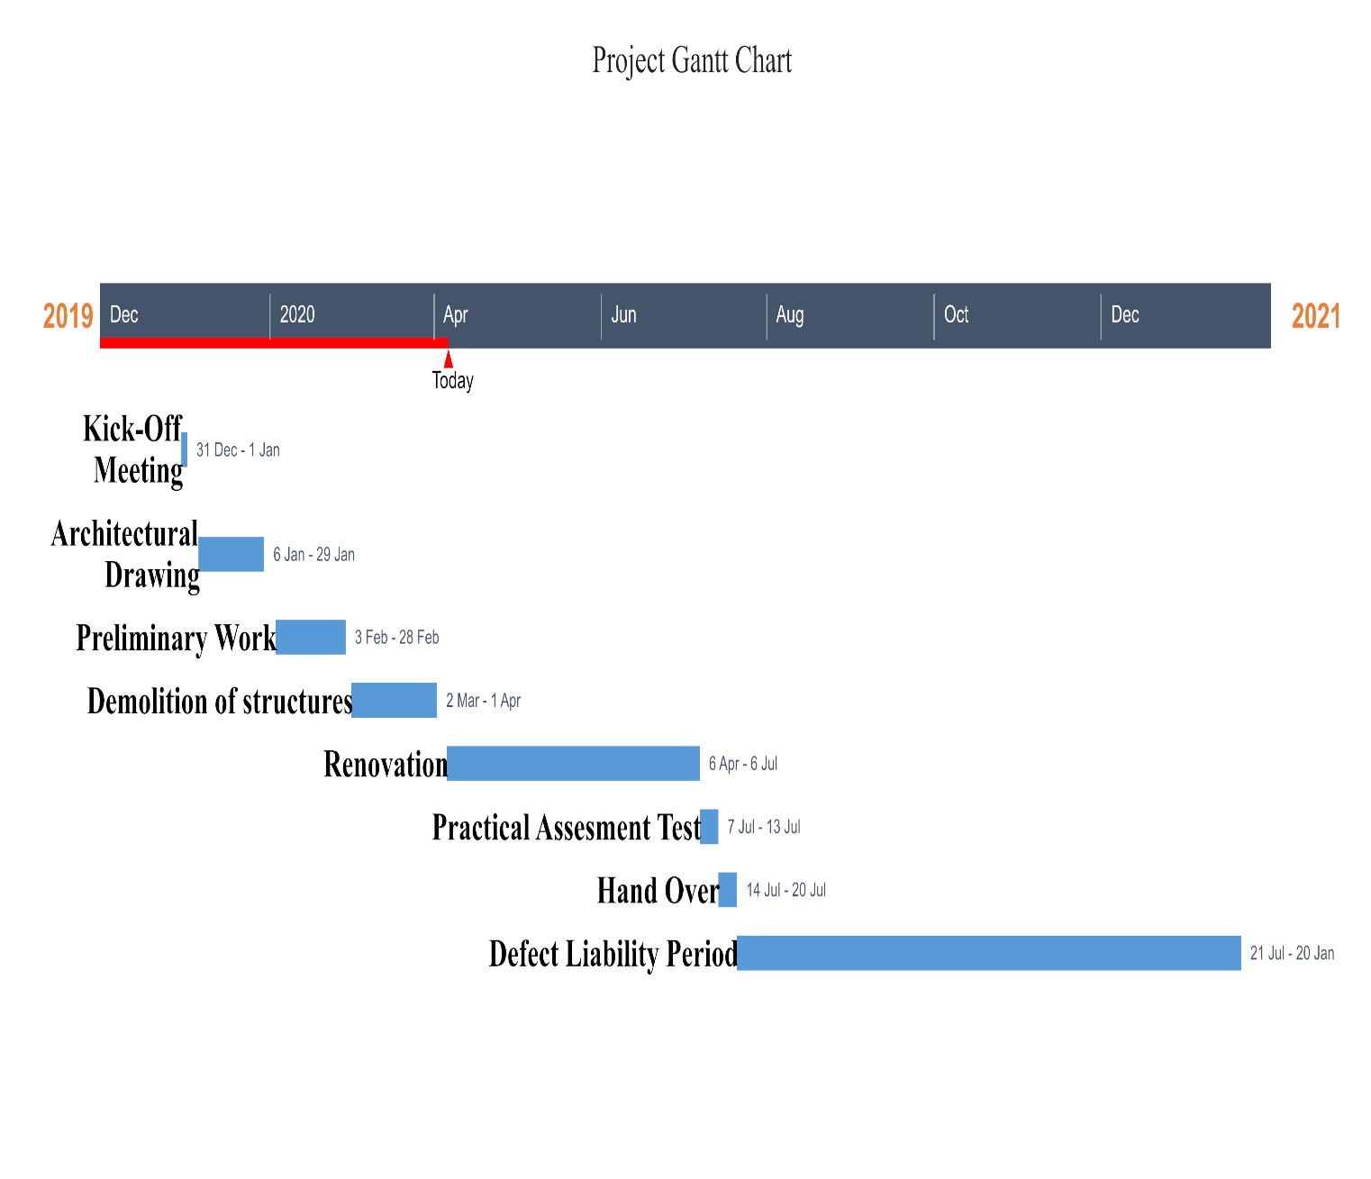

3.

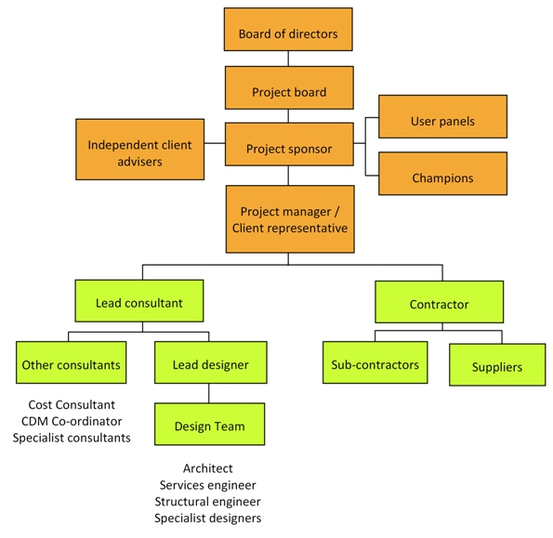
Other human resources include: Electrical Engineers, Civil engineers, etc.
The lead consultant should be the Architect as the renovation plans were drawn by him/her

4. The site was secured to prevent:
a) Injury to students from falling objects
b) Accidents occurring between delivery vehicles to site and students
c) Students from falling into excavation holes or piles of sand or gravel during renovation
d) Dust that affects students
e) Students from stepping on sharp objects
f) Students from entering the renovated building when it is not safe
5.

BEME (Bill of Engineering Measurements and Evaluation)
S/N | Description | Percentage | Total Estimated Cost(tec) | Description cost
1 | Miscellaneous | 10% | ₦ 700,000,000 | ₦ 70,000,000
2 | Consultancy fee | 15% | ₦ 700,000,000 | ₦ 105,000,000
3 | Site Preparations and Clearing after completion | 5% | ₦ 700,000,000 | ₦ 35,000,000
4 | Transport cost | 12% | ₦ 700,000,000 | ₦ 84,000,000
5 | Profit | 20% | ₦ 700,000,000 | ₦ 140,000,000
 | Total | 62% |  | 434,000,000.00

6.
Payment Schedule
Description | Percentage | Total Estimated Cost(tec) | Total amount to be paid | Percentage Retained | Amount Retained | Payment
Mobilization | 30% | ₦ 700,000,000 | ₦ 210,000,000 | 0% | ₦ - | ₦ 210,000,000
At 50% completion | 30% | ₦ 700,000,000 | ₦ 210,000,000 | 0% | ₦ - | ₦ 210,000,000
Final Payment | 40% | ₦ 700,000,000 | ₦ 280,000,000 | 10% | ₦ 70,000,000 | ₦ 210,000,000
After 6months (and no defect found) | 10% | ₦ 700,000,000 | ₦ 70,000,000 | 0% | ₦ - | ₦ 70,000,000
Total |  |  |  |  |  | ₦ 700,000,000

7. BEME (Bill of Engineering Measurement and Evaluation): This is a tool used before, during and post-construction to assess and value the cost of construction works. This includes the cost of materials, labour, equipment, and all/any other resource(s) required for the success of any construction endeavour based on a pre-determined scope and specification. Its objectives are to sufficient information during construction planning, for tendering and contracting purposes or for the purpose of knowing the estimated cost of the proposed project. Also, to facilitate the comparison of rates and prices between biddeSrs.
Defect Liability Period: Is a period of time following practical completion during which a contractor remains liable under the building contract for dealing with any defects that become apparent. During this period the client reports any defects that arise to the contractor.
Lead Consultant: The lead consultant is the consultant that directs the work of the consultant team and is the main point of contact for communication between the client and the consultant team, except for on significant design issues where the lead designer may become the main point of contact. His role may include: Co-ordinating, monitoring and reviewing the work of the consultant team (and others, such as specialist designers and specialist contractors), Arranging consultant team meetings and planning work stages, Preparing programmes and progress reports, Seeking instructions from the client, Advising the client on the choice of procurement route, Advising the client on the need to appoint additional advisers, consultants or specialist designers, Establishing change control procedures at key stages, for example when the project brief is frozen or when detailed design is frozen, Arranging value management exercises, Advising the client on the choice of contract and contract conditions, Assist the client in defining selection criteria for contractors and preparing pre-qualification questionnaires, Co-ordinating the review of tenders.
Project Life cycle: The phases that represent the path a project takes from the beginning to its end and are generally referred to as the project “life cycle.” There are 4 phases in a project life cycle namely; initiation, planning, implementation, closing phase.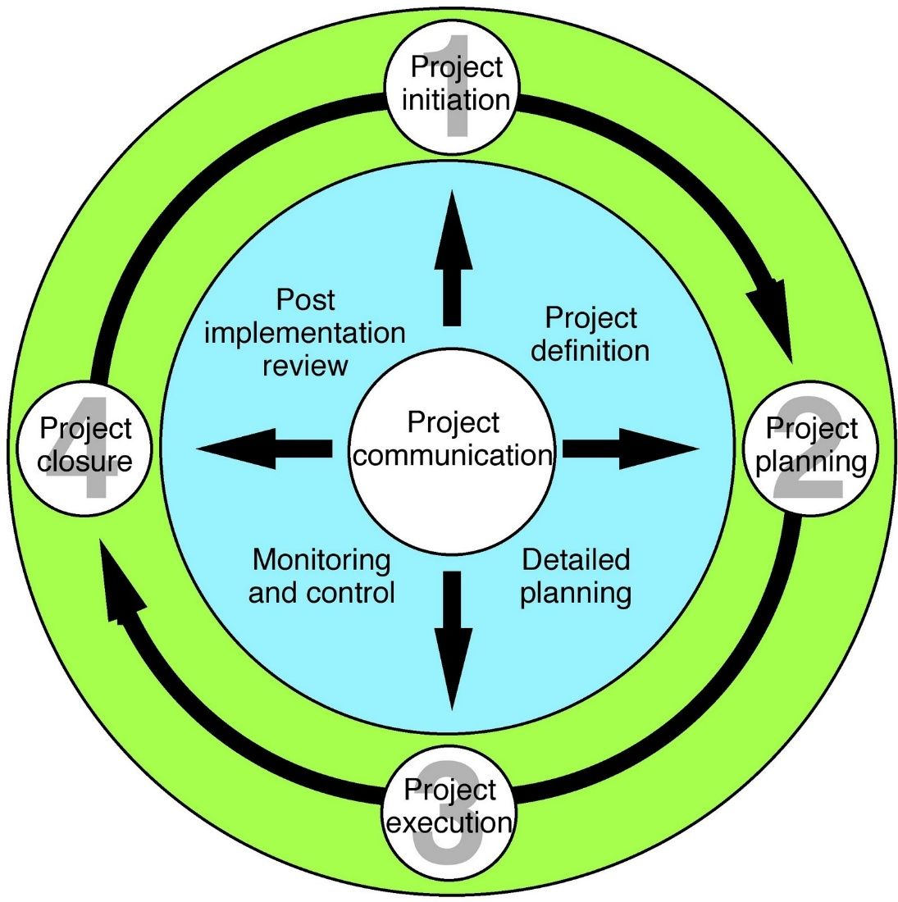
Environmental Impact Assessment (EIA): This is the assessment of the environmental consequences of a plan, policy, program, or actual projects on the people or the natural resources in the area prior to the decision to move forward with the proposed action. In Nigeria, it must be sent to FCDA (Federal Capital Development Authority) or FHA (Federal Housing Authority)

