NAME: UGBECHIE VALENTINA CHINONSO
MATRIC NUMBER: 18/ENG08/023
DEPARTMENT:BIOMEDICAL ENGINEERING
COURSE:ENGINEERS-IN-SOCIETY
ENG 284

Scope of Works
Alfa BELGORE Hall is a multi-purpose hall that hosts most of Afe-Babalola University’s activities and events such as convocations, matriculation,Congress, dinners, seminars and so on. It is used basically for massive gatherings
Problem Statement
Due to the rapid growth of the school in population, there will come a time where the hall will not be able to accommodate the number of students.
The Goal of the project
The goal of this project is to renovate and to rehabilitate. This includes raising the building, general repairs, adding useful facilities, new and improved roofing, new entrances and exit points, new windows and doors, more efficient plumbing and electric etc.
Realizations
- A new storey
- Modern facilities
- A more reoriented appearance
Timeline:
Planning
Substantial planning of the design, materials to be used, grade of materials to be used and so on is done before any physical work can start. At this stage, various engineers, architects and construction workers are employed to carry out the project.
Clearing
All valuable appliances are taken out of the building and the construction site is demarcated to ensure maximum safety.
Demolition
The existing roof, along with some other parts of the building are completely torn down by heavy machinery.
Adjustments
With respect to the structure of the building, many modifications are going to be made such as the addition of a new storey, addition of rooms, etc. This includes erection of columns and laying of bricks that constitute the new storey.
Roof Work
The building will be covered with high-grade Aluminium sheets.
Windows and Door Installation
New windows and doors will need to be added to the new storey for easy accessibility and proper ventilation.
Finishing
This is the concluding stage of the construction process that involves addition of finishes including painting, flooring and other decorative pieces to add to the visual aesthetic of the building.
Mechanical, Electrical and Plumbing (MEP)
The electric cables and pipes are set up in such a way to maximise efficiency and avoid one affecting the other negatively by MEP engineers. This also involves setting up head, ventilation and air condition (HVAC) for optimal comfort of occupants.

GANTT CHART
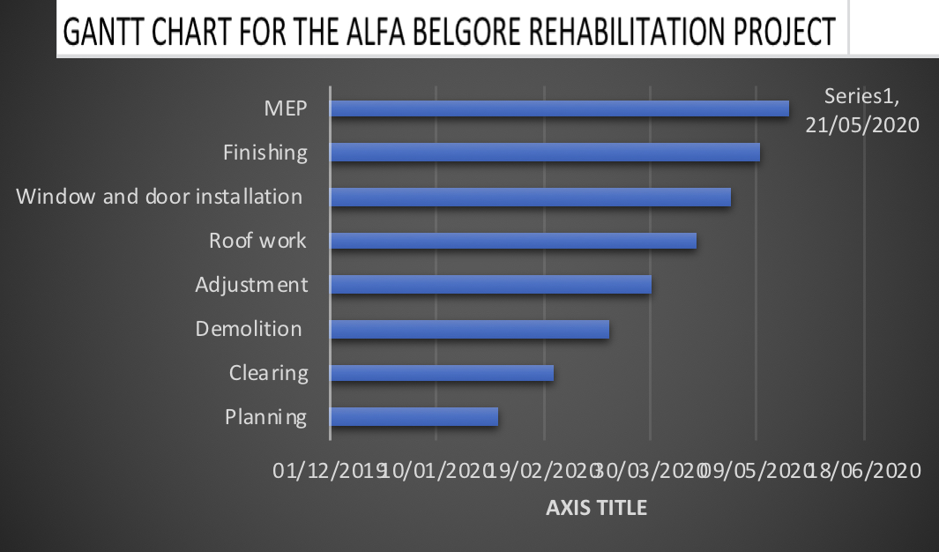

Project Team
- Civil Engineers (Including the Lead Consultant)
- Architect
- Mechanical Engineers
- Electrical Engineers
- Quantity Surveyor
- Carpenters
- Masons
- Electricians
- P.O.P workers
- Painters

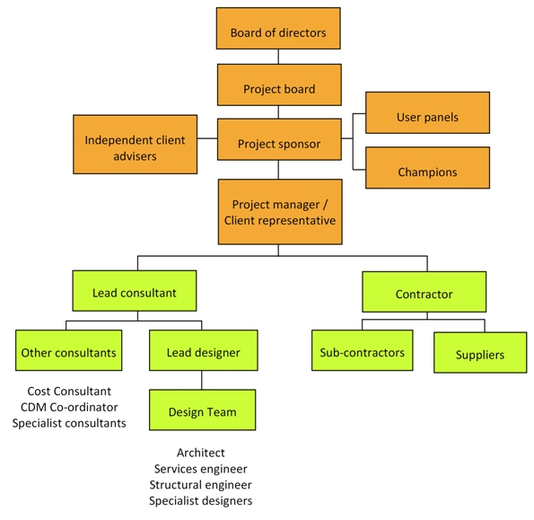

Why Was This Site Secured?
The site was secured to ensure safety of both workers and students. Alfa Belgore is located in the middle of the campus and even close to hostels where a large number of students walk past everyday to get to class. If the site was not secured to restrict indiscriminate access, some students may wander into the construction site unguarded and without any safety equipment. So, to avoid accidents, the construction site was demarcated.
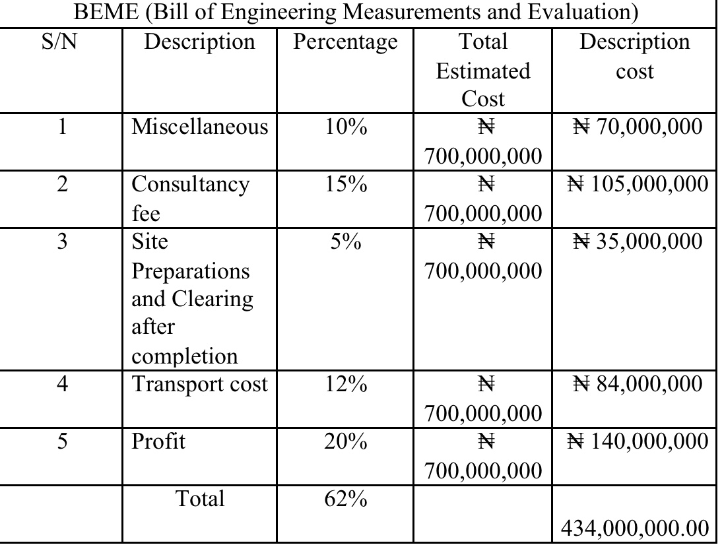

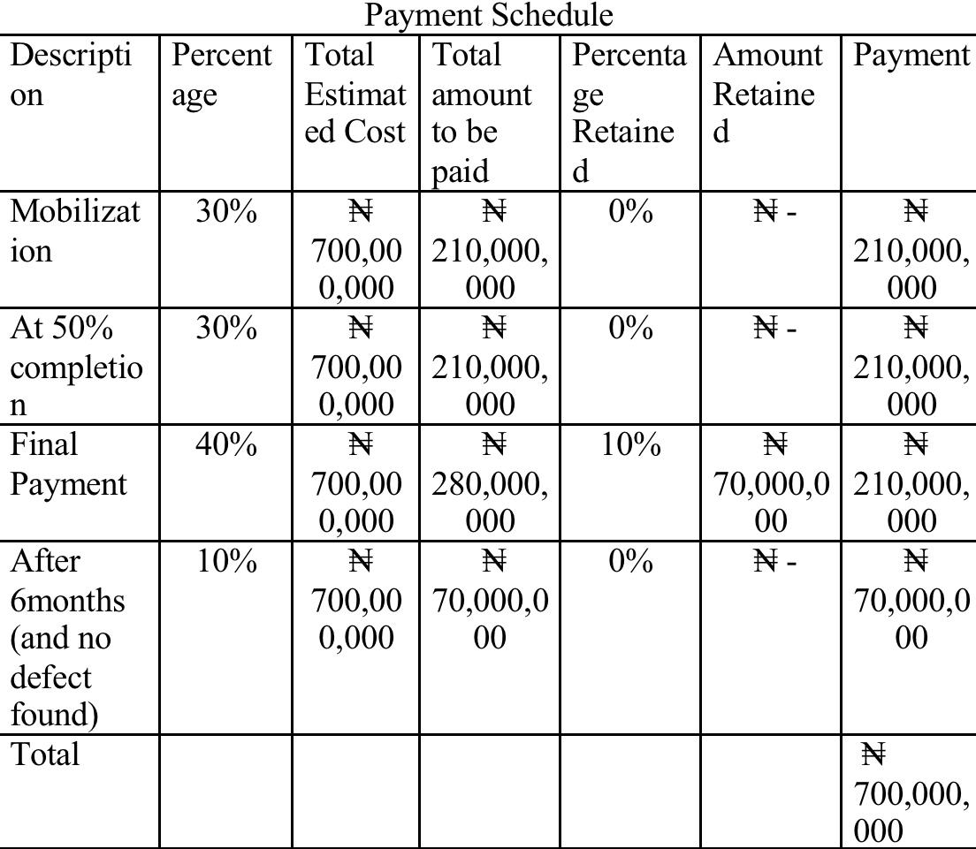

Definition of Terms
- BEME: BEME is the Bill of Engineering Measurement and Evaluation (BEME) also referred to as BILL, is a tool. Used before during and post-construction to assess and value the cost of construction works. This includes the cost of materials, labour, equipment and all/any other resources required for the success of any construction endeavour based on a pre-determined scope and specification.

Objectives of BEME:
- To facilitate the comparison of rates and prices between bidders
- To enable the clients to assemble actual tendered rates and prices to prepare for future estimating and budgeting.

- PROJECT LIFE CYCLE: A standard project typically has the following four major phases (each with its own agenda of tasks and issues) initiation, planning, implementation, and closure, taken together, these phases represent the path a project takes from the beginning to its end and are generally referred to as the project life cycle.

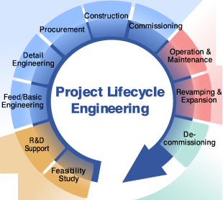

- LEAD CONSULTANT: The lead consultant is simply an entity (company or personnel) appointed by the client to manage and administer the services of all consultants on multi-disciplinary projects where more than one professional service provider is appointed on a project. In multi-disciplinary engineering projects where these services are provided they are often called "Engineering Management Services". In other words, the lead consultant is the consultant that directs the work of the consultant team and is the main point of contact for communication between the client and the consultant team, except for on significant design issues where the lead designer may become the main point of contact.
ROLES OF A LEAD CONSULTANT
  - Arranging consultant team meetings and planning work stages
  - Preparing programs and progress reports
  - Advising the client on the choice of procurement route.

- DEFECT LIABILITY: Defects liability period (DLP) is a fixed period of time, starting from the date of practical completion, during which the contractor has an express contractual right to return to the site to rectify defects. This period is sometimes referred to as rectification period or defects correction period. Typically, during this period, the contractor has the right to return to the site to rectify defects or complete unfinished work; the principal is entitled to continue holding security, to secure the contractor’s obligations in respect of incomplete or defective work; and the superintendent continues to remain involved in the project.

- ENVIRONMENTAL IMPACT ASSESSMENT: Environmental Impact Assessment (EIA) is a systematic analysis tool used to identify and evaluate the likelihood of environmental impacts as a result of a proposed project or development, considering inter-related socio-economic, cultural and human-health impacts, both beneficial and adverse. It aims to predict environmental impacts at an early stage in project planning and design, find ways and means to reduce adverse impacts, shape projects to suit the environment and present the predictions and options to decision-makers.

