WAKAMA FESTA NENGI ENGINEER IN SOCIETY
CIVIL ENGINEERING
18/SCI14/025
1)
TITLE: SCOPE OF WORK FOR THE REHABILITATION OF THE ALFA BELORE HALL , AFE BABALOLA UNIVERSITY
Introduction:
Afe Babalola University has a requirement has a requirement to obtain the service for the rehabilitation of the existing Alfa Belgore Hall. This work would include the supply of materials and the furnishing of all labor, equipment and tools to configure the area.
Statement of Purpose:
The purpose of the scope of work is the implementation of the approved project by Afe Babalola University that is to be funded by the University. The purpose of this scope of work is to secure the materials and qualified labour required to successfully accomplish the following tasks.
- Site Visit: The site is visited and the conditions of the existing building are verified. This means that the contractor shall inspect visually the space and investigate to determine any problem to perform the job. A discussion with the customer to ensure no other information useful for the assessment is missing.
- The Alfa Belgore hall Located opposite the College of Engineering building will be modified in order to have a raised roof and wider walls.
- The contractor will be responsible for providing tools, equipment and enough trained personnel in order to perform the work problems and delays. The building is thereafter demolished and dismantled.

The works to be done include the following:
- Concrete works
- Block works
- Water proofing, system provisions
- Plastering works
- Painting works
- Tilling and Marble works
- Doors, windows, metal works and ceilings
- Plumbing and Sanitary works
- Air Condition works
- Electrical works

2) Gant chart
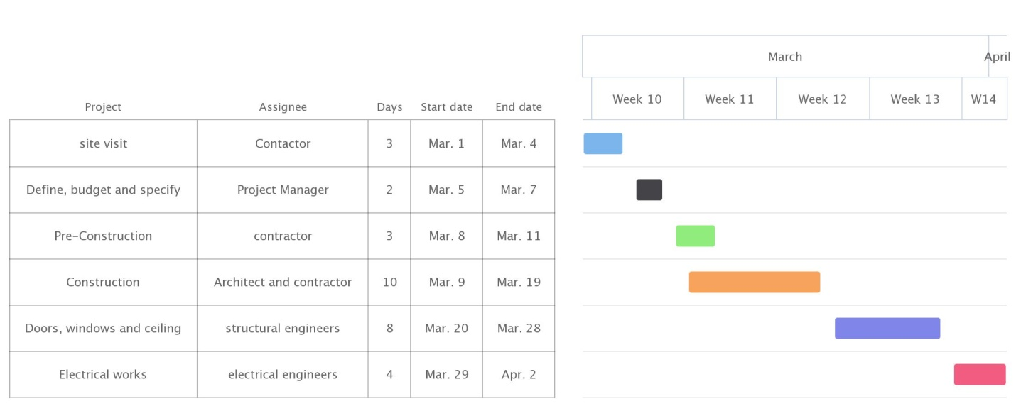

3) Project team
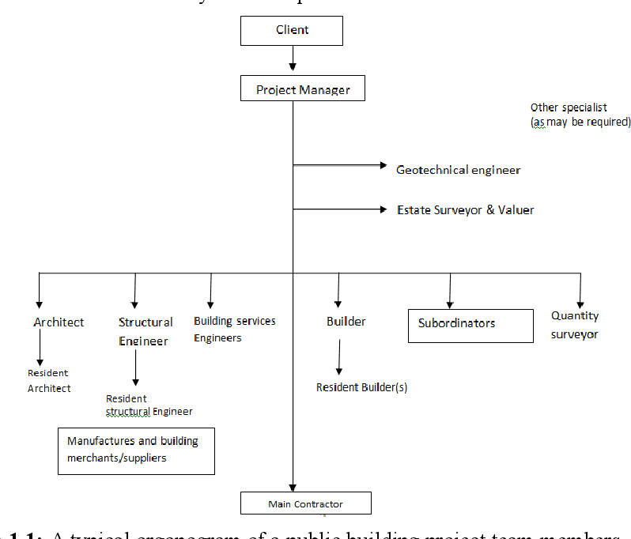

4) Why the site was secured
Temporary site fencing helps prevent unwanted access to the site and is an inconvenience that will make a thief think twice. The wardens gets rid of any form of distortion of the work.

BEME; Bill of Engineering Measurement and Evaluation (BEME) also referred to as 'Bill'; is a tool used before, during and post-construction to assess and value the cost of construction works. This includes the cost of materials, labor, equipment and all/any other resource(s) required for the success ofany construction endeavor based on a pre-determined scope and specification
Defect Liability Period: A defects liability period is a period of time following practical completion during which a contractor remains liable under the building contract for dealing with any defects which become apparent. ... A defects liability period is usually a period of around six or 12 months but it can vary depending on the contract used. Any defects or faults which arise during this period (for example –due to defective materials or workmanship) must be put right by the contractor as its own expense.
Project Life Cycle: A project life cycle is the sequence of phases that a project goes through from its initiation to its closure. The number and sequence of the cycle are determined by the management and various other factors like needs of the organization involved in the project, the nature of the project, and its area of application. The phases have a definite start, end, and control point and are constrained by time. The project lifecycle can be defined and modified as per the needs and aspects of the organization. Even though every project has a definite start and end, the particular objectives, deliverables, and activities vary widely. The lifecycle provides the basic foundation of the actions that has to be performed in the project, irrespective of the specific work involved.
Environmental Impact Assessment(EIA): Environmental Impact Assessment (EIA) is a process of evaluating the likely environmental impacts of a proposed project or development, taking into account inter-related socio-economic, cultural and human-health impacts, both beneficial and adverse.
UNEP defines Environmental Impact Assessment (EIA) as a tool used to identify the environmental, social and economic impacts of a project prior to decision-making. It aims to predict environmental impacts at an early stage in project planning and design, find ways and means to reduce adverse impacts, shape projects to suit the local environment and present the predictions and options to decision-makers. By using EIA both environmental and economic benefits can be achieved, such as reduced cost and time of project implementation and design, avoided treatment/clean-up costs and impacts of laws and regulations.

