NAME: OLA-AMUDA OLUWOLE TEMITOPE
MATRIC NO.: 18/ENG07/011
DEPARTMENT: PETROLEUM ENGINEERING
COURSE TITLE: ENGINEER IN SOCIETY
COURSE CODE: ENG 284
ASSIGNMEMT

Conceptualization
- Scope of work
- Need assessment (Building survey)
- Bill of quantity
- Gant chart
- Resource

Title of Project: Rehabilitation of Alfa Belgore of Afe Babalola University Ado-Ekiti
Address of Client: KM 85, Ado-Ekiti, Ekiti state.
Location: Afe Babalola University Ado-Ekiti
Company in Charge: Wolex Enterprise
Scope of work
The following include the procedure for the ongoing project;
- Conceptual Design (Alfa Belgore Rehabilitation Project)
- Detail Engineering
- Project Management
- Procurement
- Subcontracting
- Construction

Need Assessment (Build Survey)
- Requirement
- Problems to be met—--Roof linkage
-Ceiling replacement
-Wall (plastering, joining and replacement)
-Paint
-Electrical gadget replacement
-Rewiring
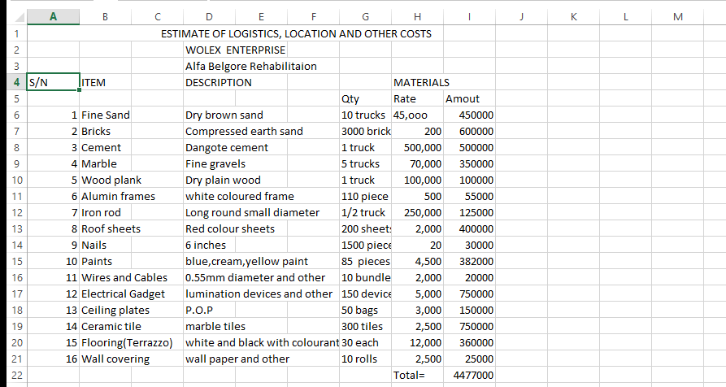
Bill of Quantity

Gantt Chart
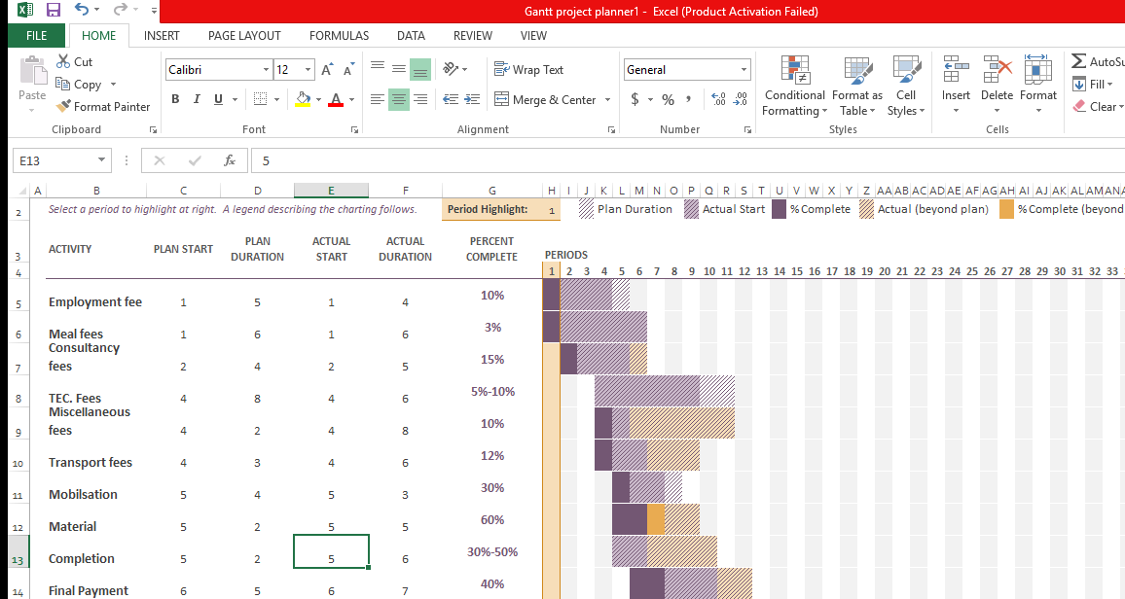

Professional team
In charge/Consultant:- Architect
Skilled Worker:- Carpenters, Mechanical Engineers, Bricklayers, Painters, Designers and Civil Engineers.
Duration:- 6 months

QUESTIONS TO BE ANSWERED IN ASSIGNMENT
- Explain why the site was secured
Ans:- The site didn’t cause any traffic disturbance
The site was secured because of Theft
The site was secured because of vandalism
- What is BEME?
Ans:- BEME – Bill of Engineering Measurement and Evaluation
It is the Systematic, logical and explicit appraisal of available information to
determine the best evidence relating to an Estimator of a Project.
- What is Liability period?
Ans:- it is a set period of time after a construction project has been completed during which a contractor has the right to return to the site to remedy defects.
- What is life Project life cycle?
Ans:- A project has a beginning and an end and passes through several phases of development known as life cycle phases.
- What is Environmental impact Assessment?
Ans:-it is assessment of environmental consequences of plan, policy, program, or actual projects prior to decision to move forward with the proposed action.

