LEGHEMO SOLOMON
18/ENG08/010
BIOMEDICAL ENGINEERING
ENG 284( ENGINEER-IN- SOCIETY)

SOLUTION
PROJECT DESCRIPTION: The Alfa Belgore hall in ABUAD is a busy multipurpose hall in which a number of school activities are held such as: church services, congresses, exhibitions,classes, seminars, and social events: including such gown-to-town engagements as: professional and agricultural exhibitions, and musical concerts, and sundry conventions.the hall has an approximate capacity of 7000 people and due to the rapid expansion of the school population and expected growth in gown-to-town engagements the need for a larger hall arises. Hence, the rehabilitation project.

- The scope of work are as follows
-Project overview ;The main objective is the rehabilitation of the alpha belgore hall
-Project scope; this contains the technical specifications and the budget allocation for the completion of the project
-Project deliverables; the objective is to ensure the rehabilitation of the alpha belgore hall from top to bottom beginning with the roof top. The top needs to be reformed due to its current state of appearance. The walls are to be reformed due to its states of appearance has brought discomfort to the school.
-Project schedule; the project is to last for a minimum of 8months but taking other problems that might come it should last for about a year.
-Project management; the project administrators are to make sure the projects are carried out effectively and ensure the payments of the workers when due.

2 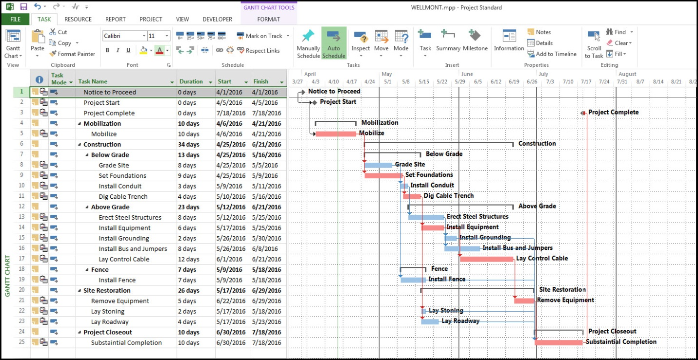

3 – Cement
Blocks
Mixer
Building tools
Project teams
The engineer(civil)
The architect
The workers
The tradesman

4. The site was secured to prevent:
a) Injury to students from falling objects
b) Accidents occurring between delivery vehicles to site and students
c) Students from falling into excavation holes or piles of sand or gravel during renovation
d) Dust that affects students
e) Students from stepping on sharp objects
f) Students from entering the renovated building when it is not safe

5
The projections | Cost
At 10% | 5 million naira
At 15% | 11 million naira
At 5% | 1 million naira
At 12% | 15 million naira
At 20% | 22 million naira

6
Mobilization | 20 million naira
Completion | 15 million naira
Completion and hand over | 10 million naira
Defect liability period | 22 million naira

7. BEME (Bill of Engineering Measurement and Evaluation): This is a tool used before, during and post-construction to assess and value the cost of construction works. This includes the cost of materials, labour, equipment, and all/any other resource(s) required for the success of any construction endeavour based on a pre-determined scope and specification. Its objectives are to sufficient information during construction planning, for tendering and contracting purposes or for the purpose of knowing the estimated cost of the proposed project. Also, to facilitate the comparison of rates and prices between biddeSrs.
Defect Liability Period: Is a period of time following practical completion during which a contractor remains liable under the building contract for dealing with any defects that become apparent. During this period the client reports any defects that arise to the contractor.
Lead Consultant: The lead consultant is the consultant that directs the work of the consultant team and is the main point of contact for communication between the client and the consultant team, except for on significant design issues where the lead designer may become the main point of contact. His role may include: Co-ordinating, monitoring and reviewing the work of the consultant team (and others, such as specialist designers and specialist contractors), Arranging consultant team meetings and planning work stages, Preparing programmes and progress reports, Seeking instructions from the client, Advising the client on the choice of procurement route, Advising the client on the need to appoint additional advisers, consultants or specialist designers, Establishing change control procedures at key stages, for example when the project brief is frozen or when detailed design is frozen, Arranging value management exercises, Advising the client on the choice of contract and contract conditions, Assist the client in defining selection criteria for contractors and preparing pre-qualification questionnaires, Co-ordinating the review of tenders.
Project Life cycle: The phases that represent the path a project takes from the beginning to its end and are generally referred to as the project “life cycle.” There are 4 phases in a project life cycle namely; initiation, planning, implementation.

