GREEN GRACE IGBOGI

18/MHS07/021

PHARMACOLOGY

PHARMACEUTICAL MICROBIOLOGY II ( PHA 206 )

QUESTIONS
- Sterilization is an essential stage in the processing of any product destined for parental administration or for contact with broken skin. Discuss??

- Discuss the importance of sterilization in the production of pharmaceutical products

- Explain gaseous sterilization, its sterilizer design and operation

- What is Radiation Sterilization?

A.

Parenteral preparations are sterile, pyrogen-freeliquids (solutions, emulsions, or suspensions) orsolid dosage forms containing one or more activeingredients, packaged in either single-dose ormultidose containers. They are intended foradministration by injection, infusion, orimplantation into the body.The dosage form for conveying a drug by meansof injection through the skin or mucousmembranes. Parenteral drugs are administereddirectly into the veins, muscles or under the skinor more specialized tissues such as the spinalcord. Circumvented the highly efficient first linebody defense that is skin and mucus membrane.Thus they should be free from microbialcontamination and should have high purityPreparations such as vaccines, human blood andproducts derived from human blood, peritonealdialysis solutions, and radioactivepharmaceuticals require special formulation,methods of manufacture, or presentationappropriate to their particular use and may notcomply with certain parts of this monograph
TYPES:
There are four main forms of parenteral preparations:
- Injections,
- Intravenous infusions (large volume parenteral),
- Powders for injections, and
- Implants.
Certain injections and intravenous infusions maybe presented in the form of sterile concentratedsolutions, which must be suitably diluted beforeuse.
FACILITIES REQUIRED FOR PARENTERALPRODUCTION:PRODUCTION:
Parenteral preparations may contain excipientssuch as solvents, suspending agents, bufferingagents, substances to make the preparationisotonic with blood, stabilizers, or antimicrobialpreservatives. The addition of excipients shouldbe kept to a minimum. When excipients are used,they should not adversely affect the stability,bioavailability, safety, or efficacy of the active

B. IMPORTANCE OF STERILIZATION IN THE PRODUCTION OF PHARMACEUTICAL PRODUCTS
The purpose of sterilization and disinfection procedures is to prevent transmission of microbes to patients. In addition to sterilization and disinfection, other important measures to prevent transmission are included in the protocol of “standard precautions” (previously known as Universal Precautions).
1. To reduce the risk of contamination on surgical apparatus.
2. To minimize the growth of organisms on culture medium.
3. Control diseases by killing some germs like deadly bacteria, fungi and virus.
4. It also minimizes some biological changes on organisms.

C. GASEOUS STERILIZATION, ITS STERILIZER DESIGN AND OPERATION

The chemically reactive gases ethylene oxide [(CH ₂) ₂ O] and formaldehyde [(methanal, H.CHO)] possess broad-spectrum biocidal activity, and have found application in the sterilization of reusable surgical instruments, certain medical, diagnostic and electrical equipment, and the surface sterilization of powders. Sterilization processes using ethylene oxide sterilization are far more commonly used on an international basis than those employing formaldehyde.
Ethylene oxide treatment can also be considered as an alternative to radiation sterilization in the commercial production of disposable medical devices . These techniques do not, however, offer the same degree of sterility assurance as heat methods and are generally reserved for temperature-sensitive items.
The mechanism of antimicrobial action of the two gases is assumed to be through alkylation of sulphydryl, amino, hydroxyl and carboxyl groups on proteins and imino groups of nucleic acids. At the concentrations employed in sterilization protocols, type A survivor curves are produced, the lethality of these gases increasing in a non-uniform manner with increasing concentration, exposure temperature and humidity. For this reason, sterilization protocols have generally been established by an empirical approach using a standard product load containing suitable biological indicator test strips (section 12.3). Concentration ranges (given as weight of gas per unit chamber volume) are usually of the order of 800–1200 mg/L for ethylene oxide and 15–100 mg/L for formaldehyde, with operating temperatures in the region of 45–63 °C and 70–75 °C, respectively. Even at the higher concentrations and temperatures, the sterilization processes are lengthy and therefore unsuitable for the re sterilization of high-turnover articles. Further delays occur because of the need to remove toxic residues of the gases before release of the items for use. In addition, because recovery of survivors in sterility tests is more protracted with gaseous sterilization methods than with other processes, an extended quarantine period may also be required.
As alkylating agents, both gases are potentially mutagenic and carcinogenic (as is the ethylene chlorohydrin that results from ethylene oxide reaction with chlorine); they also produce symptoms of acute toxicity including irritation of the skin, conjunctiva and nasal mucosa. Consequently, strict control of their atmospheric concentrations is necessary and safe working protocols are required to protect personnel. The table below summarizes the comparative advantages afforded by ethylene oxide and low-temperature steam and formaldehyde (LTSF) processes.
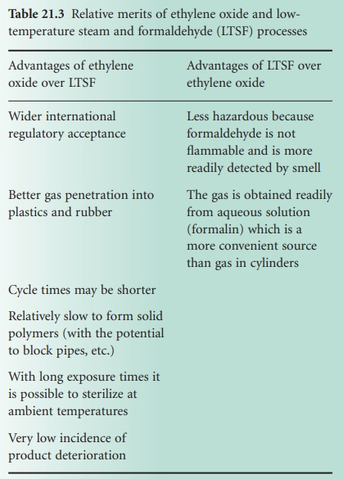

- STERILIZER DESIGN AND OPERATION

An LTSF sterilizer is designed to operate with sub-atmospheric-pressure steam. Air is removed by evacuation and steam is admitted to the chamber to allow heating of the load and to assist in air removal. The sterilization period starts with the release of formaldehyde by vaporization from formalin (in a vaporizer with a steam jacket) and continues through either a simple holding stage or through a series of pulsed evacuations and steam and formaldehyde admission cycles. The chamber temperature is maintained by a thermostatically controlled water jacket, and steam and condensate are removed via a drain channel and an evacuated condenser. At the end of the treatment period formaldehyde vapour is expelled by steam flushing and the load is dried by alternating stages of evacuation and admission of sterile, filtered air. A typical pulsed cycle of operation is shown in Figure 21.8.

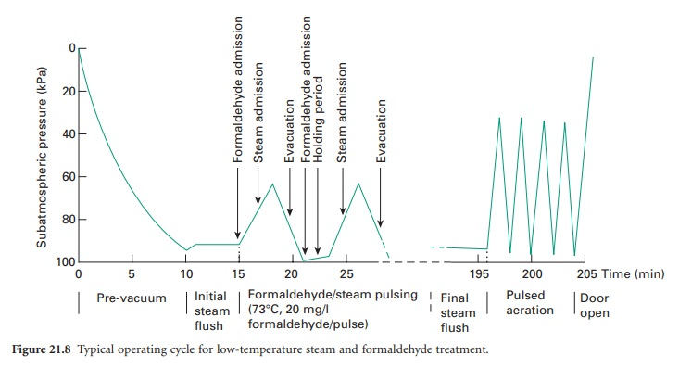

D. RADIATION STERILIZATION
Radiation sterilization relies on ionizing radiation, primarily gamma, X-ray or electron radiation, to deactivate microorganisms such as bacteria, fungi, viruses and spores. Due to numerous advantages over heat or chemical based sterilization techniques, this method is particularly attractive in medicine and healthcare-related fields. For example, radiation sterilization is readily applied during tissue allograft preparation, pharmaceutical packaging and medical device manufacturing.

Sources of Radiation

Three forms of radiation commonly used for commercial radiation sterilization include gamma radiation, electron beam (e-beam) radiation and X-ray radiation

Electromagnetic or particulate radiation can be energetic enough to ionize atoms or molecules (ionizing radiation), which is the number 1 type of radiation; or less energetic (non-ionizing radiation) been the second type of radiation.

1.

Ionizing radiation sterilization
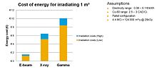
Efficiency illustration of the different radiation technologies (electron beam, X-ray, gamma rays)
The safety of irradiation facilities is regulated by the United Nations International Atomic Energy Agency and monitored by the different national Nuclear Regulatory Commissions (NRC). The radiation exposure accidents that have occurred in the past are documented by the agency and thoroughly analysed to determine the cause and improvement potential. Such improvements are then mandated to retrofit existing facilities and future design.

2.

Non-ionizing radiation sterilization.
Ultraviolet light irradiation (UV, from a germicidal lamp) is useful for sterilization of surfaces and some transparent objects. Many objects that are transparent to visible light absorb UV. UV irradiation is routinely used to sterilize the interiors of biological safety cabinets between uses, but is ineffective in shaded areas, including areas under dirt (which may become polymerized after prolonged irradiation, so that it is very difficult to remove). It also damages some plastics, such as polystyrene foam if exposed for prolonged periods of time.

