MATRIC NUMBER: 17/MHS01/314

NAME: UMOH EDIDIONG ENOBONG

DEPARTMENT: MECHANICAL ENGINEERING

COURSE: ENGINEER IN THE SOCIETY

SCOPE OF WORK
Rehabilitation of Alfa Belgore hall in Afe Babalola University, Ado-Ekiti to increase the amount of persons it can occupy.
The projects were carried out as follows:
- Evacuation of office equipments and furniture (2 weeks)
- Uninstallation of electrical fixtures (1 week)
- Removal of windows and doors (2 weeks)
- Site preparation (3 days)
- Removal of the roof (3 weeks)
- Breaking down unwanted walls (1 week)
- Building of areas where needed (2 weeks)
- Raising the building to add an extra floor/balcony (4 weeks)
- Re-roofing (3 weeks)
- Placement of doors and windows (2 weeks)
- ceiling placements (2 weeks)
- Repainting and re-decoration of walls (4 weeks)
- Re-wiring to accommodate new lighting structure (2 weeks)
- Installation of electrical fixtures (2 weeks)
- Replacement of furnitures and electrical applia bences (1 week)
2.
GNATT CHART
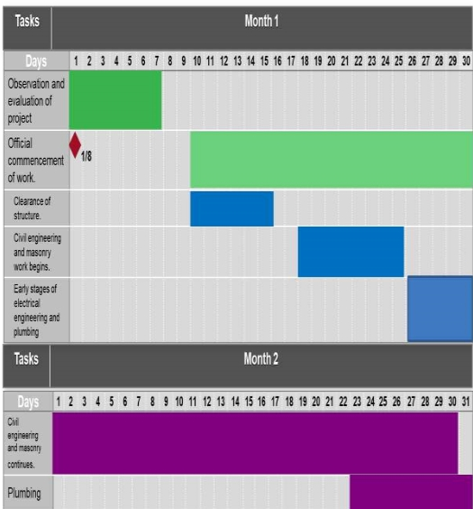

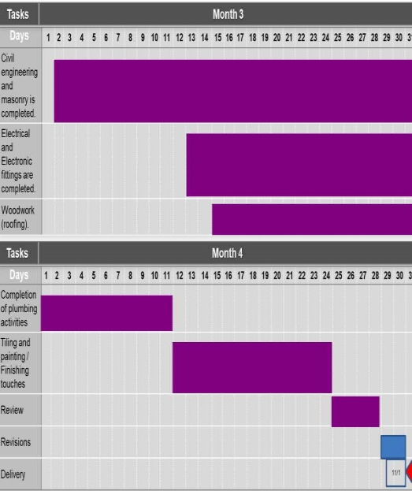

3.
Human resources needed:
- Engineering consultants
- Architect
- Artisans
- Mason’s
- Plumbers
- Civil engineers
- Mechanical Engineers
- Electrical engineers
- Water and waste engineers
TEAMS
The lead consultant is the architect.
ARTISANS: These are Carpenters, welders, etc, they are in charge of roofing and other jobs related to thier expertise. The would be 8 in number.
MASONS: These are in charge of the building and destruction of walls and some parts of the hall. They would be 15 in number.
PLUMBERS: These are in charge of the water pipe arrangement and installation. They would be 5 in number.
CIVIL ENGINEERS: These would be 4 in number. They are charge with the project implementation and supervision of the labourers.
MECHANICAL ENGINEERS: These would be 3 in number and charged to supervise the hands on work of some of the labourers.
ELECTRICAL ENGINEERS: These would be 3 in number and given the responsibility of re-wiring, installation of the electrical fixtures and equipments.
WATER AND WASTE ENGINEERS: These would be 2 in number. They are given the responsibility of ensuring that the building is provided with a good water flow system and waste is properly disposed of.

4.
The site was secured to protect vehicles and non-construction workers from getting harmed during the construction process.
The equipments being used can be placed carelessly or construction waste can be discarded from the building in way that would be hazardous to anything in the buildings surrounding.
5.
BILL OF ENGINEERING MEASUREMENT AND EVALUATION.
S/N | TASKS | SUB TASKS | Percentage TEC | Amount(NGN)
1 | Consultancy fee | Chief consultant | 15% | 1,500,000
2 | Site preparation and clearing | Interlocking | 5% | 500,000
 | after construction.
 |  | Fencing
 |  | Felling of trees and removal of obstacles
 |  | Sweeping and cleaning
3 | Transport costs. | Movement of tools. | 12% | 1,200,000
 |  | Movement of workers.
4 | Profit |  | 20% | 2,000,000
5 | Miscellaneous | Small payments | 10% | 1,000,000
 |  | Workers’ feeding
 |  | Accommodation
6 | Other expenses | Testing and inspection. | 38% | 3,800,000
 |  | Workers’ wages
 |  | Insurance
 |  |  | Total | 10,000,000

6.
PAYMENT SCHEDULE
S/N | Work Description | Percentage TEC required | Time Payment is Due | Amount (NGN)
1 | Mobilization : Down-payment | 30% | On commencement of project. | 30,000,000
 | of wages, importation of some materials and machinery, procurement of accommodation.
2 | Second payment : Procurement of materials, payment of worker, miscellaneous costs and other expenses. | 30% | After 50% completion of project. | 30,000,000
3 | Final payment : Completion of wages, profits, consultancy fees. | 40% | Completion and | 40,000,000
 |  |  | Handover

7.
BEME stands for Bill of Engineering Measurement and Evaluation. It is a tool used before, during and post-construction to assess and value the cost of construction work.
Defect liability period is period of time following practical completion during which a contractor remains liable under the building contract for dealing with any defects which become apparent. It is usually a period of around six or 12 months but it can vary depending on the contract used.
A lead consultant is a person that is in charge of communication between the client and the rest of the construction teams.
EIA stands for environmental impact assessment.It is a process of evaluating the likely environmental impacts of a proposed project or development taking into account interrelated socio-economic, cultural and human-health impacts, both beneficial and adverse.

