NAME: FIDUDUSOLA FISEYE SAMUEL

MATRIC N0: 18/ENG06/023

DEPARTMENT: MECHANICAL ENGINEERING

COURSE: ENGINEER IN SOCIETY (ENG284)

ASSIGNMENT TITLE: ENGINEERING CONSULTANCY ASSIGNMENT

The Alfa Belgore Rehabilitation project is ongoing. As a designated Student Consulting Engineer you are expected to do the following 1. Outline the Scope of work in detail in order of occurrence
- Relocating of personnel’s i.e ICT
  - Clearing out of equipment and moveable materials i.e chairs, curtains, windows etc
  - Site securing
  - Removal of wiring and plumbing
  - Removing of roofing
  - Building of temporary storage house
  - Building of water reservoir
  - Scaffolding
  - Main work begins
  - Roofing
  - Installation of wiring and plumbing
  - Plastering
  - screeding
  - repainting
  - cleaning

- Prepare a project Gant Chart
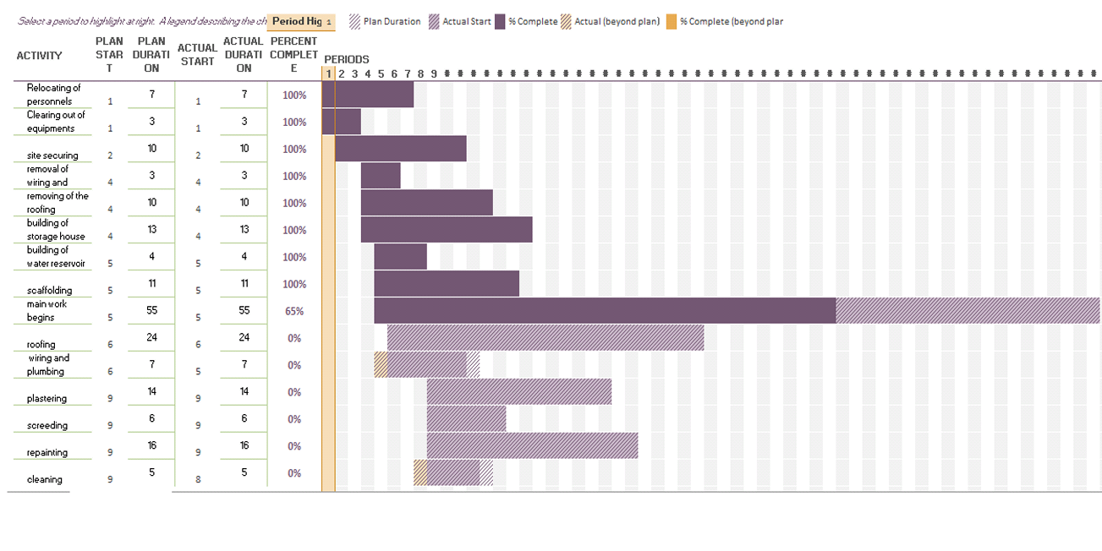

- List all the human resources needed and constitute the Project Team stating who the Lead Consultant is.
Human resources
- construction laborers
- painters
- blacksmiths
- plumbers
- carpenters

project team
  - designer
  - consulting engineer (Lead Consultant)
  - civil engineer • structural engineer
  - electricians
  - Project Manager (responsible for delivering the project)
  - Main contractor
  - Site manager (clerk of works)
  - Site engineer
  - Sub-contractors
  - project board
  - client representatives
  - design team
  - General supervisors.

- . Explain why the site was secured
  - For security; to avoid unnecessary theft.
  - For safety; to prevent staffs/workers and students from objects that may possible cause injuries
  - To prevent accidents

- Develop a BEME for the project by lump sum projections including 10% of the total estimated cost (tec) as Miscellaneous, 15 % tech as consultancy fee, 5% tec for site preparations and clearing after completion, 12% of tec for transport cost. 20% tec as profit

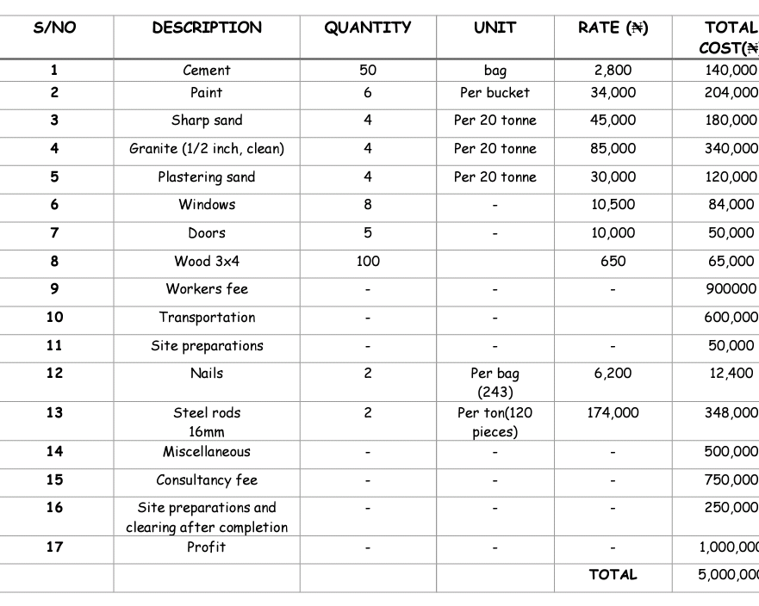

- Prepare a payment schedule as follows
(a) 30 % tec for Mobilisation (b) Next 30 % tec at 50% completion (c) Final Payment of 40 %tec at completion and hand over. Retain 10 % tec for a 6 months Defect liability period

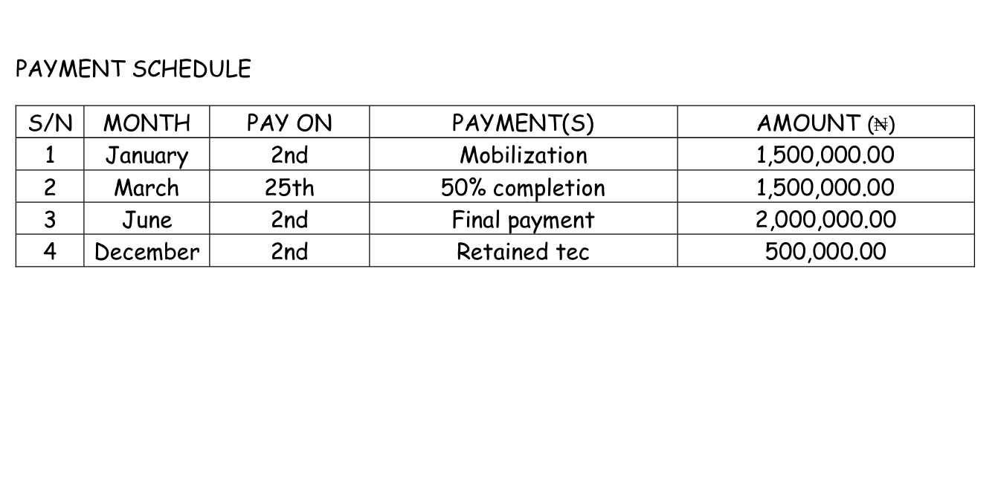
- What is BEME, Defect Liability Period, Lead Consultant, Project Life cycle, Environmental Impact Assessment (EIA)
- BEME - BEME stands for Bill of Engineering Measurement and Evaluation. It is a tool used before, during and post construction to assess and value the cost of construction works.
- Defect Liability Period - This is a period following practical completion during which a contractor remains liable under the building contract for dealing with any defects which become apparent. Using a period of around 6 or 12 months but can vary depending on the contract used. any defects or faults which arise during this period (for example; due to defective materials or workmanship) must be put right by the contractor at its own expense.
- consultant - The consultant that directs the work of the consultant team and is the main point of contact for communication between the client and the consultant team.
- Project life cycle - The sequence of phases that a project goes through from its initiation to its closure. The number and sequence of the cycle are determined by the management and various other factors like needs of the organization involved in the project, the nature of the project, and its area of application.
- Environmental Impact Assessment (EIA) - This is the assessment of environmental sequences of a plan, policy, program, or actual projects prior to the decision to move forward with the proposed action.

