NAME: ZAKKA ANDERSEN RISHAMMAH

MATRIC NO: 19/ENG03/035

COURSE: ENG 284

PROJECT: THE ALFA BELGORE REHABILITATION PROJECT.

SCOPE OF WORK
Based on the current condition of the building, provide a narrative scope of work describing in detail construction work to be performed. The scope of work for rehabilitation projects should be comprehensive and should address each significant building component and state whether it is to be repaired and/or replaced and to what extent. The scope should cover heating and ventilation; electrical; plumbing, including fixtures, cabinets, and appliances; windows and doors; interior finishes; public spaces; security systems; lead and asbestos; roof; building structure and building envelope. The narrative should address whether the capacity, age, and effectiveness of existing systems was considered. Be sure to address site conditions, such as soil, hazardous materials, and predictable subsurface conditions such as rock and groundwater, wetlands, etc. based on a due diligence review of available information, as appropriate. Identify any areas not accessible for inspection, provide an analysis of potential implications and an estimate of related additional costs. Therefore, the construction works to be performed include:
- A preliminary list is drafted to show the project specifications and a simple breakdown of the project requirements is created.
- A team of professionals is then brought to the site to do a brief survey and determine how many workers would be required to meet project delivery deadline.
- The clearance of the valuables within the structure commences, starting with the removal of furniture, electrical and mechanical appliances (such as computers, printers and other gadgets, speakers and sound systems). These items are then moved to another location.
- The fixed equipment in the structure are removed. (Air conditioners, partitioning frames, doors, windows).
- The perimeter of the structure is closed off using aluminum sheets and bamboo sticks, to restrict movement in and out of the working area.
- The roofing sheets are taken off.
- The civil engineers and laborers commence the additional construction work required, in conjunction with the electrical engineers to specify areas where additional electrical wiring spaces are required and the plumbers/water and waste water engineering team for plumbing and pipe layout space specifications.
- On completion of the added floor, the roofing team arranges the sheets and put them in place.
- The painters and tilers come in to work together and simultaneously do their jobs in sections.
- The debris around the site is cleared and properly disposed.
- The workers now place all initially removed equipment in their new positions, and installs the new additional appliances in their appropriate location.

HUMAN RESOURCES NEEDED FOR THE PROJECT.
1. Engineering Consultants
2. Civil engineers
3. Mechanical engineers
4. Electrical engineers
5. Water and waste water engineers
6. Technicians
7. Artisans (Carpenters)
8. Laborers (Masons and Plumbers)
PROJECT TEAM AND THEIR DESIGNATIONS.
- Engineering consultants: The team constitutes of three (3) consultants; an Engineering Professor (Lead consultant), and two Engineering Doctors.
- Mechanical engineers: Two (2) mechanical engineering doctors serve as project sub-managers, supervising the rest of the engineers in hands-on project work and achievement of project objectives.
- Civil engineers: There are four (4) civil engineers enlisted for the project implementation. These four engineers have one of them as the civil leader, and they supervise the laborers and artisans in project actualization.
- Electrical engineers: On this project, there are five (5) electrical and electronics engineers, handling the wiring and electrical and electronics components installation.
- Water and Waste Water engineers: These two (2) engineers have the duty of monitoring the creation and implementation of an effective water system and waste water disposal system for the structure by the plumbers and their apprentices.
- Artisans: The twenty artisans to work on the roofing aspect of the project are monitored and supervised by the project foreman (one of the supervising mechanical engineers), ensuring safety precautions are observed and effective delivery of quality service.
- Laborers: Forty laborers and ten plumbers are enlisted for the project, and are expected to do the majority of the heavy lifting in the course of the project completion.

Definition of Terms.
- BEME: Bill of Engineering Measurement and Evaluation (BEME) also referred to as 'Bill'; is a tool used before, during and post-construction to assess and value the cost of construction works. This includes the cost of materials, labor, equipment and all/any other resource(s) required for the success of any construction endeavor based on a predetermined scope and specification.
- Defect Liability Period: A defects liability period is a period of time following practical completion during which a contractor remains liable under the building contract for dealing with any defects which become apparent. Depending on the form of contract you are reading, it may also be referred to as a rectification period or defects correction period.
- Lead Consultant: Lead consultants have hands-on roles which involve the day-to-day running of continuing client projects. They are team leaders, analyzing and reviewing proposals from the team, providing appropriate solutions to problems, and making decisions on the way forward by acting as liaisons between the client and the consultancy team. Their work involves directly dealing with the client to clearly understand its needs, and to provide possible solutions for the client’s consideration. The team receives and works on the client’s information from the lead consultant.
- Project Life Cycle: A project life cycle is the sequence of phases that a project goes through from its initiation to its closure. The number and sequence of the cycle are determined by the management and various other factors like needs of the organization involved in the project, the nature of the project, and its area of application. The phases have a definite start, end, and control point and are constrained by time. The project lifecycle can be defined and modified as per the needs and aspects of the organization.
- Environmental Impact Assessment [EIA]: Environmental Impact Assessment is defined as an activity designed to identify the impact on the bio-geophysical environment, on man and well-being, of legislative proposals, projects, policies and operational procedures and to interpret and communicate information.

PROJECT GANTT CHART

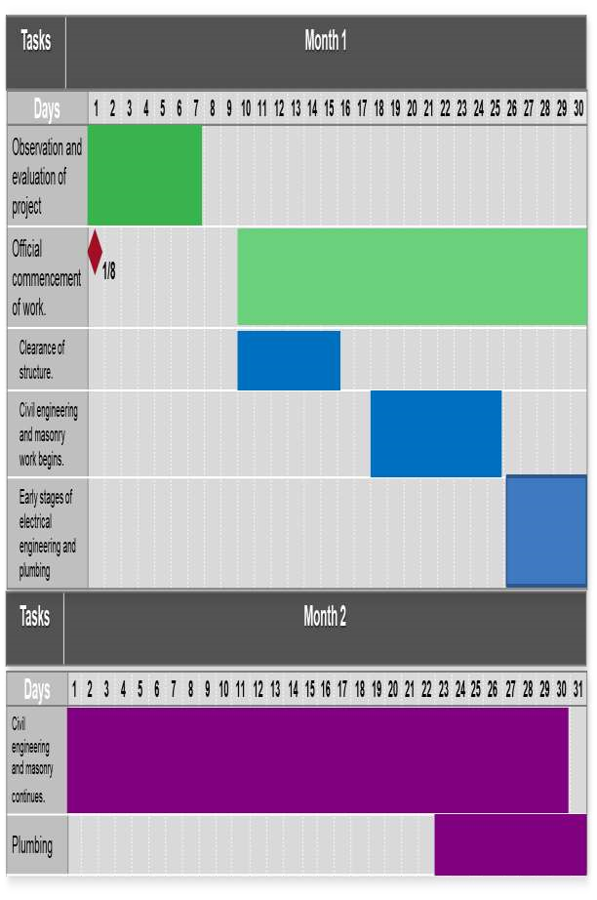
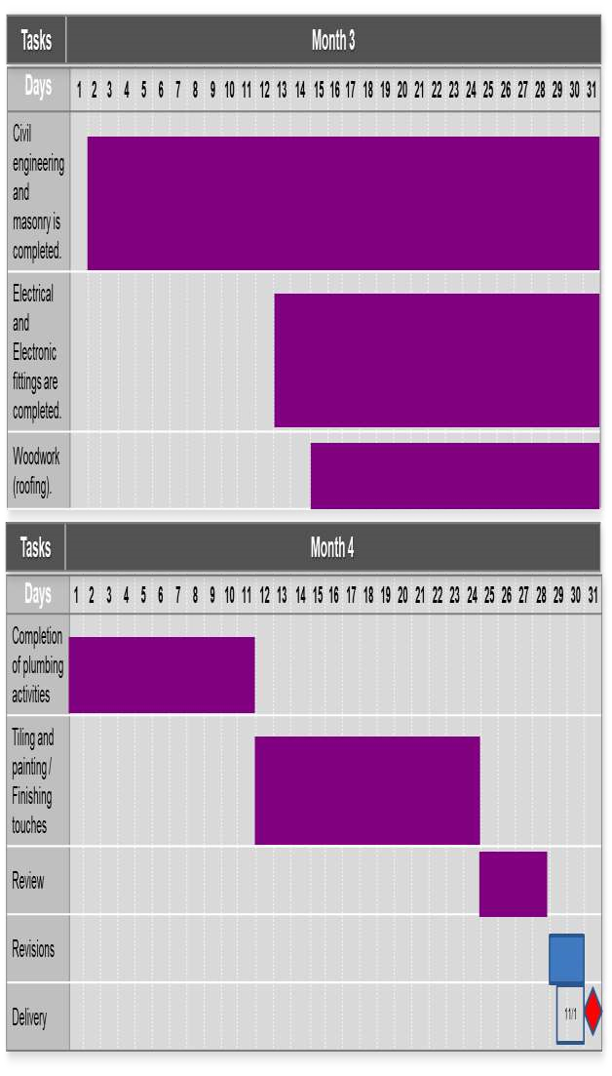

Bill of Engineering Measurement and Evaluation (BEME) for the Rehabilitation and Expansion of Alfa Belgore Hall.
S/N | Tasks | Sub-tasks | Percentage  TEC | Amount (NGN)
1. | Consultancy fee | Chief consultant | 15% | 15,000,000
 |  | Other consultants
2. | Site preparation and clearing  after construction. | Interlocking | 5% | 5,000,000
 |  | Fencing
 |  | Felling of trees and removal of obstacles
 |  | Sweeping and cleaning
3. | Transport costs. | Movement of tools. | 12% | 12,000,000
 |  | Movement of workers.
4. | Profit |  | 20% | 20,000,000
5. | Miscellaneous | Small payments | 10% | 10,000,000
 |  | Workers’ feeding
 |  | Accommodation
6. | Other expenses | Testing and inspection. | 38% | 38,000,000
 |  | Workers’ wages
 |  | Insurance
 |  |  | Total | 100,000,000

Payment Schedule for the Project.
S/N | Work Description | Percentage TEC required | Time Payment is Due | Amount (NGN)
1. | Mobilization : Down-payment  of wages, importation of some materials and machinery, procurement of accommodation. | 30% | On commencement of project. | 30,000,000
2. | Second payment : Procurement of materials, payment of worker, miscellaneous costs and other expenses. | 30% | After 50% completion of project. | 30,000,000
3. | Final payment : Completion of wages, profits, consultancy fees. | 40% | Completion and  Handover | 40,000,000

