18/MHS07/044
ONWUGHALU CHIAMAKA VIVIAN
PHA 208(MOLECULAR CELL BIOLOGY AND GENETICS)
QUESTION; Discuss in detail and cite your references, the transcription of DNA molecule to RNA
Answer;
Key points:
Transcription is the process in which a gene's DNA sequence is copied (transcribed) to make an RNA molecule.
RNA polymerase is the main transcription enzyme.
Transcription begins when RNA polymerase binds to a promoter sequence near the beginning of a gene (directly or through helper proteins).
RNA polymerase uses one of the DNA strands (the template strand) as a template to make a new, complementary RNA molecule.
Transcription ends in a process called termination. Termination depends on sequences in the RNA, which signal that the transcript is finished.
NB;
RNA polymerase is crucial because it carries out transcription, the process of copying DNA (deoxyribonucleic acid, the genetic material) into RNA (ribonucleic acid, a similar but more short-lived molecule).
Transcription is an essential step in using the information from genes in our DNA to make proteins. Proteins are the key molecules that give cells structure and keep them running. Blocking transcription with mushroom toxin causes liver failure and death, because no new RNAs—and thus, no new proteins—can be made.
Transcription is essential to life, and understanding how it works is important to human health. Let's take a closer look at what happens during transcription.
Transcription overview
Transcription is the first step of gene expression. During this process, the DNA sequence of a gene is copied into RNA.
Before transcription can take place, the DNA double helix must unwind near the gene that is getting transcribed. The region of opened-up DNA is called a transcription bubble.

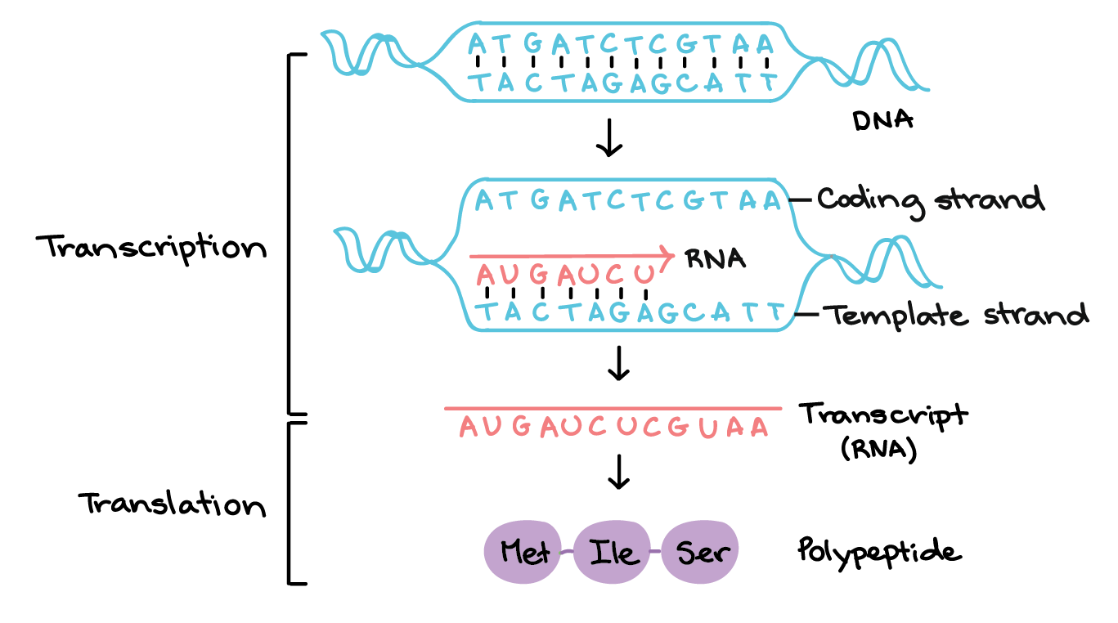
In transcription, a region of DNA opens up. One strand, the template strand, serves as a template for synthesis of a complementary RNA transcript. The other strand, the coding strand, is identical to the RNA transcript in sequence, except that it has uracil (U) bases in place of thymine (T) bases.
Example:
Coding strand: 5'-ATGATCTCGTAA-3' Template strand: 3'-TACTAGAGCATT-5' RNA transcript: 5'-AUGAUCUCGUAA-3'
In translation, the RNA transcript is read to produce a polypeptide.
Example:
RNA transcript: 5'-AUG AUC UCG UAA-3' Polypeptide: (N-terminus) Met - Ile - Ser - [STOP] (C-terminus)
Transcription uses one of the two exposed DNA strands as a template; this strand is called the template strand. The RNA product is complementary to the template strand and is almost identical to the other DNA strand, called the nontemplate (or coding) strand. However, there is one important difference: in the newly made RNA, all of the T nucleotides are replaced with U nucleotides.
The site on the DNA from which the first RNA nucleotide is transcribed is called the
+
1
+1
+1
plus, 1
site, or the initiation site. Nucleotides that come before the initiation site are given negative numbers.
RNA polymerase
RNA polymerases are enzymes that transcribe DNA into RNA. Using a DNA template, RNA polymerase builds a new RNA molecule through base pairing. For instance, if there is a G in the DNA template, RNA polymerase will add a C to the new, growing RNA strand.

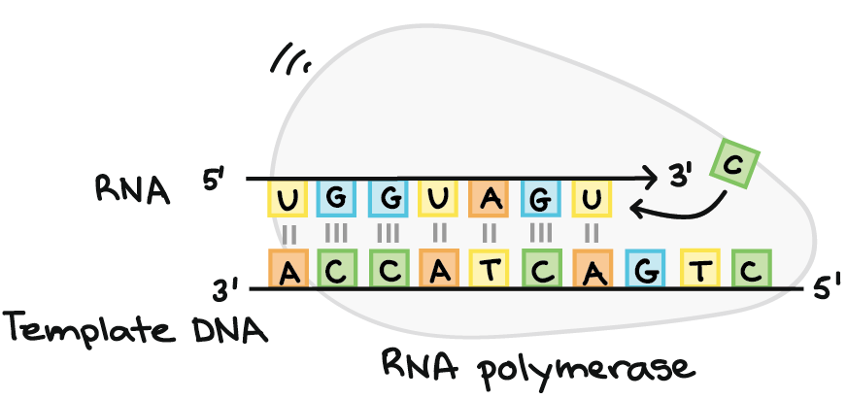
RNA polymerase synthesizes an RNA strand complementary to a template DNA strand. It synthesizes the RNA strand in the 5' to 3' direction, while reading the template DNA strand in the 3' to 5' direction. The template DNA strand and RNA strand are antiparallel.
RNA transcript: 5'-UGGUAGU...-3' (dots indicate where nucleotides are still being added at 3' end) DNA template: 3'-ACCATCAGTC-5'
RNA polymerase always builds a new RNA strand in the 5’ to 3’ direction. That is, it can only add RNA nucleotides (A, U, C, or G) to the 3' end of the strand.
[What do 5' and 3' mean?]
The two ends of a strand of DNA or RNA strand are different from each other. That is, a DNA or RNA strand has directionality.
At the 5’ end of the chain, the phosphate group of the first nucleotide in the chain sticks out. The phosphate group is attached to the 5' carbon of the sugar ring, which is why this is called the 5' end.
At the other end, called the 3’ end, the hydroxyl of the last nucleotide added to the chain is exposed. The hydroxyl group is attached to the 3' carbon of the sugar ring, which is why this is called the 3' end.
Many processes, such as DNA replication and transcription, can only take place in one particular direction relative the the directionality of a DNA or RNA strand.
You can learn more in the article on nucleic acids.
RNA polymerases are large enzymes with multiple subunits, even in simple organisms like bacteria. Humans and other eukaryotes have three different kinds of RNA polymerase: I, II, and III. Each one specializes in transcribing certain classes of genes. Plants have an additional two kinds of RNA polymerase, IV and V, which are involved in the synthesis of certain small RNAs.
Transcription initiation
To begin transcribing a gene, RNA polymerase binds to the DNA of the gene at a region called the promoter. Basically, the promoter tells the polymerase where to "sit down" on the DNA and begin transcribing.

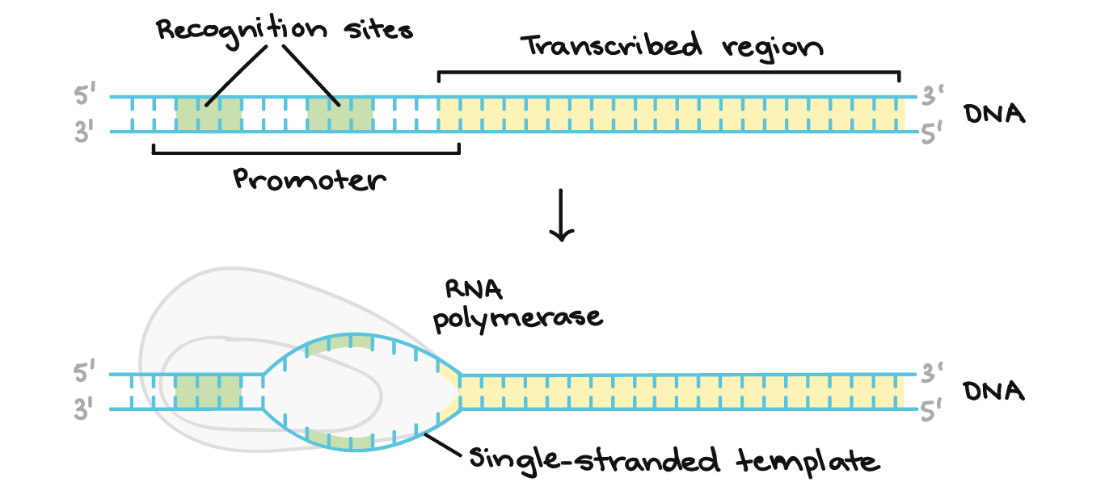

The promoter region comes before (and slightly overlaps with) the transcribed region whose transcription it specifies. It contains recognition sites for RNA polymerase or its helper proteins to bind to. The DNA opens up in the promoter region so that RNA polymerase can begin transcription.
Each gene (or, in bacteria, each group of genes transcribed together) has its own promoter. A promoter contains DNA sequences that let RNA polymerase or its helper proteins attach to the DNA. Once the transcription bubble has formed, the polymerase can start transcribing.
Elongation
Once RNA polymerase is in position at the promoter, the next step of transcription—elongation—can begin. Basically, elongation is the stage when the RNA strand gets longer, thanks to the addition of new nucleotides.
During elongation, RNA polymerase "walks" along one strand of DNA, known as the template strand, in the 3' to 5' direction. For each nucleotide in the template, RNA polymerase adds a matching (complementary) RNA nucleotide to the 3' end of the RNA strand.

Polymerization reaction in which a RNA nucleotide triphosphate is added to the existing RNA strand. The RNA nucleotide triphosphate has a series of three phosphate groups attached to it. The innermost phoosphate group reacts with the 3' hydroxyl on the nucleotide at the end of the existing strand, forming a phosphodiester bond that attaches the new nucleotide to the end of the chain. A pyrophosphate (molecule consisting of two phosphate groups) is lost in this process, and is later cleaved into two individual inorganic phosphates. In general, this reaction will occur only when an incoming nucleotide is complementary to the next exposed nucleotide in the DNA strand that serves as a template for RNA synthesis.
The RNA strand looks similar to DNA, except that it contains the base uracil in place of thymine and has ribose sugars (which have a hydroxyl group on the 2' carbon) in place of deoxyribose sugars.

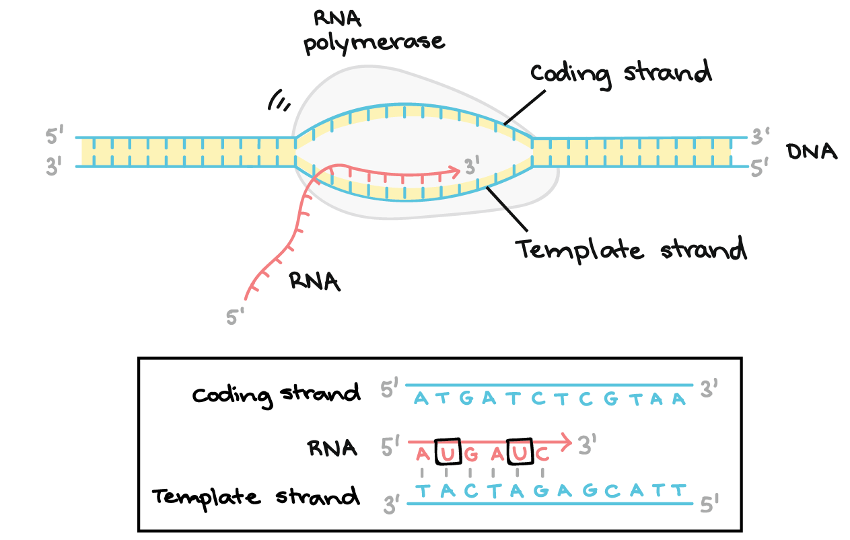
RNA polymerase synthesizes an RNA transcript complementary to the DNA template strand in the 5' to 3' direction. It moves forward along the template strand in the 3' to 5' direction, opening the DNA double helix as it goes. The synthesized RNA only remains bound to the template strand for a short while, then exits the polymerase as a dangling string, allowing the DNA to close back up and form a double helix.
In this example, the sequences of the coding strand, template strand, and RNA transcript are:
Coding strand: 5' - ATGATCTCGTAA-3'
Template strand: 3'-TACTAGAGCATT-5'
RNA: 5'-AUGAUC...-3' (the dots indicate where nucleotides are still being added to the RNA strand at its 3' end)

REFERENCE; www.khanaacademy.org

