NAME: BELEMA SUCCESS
COLLEGE: MEDICINE AND HEALTH SCIENCES
DEPARMENT: NURSING SCIENCE
COURSE CODE: ANA 210
MATRIC NUMBER: 18/MHS02/054

QUESTION:
- DESCRIBE THE IMPORTANCE OF VASCULATURE IN RELATION TO IMMUNE SYSTEMAND OUTBREAK OF PANDEMIC COVID-19 ON THE HUMAN BODY.
- SUBSATORIAL CANAL IS AN IMPORTANT AREA IN THE LOWER LIMB, DISCUSS.
- DESCRIBE THE EXTRAOCULAR AND INTRAOCULAR MUSCLES WITH THERE NERVE SUPPLY.

QUESTION 1
The immune system is a host defence system comprising many biological structures and processes within an organism that protects against disease. Even simple unicellular organisms such as bacteria possess a rudimentary immune system in the form of enzymes that protect against bacteriophage infections. The immune system is made up of organs that control the production and maturation of certain defense cells, the lymphocytes. Bone marrow and the thymus, a gland situated above the heart and behind the breast bone, are so-called primary lymphoid organs.
The blood vessel wall is largely composed of three cell types : Endothelial cells lining the entire vascular tree, Pericytes supporting the endothelium of microvessels and smooth muscles cells forming the bulk of large vessel walls. Each of these cell types interact with and alters the behaviour of infiltrating T cells in different ways, making these cells active participants in the processes of immune-mediated inflammation. Circulating T cells contact blood vessels either when they extravasate across the walls of microvessels into inflamed tissues or when they enter into the walls of larger vessels in inflammatory diseases such as atherosclerosis. Immune-mediated inflammation of peripheral tissues depends upon local recruitment of circulating leukocytes into an extravascular site. In most instances, leukocytes are recruited across the wall of post-capillary venules, which are composed of a continuous, one cell thick inner lining of endothelial cells (ECs) supported by an incomplete outer layer of pericytes (PCs) located within the basement membrane to which causes the ECs are attached.
Larger vessels are not directly involved in leukocyte trafficking into tissues, but may themselves be a target of inflammation, for example when arteries become involved by cell-mediated immune responses as occurs in atherosclerosis. In the arterial wall, the EC lining of the vessel is completely covered by vascular smooth muscle cells (SMCs), some of which are located within the vessel intima, consisting of the EC lining and the anatomic space immediately beneath the basement membrane of the ECs. Some mononuclear leukocytes may also be present in each of these compartments that can increase dramatically in number with inflammation. It is increasingly appreciated that resident cell populations within the environment in which an immune response develops can play a major role in shaping the form of that immune response. While much of this emphasis has been on the roles played by parenchymal cells in peripheral tissues, cells of the blood vessel wall are also positioned to affect lymphocytes and recent observations have provided a deeper understanding of how blood vascular ECs, PCs and SMCs interact with infiltrating T cells in adaptive immune responses that occur near microvessels of inflamed peripheral tissues and within the wall of inflamed macrovessels. While each vascular cell type displays that define it as an EC, PC or SMC, each of these populations may vary significantly in both phenotype and function depending on the anatomic location; i.e. their most defining feature is simply their anatomic position within the vessel wall. Heterogeneity among vascular cells arises from several causes. The body’s natural barriers against disease-causing intruders, for example, our skin, the mucous and hairs in our nose, and the acid in our stomachs, are part of our innate immune systems. Adaptive immunity develops over a lifetime of contact with pathogens and vaccines, preparations which help our immune systems to distinguish friend from foe. Until a vaccine is available, our immune systems will need to adapt clinicunaided to COVID-19.
QUESTION 2
The subsartorial also called the adductor canal or Hunter's canal, John Hunter was an anatomist and surgeon at London. Hunter’s operation for the treatment of popliteal aneurysm by ligating the femoral artery in the adductor canal is a landmark in the history of vascular surgery. The adductor canal is an intermuscular space situated on the medial side of the middle one-third of the thigh. It is an aponeurotic tunnel in the middle third of the thigh, extending from the apex of the femoral triangle to the opening in the adductor Magnus, the adductor hiatus (a gap between the adductor and hamstring attachments of the adductor Magnus muscle). It is approximately 15cm long.
Borders
It has anterior, posterior and medial walls
- The anterior wall is formed by the vastus medialis
- The posterior wall or floor is formed by the adductor longus
above and the adductor magus below.
- The medial wall or roof is formed by a strong fibrous
membrane joining the anterior and posterior walls.
- The roof is overlapped by the Sartorius.
The subsartorial plexus of nerves lies on the fibrous roof of the canal under cover of the sartorius.

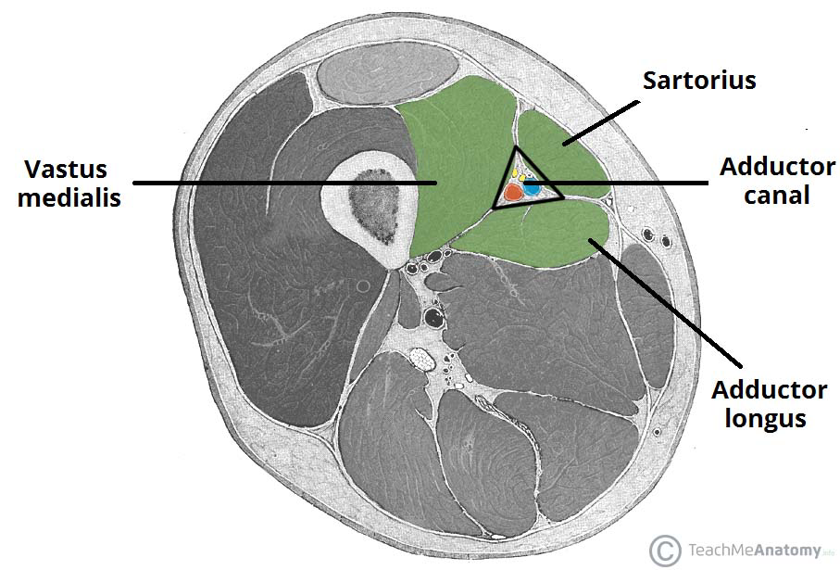

Contents:
- The femoral artery enters the canal at the apex of the femoral triangle. Within the canal it gives off muscular branches and a descending genicular branch. The descending genicular artery is the last branch of the femoral artery arising just above the hiatus magus.
- The femoral vein lies posterior to the femoral artery in the upper part and lateral to the artery in the lower part of the canal.
- The saphenous nerve crosses the femoral artery anteriorly from lateral to medial side.
- The nerve to the vastus medialis.
- Two divisions of the obturator nerve (ant division emerges at the lower border of the adductor longus to give branches to the subsartorial plexus and ends by supplying the femoral artery while the posterior division runs on the anterior of the adductor magnus accompanies the femoral and popliteal arteries and ends by supplying the knee joint.

IMPORTANCE OF SUBSARTORIAL CANAL
The adductor canal serves as a passageway for structures moving between the anterior thigh and posterior leg.
It transmits the femoral artery, femoral vein (posterior to the artery), nerve to the vastus medialis and the saphenous nerve – the largest cutaneous branch of the femoral nerve.
As the femoral artery and vein exit the canal, they are called the popliteal artery and vein respectively.

Clinical Relevance - Adductor Canal Block
In the adductor canal block, local anaesthetic is administered in the adductor canal to block the saphenous vein in isolation, or together with the nerve to the vastus medialis.
The block can be used to provide sensory anaesthesia for procedures involving the distal thigh and femur, knee and lower leg on the medial side. The Sartorius and femoral artery are used as anatomical landmarks to locate the saphenous nerve.
Clinical Relevance - Adductor Canal Compression Syndrome
Adductor canal compression syndrome describes entrapment of the neurovascular bundle within the adductor canal. A rare condition, it is usually caused by hypertrophy of adjacent muscles such as vastus medialis.
It is most common in young males, who may present with claudication symptoms due to femoral artery occlusion (more common) or neurological symptoms due to entrapment of the saphenous nerve.

QUESTION 3
The muscles of the eye are integral to its function and motion. Muscles directly associated with the eye include the; extraocular muscles which control the external movement of the eye; the intraocular muscles, which are responsible for pupil accommodation and reaction to light; and the protractor and retractors of the eyelids. Deficits in the muscles or the nerves innervating these muscles can result in functional impairment of the involved structures.
Structure and Function
The intraocular muscles include the ciliary muscle, the sphincter pupillae and the dilator pupillae. The ciliary muscle is a smooth muscle ring that controls accommodation by altering the shape of the lens, as well as controlling the flow of aqueous humor into Schlemm's canal. The ciliary muscle is attached to the zonular fibers which suspend the lens. Upon contraction of the ciliary muscle, the tension on the lens is lessened which causes it to adopt a more spherical shape to focus on near objects. Relaxation of the ciliary muscle has the opposite effect, optimising distant focus. The sphincter pupillae and dilator pupillae are also composed of smooth muscle. The sphincter pupillae encircles the pupil and is responsible for the constriction of its diameter, while the dilator muscle is arranged radially and increases the pupillary diameter.
There are three primary axes of ocular movements: vertical, transverse, and anteroposterior. Rotation around the vertical axis results in either adduction (medial movement) or abduction (lateral movement) of the eye. Rotation around the transverse axis causes elevation (superior motion) or depression (inferior motion). The anteroposterior axis enables movement of the superior pole of the eye medially (intorsion) or laterally (extorsion). The rotations around the anteroposterior axis allow the eye to adjust to tilting of the head. The medial rectus muscle is responsible for medial rotation around the vertical axis, and the lateral rectus lateral rotation. The superior rectus muscle primarily elevates the eye and contributes to adduction and intorsion. The inferior rectus depresses and laterally rotates the eye and contributes to adduction and extorsion. The superior oblique abducts, depresses, and medially rotates the eye, while the inferior oblique abducts, elevates, and laterally rotates the eye.
The primary retractor of the upper eyelid is the levator palpebrae superioris, which is a skeletal muscle. The superior tarsal muscle (Müller's muscle) is comprised of smooth muscle and also contributes to the elevation of the upper eyelid. In the lower eyelid, the retractors are the capsulopalpebral fascia and the inferior tarsal muscle. The orbicularis oculi is the main protractor (closure) of the eyelids. It is a flat, ring like band of skeletal muscle surrounding the anterior orbit composed of three parts: the orbital portion, the palpebral portion, and the lacrimal portion.
The ciliary muscle and both pupillary muscles are cranial neural crest derivatives and develop from mesenchyme of the choroid.
The extraocular muscles, including the levator palpebrae superioris, are derivatives of periocular mesenchyme. Five of the six extraocular muscles originate at the Annulus of Zinn (a tendinous ring), while the inferior oblique originates on the orbital portion of the bony maxilla. Three patriotic somites found anterior to the developing ear of the embryo are responsible for the development of the extraocular muscles. These three somites correspond with the distribution of cranial nerves III, IV, and VI.
The orbicularis oculi is derived from mesenchyme of the second pharyngeal arch, and forms from mesoderm of the eyelid.
Blood Supply and Lymphatic
The majority of the blood supply to the orbit is supplied by the ophthalmic artery which branches off of the internal carotid artery. A branch of the external carotid artery, the infra-orbital artery, also contributes blood supply to the orbital floor. Branches of the ophthalmic artery include the central retinal, supra-orbital, supratrochlear, lacrimal, dorsal nasal, short posterior ciliary, long posterior ciliary, posterior ethmoidal, anterior ethmoidal, and anterior ciliary (off of the muscular branches of the ophthalmic artery) arteries. Except for the central retinal artery and the ciliary arteries, which supply intraocular structures, these branches, as well as the infra-orbital artery off of the external carotid, all contribute to the vascular supply of the extraocular muscles and structures. The superior and inferior ophthalmic veins are responsible for venous drainage of the orbit.
Nerves
The extraocular muscles are innervated by nerves that enter the orbit through the superior orbital fissure. The oculomotor nerve (CN III) divides into superior and inferior branches and innervates the superior, medial, and inferior recti, the levator palpebrae superioris, and the inferior oblique. It also carries presynaptic parasympathetic fibers to the ciliary ganglion. Sympathetic fibers of CN III contribute to upper eyelid retraction by innervation of the superior tarsal muscle (Müller's muscle). The trochlear nerve (CN IV) innervates the superior oblique, and the lateral rectus is innervated by the abducens nerve (CN VI). The orbicularis oculi is innervated by the temporal and zygomatic branches of the facial nerve (CN VII).
The ophthalmic nerve (CN V: V1) branches into the frontal, nasociliary, and lacrimal nerves. The ciliary ganglion is made up of postsynaptic parasympathetic nerve cell bodies associated with the ophthalmic nerve. The short ciliary nerves originate from the ciliary ganglion and carry parasympathetic and sympathetic fibers to the iris and ciliary body. The long ciliary nerves branch off of the nasociliary nerve and carry postsynaptic sympathetic fibers to the dilator pupillae and afferent fibers from the cornea and iris. The sphincter pupillae is parasympathetically-stimulated while the dilator pupillae is sympathetically-stimulated.
Clinical Significance
Strabismus occurs when the eyes are misaligned such that an object is not focused simultaneously on the fovea of each eye. A phoria is defined as the turning of an eye in (esophoria) or out (exophoria) upon occlusion of the opposite eye. Phorias are often asymptomatic but may degenerate into tropias. Tropias are recognized as spontaneous eye turn in the absence of an ocular occlusion. Tropias are often more prevalent with tiredness as phorias become more pronounced and the ability to compensate decreases. There are certain drugs which can result in temporary tropias.
Amblyopia results when the vision in one of the eyes is reduced because the eye and the brain are not working together properly. Strabismic amblyopia is the result of an eye misalignment and is treated initially by patching the good eye to force the child to use the amblyopic eye, and may ultimately require strabismus surgery. After age five, it is difficult to reverse amblyopic vision.
Extraocular muscle paralysis can occur due to disease or injury and may involve one or multiple muscles.
Oculomotor nerve palsy affects the majority of the extraocular muscles as well as the sphincter pupillae and the levator palpebrae superioris.
CN III palsy presents with a "down and out" positioning of the eyeball of the affected side with a fully dilated and non-reactive pupil. Abducens nerve palsy affects only the lateral rectus muscle and presents as an inability to abduct the eye on the affected side, with the eye reverting to an adducted position due to the unopposed pull of the medial rectus.

