NAME: OBODO JOSEPH CHIJIOKE

MATRIC NO: 18/ENG09/006

DEPARTMENT: AERONAUTICAL ENGINEERING

COURSE TITLE: THE ENGINEER IN SOCIETY

COURSE CODE: ENG284

PROJECT TITLE: REHABILITATION OF THE ALFA BELGORE HALL OF AFE BABALOLA UNIVERSITY

- SCOPE OF WORK
- PROJECT TITLE:
The project to be carried out is the renovation of the Alfa Belgore Hall of Afe Babalola University. The project is intended to increase the capacity of the hall to hold a greater number of occupants as well as introduce an Upstairs directed for the same purpose, renovate the convenience rooms to serve a larger number of people and for maintenance, build a larger back stage for adequate preparation before Church programmes of the Abuad Catholic Chaplaincy and the Abuad Chapel. These are a few reasons among others.

- CLIENT: Afe Babalola University.

- CLIENT ADDRESS: Km 8.5 along Afe Babalola Way, Ado-Ekiti, Ekiti.

- FOUNDATION:
Foundation deals with site clearing which in this case includes expansion and renovation which has to do with the removal of existing roof and asbestos, and selective demolition of the concrete work for the expansion. It also includes:
- Clearing of rubble
- General excavation for placing of framework and reinforcement of concrete.
- Installing of sewer lines and other utilities.
- Blockwork for the construction of blocks by mixing sand, cement and granite.

- FRAMING:
It encompasses the frameworks of all the materials necessary for the Structure and support of the building. It includes the reinforced concrete used in the structuring of the beams and columns of the building, timber or woodwork for door and window framing as well as the roof.

- ELECTRICAL INSTALLATIONS:
Electrical system is a network of conductors and equipment designed to carry, distribute and convert electrical power safely from the point of generation to the various loads around the building that consume the electrical energy. Its components include:
- PVC Pipes, knockout boxes, fittings like sockets, chandeliers, switches, wall roses, bulbs, wire cables of various sizes in mm (1.5, 2.5, etc.)
- Electrical gadgets such as Air conditioners, public address system, projectors, simulators etc.
- Protection from Lightning by the use of specified Lightning conductors.

- INSULATION:
Insulation encompasses protection from various pollutants such as thermal pollution through loss or gain of heat through the ceiling, floors, windows, and doors, noise pollution, infiltration of moisture and water especially during rainfalls. This is done through:
- Use of double paneled fiber glass windows to make it sound proof, as well as padding of the walls to reduce echoes.
- Plaster Of Paris(POP) used for ceiling to reduce influx and efflux of heat. Recommendation of Marble tiles for flooring to reduce heat on sunny or hot days.
- Double folding of the edges of the roofing tiles to prevent entry of water.

- PLUMBING/MECHANICAL:
This deals considerably with the installation and servicing of pipes which distributes water in the different parts of the house (for water and sewage flow). This system of Fluid transmission in the building consists:
- Vent pipes;
- fixture traps;
- waste pipes;
- sewers;
- drainage pipes and;
- devices within and outside the house for the same purpose.

- FINISHING:
The Finishing of the building is the final part of the construction process forming the final surface of a building. It protects the building from water infiltration, impact, frost, corrosion, abrasion etc and is also used for aesthetics. It is classified into two (2) namely:
- Exterior Finishing:
This includes plaster or mortar for surface rendering on concrete wall, screeding with resin or other moisture-resistant coating. Painting of the walls to give an aesthetic finish to the walls as well as preventing the influx of moisture consequently preventing the growth of algae on the walls.
- Interior Finishing:
This includes the use of resins for coatings, primers and plastering. Wall papering, floor finishing with the use of tiles (e.g marble tiles) also known as glazing.

- GANTT CHART

The Gantt chart is a type of bar chart that illustrates a project schedule from start to completion, durations and dependency relationship between working activities in a given project. It is named after the inventor Henry Gantt.

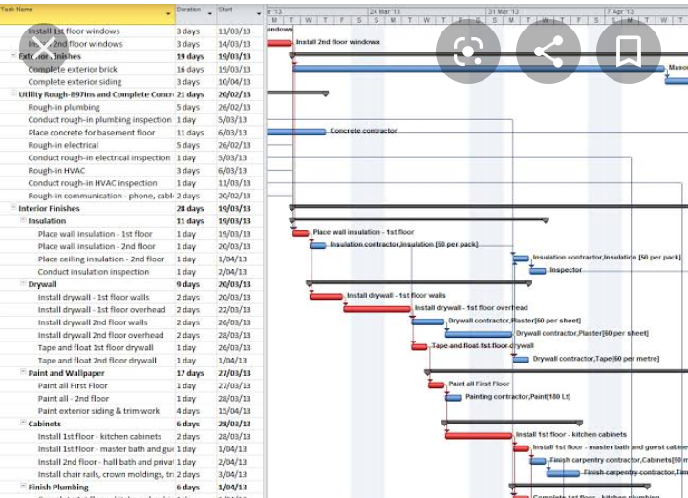

- PROJECT TEAM
The Project team consists of a number of individuals from the skilled to Unskilled Labour. For a project of this setting, the Lead consultant is the Architect of the project who has the design of the projected renovation. The team includes:
- Architect: As explained above is the Lead Consultant and designs the blueprints of the renovated structure for which he supervises the site work to ensure that the structure conforms with the design.
- Consultant Engineer: An adept in many engineering fields, the consultant engineer plays a delicate role in supervising the site work, coordinating the civil engineers, electrical engineers and water-waste engineers in the building construction, plumbing and electrical installations.
- Civil Engineer: The civil engineer takes of charge of supervising the framing, foundation, insulation designs etc. He makes direct contact with the masonry to supervise adequate dispensation in mixing blocks, raising columns etc.
- Electrical Engineers: They find their dispensation in managing the wiring, power distribution, and installation of electrical gadgets in the building.
- Water-waste Engineers: Their primary concern is the fluid network of the building for proper connection of water and sewage pipes and drainages.
The others include:
- Quantity Surveyors.
- Project Manager.
- First Aid workers, and Health and Safety inspectors.
- Storekeeper.
- Sub-contractors.
- Artisans and other employees.

- SITE SECURITY
A site is secured to ward off potential criminals, guide against intruders, who may be prone to various risks around the site. The site is secured with corrugated Zinc fences, locks, CCTV and security guards to checkmate internal crime by the staff.

- BILL OF ENGINEERING MEASUREMENT AND EVALUATION
The BEME contains the lump sum projections of the construction project. The total estimated cost (tec) has been approximated to Two Hundred Million Naira (follows):
- Miscellaneous: 10% of tec
- Consultancy fee: 15% of tec
- Site Preparation: 5% of tec
- Transport cost: 12% of tec
- Profit: 20% of tec
Miscellaneous = $\frac{10}{100}×200,000,000$ = 20,000,000
Consultancy fee = $\frac{15}{100}×200,000,000$ = 30,000,000
Site Preparation = $\frac{5}{100}×200,000,000$ = 10,000,000
Transport cost = $\frac{12}{100}×200,000,000$ = 24,000,000
Profit = $\frac{20}{100}×200,000,000$ = 40,000,000
Due to the limited information provided the figures for the construction are majorly estimates. Thus, the BEME will not contain Quantity or Unit price figures and estimates.
- Concrete/Masonry work = 11,500,000
- Metal work = 16,500,000
- Woodwork and roofing = 7,800,000
- Insulation = 5,400,000
- Doors and Windows = 2,700,000
- Finishing = 18,100,000
- Equipment = 6,500,000
- Mechanical/Plumbing = 3,500,000
- Electrical Installations = 4,000,000
S/N | DESCRIPTION | PRICE (Naira) | REMARK
1 | Miscellaneous | 20,000,000 | Unexpected expenses or cost during the project
2 | Consultancy fee | 30,000,000 | Cost of the Consultant Engineer’s services
3 | Site Preparation | 10,000,000 | Cost of clearing site area excavating and demolishing old structures as well as securing the site.
4 | Transport cost | 24,000,000 | Cost of transporting raw materials to the site
5 | Profit | 40,000,000 | Gross profit of the contractors’ VAT inclusive.
6 | Concrete/Masonry work | 11,500,000 | The cost of labour and materials e.g cement, sand, granite.
7 | Metal Work | 16,500,000 | Includes iron rods, burglary and nails.
8 | Woodwork and roofing | 7,800,000 | Converted timber logs and other important processed wood materials as well as roofing materials.
9 | Insulation | 5,400,000 | The requirements for noise, heat and moisture insulation of the hall.
10 | Doors and Windows | 2,700,000 | Construction and placement of the door and window constructs and the purchase of double paneled windows
11 | Finishings | 18,100,000 | Screeding, Painting, Glazing of tiles etc.
12 | Equipment | 6,500,000 | Public Address system, chairs, tables, air conditioners, fire alarms, fire retarders, fire extinguishers etc.
13 | Mechanical/Plumbing | 3,500,000 | Vent pipes, sewers, W/Cs, wash basins, water and sewage drainage pipes etc.
14 | Electrical Installations | 4,000,000 | Wall roses, bulbs, sockets, switches, wires and cables etc.

- PAYMENT SCHEDULE
THIS AGREEMENT, Made as of (20th February), in the Year of (2020)
Between the Owner: Afe Babalola University.
Km 8.5 along Afe Babalola Way,
Ado-Ekiti, Ekiti.
And the Contractor: Obodo Joseph Chijioke
RD111, 3rd Avenue,
Gwarinpa, Abuja.
For the Project: Rehabilitation of the Alfa Belgore Hall
Km 8.5 along Afe Babalola Way,
Ado-Ekiti, Ekiti.
- (30% tec for Mobilization): Start of the Project (Mobilization).
Amount = 60,000,000.
- (30% tec at 50% completion): 50% completion (After a 3months duration).
Amount = 60,000,000.
- (40% tec at completion and hand over): After a 6 months duration.
Amount = 80,000,000.
- (10% tec retained): During 6months Defect Liability period.
Amount = 20,000,000.
- DEFINITIONS
- BEME: It is an acronym that stands for Bill of Engineering measurement and Evaluation. It is a tool used before, during and post-project to assess and value the construction works. It includes the cost of materials, equipment, labour and any other resource(s) used for carrying out a project.

- Defect Liability Period: A defect liability period is a period of time following practical completion of a project during which a contractor is liable under building contract for dealing with any defects which become apparent. It usually lasts within the range of 12-24 months but, it can still vary depending on the project.

- Lead Consultant: This is the Consultant that directs the work of the consultant team and is the main point of contact between the client and the consultant team. The qualities of a lead consultant include:
- Industry experience
- Issue-specific knowledge
- Operating or Consulting Experience
- Seniority and Experience level
- Motivation etc.

- Project Life Cycle: A Project Life Cycle is the sequence of phases a project undergoes from start to completion under a specified time line. These phases are usually classified as five (5) namely:
- Initiation
- Planning
- Execution
- Control; and
- Closure.
- Environmental Impact Assessment (EIA):
This is the process of evaluating the likely environmental impacts of a proposed project or development, taking into account inter-related socio-economic, cultural and human-health impacts both beneficial and adverse.
The steps for performing an Environmental Impact Assessment (EIA) are:
- Select the project(s) to be assessed.
- Conduct an evaluability assessment.
- Prepare a research plan.
- Contract and staff the Impact Assessment.
- Carry out Field research and Analyze its results.
- Disseminate the Impact Assessment Findings.

