NAM; ALAMIN DALA UMAR
MATRIC NUMBER; 18/ENG03/024
DEPARTMENT; CIVIL ENGINEERING
COURSE TITLE; ENGINEER IN SOCIETY

[1]OUTLINE THE SCOPE OF WORK IN DETAIL IN ORDER OF OCCURRENCE
AFE BABALOLA the founder of the school intends to rehabilitate the former hall called Alfa Belgore to be increased in size for use in major programs and in order to have enough space, this including detailed technical design, supply and installation of sound equipment’s. This includes all works described in detail in the attached Bill of Quantities (BOQ).
The tender is sought for the design, building and supply-and-fix of equipment for a part of a separate selfstanding building. The building construction stage completed is gold shell and partition. The building has always been in use before the current student’ influx.
Presently approximately 4000 students can accommodate the hall.
The building that has been proposed for the rehabilitation of a bigger hall is one storied building with frame structure and masonry. The building has two different parts with a outer corridor. The partitions walls are made with cement in particularly good condition. The windows are steel made, single glazed.
The total floor area to be renovated is approximately 1170 Sqm. The hall areas are approximately 36X 12 m .The structural height CFL-CCL is approximately 4.6 m.
Front part of the building proposed for rehabilitation of hall that was also planned for that purpose.
There is a corridor on that building. The library space is properly planned for the model library and hall. There are several areas set aside for the Bookshop, ICT section and the store. The building structure’s (column, beam, panel roof) visual inspection showed no signs of structural defects.
The roof is constructed with RCC panel; on a top of this panel there is another part of roof that is constructed with wooden beams and CGI sheets to protect the RCC roof and to maintain the slop for rain water and snow fall. From eye judgment, RCC roof panels seem to be in a good condition but the additional roof is partially damaged and thus requires rehabilitation.
The existing steel window frames are in good condition; need to paint with enamel paint. All steel doors should be replaced. The steel windows and entrance doors are single glazed.
The under floor utilities (sewage) is condemned and is proven blocked. There is temporary water and power supply to the building.
The purpose of the rehabilitation, renovation of hall, Bookshop and ICT area and fix is to establish adequate facilities for the size of the accommodated students.
The architectural plan is included in the tender documents. The bidder should not change the main structural elements of the building and he does not need to calculate the main structural elements (frame structure) of the building. They bidder should submit other detailed calculation for all utility supplies like water, sewage, electricity and HVAC etc, as there is no proper utility supply systems on that building
Contractor should visit the site with DORI Engineer and should access the present condition of the building and its systems and make a technical and financial proposal for total rehabilitation works for the Hall, Bookshop, ICT and storage areas. The pricing document (BOQ) is prepared as a guidance document forbidders. All bidders are advised to satisfy themselves during the site visit that all possible items of work are included. The bidder is given an opportunity in the financial proposal form to include any additional items deemed necessary for proper completion of the works.

[2]PREPARE A PROJECT GANT CHART
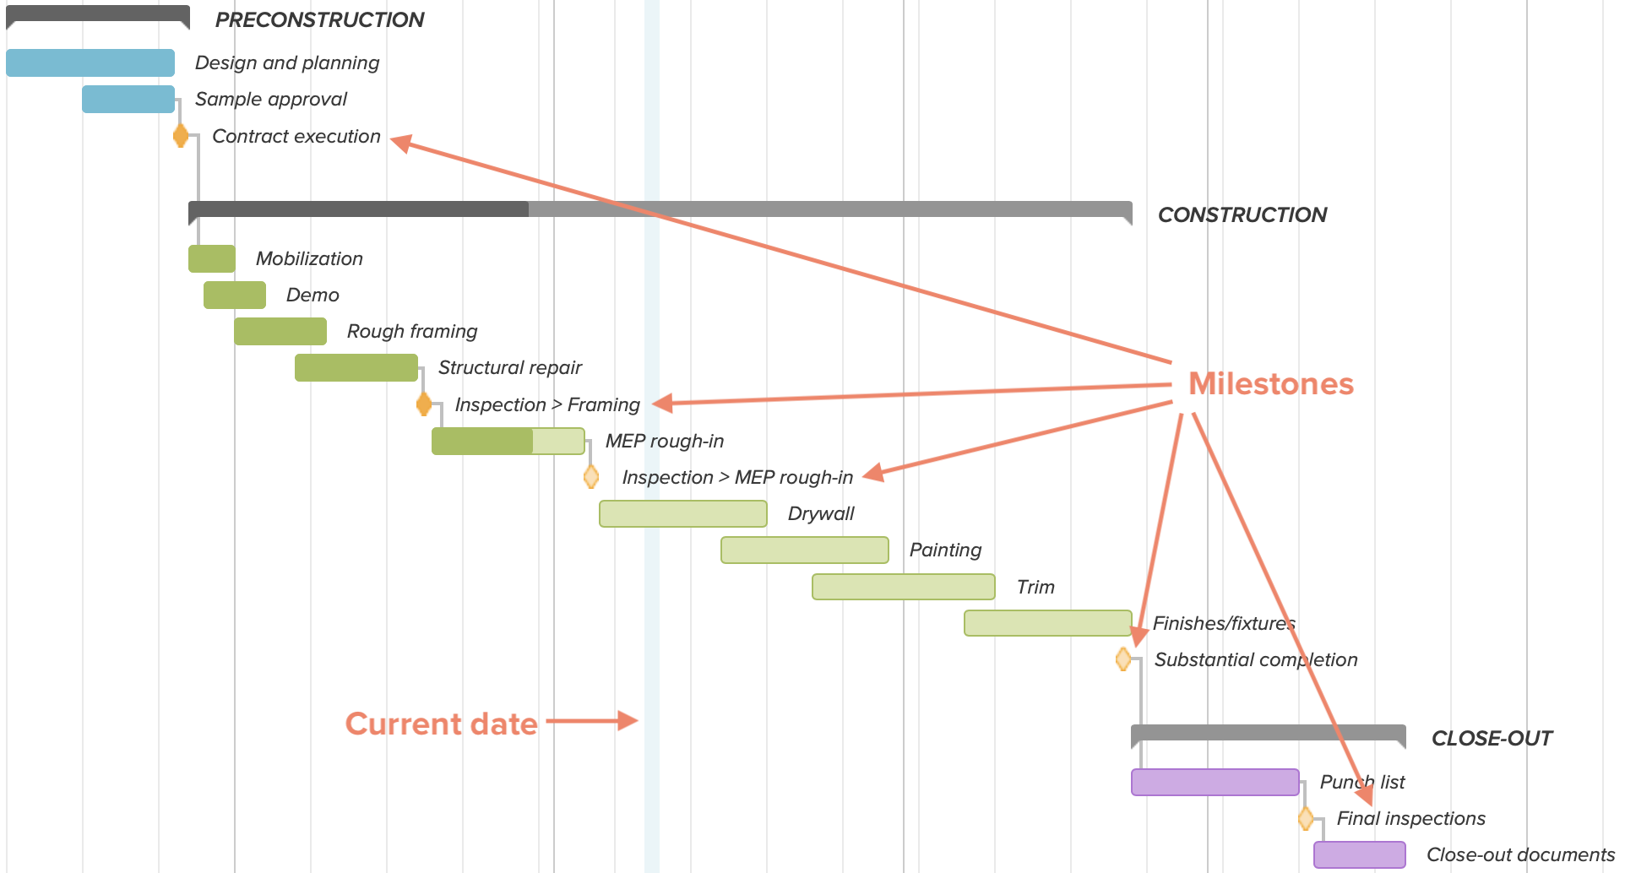

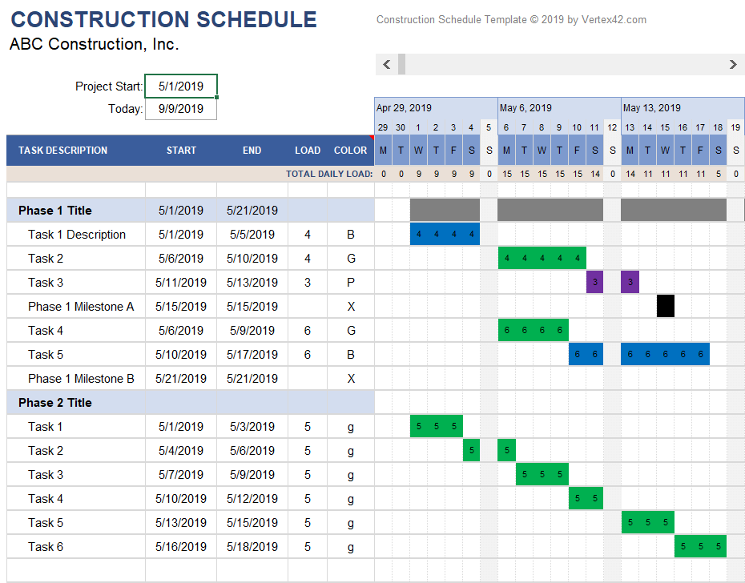
[3] LIST ALL THE HUMAN RESOURCES NEEDED AND CONSTITUTE THE PROJECT TEAM STATING WHO THE LEAD CONSULTANT IS;
- Architect,
- Engineer,
- General Contractor,
- Electrician and a Plumber.

Project team roles and responsibilities are largely defined by the specific area they address – ie. Architect – design, drawings; Engineer – structure, drawings; General Contractor – building, labor etc. These Construction Professionals have a professional responsibility to ensure project work conforms to building code requirements.

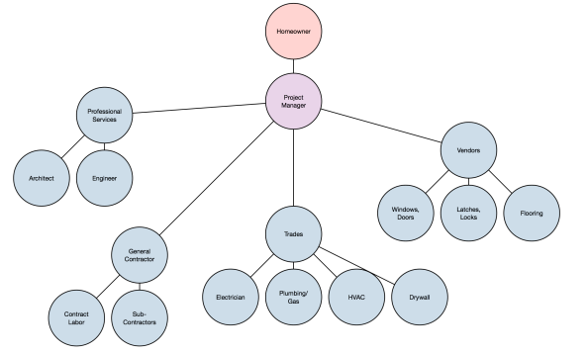
Excellence in Project Management with a successful outcome is achieved through a structured process that includes multiple phases:
- Initiation and Planning
- Execution
- Monitoring and Control
- Closeout
The process balances the key project constraints and provides a tool for making decisions throughout the project based on stakeholder values, performance metrics, established procedures and project goals.
When evaluating options, the whole-life value should be considered and not limited to the short term initial investment. Factors that affect the longer term costs of a facility, such as maintainability, useful service life, and resource consumption should be integrated into the decision matrix.
- Project Delivery Teams—How to assemble and effectively manage the project team.
- Risk Management—Provides details on how risk analysis is used as an organized method of identifying and measuring risk.
- Building Commissioning—Provides an overview of commissioning drivers, benefits, goals, and principles for improving building quality.

[4] EXPLAIN WHY THE SITE IS SECURED?
A building will start deteriorating if it is left empty for more than a few months. This can rapidly accelerate if damp gets inside due to broken windows, slipped tiles, and so on. An empty property may also be susceptible to vandalism, trespassing and theft. It is important therefore that a property is secured and made weathertight before work begins. Metal shutters can be rented, or sheets of plywood used to board up windows and doors. Waterproof sheets can be used to secure missing or damaged roof sections. Buildings and public liability insurance cover may be required to protect against damage, fire, construction works, and so on.

[5] DEVELOP A BEME FOR THE PROJECT BY LUMP SUM PROJECTIONS
NO | DESCRIPTION | QUANTITY | UNIT COST | TOTAL COST
1 | Roofing sheet | 100 | #1,400.00 | #140,000
2 | Cement bags | 500 | #180,000.00 | #90,000,000
3 | Trucks of sand | 12 | #45,000.00 | #585,000
4 | Trucks of Gravel | 13 | #35,000.00 | #420,000
5 | Glass which will be bought at 12x12 | 10 | #50,000.00 | #500,000
6 | Light Bulb Fittings | 40 | #8,000.00 | #320,000
7 | Light bulbs | 40 | #2,500.00 | #100,000
8 | Copper wires | 60 | #2,000.00 | #120,000
9 | Projector | 3 | #150,000.00 | #450,000
10 | T.V | 4 | #100,000.00 | #400,000
11 | Pipes of different sizes | 46 | #80,000.00 | #3,680,000
12 | Window | 13 | #450,000.00 | #5,850,000
13 | CCTV cameras for security | 12 | #25,000.00 | #300,000
14 | CCTV System | 1 | #50,000.00 | #50,000
15 | Total estimated cost |  |  | #102,915,000 |  | #102,915,000
16 | Miscellaneous (10%) |  |  | #10,291,500
17 | Consultancy fee (15%) |  |  | #15,437,250
18 | Site preparation and clearing after completion fee (5%) |  |  | #5,145,750
19 | Transportation (12%) |  |  | #12,349,800
20 | Profit (20%) |  |  | #20,583,00

[6]PREPARE A PAYMENT SCHEDULE
- 30% of Total Estimated Cost For Mobilization
- 30% of Total Estimated Cost
- Finally payment of 40% of Total Estimated cost at completion and hand over
- Retain 10% of Total Estimated cost for a 6 months defect liability period

[7] WHAT ARE THE FOLLOWING;

1.BEME: A BEME review is the systematic, logical and explicit appraisal of available information to determine the best evidence relating to an issue in health professional and medical education. A BEME review is designed to assist individual teachers, institutions and national bodies to make informed decisions about educational practice and policy. A BEME review is a description and evaluation of evidence pertinent to a clearly formulated topic/question that uses explicit scientific methodologies and methods to systematically identify, assemble, critically analyze and synthesize information relevant to the review topic.
- DEFECT LIABILITY PERIOD: A defects liability period is a period of time following practical completion during which a contractor remains liable under the building contract for dealing with any defects which become apparent. Depending on the form of contract you are reading, it may also be referred to as a rectification period or defects correction period. A defects liability period is usually a period of around six or 12 months but it can vary depending on the contract used. Any defects or faults which arise during this period (for example - due to defective materials or workmanship) must be put right by the contractor at its own expense.
- LEAD CONSULTANT: The lead consultant is the consultant that directs the work of the consultant team and is the main point of contact for communication between the client and the consultant team, except for on significant design issues where the lead designer may become the main point of contact.
- PROJECT LIFE CYCLE: A project life cycle is the sequence of phases that a project goes through from its initiation to its closure. The number and sequence of the cycle are determined by the management and various other factors like needs of the organization involved in the project, the nature of the project, and its area of application. The phases have a definite start, end, and control point and are constrained by time. The project lifecycle can be defined and modified as per the needs and aspects of the organization. Even though every project has a definite start and end, the particular objectives, deliverables, and activities vary widely. The lifecycle provides the basic foundation of the actions that has to be performed in the project, irrespective of the specific work involved.
- ENVIRONMENTAL IMPACT ASSESSMENT: Environmental Impact Assessment (EIA) is a process of evaluating the likely environmental impacts of a proposed project or development, taking into account inter-related socio-economic, cultural and human-health impacts, both beneficial and adverse.

