Instrumentation is a collective term for measuring instruments that are used for indicating, measuring and recording physical quantities. The term has its origins in the art and science of scientific instrument-making.
Instrumentation can refer to devices as simple as direct-reading thermometers, or as complex as multi-sensor components of industrial control systems. Today, instruments can be found in laboratories, refineries, factories and vehicles, as well as in everyday household use (e.g., smoke detectors and thermostats)
Stationary phase, in analytical chemistry, the phase over which the mobile phase passes in the technique of chromatography. Chromatography is a separation process involving two phases, one stationary and the other mobile. Typically, the stationary phase is a porous solid (e.g., glass, silica, or alumina) that is packed into a glass or metal tube or that constitutes the walls of an open-tube capillary. The mobile phase flows through the packed bed or column. The sample to be separated is injected at the beginning of the column and is transported through the system by the mobile phase. In their travel through the column, the different substances distribute themselves according to their relative affinity for the two phases.
Stationary phase, in analytical chemistry, the phase over which the mobile phase passes in the technique of chromatography. Chromatography is a separation process involving two phases, one stationary and the other mobile. Typically, the stationary phase is a porous solid (e.g., glass, silica, or alumina) that is packed into a glass or metal tube or that constitutes the walls of an open-tube capillary. The mobile phase flows through the packed bed or column. The sample to be separated is injected at the beginning of the column and is transported through the system by the mobile phase. In their travel through the column, the different substances distribute themselves according to their relative affinity for the two phases.

Chromatography
Chromatography usually is divided into two categories depending on the type of mobile phase that is used. If the mobile phase is a liquid, the technique is liquid chromatography; if it is a gas, the technique is gas chromatography. In a simple liquid chromatographic apparatus the stationary phase is held in place either in a column or on a plane (such as a plate of glass, metal, or plastic or a sheet of paper). In the case of a column, the lower end is loosely plugged, often with glass wool or a sintered glass disk. Prior to the separation, the column is filled with the mobile phase to a level that is slightly above the level of the stationary phase. The mixture to be separated is added to the top of the column and is allowed to drain onto the stationary phase.
In the most common form of chromatography, known as elution chromatography, the mobile phase is continuously added to the top of the column as solution flows from the bottom. The stationary phase must be continuously immersed in the mobile phase to prevent air bubbles from entering the column and impeding the mobile-phase flow. As the components of the mixture are flushed through the column, they are partitioned between the two phases depending on their attractions to the stationary phase. Because different mixture components have different attractions for the stationary phase, a separation occurs. The components that are more attracted to the stationary phase remain in the column longer, while those components that are less attracted are flushed more rapidly from the column. The separated components are collected as they exit the column.
REASONS WHY MOISTURE MEASUREMENTS ARE IMPORTANT IN PROCESS INDUSTRIES
Moisture is an unwanted contaminant that exists in industrial gases and the atmosphere, and is able to penetrate virtually any surface including such metals as copper, bronze and carbon steel. Therefore, it is important to first accurately measure the moisture content in order to subsequently control or remove the unwanted moisture. By understanding when and how to measure and manage moisture, we are able to improve product quality, minimize equipment damage, save energy, reduce costs, and meet contractual obligations. The downside of humidity includes condensation, corrosion and contamination.
Moisture can:
• Penetrate virtually any surface • Render test results useless • Result in poor product quality • Cause corrosion in tubing • Lead to ice formation at low temperature • Cause premature wear and equipment failure • React with other chemicals and gases
Clearly moisture has the capacity to cause expensive problems and potentially catastrophic failures

METHODS OF MOISTURE MEASUREMENT
KARL FISCHER MOISTURE METER METHOD (KF)
LOSS ON DRYING MOISTURE METER METHOD (LOD)
ELECTRICAL MOISTURE METER METHOD
MICROWAVE MOISTURE METER METHOD (MW)
NUCLEAR MOISTURE METER METHOD (NUC)

The reasons for measuring and controlling of process variable are
- To get regular feedback on error from the controller which will change the manipulated variable back to the desired value
- To be able to detect and monitor physical variables such as temperature pressure and flow
- To be able to avoid any chemical hazard such as explosion and hammering
- To ensure that the specific parameters for the process variable are maintained in order to acquire desired results

TYPICAL APPLICATIONS OF MAGNETIC FLOW METERS
- Magnetic flow meter is used to measure the velocity of conductive liquids in pipes such as water and acid
- Magnetic flow meter does not require much upstream and downstream straight run so they can be installed in relatively short meter runs
- Magnetic flow meter are used in water treatment plants to measure treated and untreated sewage

Working Principle of a Pressure Sensor
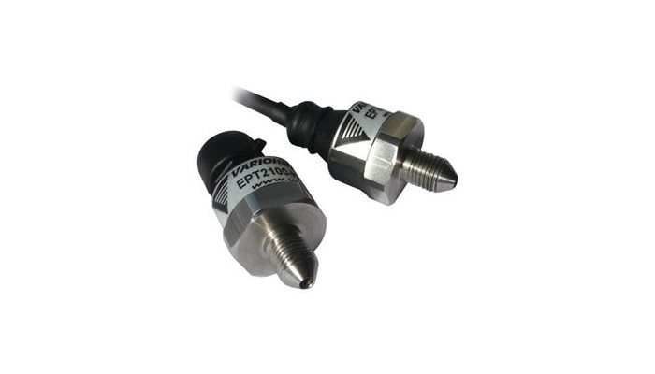
What is the working principle of a pressure sensor? A pressure sensor works by converting pressure into an analogue electrical signal.
The demand for pressure measuring instruments increased during the steam age. When pressure sensing technologies were first manufactured they were mechanical and used Bourdon tube gauges to move a needle and give a visual indication of pressure. Nowadays we measure pressure electronically using pressure transducers and pressure switches.
Static Pressure
Pressure can be defined as force per unit area that a fluid exerts on its surroundings. The basic physics of static Pressure (P), is calculated as force (F) divided by area (A).
P=F/A
The Force can be generated by liquids, gases, vapours or solid bodies.
The most commonly used pressure units are;
- Pa - [Pascal] in 1 Pa = 1(N/m²)
- Bar - [Bar] in 1 bar = 105 ð‘ƒð‘Ž
- psi: (pound(-force) per square inch)
Working Principle of a Pressure Transducer
Pressure transducers have a sensing element of constant area and respond to force applied to this area by fluid pressure. The force applied will deflect the diaphragm inside the pressure transducer. The deflection of the internal diaphragm is measured and converted into an electrical output. This allows the pressure to be monitored by microprocessors, programmable controllers and computers along with similar electronic instruments.
Most Pressure transducers are designed to produce linear output with applied pressure.
What are pressure sensors used for?
Pressure sensors are used in a range of industries, including the automotive industry, Biomedical Instrumentation, aviation and the marine industry, to name a few.
Pressure Sensors from Variohm
We can offer Pressure Sensors in the form of pressure transducers, pressure switches, combined pressure and temperature transducers, PCB mountable pressure sensors and hazardous area pressure sensors. Our Combined Pressure and Temperature Transducers are particularly well suited for applications where space is at a premium.
Our pressure transducers have a robust and modular design, stainless steel housing and a welded housing into the pressure port. They are available in miniature format starting from 12mm diameter.

Bourdon Pressure Gauge:

It works on the same principle as the snakelike party whistle, which opens up when you blow it.
In the Bourdon tube, a thin walled metal tube is bent in the form of a C. Attached to the free end is the lever which magnifies any motion of the free end of the tube. On the fixed end of the gauge is the fitting you thread of the system. As the pressure increases in the system, the air travels through the tube, and like the snake like whistle, the tube straightens as the pressure increases inside it. As the tube straightens, the pointer moves and indicates the pressure in psi.
It is a highly accurate, but a rather delicate instrument.

Pitot tube:
The pitot tube is a device to measure the local velocity along a streamline. The pitot tube has two tubes: one is static tube(b), and another is impact tube(a). The opening of the impact tube is perpendicular to the flow direction. The opening of the static tube is parallel to the direction of flow. The two legs are connected to the legs of a manometer or equivalent device for measuring small pressure differences. The static tube measures the static pressure, since there is no velocity component perpendicular to its opening. The impact tube measures both the static pressure and impact pressure (due to kinetic energy). In terms of heads the impact tube measures the static pressure head plus the velocity head.





