OREOLUWA OGUNLANA
19/sms04/029
SMS
MEDIA AND COMMUNICATION STUDIES

Write a report, of not more than two pages, on the Corona virus pandemic and the effects of the lockdown and restriction of movement on nigerians.

Epidemiology
As of 26 February, 81,372 cases have been confirmed worldwide, over 96% in mainland China.^{[4]}
Epidemiological analysis of the outbreak has shown a probable pattern of a "mixed outbreak" – there was likely a continuous common source outbreak at the Huanan Seafood Wholesale Market in December 2019, potentially from several zoonotic events.^{[5][6][36]} Following this, the epidemiologists found that the outbreak likely became a propagated source (transmitted from person to person), potentially due to the virus' ability to mutate.^{[5][6]} Hence, as the number of cases has increased, the significance of the market has lessened.^{[37][38][39]}
During the early stages, the number of cases doubled approximately every seven and a half days.^{[39]} In early and mid-January 2020, the virus spread to other Chinese provinces, helped by the Chinese new year migration. On 20 January, China reported nearly 140 new patients in a day, including two people in Beijing and one in Shenzhen.^{[40]} Later official data shows that 6,174 SARS-CoV-2-infected patients had already developed symptoms by 20 January 2020.

Prevention
A medical worker wearing Personal Protective Equipment sees a patient in a Wuhan hospital
- To reduce the chances of becoming infected, health organizations recommend avoiding close contact with sick individuals; frequently washing hands with soap and water; not touching the eyes, nose, or mouth with unwashed hands; and practicing good respiratory hygiene.^{[102][103]}
- Those who may already be infected are advised to stay at home except to get medical care, call ahead before visiting a healthcare provider, wear a facemask (especially in public), cover coughs and sneezes with a tissue, regularly wash hands with soap and water, and avoid sharing personal household items.^{[104]}
- No vaccine currently exists.^{[105]}
- A number of governments advise against all non-essential travel to countries and areas affected by the outbreak.^{[106]} The Government of Hong Kong warned anyone travelling outside the city to not touch animals; to not eat game meat; and to avoid visiting wet markets, live poultry markets, and farms.^{[107]} There is no evidence that pets, such as dogs and cats, can be infected.^{[108]} The Government of China has banned the trading and consumption of wild animals.^{[109]}
- For health care providers taking care of someone who may be infected standard precautions, contact precautions, and airborne precautions with eye protection are recommended

. Hand washing is recommended to prevent the spread of coronavirus. The CDC recommends that individuals. Those who suspect they are infected should wear a surgical mask (especially when in public) and call a doctor for medical advice.^{[107][115][116]} By limiting the volume and travel distance of expiratory droplets dispersed when talking, sneezing.
The impact on the Nigerian economy
Before the pandemic, the Nigerian government had been grappling with weak recovery from the 2014 oil price shock, with GDP growth tapering around 2.3 percent in 2019. In February, the IMF revised the 2020 GDP growth rate from 2.5 percent to 2 percent, as a result of relatively low oil prices and limited fiscal space. Relatedly, the country’s debt profile has been a source of concern for policymakers and development practitioners as the most recent estimate puts the debt service-to-revenue ratio at 60 percent, which is likely to worsen amid the steep decline in revenue associated with falling oil prices. These constraining factors will aggravate the economic impact of the COVID-19 outbreak and make it more difficult for the government to weather the crisis.
Aggregate demand will fall, but government expenditure will rise
In Nigeria, efforts were already being made to bolster aggregate demand through increased government spending and tax cuts for businesses. The public budget increased from 8.83 trillion naira ($24.53 billion) in 2019 to 10.59 trillion naira ($29.42 billion) in 2020, representing 11 percent of the national GDP, while small businesses have been exempted from company income tax, and the tax rate for medium-sized businesses has been revised downwards from 30 to 20 percent. Unfortunately, the COVID-19 crisis is causing all components of aggregate demand, except for government purchases, to fall (Figure 1).
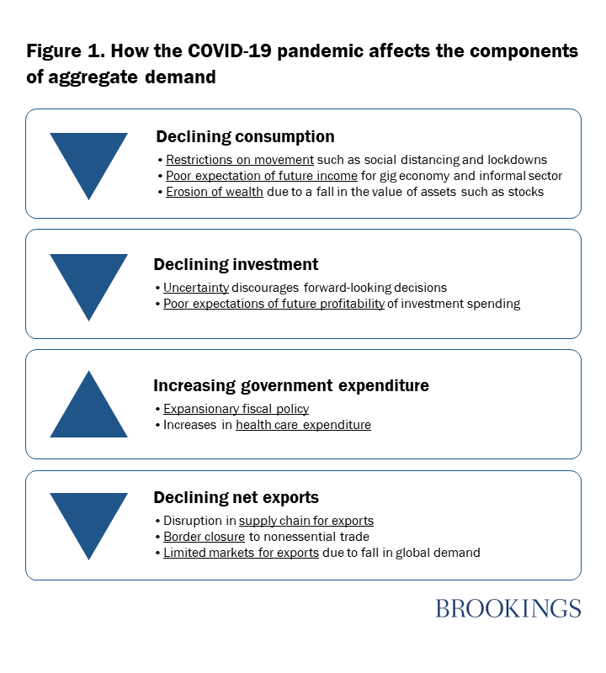
The fall in household consumption in Nigeria will stem from 1) partial (or full) restrictions on movement, thus causing consumers to spend primarily on essential goods and services; 2) low expectations of future income, particularly by workers in the gig economy that are engaged on a short-term/contract basis, as well as the working poor in the informal economy; and 3) the erosion of wealth and expected wealth as a result of the decline in assets such as stocks and home equity. The federal government has imposed a lockdown in Lagos and Ogun states as well as Abuja (which have the highest number of coronavirus cases combined). Subnational governments have quickly followed suit by imposing lockdowns in their states. Nigeria has a burgeoning gig economy as well as a large informal sector, which contributes 65 percent of its economic output. Movement restrictions have not only reduced the consumption of nonessential commodities in general, but have affected the income-generating capacity of these groups, thus reducing their consumption expenditure

