NAME: SHOSAN HADIJAT ABIMBOLA
MATRIC NO:17/SCI01/076
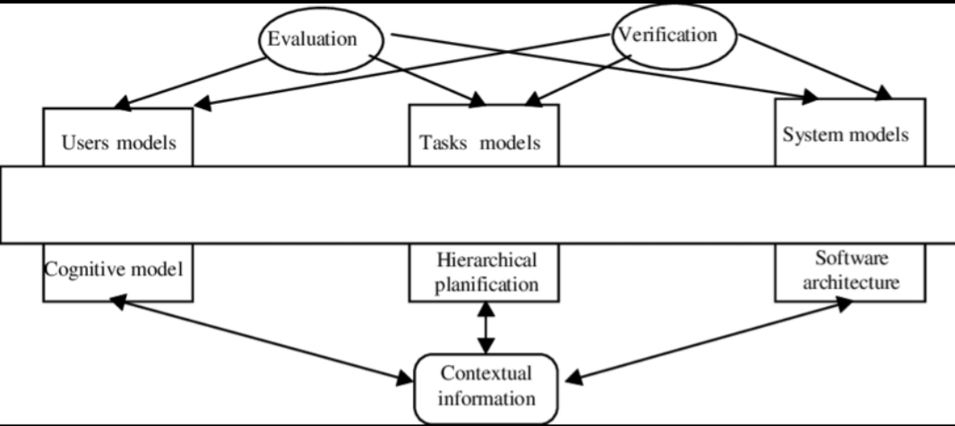
1a(i).

Formal methods are techniques used to model complex systems as mathematical entities. By building a mathematically rigorous model of a complex system, designers can not only verify the system’s properties in a more thorough fashion (than they could via empirical testing) but also use mathematical proof as a complement to system testing so as to ensure correct behavior.
1a(ii). Formal methods are intended to systematize and introduce rigor into all the phases of software development. This helps us to avoid overlooking critical issues, provides a standard means to record various assumptions and decisions, and forms a basis for consistency among many related activities.
1b. Nonfunctional requirements describe the general characteristics of a system. They are also known as quality attributes. Functional requirements describe how a product must behave, what its features and functions
2. I.Waterfall Model: The waterfall model is a breakdown of project activities into linear sequential phases, where each phase depends on the deliverables of the previous one and corresponds to a specialisation of tasks. The approach is typical for certain areas of engineering design. In software development, it tends to be among the less iterative and flexible approaches, as progress flows in largely one direction ("downwards" like a waterfall) through the phases of conception, initiation, analysis, design, construction, testing, deployment and maintenance.Moreover, this methodology also talks about the fact that going back to deal with the changes is not possible.
Pros:
- Easy to understand and functional
- Simple enough to handle as model is rigid
- Saves significant amount of time
- Allows for easy testing and analysis
Cons:
- Only matches precise needs
- Not applicable for maintenance projects
- No option to know possible outcome of a project
- Not excellent for long and ongoing projects
ii. Prototype Methodology: It is a specialized software development procedure that initiates developers towards making only the sample of the resolution to validate its functional essence to the customers and make essential changes before creating the authentic final solution.
The prototyping model is a systems development method in which a prototype is built, tested and then reworked as necessary until an acceptable outcome is achieved from which the complete system or product can be developed. This model works best in scenarios where not all of the project requirements are known in detail ahead of time. It is an iterative, trial-and-error process that takes place between the developers and the users.
Pros:
- Gives clear idea about the functional process of the software
- Reduces the risk of failure in a software functionality
- Assists well in requirement gathering and the overall analysis
Cons:
- Chances of extension in management cost
- Excessive involvement of client can affect processing
- Too many changes affect the workflow of the software
iii.Agile Software Development Methodology: As an innovative approach, the agile software development methodology is used for articulating a well-organized project management procedure allowing for recurrent alterations.Certainly, such type of a methodology is one theoretical outline for undertaking several software engineering projects.Another good thing about it is that it minimizes peril by creating software in short time boxes, known as iterations, which happen to last from one week to one month.
Pros:
- Adaptive approach that responds to changes favorably
- Allows for direct communication to maintain transparency
- Improved quality by finding and fixing defects quickly and identifying expectation mismatches early.
Cons:
- Focuses on working with software and lacks documentation efficiency
- Chances of getting off-track as outcome are not clear
iv .Rapid Application Development: Rapid application development (RAD) describes a method of software development which heavily emphasizes rapid prototyping and iterative delivery. The RAD model is, therefore, a sharp alternative to the typical waterfall development model, which often focuses largely on planning and sequential design practices.In disparity to the waterfall model, which emphasizes meticulous specification and planning, the RAD approach means building on continuously evolving requirements, as more and more learnings are drawn as the development progresses.
Pros:
- Makes the entire development process effortless
- Assists client in taking quick reviews
- Encourages feedback from customers for improvement
Cons:
- Dependant on the team for performance
- Works on modularized system confined on this methodology
- Requires extremely skilled personnel to handle complexities
- Not applicable for the small budgeted projects.

v. Dynamic System Development Model Methodology: Authentically formulated and derived from the rapid application development methodology, it is an iterative and incremental approach that focuses on the involvement of the user.The Dynamic Systems Development Method (DSDM) is an agile project delivery framework, primarily used as a software development method. It is a framework which embodies much of the current knowledge about project management. DSDM is rooted in the software development community, but the convergence of software development, process engineering and hence business development projects has changed the DSDM framework to become a general framework for complex problem solving tasks. The DSDM framework can be implemented for agile and traditional development processes.
DSDM is a,
- Straight forward framework based on best principles to start implementing a project structure.
- Simple
- Extendible
- But not calming to be the solution to all kind of projects.
Pros:
- Users getting a grip of the software development process
- Functionality deliverables are quick
- Offers easy access to end users by the developers
Cons:
- This methodology is costly to implement
- Not suitable for small organizations

vi. Spiral Model: The spiral model combines the idea of iterative development with the systematic, controlled aspects of the waterfall model. This Spiral model is a combination of iterative development process model and sequential linear development model i.e. the waterfall model with a very high emphasis on risk analysis. It allows incremental releases of the product or incremental refinement through each iteration around the spiral.
Spiral Model - Design
The spiral model has four phases. A software project repeatedly passes through these phases in iterations called Spirals.
Identification
This phase starts with gathering the business requirements in the baseline spiral. In the subsequent spirals as the product matures, identification of system requirements, subsystem requirements and unit requirements are all done in this phase.This phase also includes understanding the system requirements by continuous communication between the customer and the system analyst. At the end of the spiral, the product is deployed in the identified market.
Design
The Design phase starts with the conceptual design in the baseline spiral and involves architectural design, logical design of modules, physical product design and the final design in the subsequent spirals.
Construct or Build
The Construct phase refers to production of the actual software product at every spiral. In the baseline spiral, when the product is just thought of and the design is being developed a POC (Proof of Concept) is developed in this phase to get customer feedback.Then in the subsequent spirals with higher clarity on requirements and design details a working model of the software called build is produced with a version number. These builds are sent to the customer for feedback.
Evaluation and Risk Analysis
Risk Analysis includes identifying, estimating and monitoring the technical feasibility and management risks, such as schedule slippage and cost overrun. After testing the build, at the end of first iteration, the customer evaluates the software and provides feedback.
The following illustration is a representation of the Spiral Model, listing the activities in each phase.
Pros:
- Risk factors are considerably reduced
- Excellent for large and complex projects
- Allows for additional functionality later
- Suitable for highly risky projects with varied business needs
Cons:
- Costly model in software development
- Failure in risk analysis phase may damage the whole project
- Not appropriate for low-risk projects
- Might get continued and never finish

vii. Extreme Programming Methodology: Extreme programming (XP) is a software development methodology which is intended to improve software quality and responsiveness to changing customer requirements. As a type of agile software development,it advocates frequent "releases" in short development cycles, which is intended to improve productivity and introduce checkpoints at which new customer requirements can be adopted.
Other elements of extreme programming include: programming in pairs or doing extensive code review, unit testing of all code, avoiding programming of features until they are actually needed, a flat management structure, code simplicity and clarity, expecting changes in the customer's requirements as time passes and the problem is better understood, and frequent communication with the customer and among programmers. The methodology takes its name from the idea that the beneficial elements of traditional software engineering practices are taken to "extreme" levels. As an example, code reviews are considered a beneficial practice; taken to the extreme, code can be reviewed continuously, i.e. the practice of pair programming.
Pros:
- It lays focus on customer involvement
- Establishes rational plans and schedules
- Developers are exceptionally committed to the project
- Equipped with modernistic methods for quality software
Cons:
- Effectiveness depends on the people involved
- Requires frequent meeting for development raising total costs
- Necessitates for excessive development changes
- Exact possibilities and future outcomes are really unknown.

viii. Feature Driven Development: Feature-Driven Development (FDD) is a client-centric, architecture-centric, and pragmatic software process. The term "client" in FDD is used to represent what Agile As the name implies, features are an important aspect of FDD. A feature is a small, client-valued function expressed in the form . For example, "Calculate the total of a sale", "Validate the password of a user", and "Authorize the sales transaction of a customer". Features are to FDD as use cases are to the Rational Unified Process (RUP) and user stories are to Scrum - they're a primary source of requirements and the primary input into your planning efforts.
Pros:
- Moves bigger projects with continuous success
- Easiest 5 procedures bring outcome in a better manner
- Built on pre-set standards of software development, it is programmed for easy development
- Projects that need continuous updates are powered by feature-driven development that ensures all needs are taken care of.
- Results in features that always outshine the inputs
- Since this is based on some of the best software development practices, any developer with relevant experience can handle and manage the project-related tasks with ease.
Cons:
- Not suitable for smaller projects and a single developer – always a huge team is required, which means that we cannot ever guarantee a brisk deadline.
- Highly dependable on the leading developers, necessitating for the complete structure – the process needs to be monitored through each phase as even a minute flaw can create chaos in the system.
- Highly dependable on the leading developers, necessitating for the complete structure – the process needs to be monitored through each phase as even a minute flaw can create chaos in the system.

ix. Joint Application Development Methodology: The Joint Application Development Methodology is a requirements-classification and user-interface expansion approach that necessitates for the end-users, clients and developers attend a powerful off-site conference to accentuate and confirm software system.This methodology serves towards including the client in the design and expansion of an application.This is effortlessly proficient through a sequence of concerted workshops known as JAD sessions.It tends to lay emphasis on the business difficulty rather than methodical details.
Pros:
- Allows for simultaneous congregation and alliance of excessive information.
- Produces huge amount of valuable information in short period
- Immediate resolving of differences with suitable assistance
- Provides forum to explore multiple points
Cons:
- Takes excessive amount of time for planning and scheduling
- Requires significant investment of time and effort
- Calls for highly trained experts, which is tough to find

x. Lean Development Methodology: As a technical advancement, Lean Development model lays emphasis on the formation of effortlessly manageable software.This exquisitely designed development technique is more deliberately engrossed than any other form of agile methodology.The objective of this procedure is to improve the software in one-third of the time, with very restricted budget, and very fewer amount of essential workflow.
Pros:
- Lower budget & time requirements
- Allows for delivery of product early
Cons:
- The workability of the team decides success of software development process
- Unsuitable business analyst can be severely problematic
- Excessive flexibility leads developer to lose focus
xi.Rational Unified Process Methodology:
Smartly called as RUP, Rational Unified Process methodology powers software development using rational tools.This methodology segregates the expansion process into four different stages that each includes business modeling, scrutiny and design, enactment, testing, and disposition.This is an object-based and web-empowered program growth methodology.The model tends to assist software developer for stating guidelines, templates, and specimens for all features and stages of software development.
Pros:
- Lays high focus on precise documentation
- Removes project risks linked with client evolving needs
- Very less requirement for integration
Cons:
- Needs excessively expert software developer
- Development procedure of the methodology is complicated
- Integration might cause confusion
- Very complicated to understand

xii. Scrum Development Methodology: SCRUM is the most widely preferred agile software development approach.(Likewise, KANBAN is a process that helps teams to collaborate and work effectively.)Basically, this excellent development is suitable for those development projects that are constantly altering or extremely developing requirements.The Scrum Software development model initiates with an ephemeral planning, conference and completes with a concluding review.
This growth methodology is used for prompt development of software that happens to include a series of iterations to generate required software.It is a perfect approach because it effortlessly brings on track the deliberate progressing projects.
Pros:
- Decision making lies in the hands of the team
- Business requirement document is considered insignificant
- Lightly controlled method empathizing with constant updating
Cons:
- The processing method suffers because of wavering costs
- Not suitable for big sized projects
- Requires highly expert team, which has no place for novices.

2b. They are techniques and tools based on mathematical and formal logic and can achieve various forms of vigour
3a. Key differences between PL and FOL
- Propositional Logic converts a complete sentence into a symbol and makes it logical whereas in First-Order Logic relation of a particular sentence will be made that involves relations, constants, functions, and constants.
- The limitation of PL is that it does not represent any individual entities whereas FOL can easily represent the individual establishment that means if you are writing a single sentence then it can be easily represented in FOL.
- PL does not signify or express the generalization, specialization or pattern for example ‘QUANTIFIERS’ cannot be used in PL but in FOL users can easily use quantifiers as it does express the generalization, specialization, and pattern.

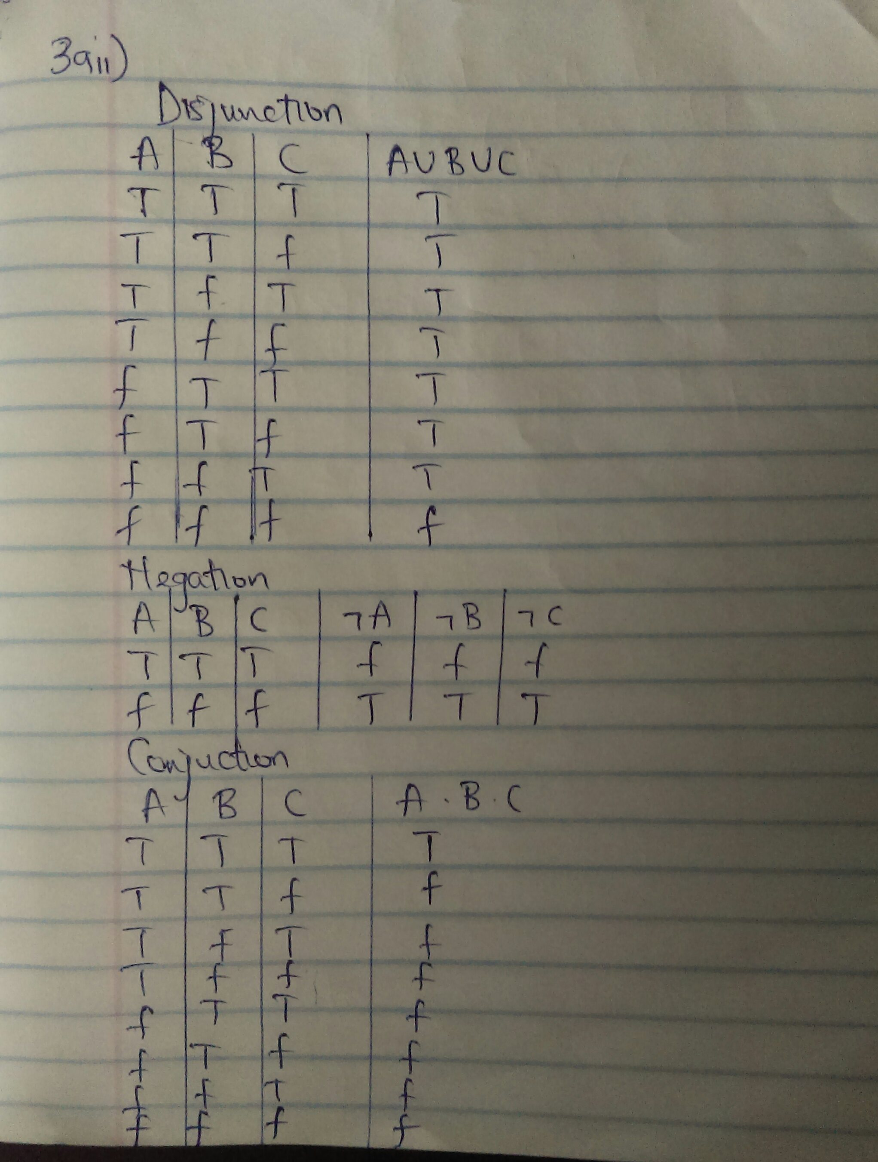
3aii.

3b. m1=mortal
m2=man
P1=every man is mortal
P2=smith is a man
[Smith is mortal]
∀(m2): m1 (p1, p2)

4a. o=object
m=monkey
~m=not monkey
∃(o):m v ~m

4b. Algebraic Specification
The use of modularization, datatypes, and object oriented programming have led to a further model called algebraic specifications, as developed by Guttag. In this model we are more concerned about the behavior of objects defined by programs rather than the details of their implementation
Z specification
The Z notation is a formal specification language used for describing and modelling computing systems. It is targeted at the clear specification of computer programs and computer-based systems in general.
Model-Based Languages
One approach to formal specifications is to build a model of the intended system by describing the different states the system could be in and the operations that will change the state. The states are often described with sets, sequences, relations, and functions, and the operations with predicates in terms of pre- and post-conditions
5a.A well-formed formula: In mathematical logic, propositional logic and predicate logic, a well-formed formula, abbreviated WFF or wff, often simply formula, is a finite sequence of symbols from a given alphabet that is part of a formal language.A formal language can be identified with the set of formulas in the language.A formula is a syntactic object that can be given a semantic meaning by means of an interpretation. Two key uses of formulas are in propositional logic and predicate logic.
Fortunately, the syntax of propositional logic is easy to learn. It has only three rules:
- Any capital letter by itself is a WFF.
- Any WFF can be prefixed with “~”. (The result will be a WFF too.)
- Any two WFFs can be put together with “•”, “∨”, “⊃”, or “≡” between them, enclosing the result in parentheses. (This will be a WFF too.)
b. A quantifier:A quantifier specifies the quantity of specimens in the domain of discourse that satisfy an open formula. The two most common formal quantifiers are "for each" (traditionally symbolized by "∀"), and "there exists some" ("∃").For example, in arithmetic, quantifiers allow one to say that the natural numbers go on forever, by writing that "for each natural number n, there exists some natural number m that is bigger than n"; this can be written formally as "∀n∈ℕ. ∃m∈ℕ. m>n".The above English examples could be formalized as "∀p∈P. m(p)",[5] "∃p∈P. m(p)", and "¬ ∃p∈P. m(p)",[6] respectively, when P denotes the set of all people, and m(p) denotes "p is mortal".
A formula beginning with a quantifier is called a quantified formula. A formal quantifier requires a variable, which is said to be bound by it, and a subformula specifying a property of that variable.
c. A predicate: A predicate is an expression of one or more variables determined on some specific domain. A predicate with variables can be made a proposition by either authorizing a value to the variable or by quantifying the variable.
d. A term: In mathematical logic, a term denotes a mathematical object and a formula denotes a mathematical fact. In particular, terms appear as components of a formula. In Logic, a term is considered particular if it represents “at least one but not all” of the individuals composing a class.
6.
- Build-and-fix software development model: This model is meant for small scale projects.In the build and fix model (also referred to as an ad hoc model), the software is developed without any specification or design. An initial product is built, which is then repeatedly modified until it (software) satisfies the user. That is, the software is developed and delivered to the user.This process goes on until the user feels that the software can be used productively. However, the lack of design requirements and repeated modifications result in loss of acceptability of software. Thus, software engineers are strongly discouraged from using this development approach.
This model includes the following two phases.
- Build: In this phase, the software code is developed and passed on to the next phase.
- Fix: In this phase, the code developed in the build phase is made error free. Also, in addition to the corrections to the code, the code is modified according to the user's requirements.

b. Waterfall software development model: This is a document-driven model. However, it might not fulfill the need of the client.In a Waterfall model, each phase must be completed before the next phase can begin and there is no overlapping in the phases. The waterfall model is the earliest SDLC approach that was used for software development.In “The Waterfall” approach, the whole process of software development is divided into separate phases. The outcome of one phase acts as the input for the next phase sequentially. This means that any phase in the development process begins only if the previous phase is complete. The waterfall model is a sequential design process in which progress is seen as flowing steadily downwards (like a waterfall) through the phases of Conception, Initiation, Analysis, Design, Construction, Testing, Production/Implementation, and Maintenance.
As the Waterfall Model illustrates the software development process in a linear sequential flow; hence it is also referred to as a Linear-Sequential Life Cycle Model.
Examples of waterfall model;In the olden days, Waterfall model was used to develop enterprise applications like Customer Relationship Management (CRM) systems, Human Resource Management Systems (HRMS), Supply Chain Management Systems, Inventory Management Systems, Point of Sales (POS) systems for Retail chains etc.
c. Rapid prototyping has long been used in the development of one-off programs, based on the familiar model of the chemical engineer’s pilot plant. More recently it has been used to prototype larger systems in two variants—the "throwaway" model and the "operational" model, which is really the incremental model to be discussed later. This development process produces a program that performs some essential or perhaps typical set of functions for the final product.A throwaway prototype approach is often used if the goal is to test the implementation method,language, or end-user acceptability. If this technology is completely viable, the prototype may become the basis of the final product development, but normally it is merely a vehicle to arrive at a completely secure functional specification.

6b. A product requirements document (PRD) is a document containing all the requirements to a certain product. It is written to allow people to understand what a product should do. A PRD should, however, generally avoid anticipating or defining how the product will do it in order to later allow interface designers and engineers to use their expertise to provide the optimal solution to the requirements.[citation needed] PRDs are most frequently written for softwareproducts, but can be used for any type of product and also for services. Typically, a PRD is created from a user's point-of-view by a user/client or a company's marketing department (in the latter case it may also be called Marketing Requirements Document (MRD)). The requirements are then analyzed by a (potential) maker/supplier from a more technical point of view, broken down and detailed in a Functional Specification (sometimes also called Technical Requirements Document).
7. Introduction
1.1 Purpose
1.2 Intended Audience
1.3 Intended Use
1.4 Scope
1.5 Definitions and Acronyms
2. Overall Description
2.1 User Needs
2.2 Assumptions and Dependencies
3. System Features and Requirements
3.1 Functional Requirements
3.2 External Interface Requirements
3.3 System Features
3.4 Nonfunctional Requirements
Once you have your basic outline, you’re ready to start filling it out.
b. Start With a Purpose
The introduction to your SRS is very important. It sets the expectation for the product you’re
building.So, start by defining the purpose of your product.
Intended Audience and Intended Use
Define who in your organization will have access to the SRS — and how they should use it. This may include developers, testers, and project managers. It could also include stakeholders in other departments, including leadership teams, sales, and marketing.
Product Scope
Describe the software being specified. And include benefits, objectives, and goals. This should relate to overall business goals, especially if teams outside of development will have access to the SRS.
Definitions and Acronyms
It’s smart to include a risk definition. Avoiding risk is top-of-mind for many developers— especially those working on safety-critical development teams.
Here’s an example. If you’re creating a medical device, the risk might be the device fails and causes a fatality.By defining that risk up front, it’s easier to determine the specific requirements you’ll need to mitigate it.
3. Give an Overview of What You’ll Build
Your next step is to give a description of what you’re going to build. Is it an update to an existing product? Is it a new product? Is it an add-on to a product you’ve already created?.These are important to describe upfront, so everyone knows what you’re building.You should also describe why you’re building it and who it’s for.
User Needs
User needs — or user classes and characteristics — are critical. You’ll need to define who is going to use the product and how.You’ll have primary and secondary users who will use the product on a regular basis. You may also need to define the needs of a separate buyer of the product (who may not be a primary/secondary user). And, for example, if you’re building a medical device, you’ll need to describe the patient’s needs.
Assumptions and Dependencies
There might be factors that impact your ability to fulfill the requirements outlined in your SRS.What are those factors?Are there any assumptions you’re making with the SRS that could turn out to be false? You should include those here, as well.Finally, you should note if your project is dependent on any external factors. This might include software components you’re reusing from another project.
4. Detail Your Specific Requirements
The next section is key for your development team. This is where you detail the specific requirements for building your product.
Functional Requirements
Functional requirements are essential to building your product.If you’re developing a medical device, these requirements may include infusion and battery. And within these functional requirements, you may have a subset of risks and requirements.
External Interface Requirements
External interface requirements are types of functional requirements. They’re important for embedded systems. And they outline how your product will interface with other components.
There are several types of interfaces you may have requirements for, including:
- User
- Hardware
- Software
- Communications
- System Features
System features are types of functional requirements. These are features that are required in order for a system to function.
Other Nonfunctional Requirements
Nonfunctional requirements can be just as important as functional ones.
These include:
- Performance
Safety
- Security
- Quality
The importance of this type of requirement may vary depending on your industry. Safety requirements, for example, will be critical in the medical device industry.IEEE also provides guidance for writing software requirements specifications, if you’re a member.
5. Get Approval for the SRS
Once you’ve completed the SRS, you’ll need to get it approved by key stakeholders. And everyone should be reviewing the latest version of the document.

