ADEDEJI FAROUQ ADEDOTUN
17/ENG04/001
ELECTRICAL ELECTRONICS ENGINEERING
EEE 326
1(a) What is the limitation of a single-Phase Induction Motor?
- They do not have a self-starting torque.
- They have low power factors because of the large magnetizing current the motor draws to overcome the reluctance offered by the air gap.
- They have low efficiency due to the high copper losses resulting from the high magnetizing current.
- They have low mechanical power output.
- Speed control of the motor is difficult to attain.
- They can be noisy and have vibrations compared to the three-phase induction motor.
(b) Explain why a single-phase induction motor does not self-start. Discuss this based on the double revolving theory
According to double field revolving theory, we can resolve any alternating quantity into two components. Each component has a magnitude equal to the half of the maximum magnitude of the alternating quantity, and both these components rotate in the opposite direction to each other. For example – a flux, φ can be resolved into two components
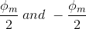
each of these components rotates in the opposite direction i. e if one φ_{m}/2 is rotating in a clockwise direction then the other φ_{m} / 2 rotates in an anticlockwise direction.
When we apply a single-phase AC supply to the stator winding of single-phase induction motor, it produces its flux of magnitude, φ_{m}. According to the double field revolving theory, this alternating flux, φ_{m} is divided into two components of magnitude φ_{m}/2. Each of these components will rotate in the opposite direction, with the synchronous speed, N_{s}.
Let us call these two components of flux as forwarding component of flux, φ_{f} and the backward component of flux, φ_{b}. The resultant of these two components of flux at any instant of time gives the value of instantaneous stator flux at that particular instant.
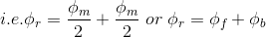
Now at starting condition, both the forward and backward components of flux are exactly opposite to each other. Also, both of these components of flux are equal in magnitude. So, they cancel each other and hence the net torque experienced by the rotor at the starting condition is zero. So, the single-phase induction motors are not self-starting motors.

(c) Explain the constructional features and principle of operation of a Single-Phase induction motor
- Stator: This is the stationary part of the motor
- Stator Windings: This consists of the main and auxiliary windings. The starting winding is provided so that, together with the main or working winding, the motor can stimulate a two-phase motor to develop torque at start. In the case of the permanent capacitor the auxiliary winding remains in the circuit after starting and thus closely approximates a two-phase motor also when it is operating under load.
- Rotor: This is the rotating part of the motor which may either be wound-type or squirrel cage type. This contains the rotor bars also.
- Bearing: This provides support to the rotating shaft and also smoothens out the motion.
- Terminal Box: Contains the connections made to the stator windings.
Principle of operation single phase induction motor
Under stationary rotor conditions (i.e, when speed N = 0 or slip s = 1), the two rotating fields slip pass the rotor at the same slip, s = 1 and inducing equal currents in the squirrel cage rotor. The two rotating fields are of the same strength and develop equal and opposite electro-magnetic torques resulting in net torque of zero value. Thus the starting torque is zero and the single phase induction motor is non- self-starting.

(d) Using the double revolving field theory explain the torque –slip characteristics of a single-phase induction. Hence explain why a Single-phase induction motor are not self-starting
From the figure, we see that at a slip of unity, both forward and backward field develops equal torque but the direction of which are opposite to each other so the net torque produced is zero hence the motor fails to start. From here we can say that these motors are not self-starting unlike the case of three phase induction motor. There must be some means to provide the starting torque. If by some means, we can increase the forward speed of the machine due to which the forward slip decreases the forward torque will increase and the reverse torque will decrease as a result of which motor will start.
From here we can conclude that for starting of single phase induction motor, there should be a production of difference of torque between the forward and backward field. If the forward field torque is larger than the backward field than the motor rotates in forward or anti clockwise direction. If the torque due to backward field is larger compared to other, then the motor rotates in backward or clockwise direction. They are not self-starting because in induction machine a rotating magnetic field is required to produce torque.
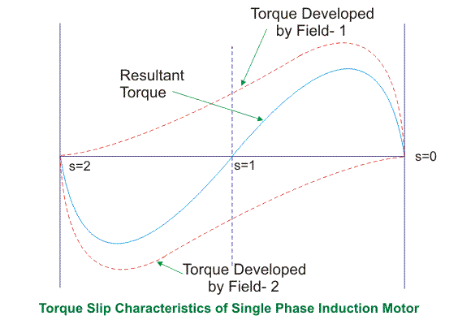
. A single-phase supply cannot produce a rotating magnetic field, but it produces a pulsating magnetic field which does not rotate. Due to this pulsating magnetic field torque cannot produce so motor is not self-starting.

(e) List five (5) types of Single-Phase Induction Motor and explain explicitly any two with relevant circuit/connection diagrams
- Resistance- START motor.
- Capacitor- START motor.
- Shaded Pole motor.
- Permanent Capacitor motor
- Capacitor START and Capacitor RUN motor.

RESISTANCE-START INDUCTION MOTOR
In addition to the main winding or running winding, the stator of single-phase induction motor carries another winding called auxiliary winding or starting winding. A centrifugal switch is connected in series with auxiliary winding. The purpose of this switch is to disconnect the auxiliary winding from the main circuit when the motor attains a speed up to 75 to 80% of the synchronous speed. We know that the running winding is inductive in nature. Our aim is to create the phase difference between the two winding and this is possible if the starting winding carries high resistance. Let us say
I_{run} is the current flowing through the main or running winding,
I_{start} is the current flowing in starting winding,
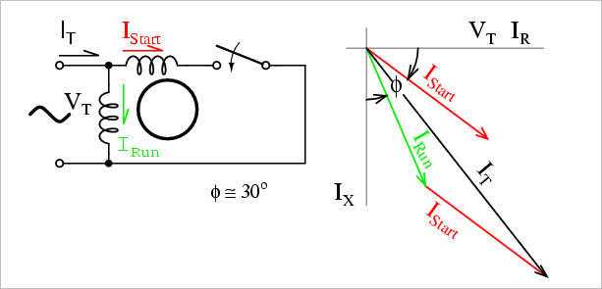
V_{T} is the supply voltage.

We know that for highly resistive winding the current is almost in phase with the voltage and for highly inductive winding the current lag behind the voltage by large angle. The starting winding is highly resistive so, the current flowing in the starting winding lags behind the applied voltage by very small angle and the running winding is highly inductive in nature so, the current flowing in running winding lags behind applied voltage by large angle. The resultant of these two currents is I_{T}. The resultant of these two current produce rotating magnetic field which rotates in one direction. In split phase induction motor the starting and main current get split from each other by some angle so this motor got its name as split phase induction motor.

Shaded Pole Single Phase Induction Motors
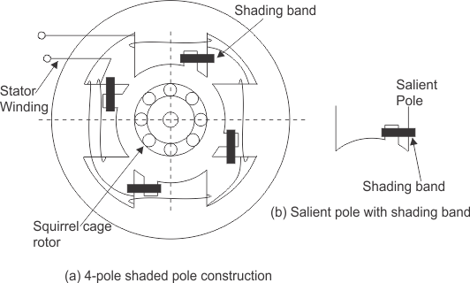
The stator of the shaded pole single phase induction motor has salient or projected poles. These poles are shaded by copper band or ring which is inductive in nature. The poles are divided into two unequal halves. The smaller portion carries the copper band and is called as shaded portion of the pole.

ACTION: When a single-phase supply is given to the stator of shaded pole induction motor an alternating flux is produced. This change of flux induces emf in the shaded coil. Since this shaded portion is short circuited, the current is produced in it in such a direction to oppose the main flux. The flux in shaded pole lags behind the flux in the unshaded pole. The phase difference between these two fluxes produces resultant rotating flux.
We know that the stator winding current is alternating in nature and so is the flux produced by the stator current. In order to clearly understand the working of shaded pole induction motor consider three regions-
    - When the flux changes its value from zero to nearly maximum positive value.
    - When the flux remains almost constant at its maximum value.
    - When the flux decreases from maximum positive value to zero.
1stREGION:
When the flux changes its value from zero to nearly maximum positive value –
In this region, the rate of rise of flux and hence current is very high. According to Faraday’s law whenever there is change in flux emf gets induced. Since the copper band is short circuited the current starts flowing in the copper band due to this induced emf. This current in copper band produces its own flux. Now according to Lenz’s law the direction of this current in copper band is such that it opposes its own cause i.e rise in current. So the shaded ring flux opposes the main flux, which leads to the crowding of flux in the unshaded part of stator and the flux weaken in shaded part. This non uniform distribution of flux causes magnetic axis to shift in the middle of the unshaded part.

2ndREGION:
When the flux remains almost constant at its maximum value-
In this region, the rate of rise of current and hence flux remains almost constant. Hence there is very little induced emf in the shaded portion. The flux produced by this induced emf has no effect on the main flux and hence distribution of flux remains uniform and the magnetic axis lies at the center of the pole.

3rdREGION:
When the flux decreases from maximum positive value to zero –
In this region, the rate of decrease in the flux and hence current is very high. According to Faraday’s law whenever there is change in flux emf gets induced. Since the copper band is short circuit the current starts flowing in the copper band due to this induced emf. This current in copper band produces its own flux. Now according to Lenz’s law the direction of the current in copper band is such that it opposes its own cause i.e decrease in current so the shaded ring flux aids the main flux, which leads to the crowding of flux in shaded part of stator and the flux weaken in unshaded part. This non uniform distribution of flux causes magnetic axis to shift in the middle of the shaded part of the pole. This shifting of magnetic axis continues for negative cycle also and leads to the production of rotating magnetic field. The direction of this field is from unshaded part of the pole to the shaded part of the pole.

(f) Describe the operation of Single-Phase Induction Motor using the Double-Field Revolving Theory
Under stationary rotor conditions (i.e, when speed N = 0 or slip s = 1), the two rotating fields slip pass the rotor at the same slip, s = 1 and inducing equal currents in the squirrel cage rotor. The two rotating fields are of the same strength and develop equal and opposite electro-magnetic torques resulting in net torque of zero value. Thus the starting torque is zero and the single phase induction motor is non- self-starting. Further, the two rotating fields induce a resultant EMF in the stator which balances the applied voltage assuming low leakage impedance of the stator winding.

2(a) What is a Universal Motor? List five (5) areas of application of this type of motor.

A universal motor is a special type of motor which is designed to run on either DC or single-phase AC supply.
Applications: Wind trimmers, Blenders, Drills, Vacuum cleaners, Hair dryers

(b) Describe the Construction of a Universal Motor.
- It consists of a stator on which the field poles are mounted.
- Field coils are wound on the field poles.
- The stator field circuit and armature are laminated to minimize the eddy currents which induce while operating on AC.
- The armature is of wound type having straight or skewed slots and commutator with brushes resting on it

(c) Distinguish Universal motor from the DC series motor with respect to the additional constructional features. Describe these additional constructional features.

UNIVERSAL MOTOR | DC SERIES MOTOR
The entire magnetic circuit is laminated to reduce eddy losses. | The entire circuit is not laminated.
The construction is more expensive | Less expensive construction
Field winding has less turns to reduce reluctance | Field winding has more turns than the universal motor

3(a) Describe the principle of operation of a three phase Induction Motor.
The stator of the motor consists of overlapping winding offset by an electrical angle of 120. When we connect the primary winding, or the stator to a 3 phase AC source, it establishes rotating magnetic ﬁeld which rotates at the synchronous speed. According to Faraday’s law an emf induced in any circuit is due to the rate of change of magnetic ﬂux linkage through the circuit. As the rotor winding in an induction motor are either closed through an external resistance or directly shorted by end ring, and cut the stator rotating magnetic ﬁeld, an emf is induced in the rotor copper bar and due to this emf a current ﬂows through the rotor conductor.
Here the relative speed between the rotating ﬂux and static rotor conductor is the cause of current generation; hence as per Lenz’s law, the rotor will rotate in the same direction to reduce the cause, i.e., the relative velocity.
Thus from the working principle of three phase induction motor, it may be observed that the rotor speed should not reach the synchronous speed produced by the stator. If the speeds become equal, there would be no such relative speed, so no emf induced in the rotor, and no current would be ﬂowing, and therefore no torque would be generated. Consequently, the rotor cannot reach the synchronous speed. The difference between the stator (synchronous speed) and rotor speeds is called the slip. The rotation of the magnetic ﬁeld in an induction motor has the advantage that no electrical connections need to be made to the rotor.

(b) State the advantages and disadvantages of Three Phase Induction Motor.
Advantages
- Simple and rugged construction
- They are self-starting
- They have good speed regulation
- Requires minimum maintenance
- They have high efficiency.
- They have good power factor
Disadvantages
- Unbalanced loading (can cause voltage fluctuations)
- Complex System (requires symmetrical components for analysis and operation)
- Phase Sequence needed to be kept in mind while making connections
- Poor starting torque

(c) A 400V, three-phase, star connected induction motor has a stator impedance of (0.06+j0.2) ohm and an equivalent rotor impedance of (0.06+j0.22) ohm. Determine the maximum gross power output and the slip at which it occurs.
Hint: take k as unity. Solve using the approximate equivalent circuit referred to the Stator (Version 2)

R₂^{I}= R₂/K²= 0.06/1=0.06Ω
X₂^{I}= X₂/K²= 0.22/1=0.22Ω
Z_{total}= [0.06+j0.2] Ω + [0.06+j0.22] Ω= [0.12+ j0.42] Ω
I₂^{I}= V/ Z_{total} = 400/ [0.12+ j0.42]= 915.74A < -74.05⁰
Power factor= cos (-74.05⁰)= 0.2748
Power output= √3 *400* 915.74* 0.2748= 174345 watts
174345= 3* (915.74)²* ((0.06-0.06s)/s)
S= 0.46

(d)
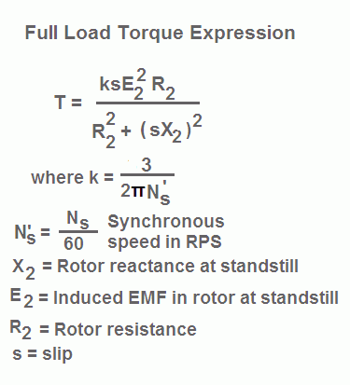
Thus, at low values of slip, torque is approximately proportional to slip s and the torque slip characteristics of induction motor is a straight line as shown in the figure. The region (from s = 0 to s = sm) is called the stable region of operation and operating point of the motor should be in this region. In the stable region, the value of slip is small. Hence this region is also called as the low slip region.

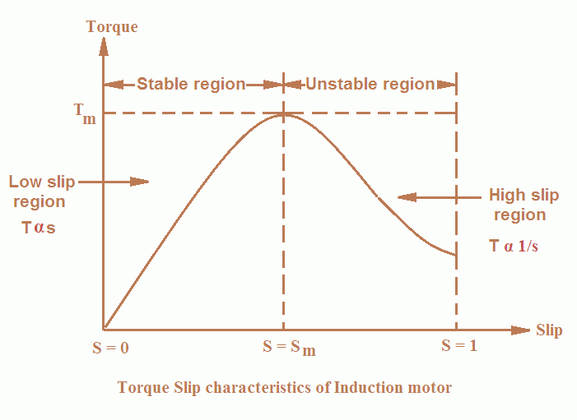
As the slip increases torque increases and attains its maximum value when s = R2/X2. This maximum value of torque is also known as break down or pull out torque. When a further increase in slip occurs due to increase in load beyond the point maximum torque
Thus at higher values of slip (i.e. the slip beyond that corresponding to maximum torque) torque is approximately inversely proportional to slip, s and the torque slip characteristics of induction motor is rectangular hyperbola as shown in the figure. The region (extending from s = sm to s = 1) is called unstable region. In this region with the increase in load, slip increases but torque decreases. The result is that the motor could not pick up the load and slows down and eventually stops. In the unstable region, the value of slip is large so this region is also called as the high-slip region.
(e) A 3-phase induction motor runs at 20rps on no-load, and 15 rps at full load when supplied with power from a 60Hz ,3-phase source. Calculate the following:
- The number of poles of the motor
- The percentage slip at full load
- The frequency of the rotor’s voltage
- The rotor’s slip speed
- The rotor’s frequency at a slip of 10 percent

20 Rps = rpm = 20 x 60 = 1200rpm
15rps = rpm = 15 x 60 = 900 rpm
Ns =$\frac{120f}{p}$
$$\frac{120 ×60}{1200}=6poles$$
$$\% slip= \left\lfloor \frac{Ns-Nr}{Ns}\right\rfloor ×100$$
=
$$\left\lfloor \frac{1200-900}{1200}\right\rfloor ×100=25\%$$
F’= sf
F’= 0.25 x 60 = 15Hz
Ns-Nr = 1200 -900 = 300
F’= SF
0.1 X 60 = 6Hz

4(a) Highlight five methods of controlling the speed of Induction Motors
- By injecting emf in rotor circuit
- Changing the applied frequency
- Changing the applied voltage
- Constant v/f control of induction motor

(b) List four methods of Starting the three phase Induction Motors
- Direct On-Line Starter (DOL)
- Stator resistance starting
- Rotor resistance starting
- Star Delta starting
(c) Explain any two methods in Q4(b) using appropriate circuit diagram
DIRECT ON-LINE STARTER
This method of starting in just what the name implies; the motor is started by connecting it directly to 3-phase supply. The impedance of the motor at standstill is relatively low and when it is directly connected to the supply system, the starting current will be high (4 to 10 times the full-load current) and at a low power factor. Consequently, this method of starting is suitable for relatively small (up to 7.5 kW) machines. Note that starting current is as large as ﬁve times the full-load current but starting torque is just equal to the full-load torque. Therefore, starting current is very high and the starting torque is comparatively low. If this large starting current ﬂows for a long time, it may overheat the motor and damage the insulation.
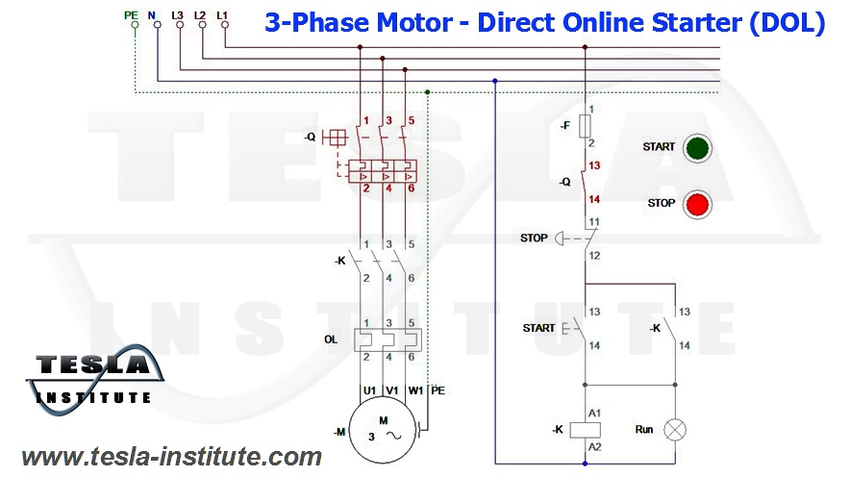

STATOR RESISTANCE STARTING
In this method, external resistances are connected in series with each phase of stator winding during starting. This causes voltage drop across the resistances so that voltage available across motor terminals is reduced and hence the starting current. The starting resistances are gradually cut out in steps (two or more steps) from the stator circuit as the motor picks up speed. When the motor attains rated speed, the resistances are completely cut out and full line voltage is applied to the rotor. This method suffers from two drawbacks. First, the reduced voltage applied to the motor during the starting period lowers the starting torque and hence increases the accelerating time. Secondly, a lot of power is wasted in the starting resistances. Thus while the starting current reduces by a fraction x of the rated-voltage starting current (Isc), the starting torque is reduced by a fraction x2 of that obtained by direct switching. The reduced voltage applied to the motor during the starting period lowers the starting current but at the same time increases the accelerating time because of the reduced value of the starting torque. Therefore, this method is used for starting small motors only.
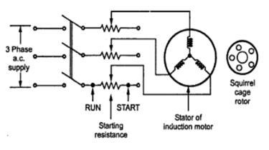

5(a) What is the importance of testing on three–phase Induction Motors\
- To find out if it works.
- To test for reliability
- To see how much performance-margin it has
- To see if it works according to its specifications
(b) State two similarity and differences between the short-circuit test of transformers and the Blocked –Rotor test in Induction Motor.
SIMILARITIES
- Secondary sides are short-circuited (as the secondary side in motors are the rotors)

DIFFERENCES
- In a short circuit test as the motor is no load the power factor is very low whch is less than 0.5 while the block rotor test is conducted at low voltage because if the applied voltage was normal voltage then the current flowing through the stator windings were high enough to overheat the windings and damage them.
- In a blocked rotor test the rotor is blocked so that it can’t move, a voltage is applied to the motor, and the resulting voltage, current and power are measured while in a short circuit test the test is performed at a rated frequency and with balanced polyphase voltages applied to the stator terminal.
(c) State two similarity and differences between the Open circuit test in transformer and the No-load test in Induction Motor

SIMILARITIES
- The open circuit and no-load test are performed for determining the parameter of the transformer like their efficiency, voltage regulation, circuit constant
- Open circuit test or no-load test on a transformer is performed to determine 'no load loss (core loss)' and 'no load current

DIFFERENCES
- An open circuit test is conducted when the secondary of the transformer is kept in open condition without connecting any load with it. Thus there will not be any current in the secondary coil. While A no-load test is conducted shorting the secondary terminals. Thus there will be huge current flow in the secondary coil when voltage is applied in the primary.
- The purpose of the open circuit test is to determine the no-load current and losses of the transformer because of which their no-load parameter are determined. While the no load test determines the copper loss occur on the full load. The copper loss is used for finding the efficiency of the transformer.
(d) List four types of testing carried out on three-phase Induction Motors and explain anyone (1)
- Ac motor winding resistance test
- Power supply test
- Insulation resistance test
- Ac motor winding continuity test

INSULATION RESISTANCE TEST
- The minimum insulation resistance of new, cleaned or repaired windings with respect to ground is 10 Megohm or more.
- The minimum insulation resistance, R, is calculated by multiplying the rated voltage U_{n}, with the constant factor 0.5 Megohm/kV.
- Minimum insulation resistance of the winding to ground is measured with 500 V DC. The winding temperature should be 25°C ± 15°C.
- Maximum insulation resistance should be measured with 500 V DC with the windings at an operating temperature of 80 – 120°C depending on the motor type and efficiency.
- If the insulation resistance of a new, cleaned or repaired motor that has been stored for some time is less then 10 Mohm, the reason might be that the windings are humid and need to be dried.
- If the motor has been operating for a long period of time, the minimum insulation resistance may drop to a critical level. As long as the measured value does not fall below the calculated value of minimum insulation resistance, the motor can continue to run.
However, if it drops below this limit, the motor has to be stopped immediately, in order to avoid that people get hurt due to the high leakage voltage.

(e)
Applied Voltage per phase, V= 400V, No load line current=3A
No load phase current=3/√3= √3A, Input on no load= 645W
Stator copper loss=45W, windage and friction loss=183W
Total stator core loss= 645-45-183=417W
No load p.f, cosᶲ=$\frac{p_{1}}{3VI_{0}}=\frac{417}{3×400×√3}$=0.2
No load line current on energy= $I_{lo}×cos∅=3×0.2=0.6A$
Magnetizing component of no load line current,
$$I_{lm}=\sqrt{{(I_{lo})}^{2}-{(I_{le})}^{2}}=\sqrt{3^{2}-{0.6}^{2}}=2.94A$$
- Energy component or no-load phase current,
$$I_{e=}I_{0}cos∅=1.732×0.2=0.3464A$$
- No load resistance,
$$R_{0}=\frac{V}{I_{e}}=\frac{400}{0.3464}=1.155Ω$$

- No load phase current,
$$I_{m}=\frac{2.94}{√3}=1.7A$$
- No load reactance,
$$X_{0}=\frac{V}{I_{m}}=\frac{400}{1.7}=236 Ω$$
- Short Circuit Voltage=200V, short circuit stator line current=12.0A
- Short Circuit stator phase current=6.928A, Input on short circuit= 1660W
- Equivalent resistance per phase as referred to the primary,
$$R_{0}=\frac{P_{s}}{{{3I}_{s}}^{2}}=\frac{1660}{3×{(6.928)}^{2}}=11.53 Ω$$
- Equivalent reactance per phase as referred to the primary,
$$Z_{0}=\frac{V_{s}}{I_{s}}=\frac{200}{6.928}=28.87Ω/phase$$
$$X_{0}=\sqrt{{Z_{0}}^{2}-{R_{0}}^{2}}=\sqrt{{(28.87)}^{2}-{(11.53)}^{2}}=26.5Ω$$
- Power factor on short circuit,
$$cos∅_{s}=\frac{P_{S}}{{3VI}_{s}}=\frac{1660}{3×200×6.928}=0.4$$
- Short Circuit current with normal voltage applied of 400 V across the stator,
$$I_{sc}=\frac{I_{s}×V}{V_{s}}=\frac{12×400}{200}=24A$$

6(a) Explain the operation of synchronous generator
Synchronous motors are a doubly excited machine, i.e., two electrical inputs are provided to it. Its stator winding which consists of a We provide three-phase supply to three-phase stator winding, and DC to the rotor winding.
The 3 phase stator winding carrying 3 phase currents produces 3 phase rotating magnetic flux. The rotor carrying DC supply also produces a constant flux
At a particular instant rotor and stator poles might be of the same polarity (N-N or S-S) causing a repulsive force on the rotor and the very next instant it will be N-S causing attractive force. But due to the inertia of the rotor, it is unable to rotate in any direction due to that attractive or repulsive forces, and the rotor remains in standstill condition. Hence a synchronous motor is not self-starting.
Here we use some mechanical means which initially rotates the rotor in the same direction as the magnetic field to speed very close to synchronous speed. On achieving synchronous speed, magnetic locking occurs, and the synchronous motor continues to rotate even after removal of external mechanical means.
But due to the inertia of the rotor, it is unable to rotate in any direction due to that attractive or repulsive forces, and the rotor remains in standstill condition. Hence a synchronous motor is not self-starting.
Here we use some mechanical means which initially rotates the rotor in the same direction as the magnetic field to speed very close to synchronous speed. On achieving synchronous speed, magnetic locking occurs, and the synchronous motor continues to rotate even after removal of external mechanical means.
(b) A Y connected, two pole,50 Hz,11kV,10MVA synchronous generator with Xs=150Ω is operating at full load and 0.8 power factor lagging. Calculate the following
- The induced emf and load angle,Ef <
- The maximum power ,Pmax
- The maximum Torque
S/MVA rating=10MVA,$V_{line}=11KV$, p.f=0.8, $X_{s}=15Ω$, f=50Hz, number of poles=2
Induced emf is given as;
$$I_{a(line)}=\frac{V_{t(lines)}}{√3}$$
So;
$$\left|E_{f(phase)}\right|=\sqrt{\left(V_{t\left(phase\right)}Cosφ^{2}\right)+(I_{a}X_{a}+Sinφ^{2})}=12,741KW$$

$$\left(Cosφ+δ\right)=\frac{V_{t\left(phase\right)}Cosφ}{E_{f(phase)}}=\frac{(6351)(0.8)}{12,741}=0.399$$
$$φ+δ=\cos^{-1}\left(0.399\right)={66.5}^{0}$$
Recall;
$$Cosφ=0.8$$
$$φ=\cos^{-1}{(0.8)}$$
$$φ=36.90$$
Hence,
$$δ=66.5-36.9={29.6}^{0}$$

ii.) maximum power,
$$P_{max}=\frac{3\left|V_{t}\right|\left|E_{f}\right|}{X_{s}}=\frac{3(12,741)(6351)}{15}=16,138,618.22W$$
iii.) Maximum torque,
$$T_{max}=\frac{P_{max}}{2πf}=\frac{16,138,618.22}{2×3.142×50}=51,507.4Nm$$

(c) Explain the concept of parrallel connection of generators and give four (4) advantages of connecting generators in parallel.
When a large number of alternators or synchronous generators are connected in parallel to an infinite bus bar system having a constant terminal voltage, constant bus bar frequency and very small synchronous impedance, then this kind of connection is known as parallel operation of alternators. Parallel operation of alternators is often called as synchronizing. Synchronization can be achieved using various methods like the synchronization lamps, relays and even a synchroscope.

BENEFITS
1. Continuity of Supply and Maintenance
A parallel connection is more favorable for repair and periodical maintenance work. It is easier for maintenance when smaller individual generating units are used, since we can schedule the maintenance of each unit, one after the other without affecting the continuity of power generation.
If instead it was a single unit, then an entire shutdown would be required for maintenance. This would drastically affect power demand during that duration.
2. Efficiency
According to the efficiency verses load curve, generator efficiency is maximum when the load is 100%, so the generator unit must run on full load. A single large unit would be uneconomical for lower loads, but with smaller individual units we can add up or switch off the generator units as per the load requirements in order to meet the maximum efficiency.
3. Expansion Plans:
Suppose the current capacity of a power plant is 500 MW. In order to expand the capacity to 700 MW to fulfill the rising future demand, it would be costlier to replace the entire setup and purchase a bigger unit.
It would be more economical to buy small individual alternator units which can be added in parallel to the bus bar system in order to reduce the initial capital investment.
4. Size of Alternators:​
The higher the rating of the generator, the bigger the size of the setup will be. It is very difficult to manage a single large alternator which may range around 1000 MVA or more.
If we are using small individual units connected in parallel, it will be easier to maintain considering its size.
5. Maximize Power System Reliability:
If any one of the generators running in parallel is tripped due to fault, other parallel generators in the system will share the load. So, the electrical system is not interrupted by the tripping of one alternator, only when the shared loads do not make other alternators over loaded.

