ESSENTIALS OF THE TRANSPORTATION PLANNING PROCESS AND THE SOCIOECONOMIC IMPLICATIONS OF EACH OF THIS FUNDAMENTALS IN RELATION TO NATIONAL DEVELOPMENT

BY
ADENIRAN MUQSITAT MORENIKEJI
MATRIC NO: 15/ENG03/002

SUBMITTED IN PARTIAL FULFILMENT
OF THE REQUIREMENT FOR THE AWARD OF THE
BACHELOR OF ENGINEEERING (B.ENG) DEGREE IN CIVIL ENGINEERING
TO
ENGR. O.O. POPOOLA
DEPARTMENT OF CIVIL ENGINEERING, COLLEGE OF ENGINEERING, AFE BABALOLA UNIVERSITY, ADO-EKITI,
NIGERIA
17TH APRIL, 2020

TRANSPORTATION
Transportation for any country is a vital aspect of its social and economic life; it enhances trade needs whereby the country’s manufacturing, industrial tourism and distribution needs are served. Therefore, a vibrant, responsive, effective and efficient transport system will enhance Nigeria’s economic, developmental and strategic roles in the global system/economy.
It is for this reason that Transport has been accorded high priority in the country and the Federal Ministry of Transport is charged with the responsibility of delivering a transport sector that is capable of meeting the needs of a modern, competitive, industrial economy.
Although Transport conventionally covers road, rail, water and air modes, the Federal Ministry of Transport is assigned the statutory responsibility for Rail and Mass transit, Inland Waterways, Maritime, Intermodal co-ordination and policy issues
Planning for effective development in the various sectors of Nigeria is a herculean task. Especially in the aspect of transportation which forms a vital part of living. Transportation systems in Nigeria over the years and since independence has continued on a relatively slow pace and experienced a lot of problems. Inadequacies in this sector has grossly affected urban centres across the nation and as such greatly influenced the country’s economic and social growth.
Transportation, put simply, is mobility – the inherent characteristic of moving from one point in space to another which occurs solely in living entities and by extension goods and services. A look at the urban and regional system shows that individuals, people as families, and people as groups are actively involved in a variety of activities that are achieved by engaging first in movement. There exists a functional criss-crossing of urban activities as no settlement is a self-contained unit.
The transportation sector is a very delicate aspect of the physical system which involves a lot more than just systems and infrastructure. Aderamo, 2012 states that; “Transportation planning is the hub of the economy, and that it connects people and makes people and places accessible and enhances social, economic and cultural interactions”. This definition of transportation clearly expresses its importance to the economy and the social spheres of the urban fabric. Socio-economic development of a place thus, is hinged on the free flow of activities in the urban and regional system.
Cities are locations having a high level of accommodation and concentration of economic activities and are complex spatial structures that are supported by transport systems (Rodriguez, 2009). The most important urban transport problems take place when transport systems for a variety of reasons cannot satisfy the numerous requirements of urban mobility. Urban productivity is highly dependent on the efficiency of its transport system to move labour, consumers and freight between multiple origins and destinations. These result in congestion and environmental problems. Among the most notable urban transport problems are;
- Traffic congestion and parking difficulties
- Longer commuting
- Public transport inadequacy
- Difficulties for non-motorised transport
- Less public space
- Environmental impacts and energy consumption
- Accident and safety
- Land consumption and freight distribution.
Other problems facing urban transportation involve the dominance of automobiles.
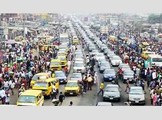

With respect to the economy, efficient transport systems provide economic and social opportunities and benefits that result in positive multipliers effects such as better accessibility to markets, employment and additional investments. Conversely, deficiency in transport systems in terms of capacity or reliability can have an economic cost such as reduced or missed opportunities. Efficient transportation reduces costs, while inefficient transportation increases costs. The impacts of transportation are not always intended, and can have unforeseen or unintended consequences such as congestion. Transport also carries an important social and environmental load, which cannot be neglected.
The social sphere of the environment on the other hand involves the individual attitudes of commuters, economic health and quality of life of inhabitants of the area. Not only does the transportation system provide for the mobility of people and goods, it also influences patterns of growth and economic activity by providing access to land. Public policy concerns like air quality, environmental resource consumption, social equity, land use, urban growth, economic development, safety, and security are concerns of the system also. Transportation planning recognizes the critical links between transportation and other societal goals. It requires developing strategies for operating, managing, maintaining, and financing the area’s transportation system in such a way as to advance the area’s long-term goals.

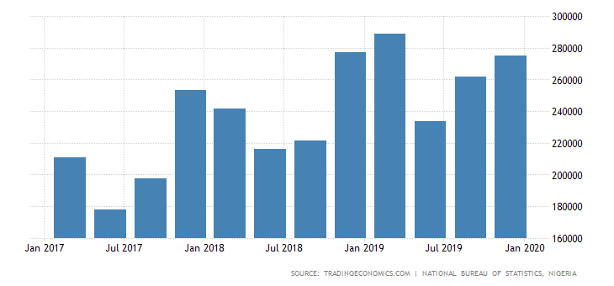
GDP From Transport in Nigeria increased to 275118.66 NGN Millions in the fourth quarter of 2019 from 261809.92 NGN Millions in the third quarter of 2019.

THE TRANSPORTATION PLANNING PROCESS
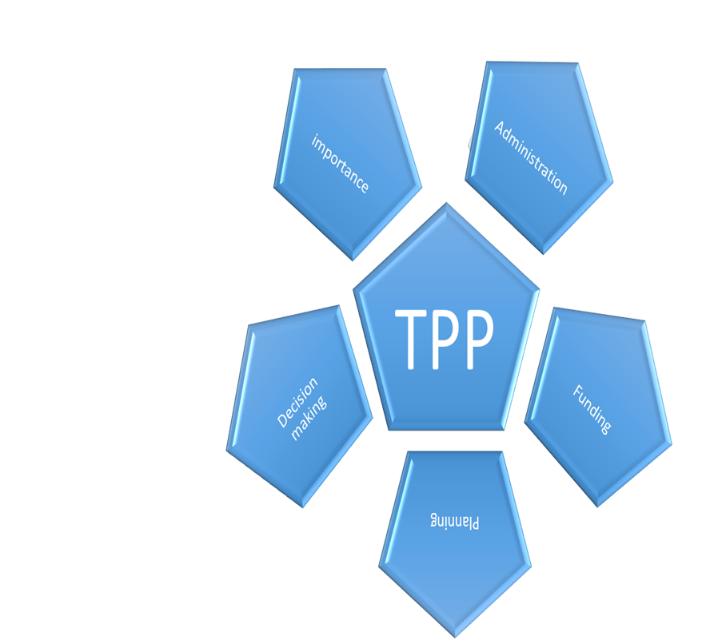
Fig1; Transportation planning process
Transportation planning is the development of a comprehensive plan for the construction and operation of transportation facilities. It is a cooperative process involving users of the system – business community, community groups, environmental organisations, commuters, freight operators, and the general public through a proactive public participatory process.
This dynamic and continuous process should be methodical as opposed to political, where decisions on construction and operation of transportation facilities are taken by political functionaries to gain short term popularity which often leads to piecemeal if not stale growth and development as is seen in Nigeria today. The process comprises of various elements as is found in the model planning process. Although similar, the model comprises of elements which are unique to transportation. The process as described in the fig. 1 illustrated above comprises of; Importance, Administration, funding, planning and decision making . Transportation is intended to help cities and other areas anticipate problems and avoid them. Some of these problems of utmost importance include; congestion, economic development and safety.
A major cause of traffic problems in Nigeria is the city structure which predates the advent of automobiles. Structural pattern of the roads, especially in the traditional areas of the city and the unplanned growth and haphazard land-use distribution, impose serious constraints on movement and the facilities provided. Therefore there is need for a comprehensive understanding of the structural pattern of an urban area and the traffic carrying capability of the roads in order to tackle its transportation problems.
In order to reduce urban transportation problems in Nigerian cities, effective traffic management measures and other remedial measures to improve traffic circulation in the cities must be adopted. This can be achieved through an understanding of the structure of the cities, their route forms and transport needs. The following specific measures are also suggested where necessary:
- Adequate drainage facilities should be provided in areas lacking. Inadequacy in this aspect results in occasional flooding of roads during the rainy season thus affecting traffic flow and reduces road life span pot-holes develop on the roads.
- Off-street parking facilities should be provided in designated areas of our cities. When off-street parking facilities are lacking, results is on- street parking in-turn reducing the width of roads leading to obstruction of traffic flow. Off-street parking is necessary especially along those roads with a high concentration of activities.
- Provision of traffic lights at major road junctions in the cities because of large volumes of traffic especially at peak periods. Other road junctions should be provided with “STOP” signs at appropriate arms of the junctions.
- To reduce pedestrian-vehicular conflicts in the cities. This could be achieved by creating barriers, overhead footbridges or under passes. Zebra crossings should be provided on major roads in our cities.
- Provision of enabling factors to Road Maintenance Agencies to carry out their duties. Roads that need rehabilitation should receive government attention.
- There has not been any comprehensive transportation study for many urban centres in Nigeria. Thus the volumes of traffic along many of the urban routes in our cities are not known. A time-series data on the various components of urban traffic is of great importance to city planners interested in future transport planning. Traffic flows along major roads in our cities need to be monitored regularly so that the design capacities of those roads are not exceeded.
At the national level, it is being suggested that the country adopts “Best Practice” which involves using the best techniques that have been tried and shown to be effective. Such techniques include using cleaner fuels, retrofitting engines, improving public transportation, coordinating interdepartmental efforts and enforcing stricter traffic rules. It has also been suggested that managing traffic and travel demand, forming public- private partnerships and using traffic calming and alternative fuels would help in reducing transportation problems in our cities. In addition, promoting non-motorised modes of transportation, integrating land-use and transportation planning, inspecting and maintaining vehicles, increasing education levels and controlling urban population growth will go a long way in reducing urban transportation problems in developing countries (Aderamo, 2012).
TRANSPORTATION AND ECONOMIC OPPORTUNITIES
Since the inception of the industrial revolution notable transportation developments have been linked to growing economic opportunities. Transport modes have been developed or adapted at each stage of human societal development. The first trade routes established a basic system of distribution and transactions that would eventually be expanded by long distance maritime shipping networks and the setting of the first multinational corporations thus showing that economic growth comes as a result of the composition of a variety of transport systems working in sync. Major flows of international migration that occurred since the 18th century were linked with the expansion of international and continental transport systems that radically shaped emerging economies such as in North America and Australia. Transport has played a catalytic role in these migrations, transforming the economic and social geography of many nations. Concomitantly, transportation has been a tool of territorial control and exploitation, particularly during the colonial era where resource-based transport systems supported the extraction of commodities in the developing world and forwarded them to the industrializing nations of the time. More recently, port development, particularly container ports, has been of strategic interest as a tool of integration to the global economy as illustrated in the case of China. While some regions benefit from the development of transport systems, marginalization sets in for others through a set of conditions in which inadequate transportation plays a role. It is pertinent to note that transportation in itself is not development but, the lack of transport infrastructures is a constraint on development. As is the case in developing countries, lack of transportation infrastructures and regulatory impediments jointly affect economic development by conferring higher transport costs, among other issues. A poor transport service level can also negatively affect the competition between regions and corporations and thus have a negative impact on the regional added value and employment. Investment in transport infrastructures is therefore a tool of regional development, particularly in developing countries and for the road sector. The standard assumption is that transportation investments tend to be more wealth producing as opposed to wealth consuming investments such as services. Still, several transportation investments can be wealth consuming if they merely provide convenience, such as parking and sidewalks, or service a market size well below any possible economic return, with for instance projects labelled "bridges to nowhere". In such a context, transport investment projects can be counter- productive by draining the resources of an economy instead creating wealth and additional opportunities. Efficient and sustainable transport markets and systems play a key role in regional development although the direction of causality between transport and wealth generation is not always clear. In a number of regions around the world, transport markets and related transport infrastructure networks are seen as key drivers in the promotion of a more balanced and sustainable development of the region or even the entire continent, particularly by improving accessibility and the situation of weaker regions and disadvantaged social groups. There is also a tendency for transport investments to have declining marginal returns. While initial infrastructure investments tend to have a high return since they provide an entirely new range of mobility options, the more the system is developed the more likely additional investment would result in lower returns. At some point, the marginal returns can be close to zero or even negative, implying a shift of transport investments from wealth producing to wealth consuming. A common fallacy is assuming that additional transport investments will have a similar multiplying effect than the initial investments had, which can lead to capital misallocation. This means quite understandably that the economic impacts of transport investments tend to be significant when infrastructures were previously inexistent or deficient and marginal when an extensive network is already present. Therefore, each development project must be considered independently.
TRANSPORTATION AND SOCIAL DEVELOPMENT
Access to essential products of society such as health care, education and employment are related to personal mobility and access to adequate transportation. Communities lacking mobility options are seen as less developed. This makes it even more difficult for them to access support and opportunities and makes it more difficult for governments to achieve the Millennium Development Goals, particularly reducing global poverty, combating epidemic diseases, reducing child mortality rates and introducing universal primary education. Access to goods and services depends not only on the physical availability of infrastructure (such as tracks, roads, and bridges) but also on access to vehicles and transport services, both public and private. Factors affecting access include location, cost, and frequency of services, journey time and physical accessibility.
Transport provisions and social development is often seen as working in harmony based on its relationship when formulating transport policies, planning, procurement, monitoring and evaluation. Social development in the transport sector focuses generally on:
- Improving access to transport for everyone;
- Mitigating the negative impacts of transport on society and communities (such as involuntary resettlement, pollution etc.) while maximising the opportunities that transport can present i.e. access to jobs, markets, education, etc.
- Using transport to promote and achieve social inclusion and cohesion;
- Reducing the social and health risks and dangers associated with transport;
- Sharing the social, economic and cultural benefits of transport more equally;
- Improving the design of transport systems and equipment so that they meet the needs of all, including users with specific needs (such as women, children, poor people, handicapped people, etc.);
- Ensuring public participation and representation in transport planning and decision-making.
The Government had previously handled all modes of transportation to the exclusion of the private sector. With the adoption of a PPP approach, Government is committed to;
▪ Concessioning of the existing rail network when fully rehabilitated and inland waterways facilities to private operators
▪ Ending public sector monopoly in the transport sector and;
▪ Eliminating all barriers to private sector participation in the ownership, planning, financing, construction, maintenance and management of transport facilities and services. In other words, Government intends to use the PPP strategy to undertake extensive Rail modernization projects and high speed rail links under the Transformation Agenda. To this end feasibility studies are being carried out for the 896km Lagos – Abuja high speed, 240km Lagos – Benin, 360km Ajaokuta – Jakwa – Baro- Abuja, 604km Zaria- Kaura Namoda- Sokoto rails and 323km Aba – Owerri – Onitsha – Agbor- Ajaokuta routes.

However, the following areas remain a challenge;
 Funding to fully carry out capital projects in the afore mentioned areas
 Capacity building of staff and workers in the sector
 Capacity building on infrastructure maintenance
 Capacity building on Research and planning.
 Limited supply of indigenous professional technical and managerial capacity in core areas
 Over dependence on foreign expertise and limited indigenous capacity building

Other challenges include; - use of substandard vessels for the water sector, inexperienced operators.
In view of the magnitude of the initial Transport challenge, the desired results cannot be achieved over-night; however, commitment to the reforms is an indication to a better repositioning of the sector.

REFERENCE
Edward, Weiner (1992): “Urban Transportation Planning In The United States – A Historical Overview” Jean-Paul Rodriguez, (2013): “The Geography of Transport Systems”
Buhari, M (2000): The Role of Infrastructural Development and Rehabilitation in Sustainable Economic Growth In Nigeria”
http://www.buhari2003.org//speeches.htm en.wikipedia.org/wiki/Transportation_in_the_united_states#road_tra nsport “Social Equity In Transport Can Contribute To Sustainability” http://www.afritest.net/index.php Social Development – Global Transport Knowledge Practice http://www.gtkp.com/themepage.php&themepgid=10
Abdulkareem Y. A. - The Roles and Impacts of Transportation in Nigerian Society. Aderamo AJ (2002). Transport and the Nigerian Urban Environment. Paper delivered at 45th Annual Conference of the Nigerian Geographical Association held at University of Ilorin. 30th June – 3rd July 2002.
Aderamo A. J. (2012). Urban Transportation Problems and Challenges in Nigeria. A Planners View. The Transportation Planning Process Key Issues – U.S. Department of Transportation www.planning.dot.gov Central Bank of Nigeria (2002): Annual Reports and Statement of Accounts, for the year ended 31st December, 2002.

