NAME: ADEBIYI ITUNUNOLUWA ISAAC
MATRIC NO: 18/MHS01/013
DEPARTMENT: ANATOMY
COURSE: BCH 204

QUESTION: Describe the three (3) stages of beta oxidation. (Show pathways where necessary)
SOLUTION:
Beta-oxidation is the catabolic process by which fatty acid molecules are broken down^{[1]} in the cytosol in prokaryotes and in the mitochondria in eukaryotes to generate acetyl-CoA, which enters the citric acid cycle, and NADH and FADH₂, which are co-enzymes used in the electron transport chain. It is named as such because the beta carbon of the fatty acid undergoes oxidation to a carbonyl group. Beta-oxidation is primarily facilitated by the mitochondrial trifunctional protein, an enzyme complex associated with the inner mitochondrial membrane, although very long chain fatty acids are oxidized in peroxisomes.
The overall reaction for one cycle of beta oxidation is:
C_{n}-acyl-CoA + FAD + NAD⁺ + H₂O + CoA → C_{n-2}-acyl-CoA + FADH₂ + NADH + H⁺+ acetyl-CoA
STAGES OF BETA OXIDATION:

- Activation of fatty acids occurring in the cytosol:
The fatty acids have to undergo activation in the cytosol by getting converted to fatty acyl CoA to pass though the mitochondrial membrane with the help of carnitine (present as L-carnitine, the active stereoisomer) after which they undergo β-oxidation in the mitochondria. Fatty acids are activated by reaction with CoA to form fatty acyl CoA. The reaction normally occurs in the endoplasmic reticulum or the outer mitochondrial membrane. This is an ATP-requiring reaction, yielding AMP and pyrophosphate (PP_{i}). Different enzymes are specific for fatty acids of different chain length. Subsequent hydrolysis of the PP_{i} by a pyrophosphatase draws the activation to completion.
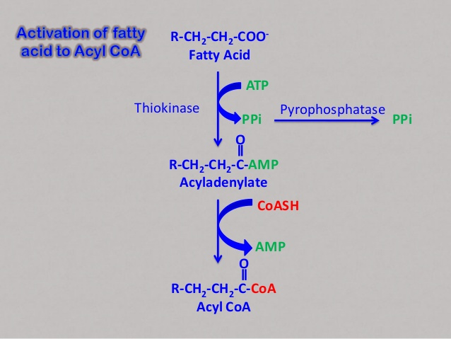

- Transport of fatty acids into mitochondria:
Cytoplasmic fatty acyl CoA is converted to fatty acyl carnitine by carnitine acyl transferase (CAT I), an enzyme of the inner leaflet of the outer mitochondrial membrane. Fatty acyl carnitine is then trransported by an antiport in exchange for free carnitine to the inner surface of the inner mitochondrial membrane. There carnitine acyl transferase II (CAT II) reverses the process, producing fatty acyl CoA and carnitine. This shuttle mechanism is required only for longer chain fatty acids. Medium- and short chain fatty acids are carnitine-independent. They cross the mitochondrial membranes, and are activated in the mitochondrion.
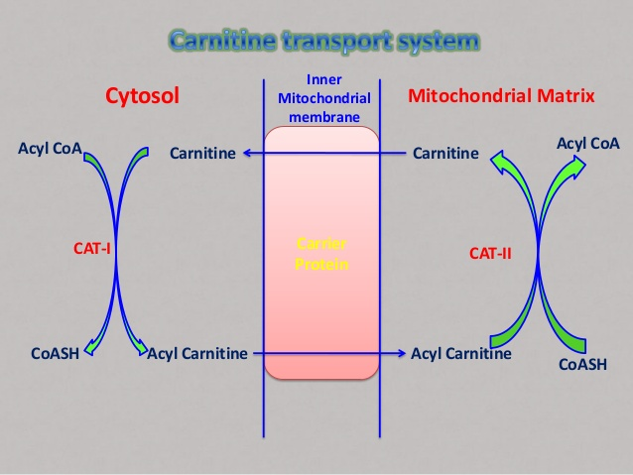
- Beta-Oxidation proper in the mitochondrial matrix:
Once the fatty acid is inside the mitochondrial matrix, beta-oxidation occurs by cleaving two carbons every cycle to form acetyl-CoA. The process consists of 4 steps.
- A long-chain fatty acid is dehydrogenated to create a trans double bond between C2 and C3. This is catalyzed by acyl CoA dehydrogenase to produce trans-delta 2-enoyl CoA. It uses FAD as an electron acceptor and it is reduced to FADH₂.
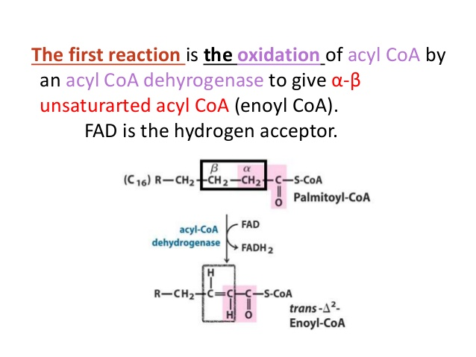
- Trans-delta2-enoyl CoA is hydrated at the double bond to produce L-3-hydroxyacyl CoA by enoyl-CoA hydratase.
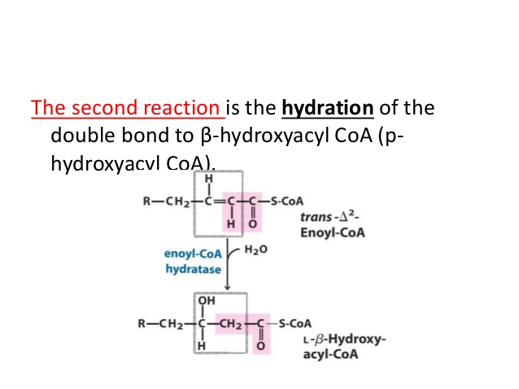

- L-3-hydroxyacyl CoA is dehydrogenated again to create 3-ketoacyl CoA by 3-hydroxyacyl CoA dehydrogenase. This enzyme uses NAD as an electron acceptor.
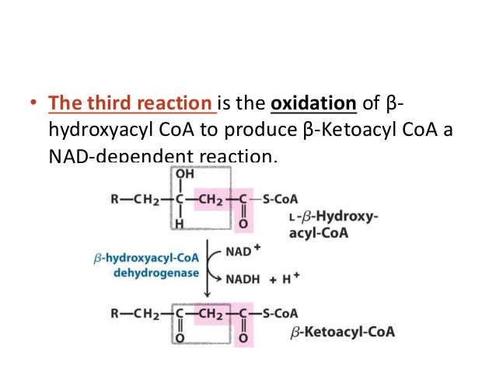

- Thiolysis occurs between C2 and C3 (alpha and beta carbons) of 3-ketoacyl CoA. Thiolase enzyme catalyzes the reaction when a new molecule of coenzyme A breaks the bond by nucleophilic attack on C3. This releases the first two carbon units, as acetyl CoA, and a fatty acyl CoA minus two carbons. The process continues until all of the carbons in the fatty acid are turned into acetyl CoA.
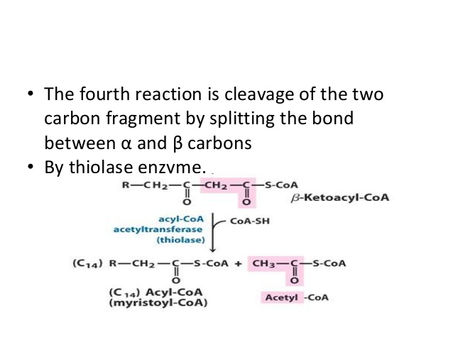
REFERENCES:
- https://www.slideshare.net/RajanKumar16/beta-oxidation-of-fatty-acids-60848977
- https://www.slideshare.net/harshrajshinde1/oxidation-of-fatty-acid
- https://microbenotes.com/beta-oxidation-of-fatty-acid/

