NAME: IKHENOBA ELIZABETH AMANDA
COURSE CODE: CVE 506
COURSE TITLE: HIGHWAY ENGINEERING

QUESTION: Discuss with respect to Nigeria, the essentials/fundamentals of transportation planning process and socioeconomic implications of each of these fundamentals in relation to National development.
ANSWER;
The fundamentals of transportation planning process include:
- Importance
- Administration
- Funding
- Planning
- Decision making

IMPORTANCE
Importance of highway transportation:
Highway transportation is the means of detail distribution between homes, shops, factories etc. It is only the roads which can carry goods from and to aero drams, harbors and railway stations.
Considering the utility of roads anywhere in the different parts of a country; they can be rightly compared to arterials in a human body.
Just as arteries maintain man's health by providing circulation of blood; similarly Roads promote nation's wealth by keeping it's people and goods moving. Thus, we see that progress and well-being of a nation depends much on roads. In fact, roads are the life lines of nation's economy.
The importance or necessity of highway transportation can be easily judged from the following purposes or advantages of roads: -
1. They facilitate, conveyance of people, goods, raw-materials, manufactured articles etc. speedily and easily in the different parts of a country.
2. They act as the only source of communication in regions of high altitudes i.e. in mountainous regions.
3. They help in growth of trade and other economic activities in and outside the villagers and towns by establishing contact between towns and villages.
4. They help in providing efficient distribution of agricultural products and natural resources all over the country.
5. They help in price stabilization of commodities due to mobility of products all over the country.
6. They help in cultural and social advancement of people and making the villagers active and alert members of the community.
7. They help in promoting the cultural and social ties among people living in different part of a country and thus strengthen the rational unity.
8. They help in providing improved medical facilities quickly to human beings, especially to those who live in rural areas.
9.They provide more employment opportunities.
10.They enhance land value and thus bring better revenue.
11. They serve as feeders for airway, waterways and railways.
12. They help in reducing distress among the people, caused due to famine, by supplying them food and clothing quickly.
13. They help in maintaining better law and order in a country.
14. They play a very important role in the defense of a country during war days.
ADMINISTRATIVE
The impact of transportation on national development. The impact of transportation on Nigeria’s national development has been pervasive. However, for ease of analysis we choose to evaluate the impact on Nigeria’s national development from three perspectives, which are;
1. Economic
2. Social,
3. Political
The economic impact of transportation on national development Economically, transportation impacts on our national development in the following ways;
1. It utilizes a sizeable number of the nation’s labor force. For instance, the transportation industry provides employment to the following categories of Nigerians.
a. All operators on road, rail, sea and air transportation services;
b. Bus, taxi, truck including private drivers of such vehicles and owners of tankers;
c. Operators of transport related terminals such as motor-parks, airports, seaports and railway stations in various locations of the country;
d. Air craft, motor vehicle equipment dealers and parts dealers
e. Transport related industries such as car-parts dealers (both new and used), car mechanics and garages, fuel service stations, highway employees and agencies, government transport employees. All these work in different capacities and different parts of the country to enhance the operation of the nation’s transport system
2. It increases the Gross Domestic Product (GDP) of Nigeria in combination of number of ways; a. Its services move goods and services to near and distant markets where they attract higher prices and profits for producers;
b. The higher prices and profits from sales attract business units to expand production which end up increasing their level of output. Second, transportation services spur the level of economic activities and economic development by enhancing the mobility of production factors such as labor, capital and entrepreneurship, thus permitting large-scale production or operation and the attendant increase in output. These activities widen the area that consumers and producers can draw upon for their products and resources as well as expanding the area to which a given producer can distribute its products.
c. Its services and related revenues to transport owners increase with increase in productive activities and the employment of personnel and their incomes, etc increase. All these increases in the value of goods and services arising from increases in the level of transportation services and prices combine to increase the value of the GDP. For instance, between 1981 and 2006, the transportation sector contributed above 3.4 percent on the average to Nigeria’s GDP. Thus, positive developments in transportation could really affect the economy favorably to make it a great and dynamic economy.
3. The Nigerian economy is crude oil and recently, natural gas driven. For instance, crude oil alone accounts for over 80 percent on the average of the Federal Government revenue annually as the figures 80.6, 84.7, 85.1, 87.2 and 78.1 percent for 2003, 2004, 2005, 2006, and 2007 respectively, show (NBS, 2008). But crude oil production in the country depend to a large extent on transportation especially pipeline, and to a lesser extent sea and road transportation. This implies that positive developments in transportation will affect the Nigerian economy positively through increase in crude oil production and the attendant increase in revenue to enable her to become a truly strong and self-reliant economy and a land of bright and full opportunities. On the other hand, negative developments in transportation could adversely affect the oil sector and thus the revenue position of the country and the attendant negative multiplier effects.
4. Electricity is vital for development such that the rate of energy utilization is often used as a development index. This is since the effect of electricity usage re-vibrates through the economy, serving first, as a source of energy for industrial and commercial outfits, as well as wide spread domestic use and second, as an outlet for the products of other industries like coal, fuel, oil, natural gas, diesel oil etc., and the attendant employment generation. Apart from the Kainji, Jebba, Shiroro and recently Zungeru power stations that are generated using water, the rests are thermal stations which make use of gas mainly, or fuel. The gas that fuels these power stations are transmitted through pipeline as discussed earlier. The import is that positive developments in transportation have the potentials of enhancing uninterrupted power supply all things being equal, and the attendant boost in virtually all the sectors of the economy, thus making the economy a truly strong, self-reliant, great and dynamic one.
5. It allows geographical specialization of industries. The existence of transportation services allows firms as well as regions of a nation to specialize in the production of goods or products and services which they can produce most economically in line with the Richardia principle of comparative advantage which asserts that an area should specialize in the production of goods for which it has the greatest comparative advantage or the least comparative disadvantage. Without effective transportation service, it will be difficult for specialization to take place. In Nigeria, the northern part uses its inertia to specialize in the production of crops like beans, pepper, onions, yams, vegetables, etc. and rear cattle, goats and sheep etc. in large quantities while the southern part concentrates on the production of forest products like kola-nuts, palm oil, garri etc. The availability of transportation has given room for the existence of a strong North- South internal trade relationship in which the excess products from the North are moved to the South where they are most needed while the excess products from the South are moved to the North where they are most needed, thus fostering unity between the two regions and strengthen the national economy. Equally, the above relationship permits large-scale production, expands local products market and provides place value to the products, all of which could combine to make the Nigerian economy a truly great, strong self-reliant and dynamic one, and land of bright and full opportunities.
6. The world today is a global village in which Nigeria is a participant. The existence of transportation networks like roads and railways and terminals like airports and seaports enables Nigeria as a nation to participate in this global village (Good and Jebbin, 2015). The social impact of transportation on national development Positive developments in transportation service equally impact positively on the social life of a nation in two significant ways;
1. Transportation makes it possible for;
- People who live in one area or part of the same city or different cities in the same country to travel to other areas or parts of the same city or different cities in order to maintain family or friendly ties over time;
- Workers to and fro on daily basis from their work places; c. Schools to operate and students to obtain education. Again, transportation complements communication network. For instance, letters, packages etc. move from senders to receivers in other parts of the country or even outside the country. Thus, the Nigerian postal services e.g. NIPOST, depend on the transportation system.

2. Finally, it brings people together. Individuals, economic units and communities develop at different rates and execute different programmes. Thus, effective transportation services can make it possible to bring together these separate individuals, economic units and communities to use common systems, standards and services such as education, sports and politics, thus fostering a united, just and egalitarian society.
Political impact of transportation on national development Positive developments in transportation services can be used to regulate the political life of a nation in two basic respects; 1. It acts as an aid to govern the states and the nation. For instance, national, state and local governments design and construct feasible rout/routes or transport facilities around the country in order to maintain an effective transport network system. These facilities as earlier observed include highways, seaports, waterways, railway routes and airports etc. Government designs the transportation in order to enable its leaders and politicians to travel easily and interact with the people they govern.
2. Transportation is needed in order to create and maintain national unity and enforce national laws and regulations.
3. It makes the defense of a country cheaper. For instance, national governments generally recruit and maintain their armies at strategic locations within the country. Transportation services is what the national command uses to effectively move military personnel and equipment’s to troubled areas whenever the need arises; the deployment of the Joint Military Task Force (JTF) to the Niger Delta region of the country in the wake of the militancy in the area and recently to the Northern states of Borno, Yobe and Adamawa to quell the Boko-Haram insurgency are cases in point. Again, effective transportation services enable the government to retain the number of soldiers which can be effectively moved to protect the nation in the event of emergencies.
FUNDING
- Public monies through federal government
- Private/design and build /DBFO
- Public private partnership
- Grants
SOCIOECONOMIC BENEFITS OF FUNDING
- Some projects may be easier to finance than others (if there is proven technology involved and/ or the extent of the private sectors obligations and liability is clearly identifiable), some projects will generate revenue in local currency only (eg water projects) while others (eg ports and airports) will provide currency in dollar or other international currency and so constraints of local finance markets may have less impact
- It creates liquidity
- Simulates domestic capital.
- Growth of labour market
PLANNING
It involves developing a transportation plan for a region. It seeks to address the transport needs of the inhabitants of the area, and with the aid of a process of consultation with all relevant groups, strives to identify and implement an appropriate plan to meet the needs. There are different levels of planning which are;
- Administrative and political
- Transport policies are formed
- Modes of transport
- Professional planners/ engineers
- Forecast future population
- Forecast economic growth
- Describes the physical nature of the system required to cope with the region’s transport needs (rail, road, cycling or pedestrian based)
- Design engineers
- Project detail defined in terms of physical extent and layout via drawings, route size, length.
SOCIOECONOMIC BENEFIT OF PLANNING
- Generation of transportation alternatives
- Definition of goals and objectives
- Formulation of measures of alternatives
- Evaluation of transport alternatives
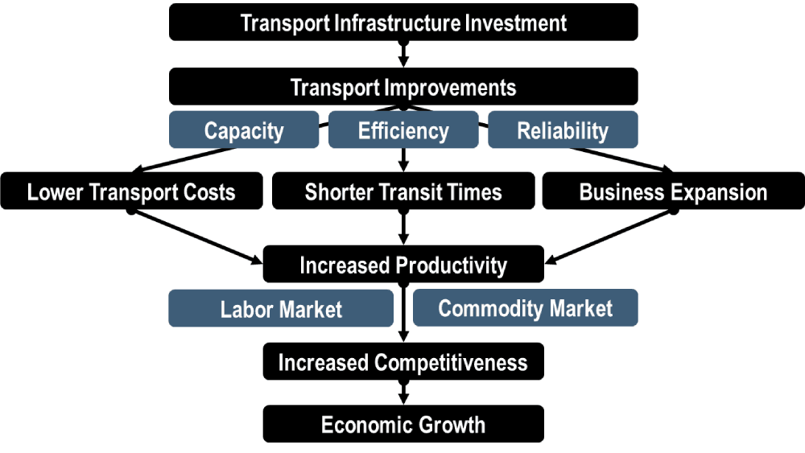
Fig 1: Effect of planning on national development

DECISION MAKING
Highway and transportation planning can be described as a process of making decision that concerns the future of a given transport system. The decision relates to the determination of future demand. It involves
- Economic assessment
- Environmental assessment (air quality, noise)
- Public consultation
SOCIOECONOMIC BENEFIT OF DECISION MAKING
- Gives better information on the general needs of the public
- Promotes safety of the public.
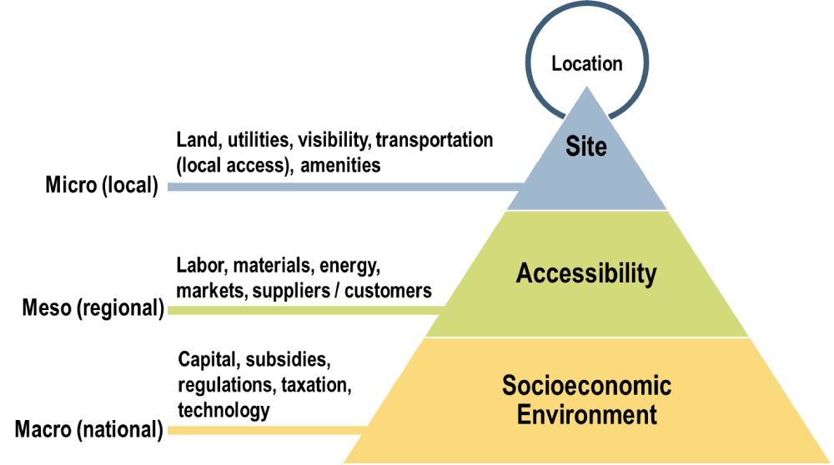
Fig 2: effect of decision making on national development

