NAME: OMOLADE BRIGHT AYOMIDE
DEPT: COMPUTER SCIENCE
MATRIC NO: 19/SCI01/078
NUMBER 1b
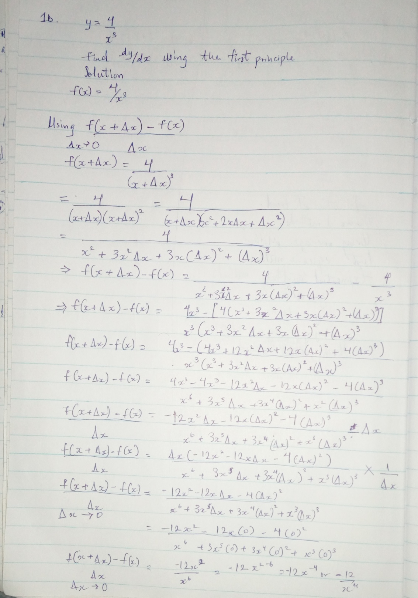

NUMBER 2a and 2b
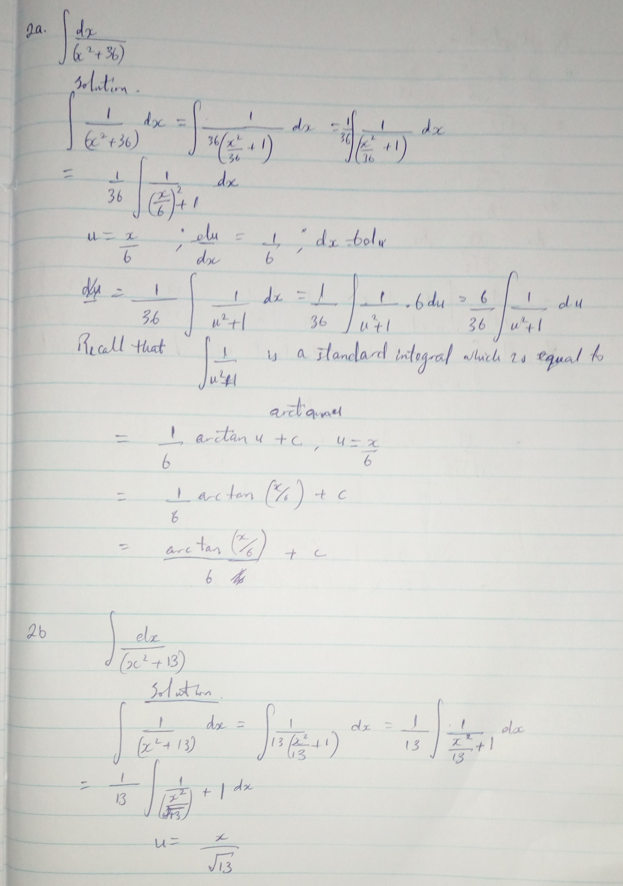

NUMBER 2b continued

