MATRIC NUMBER: 16/MHS02/016
COURSE TITLE: MATERNAL AND HEALTH AND NORMAL MIDWIFERY II
COURSE CODE: NSC 404
ASSIGNMENT
Reading assignment
1. USE OF PARTOGRAPH IN THE MANAGEMENT OF FIRST STAGE OF LABOUR
2. MANAGEMENT OF 2ND AND 3RD STAGES OF LABOUR
. USE OF PARTOGRAPH IN THE MANAGEMENT OF FIRST STAGE OF LABOUR
DEFINITION: Partograph is a basic tool or a chart where all labour observations are recorded in a clear way and these observations are interpreted to detect abnormality at a glance.
Partograph can also be defined as a tool for assessing the progress of labour that offers normal progress or an early warning for complications such as fetal distress, prolonged or obstructed labour.
Partograph may not be used in all conditions. Women who are not eligible for partograph include:
- Cervical dilatation of 9-10cm
- Elective caesarian section
- Emergency caesarian section on admission
- Gestational age less than 30 weeks
- Ante-Partum haemorrhage
- Severe pregnancy induced hypertension (PIH), e.g. severe pre-eclampsia.
- Malpresentation and abnormal lie, e.g. breech, face, brow, and transverse lie.
- Confirmed cephalo-pelvic disproportion (CPD).
CHARTING ON THE PARTOGRAPH
- Patient’s information: full name, gravida, parity, hospital number, date and time of admission, etc, are written at the top of the graph.
- Time is recorded using the time of admission as zero-time. The actual time of the day is recorded below the hour line.
- The maternal condition: temperature and respiration are recorded in the spaces provided. Blood pressure recorded with a plus sign (+), pulse recorded with a dot sign (.).
All observations on the mother’s condition are recorded on the time line at which the observations are made at the bottom of the partograph (i.e. every 4 hours).
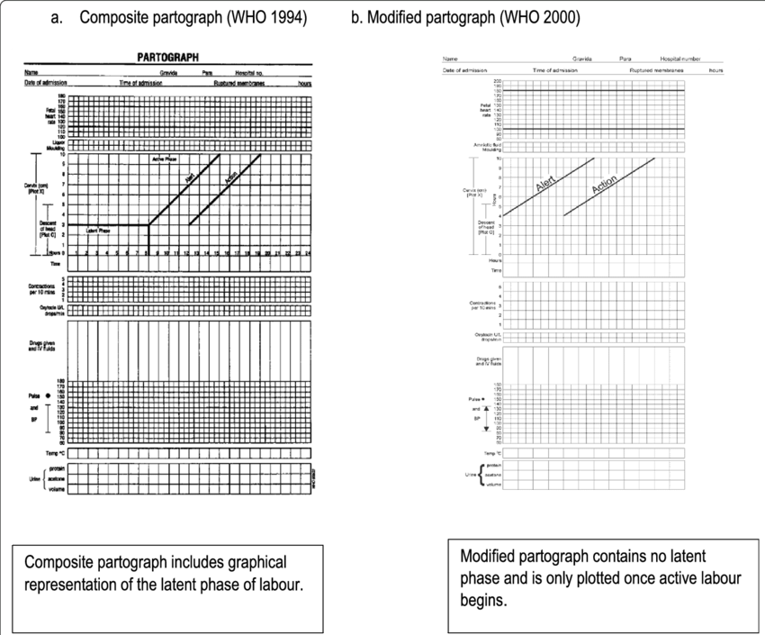

MANAGEMENT OF 2ND STAGE OF LABOUR
- Hourly check of vital signs; temperature, blood pressure and pulse (palpated simultaneously with the FHR)
- Abdominal palpation for presentation and position of the baby
- Ensure bladder is emptied 4hrly
- Urinalysis should be done
- Assessment of progress should include maternal behaviour, effectiveness of pushing and fetal wellbeing
- Document effectiveness of pushing
- Assess the patient’s pain, discussing her preferred coping strategies and supporting her wishes.
- Discourage the woman from lying supine or semi-supine in the second stage of labour,
- Inform the woman that in the second stage she should be guided by her own urge to push.
- If any of the indications for transfer are met transfer the woman to obstetric-led care.
- Follow the general principles for transfer of care described in the guideline entitled ‘Transfer of mothers and babies to different care settings’.
MANAGEMENT OF 3RD STAGE OF LABOUR
- After administering the oxytocin, clamp and cut the cord.
- Do not clamp the cord earlier than 1 minute from the birth of the baby
- Clamp the cord before 5 minutes in order to perform controlled cord traction as part of active management.
- After cutting the cord, use controlled cord traction.
- Record the timing of cord clamping in both active and physiological management.
- Do not use either umbilical oxytocin infusion or prostaglandin routinely in the third stage of labour. If retained placenta is diagnosed
- Observations in the third stage of labour should include: Estimating the amount of vaginal blood loss; Assessing the general condition of the mother i.e. her respirations, colour and her own report of how she feels; Where haemorrhage, retained placenta or maternal collapse is diagnosed
- Documentation

