NAME : BELLO MOYONINUOLUWA ESTHER

MAT.NO:19/MHS02/035

DEPARTMENT: NURSING

COURSE CODE: PHY 102

COURSE TITLE: ELECTRICITY, MAGNETISM, AND MODERN PHYSICS

1a) Charging by induction
One common demonstration performed in a physics classroom involves the induction charging of two metal spheres. The metal spheres are supported by insulating stands so that any charge acquired by the spheres cannot travel to the ground. The spheres are placed side by side (see diagram i. below) so as to form a two-sphere system. Being made of metal (a conductor), electrons are free to move between the spheres - from sphere A to sphere B and vice versa. If a rubber balloon is charged negatively (perhaps by rubbing it with animal fur) and brought near the spheres, electrons within the two-sphere system will be induced to move away from the balloon. This is simply the principle that like charges repel. Being charged negatively, the electrons are repelled by the negatively charged balloon. And being present in a conductor, they are free to move about the surface of the conductor. Subsequently, there is a mass migration of electrons from sphere A to sphere B. This electron migration causes the two-sphere system to be polarized (see diagram ii. below). Overall, the two-sphere system is electrically neutral. Yet the movement of electrons out of sphere A and into sphere B separates the negative charge from the positive charge. Looking at the spheres individually, it would be accurate to say that sphere A has an overall positive charge and sphere B has an overall negative charge. Once the two-sphere system is polarized, sphere B is physically separated from sphere A using the insulating stand. Having been pulled further from the balloon, the negative charge likely redistributes itself uniformly about sphere B (see diagram iii. below).
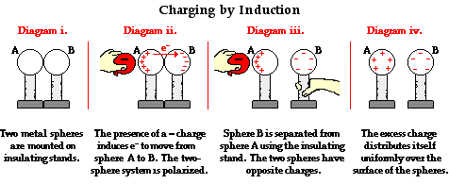

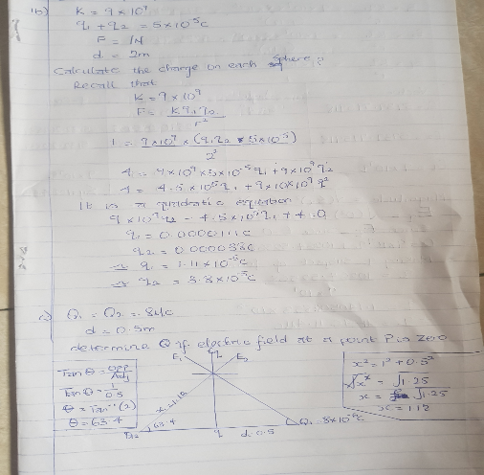

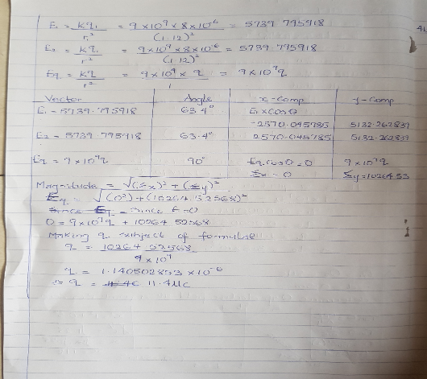

3ai) volume charge density, $ρ=\frac{q}{v}$

ii) Surface charge density, $σ=\frac{q}{a}$

iii)Linear charge density, $⋋=\frac{q}{l}$
b)ELECTRIC POTENTIAL DIFFERENCE
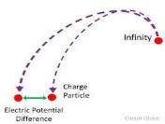
The electric potential difference between two points in an electric field can be defined as the work done per unit charge against electrical forces when a charge is transported from one point to the other. It is measured in Volt (𝒗) or Joules per Coulomb (𝑱/𝑪). Electric potential difference is a scalar quantity.

Consider the diagram above, suppose a test charge 𝒒𝒐
is moved from point 𝑨 to point 𝑩
along an arbitrary path inside an electric field 𝑬. The electric field 𝑬 exerts a force 𝑭 = 𝒒𝒐𝑬
on the charge as shown in fig 3.1. To move the test charge from 𝑨 to 𝑩 at constant velocity, an external force of 𝑭 = −𝒒𝒐𝑬 must act on the charge. Therefore, the elemental work
done 𝒅𝑾 is given as:
𝒅𝑾 = 𝑭. 𝒅𝑳 … (𝟏)
But
𝑭 = −𝒒𝟎𝑬 … (𝟐)
Substituting equation (𝟐) in (𝟏) yields
𝒅𝑾 = −𝒒𝟎𝑬𝒅𝑳 … (𝟑)W-q_0EdL … (3)
Then total work done in moving the test charge from 𝑨 to 𝑩 is:
𝑾(𝑨 → 𝑩)𝑨𝒈 = −𝒒𝟎 ∫ 𝑬𝒅𝑳𝑩𝑨… (𝟒)
From the definition of electric potential difference, it follows that:
𝑽𝑩 − 𝑽𝑨 =𝑾(𝑨→𝑩)𝑨𝒈𝒒𝟎… (𝟓) Putting equation (𝟒) in (𝟓) yields
𝑽𝑩 − 𝑽𝑨 = − ∫ 𝑬𝒅𝑳𝑩𝑨… (𝟔)

SECTION B
4a) The magnetic flux (often denoted Φ or Φ_{B}) through a surface is the surface integral of the normal component of the magnetic field flux density B passing through that surface. The SI unit of magnetic flux is the weber (Wb).
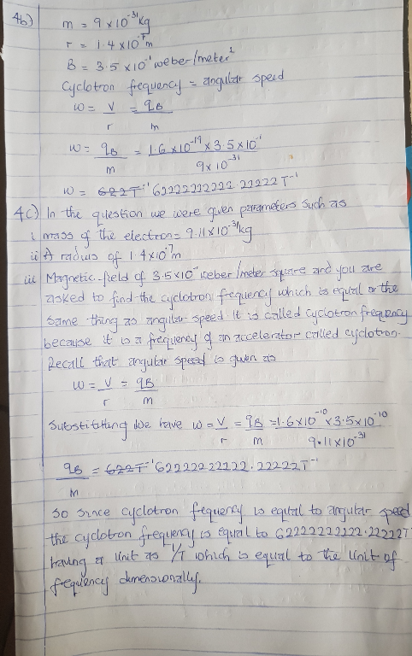
b)

5a)Biot-Savart law relates magnetic fields to the currents which are their sources.In a similar manner,coulomb’s law relates electric fields to the point charges which are their sources.Finding thee magnetic field resulting from a current distribution involves the vector product, and is inherently a calculus problem when the distance from the current to the field point is continuously changing.
b) The Biot-Savart law starts with the following equation:
B⃗ =μ04π∫wireIdl⃗ ×r^r2.B→=μ04π∫wireIdl→×r^r2.
As we integrate along the arc, all the contributions to the magnetic field are in the same direction (out of the page), so we can work with the magnitude of the field. The cross product turns into multiplication because the path dldl and the radial direction are perpendicular. We can also substitute the arc length formula, dl=rdθdl=rdθ:
B=μ04π∫wireIrdθr2.B=μ04π∫wireIrdθr2.
The current and radius can be pulled out of the integral because they are the same regardless of where we are on the path. This leaves only the integral over the angle,
B=μ0I4πr∫wiredθ.B=μ0I4πr∫wiredθ.
The angle varies on the wire from 0 to θθ; hence, the result is
B=μ0Iθ4πr.B=μ0Iθ4πr.

