MATRIC NUMBER: 16/MHS02/029

ASSIGNMENT
- USE OF PARTOGRAPH IN THE MANAGEMENT OF FIRST STAGE OF LABOUR

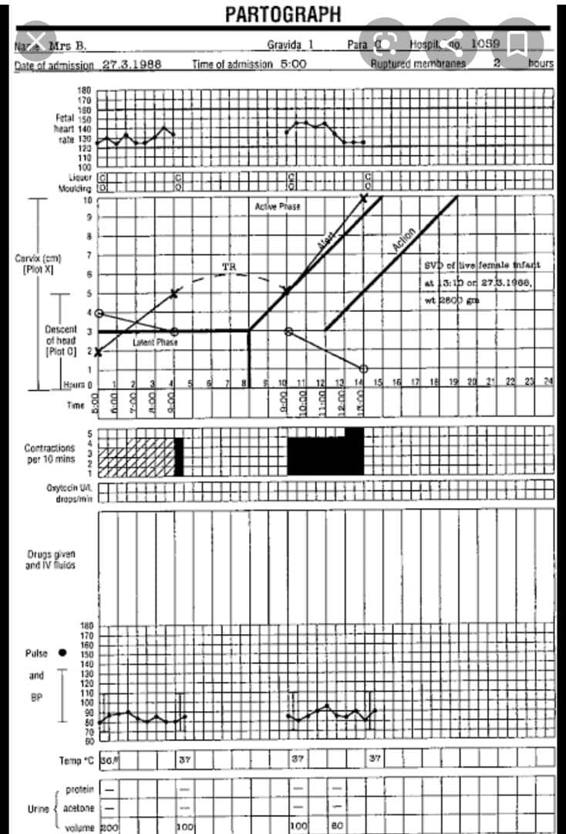

It consists of 3 parts as follow;
- THE FOETAL CONDITION:
Observations charted are the foetal heart rate, membranes, liquor and moulding of the foetal skull.
Foetal heart rate
Listening and recording fetal heart rate is a safe and reliable way of knowing that fetus is well.
Record half hourly. This is recorded at the top of the patograph. Each square represents 30 minutes check and record the fetal rate at least every hourly. If any problem you may listen to fetal heart rate after every contraction.
Membranes and liquor (amniotic fluid)
The following observations are recorded on the partograph immediately below the fetal heart rate recordings. The observations are made at each vaginal examination as follows:
If the membranes are ruptured;
Liquor is clear; write the letter C for clear
Liquor is blood stained write the letter ‘B’
Liquor is meconium stained, write letter ‘M’
Liquor is absent; write the letter ‘A’ for absent
Moulding of the foetal skull bone
The amount of moulding helps you to know how well the pelvis is making room for the fetal head. Moulding is evaluated each time you do a vaginal examination
Recording the moulding:
0 = bones are separated and the sutures can be felt easily
+ = bones are just touching each other
++ = bones are overlapping, can be separated easily with pressure from your finger
+++ = bones are overlapping, cannot be separated easily with pressure from your fingers

- THE PROGRESS OF LABOUR
Observations charted are the cervical dilation, decent of the foetal head through abdominal palpations and uterine contractions at frequency of 10 minutes duration.

Cervical dilation
Assessed at every vaginal examination and marked with a cross (x) begin plotting on the partograph at 4cm
Alert line: this starts at 4cm of cervical dilation to the point of expected full dilation at the rate of 1cm per hour
Action line: parallel and four hours to the right of the alert line
Descent assessed by palpation
This refers to the part of the head (divided into five parts) palpable above the symplysis pubis recorded as a circle at every abdorminal examination at 0/5, th sinciput(s) at the level of the symplysis pubis
Contractions
Plot contractions per 10 minutes below the time line and on the left hand side Chart every half hourly, count the number of contractions in a 10 minutes time period, and their duration in seconds.
Squares are numbered from 0 to 5. Each square represents one contraction; the squares below show the key to the 3 ways the strength of contractions are recorded on the partograph.
DOTS are for mild contractions of less than 20 seconds duration
DIAGONAL LINES indicate moderate contractions of 20 to 40 seconds duration
SOLID COLOR represents strong contractions of loner than 40 seconds

- THE MATERNAL CONDITIONS
Observations charted are pulse, blood pressure and temperature. Others include urine (volumes, protein, and acetone) drugs and intravenous fluids, oxytocin regimen.
- Pulse, blood pressure, and temperature: take the blood pressure 2hourly temperature and pulse every 2 hours
- Urine: ask the mother to pass urine every 2hours. Inspect the urine for amount and concentration.
- Drugs and rehydration fluid: chart these when you give them.
- Oxytocin: there is a separate column for oxytocin above the column for rehydration fluids and drugs.

- MANAGEMENT OF SECOND AND THIRD STAGES OF LABOUR

MANAGEMENT OF SECOND STAGE OF LABOUR
Second stage is maximum of 30 minutes irrespective of the gravida
- Check frequency of contraindications, strength and duration
- Monitor vital signs and foetal heart rate
- Note mother’s uncontrollable urge to push
- Check pointing anus
- Clean up sweats on the face if present
- Check foetal head visible at the vulva
- Note nausea and/or vomiting
- Perform vaginal examination to confirm full dilation of the cervix
CONDUCTIING DELIVERY:
- Position patient on her back with her two legs flexed and open
- Swab the vulva with antiseptic lotion
- Monitor progressive descent of the presenting part on the perineum
- Instruct her to take up fast deep breathing in and out
- Encourage her to pant at the crowning of the head
- Deliver the head gently, and feel for cord round the neck
- If present but the loose, slip over the head
- If tight, clamp in two places and cut between clamps

MANAGEMENT OF THIRD STAGE OF LABOUR
This stage may last up to 30 minutes
- Within 1 minute of the birth of the baby palpate the abdomen to rule out the presence of an additional baby(s) and give oxytocin 10 IU units IM.
- Encourage to pass urine, if not catheterize if bladder is full
- Deliver the placenta and membranes using controlled cord traction
- Expel blood clots to make the uterus contract
- Inspect perineum, vulva and vagina for lacerations
- Clean the client up
- Check vital signs
- Feel uterus for firmness
- Make mother comfortable and offer her a drink
- Give baby to mother to breast feed
- Examine placenta and membranes for completeness
- Estimate blood loss and record your findings
- Recheck blood pressure
- Avoid application of fundal pressure throughout labour

