Name:OKechukwu Peter Chukwukasi
Marric no: 18/sci03/007
Assignment Title: Microbial Variation and Hereditary
Course Title: General Microbiology II
Course Code: MCB 202

Question
1. Discuss microbial variation and hereditary in bacteria
2. Explain microbial recombination

Bacterial Genetics
Bacterial genetics is the study of how genetic information is transferred, either from a particular bacterium to its offspring or between interbreeding lines of bacteria, and how that genetic information is expressed. Given the short generation times of most bacteria, the inheritance of genetic information must be extremely faithful. Occasionally genetic variation or the transfer of genetic information between bacteria gives rise to mutations. The large sizes of bacterial populations ensure that even extremely rare genetic events are likely to occur. This genetic variation makes it possible for individual members of huge populations of bacteria to evolve new traits rapidly. For example, a single mutation may allow a bacterium to survive environmental conditions that would kill its nonmutant siblings (e.g., exposure to an antibiotic), or a group of genes transferred from another bacterial species may enable such an altered bacterial species to invade a new environmental niche (e.g., the ability to infect a new host). In the laboratory, genetic variation is exploited to study the properties of bacteria, to explore the fundamental characteristics of gene transfer and gene expression, and to construct mutants with desired characteristics. Prokaryotes can share genes by three other mechanisms: conjugation, transformation, and transduction.

Transformation
In transformation, a bacterium takes in DNA from its environment, often DNA that's been shed by other bacteria. In a laboratory, the DNA may be introduced by scientists. If the DNA is in the form of a circular DNA called a plasmid, it can be copied in the receiving cell and passed on to its descendants.
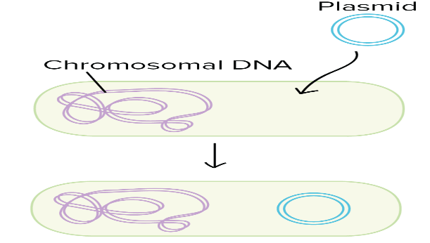
Left: plasmid taken up by transformation.
Right: linear DNA fragment taken up by transformation and swapped into the bacterial chromosome by homologous recombination.
Imagine that a harmless bacterium takes up DNA for a toxin gene from a pathogenic (disease-causing) species of bacterium. If the receiving cell incorporates the new DNA into its own chromosome (which can happen by a process called homologous recombination), it too may become pathogenic.

Transduction
In transduction, viruses that infect bacteria move short pieces of chromosomal DNA from one bacterium to another "by accident."
The viruses that infect bacteria are called Bacteriophages. Bacteriophages, like other viruses, are the pirates of the biological world—they commandeer a cell's resources and use them to make more bacteriophages.
However, this process can be a little sloppy. Sometimes, chunks of host cell DNA get caught inside the new bacteriophage as they are made. When one of these "defective" bacteriophages infects a cell, it transfers the DNA. Some bacteriophages chop the DNA of their host cell into pieces, making this transfer process more likely.
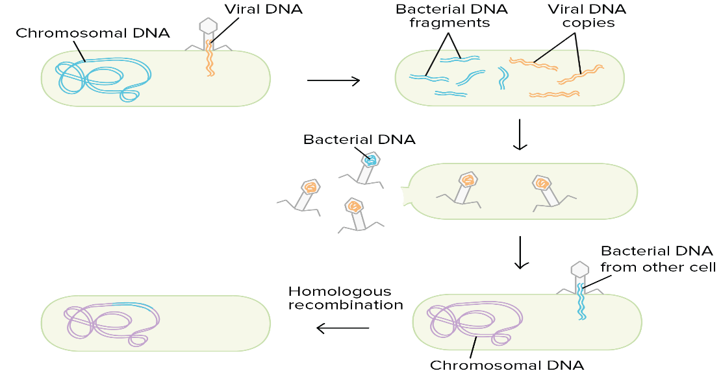
Virus infects cell by injecting its DNA. Bacterial DNA is fragmented and viral DNA is replicated. New viral particles are made and exit the cell. One contains host DNA instead of viral DNA. When this virus infects a new host, it injects the bacterial DNA, which can recombine with the chromosome of the new ones.
Archaea, the other group of prokaryotes besides bacteria, are not infected by bacteriophages but have their own viruses that move genetic material from one individual to another.

Conjugation
In conjugation, DNA is transferred from one bacterium to another. After the donor cell pulls itself close to the recipient using a structure called a pilus, DNA is transferred between cells. In most cases, this DNA is in the form of a plasma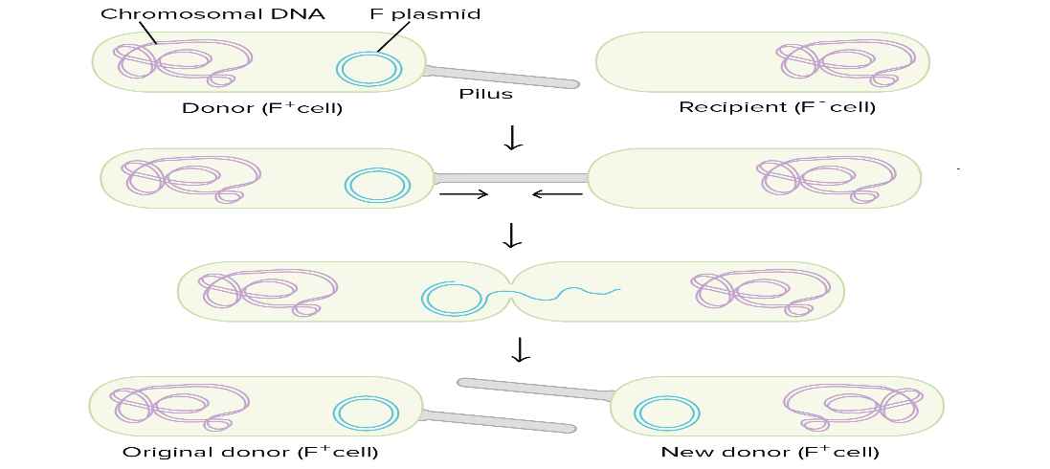

- An F+ donor cell contains its chromosomal DNA and an F plasmid. It has a rodlike pilus. A recipient F- cell has only a chromosome and no F plasmid.
- The donor cell uses its pilus to attach to the recipient cell, and the two cells are pulled together.
- A channel forms between the cytoplasms of the two cells, and a single strand of the F plasmid is fed through.
- Both of the cells now have an F plasmid and are F+. The former recipient cell is now a new donor and can form a pilus.
Donor cells typically act as donors because they have a chunk of DNA called the fertility factor (or F factor). This chunk of DNA codes for the proteins that make up the sex pilus. It also contains a special site where DNA transfer during conjugation begins^22squared.
If the F factor is transferred during conjugation, the receiving cell turns into an F^++start superscript, plus, end superscript donor that can make its own pilus and transfer DNA to other cells. Here's one analogy: this process is sort of like how a vampire can turn other people into vampires by biting them.

Transposable elements
Transposable elements are also important in bacterial genetics. These chunks of DNA "jump" from one place to another within a genome, cutting and pasting themselves or inserting copies of themselves in new spots. Transposable elements are found in many organisms, not just in bacteria.
In bacteria, transposable elements sometimes carry antibiotic resistance and pathogenicity genes (genes that make bacteria disease-causing). If one of these transposable elements "jumps" from the chromosome into a plasmid, the genes it carries can be easily passed to other bacteria by transformation or conjugation. That means the genes can spread quickly through the population.
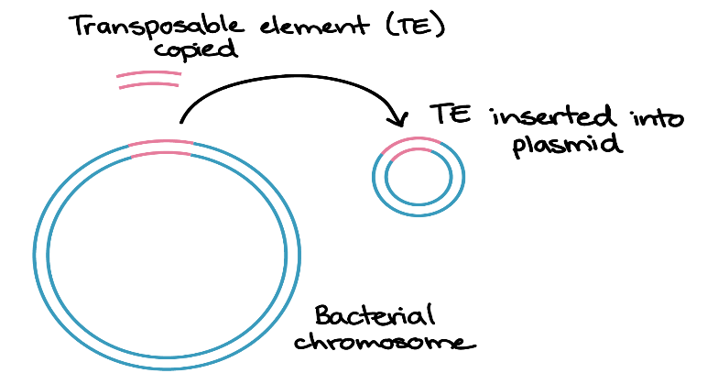

Bacterial recombination
is a type ogenetic recombination in bacteria characterized by DNA transfer from one organism called donor to another organism as recipient. This process occurs in three main ways:
- transformation, the uptake of exogenous DNA from the surrounding environment.
- transduction, the virus-mediated transfer of DNA between bacteria.
- conjugation, the transfer of DNA from one bacterium to another via cell-to-cell contact.
The final result of conjugation, transduction, and/or transformation is the production of genetic recombinants, individuals that carry not only the genes they inherited from their parent cells but also the genes introduced to their genomes by conjugation, transduction, and/or transformation.
The ability to undergo natural transformation is present in at least 67 bacterial species. Natural transformation is common among pathogenic bacterial species. In some cases, the DNA repair capability provided by recombination during transformation facilitates survival of the infecting bacterial pathogen. Bacterial transformation is carried out by numerous interacting bacterial gene products

